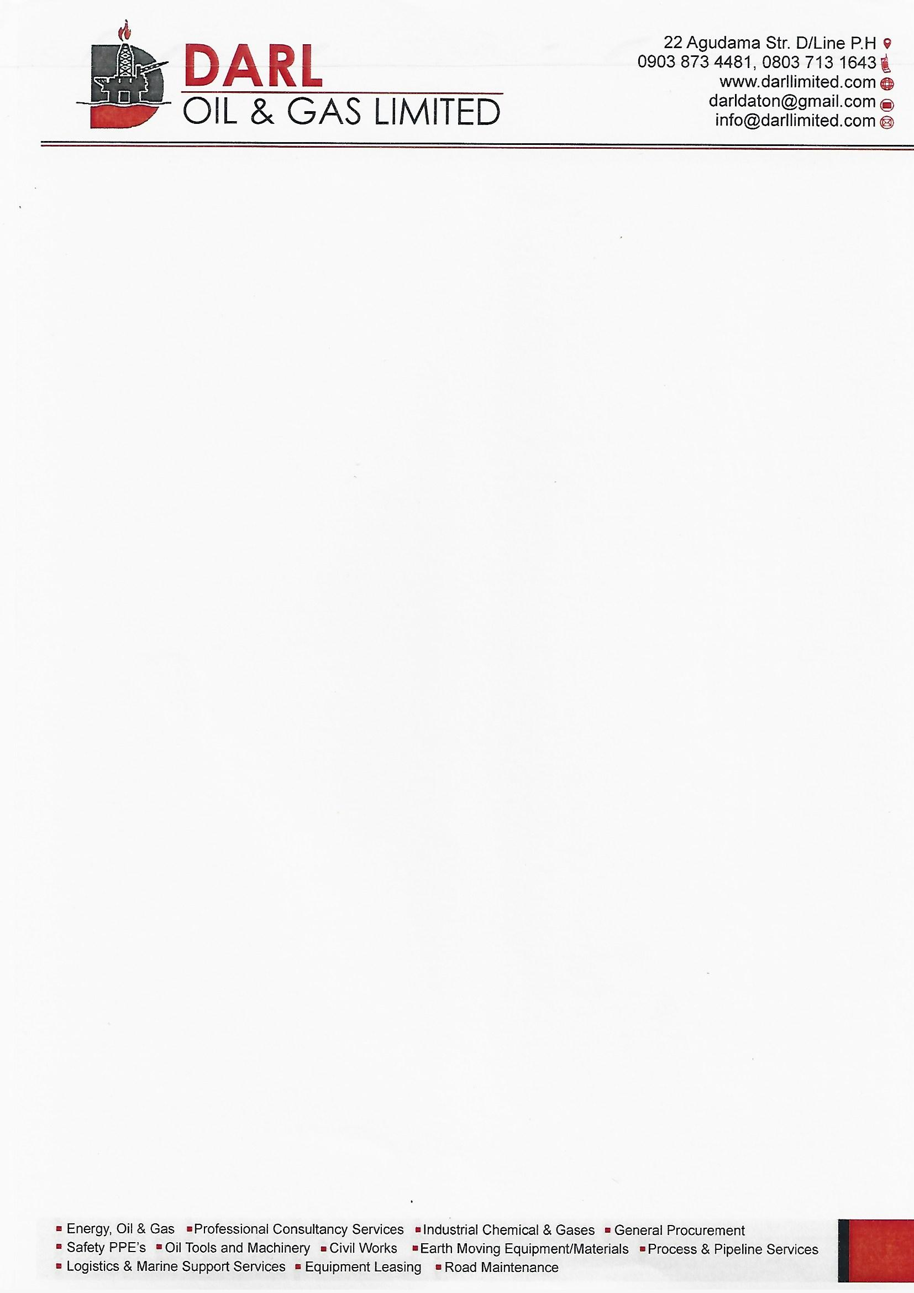

**QUOTATION NO: 0001**

**DATE: 20TH JUNE, 2022.**

**CLIENT: ELSHCON NIGERIA LIMITED**

|  |  |  |  |  |  |  |  |
| --- | --- | --- | --- | --- | --- | --- | --- |
| **S/N** | | **DESCRIPTION** | | **QTY** | **UNIT PRICE** | **AMOUNT** | |
| 1 | | GENERATOR OIL SWITCH SENSOR (10BAR) | | 3 PCS | 40,000 | 120,000 | |
| 2 | | INSULATOR MEGGAR TEST MWTER (FLUKE 1507) | | 1 PC | 520,000 | 520,000 | |
| 3 | | SOLDERING LEIT | | 1ROLL | 4,500 | 4,500 | |
| 4 | | INSECT KILLER LIGHT TUBE (T8/10W) | | 10 PCS | 2,800 | 28,000 | |
| 5 | | SOLDERING IRON (1000WATT) | | 1 PC | 8,500 | 8,500 | |
| 6 | | MASKING TAPE | | 5 PCS | 550 | 2,750 | |
| 7 | | SET OF ELECTRICAL SCREW DRIVER | | 1 SET | 12,000 | 12,000 | |
| 8 | | ELECTRICAL CONTECT CLEANER | | 2 PCS | 6,500 | 13,000 | |
| 9 | | METRO ONE KILLER bk L20, 2X10W T8, 220V, 50HZ/60HZ | | 3 PCS | 18,000 | 54,000 | |
|  |  | | **TOTAL: N762,750**  **VAT @7.5%: N23,868.75**  **SUM TOTAL: N786,618.75**  ***THANKS FOR YOUR BUSINESS!*** | | | |
|  |  | |  | | | |
|  |  | |  | | | |
|  |  | |  | | | |
|  |  | |  | | | |