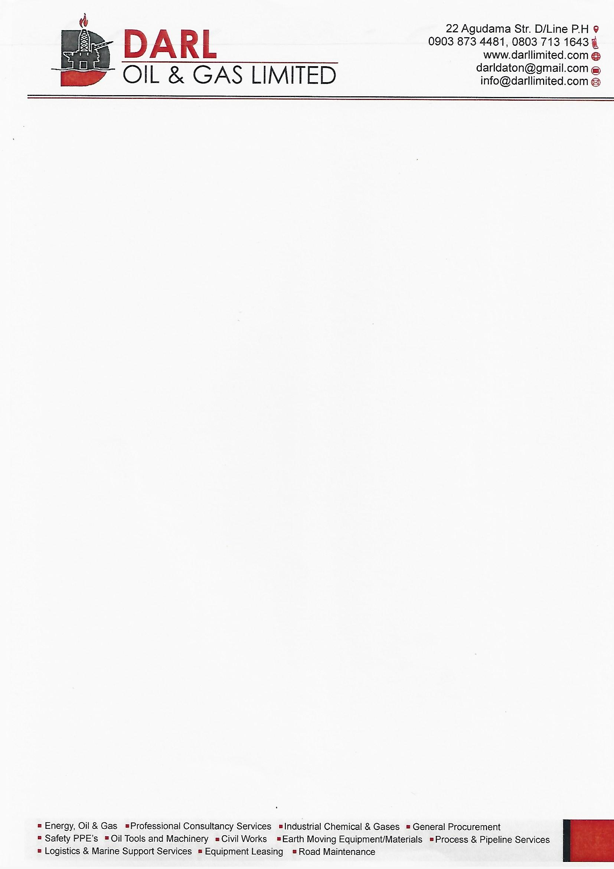

**QUOTATION NO: 0001**

**DATE: 20TH JUNE, 2022.**

**CLIENT: ELSHCON NIGERIA LIMITED**

|  |  |  |  |  |  |  |  |
| --- | --- | --- | --- | --- | --- | --- | --- |
| **S/N** | | **DESCRIPTION** | | **QTY** | **UNIT PRICE** | **AMOUNT** | |
| 1 | | TYPE 4 LIFE JACKET WITH MOB LIGHT | | 12 PCS | 60,000 | 720,000 | |
|  |  | | **TOTAL: N720,000**  **VAT @7.5%: N18,000**  **SUM TOTAL: N738,000**  ***THANKS FOR YOUR BUSINESS!*** | | | |
|  |  | |  | | | |
|  |  | |  | | | |
|  |  | |  | | | |
|  |  | |  | | | |