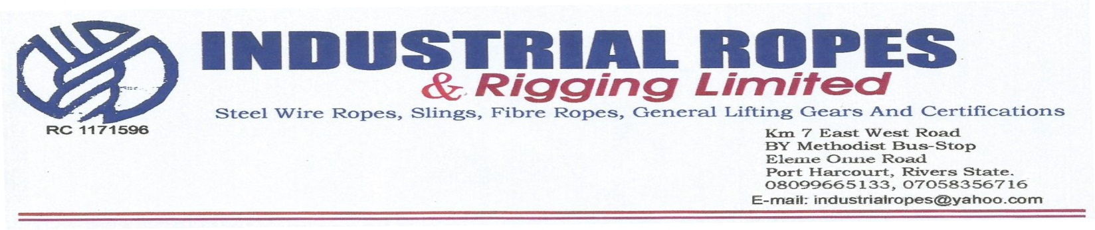14th July 2022

**Elshcon Nigeria Limited,**

**Port Harcourt.**

**PRO FORMA INVOICE FOR STEEL WIRE ROPE**

|  |  |  |  |  |
| --- | --- | --- | --- | --- |
| **S/N** | **QTY** | **DESCRIPTION** | **UNIT PRICE** | **AMOUNT(N)** |
| 1. | 1pc | x 90 mtrs, 22mm dia steel wire rope equipped with plain end both side. | 4,500.00 | 405,000.00 |
| 3. |  | Profit  VAT | 500  7.5% | 45,000  3,375.00 |
|  | **TOTAL** | | | **408,375.00** |
|  | **GRAND TOTAL** | | | **408,375.00** |

**Amount in Words: Four Hundred and Eight thousand Three Hundred and Seventy Five naira only**

**TERMS:**

ADD 7.5% VAT TIN: 17792697-0001

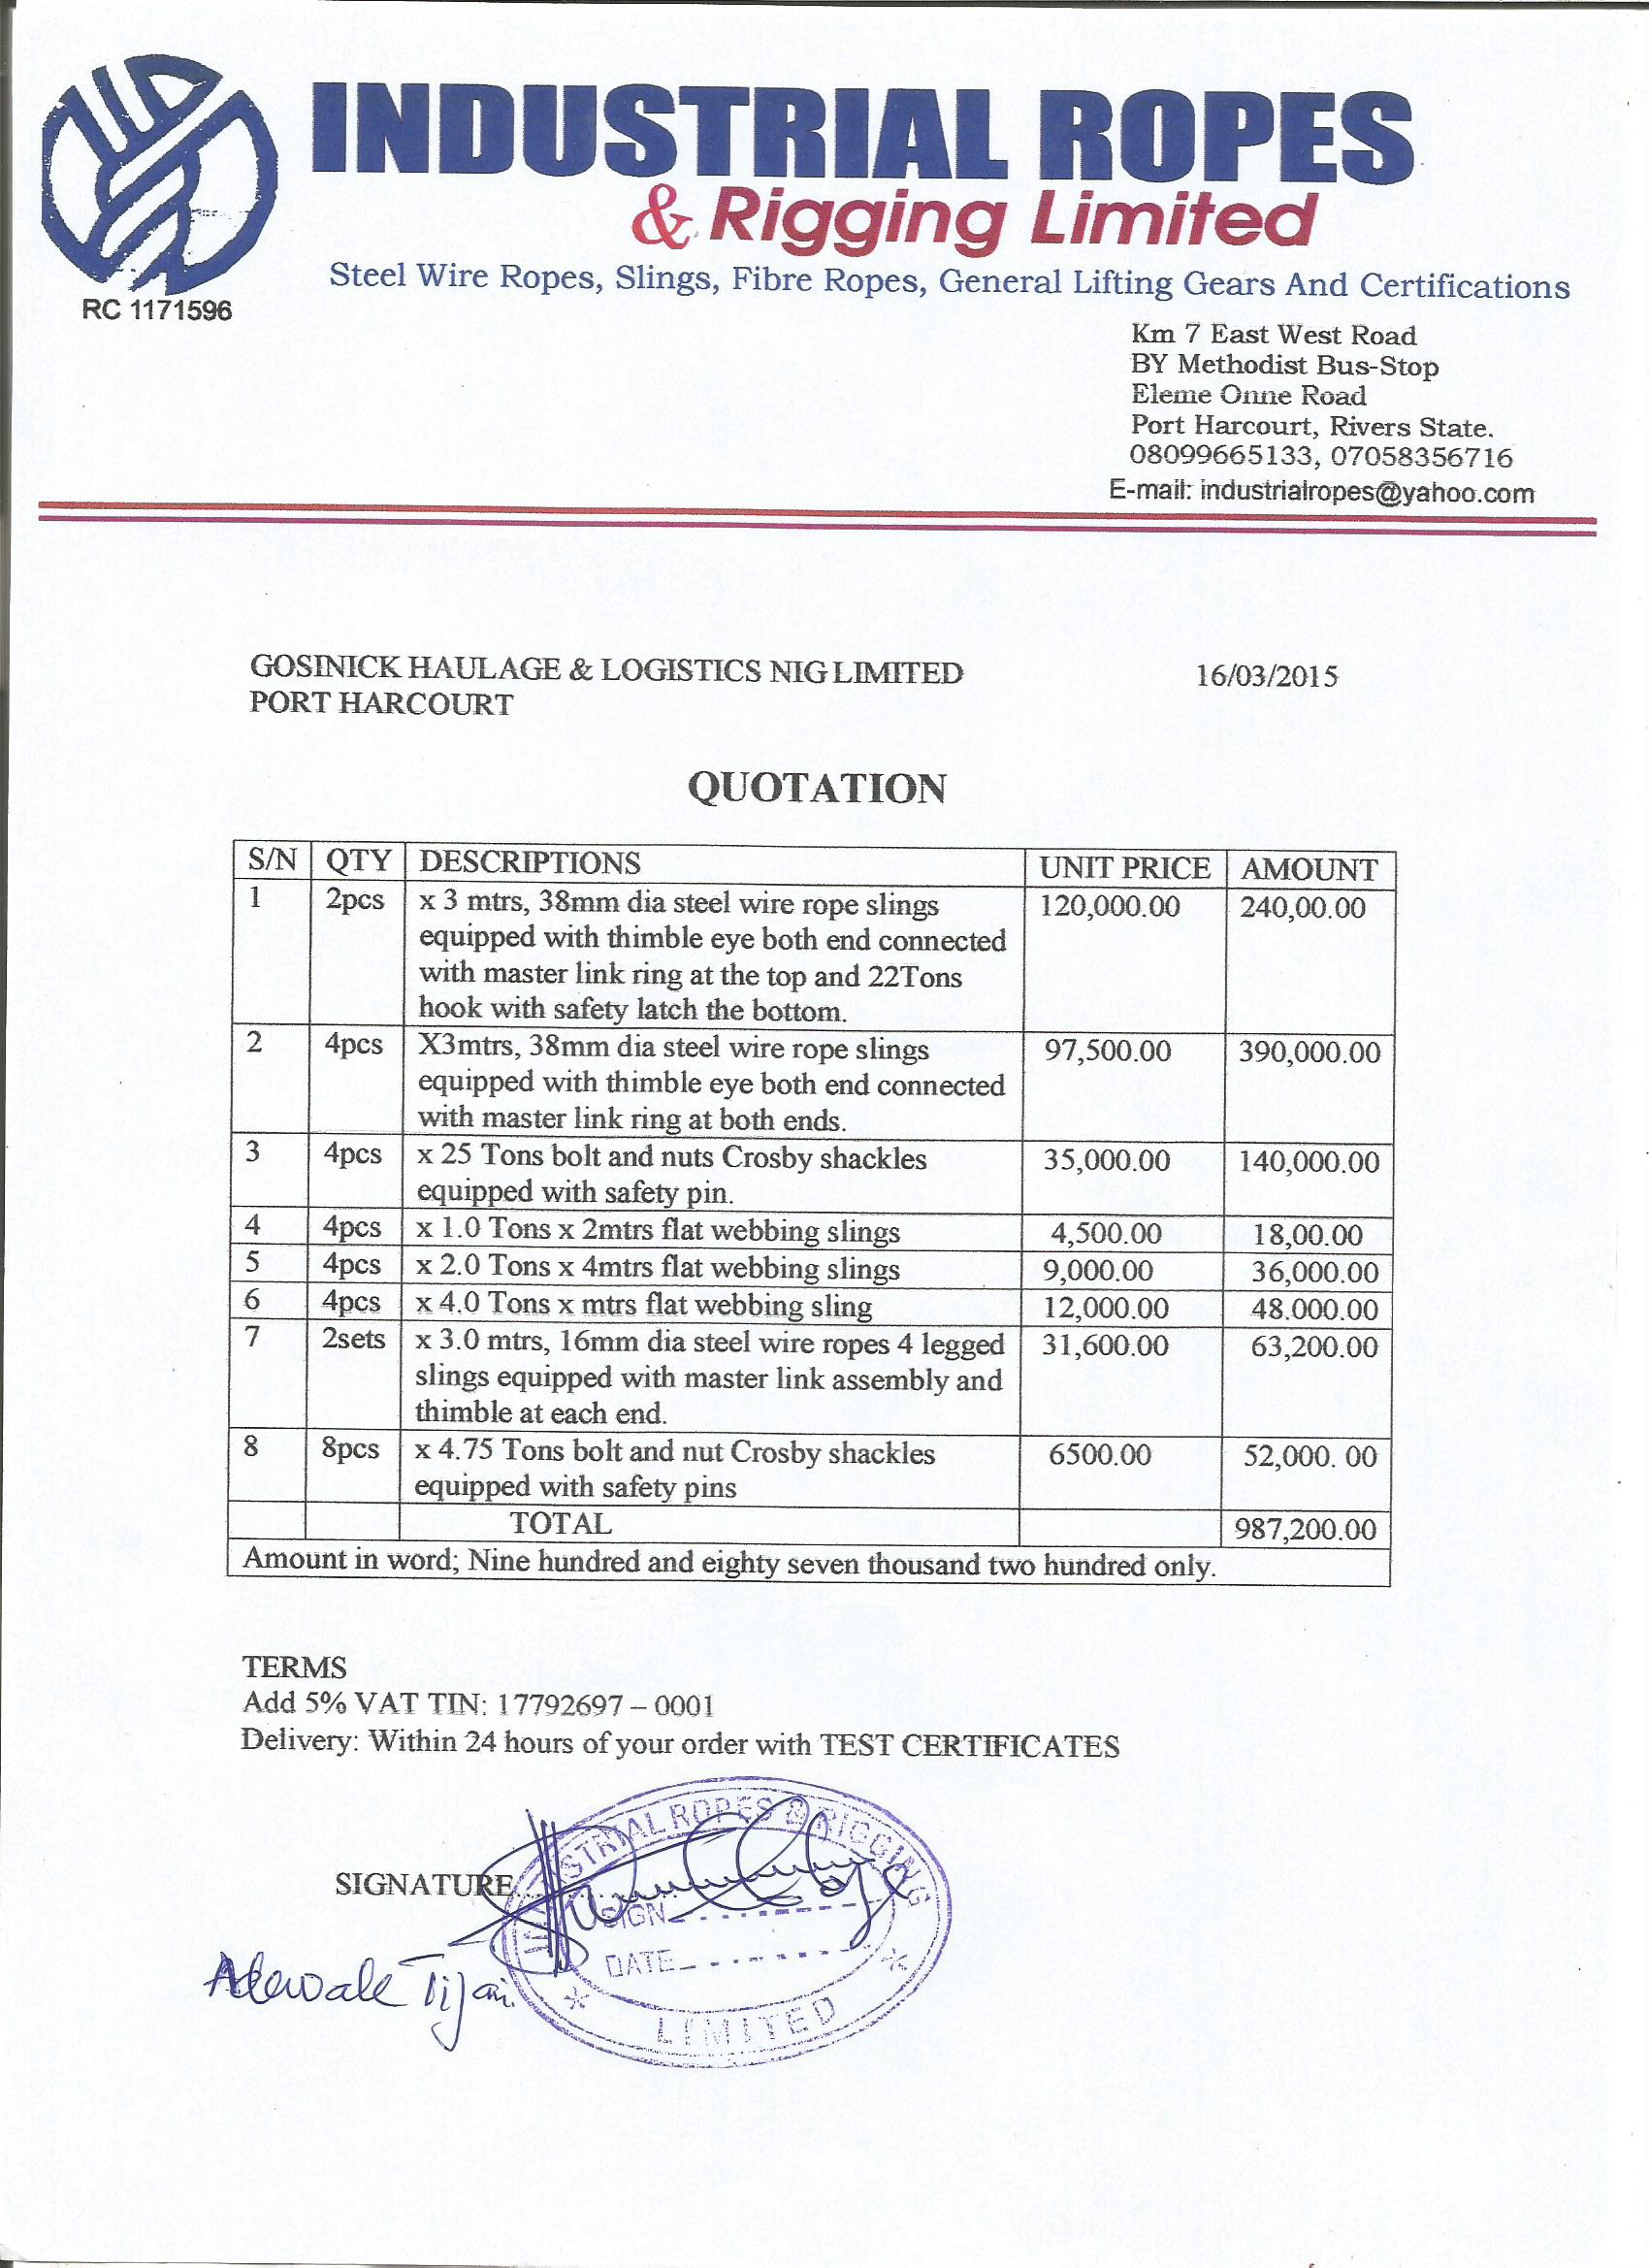**Delivery:** Within 48hours of your order with TEST CERTIFICATE