**GENERAL REQUISITION FORM**

|  |  |  |  |
| --- | --- | --- | --- |
| ***Requested by:*** | BRIGGS OLAWUMI | ***Position:*** | HR/ADMIN  OFFICER |
| ***Date of Request:*** | 22/7/22 | ***Location of need*** | ALL LOCATIONS |
| ***Purpose:*** | **REFRESHMENT FOR WORKOUT AND JULY SEMINAR** | | |
| ***Signature:*** |  | | |

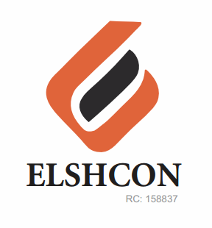

**ITEMS**

|  |  |  |  |  |
| --- | --- | --- | --- | --- |
| **S/N** | **DESCRIPTION OF ITEMS** | **QTY** | **MARKET**  **PRICE PER ITEM** | **TOTAL**  **(N)** |
| 1. | MEATPIE | 65 PCS | 400 | 26,000 |
| 3. | BOTTLED WATER (FOR WORKOUT) | 4 CARTONS | 1,900 | 7,800 |
| 4. | INSTRUCTOR FEE |  |  | 5,000 |
|  |  |  |  |  |
|  |  |  | **TOTAL** | **#38,800** |
|  | **FOR SEMINAR** |  |  |  |
| 1 | MEAPIE | 65 | 400 | 26,000 |
| 2 | BOTTLED WATER | 3 CARTONS | 1900 | 5,700 |
| 3 | RENTING OF CHAIRS | 65 | 100 | 6,500 |
| 4 | AMSTEL MALT | 3 CARTONS | 5,040 | 15,120 |
|  |  |  | |  | | --- | |  | |  |
|  |  |  | **TOTAL** | **53,320** |

***GRAND TOTAL # 92,120***