**GENERAL REQUISITION FORM**

|  |  |  |  |
| --- | --- | --- | --- |
| ***Requested by:*** | BRIGGS OLAWUMI | ***Position:*** | HR/ADMIN  OFFICER |
| ***Date of Request:*** | 1/8/22 | ***Location of need*** | ALL LOCATIONS |
| ***Purpose:*** | SUNDRY ITEMS AUGUST 2022. (BASE 1 & 2)& BOMADI OFFICE USE | | |
| ***Signature:*** |  | | |

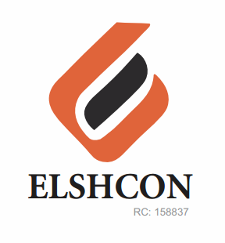

**ITEMS**

|  |  |  |  |  |
| --- | --- | --- | --- | --- |
| **S/N** | **DESCRIPTION OF ITEMS** | **QTY** | **MARKET**  **PRICE PER ITEM** | **TOTAL**  **(N)** |
| 1. | AIR FRESHENER (AIR WICK BRAND) | 3 ROLL | 1.800 | 3,600 |
| 2. | |  |  |  |  | | --- | --- | --- | --- | | MAMA LEMON WASHING UP LIQUID (BIG SIZE) | 12 BTLS | 500.00 | 6,000.00 | | 1CTN | 14,400 | 14,400 |
| 3. | DETERGENT (big size) | 5 PKTS | 1,300 | 6,500 |
| 4. | HYPO BLEACH 450g | ½ CARTON | 12,200 | 12,200 |
| 5. | HARPIC TOILET CLEANER | ½ CARTON | 10,680 | 10,680 |
| 6. | HAND SANITIZER 200GM | 5 | 2,200 | 11,000 |
| 7 | EVAPORATED THREE CROWN MILK(FOR WELDERS) | 24PCS | 310 | 6,840 |
| 8 | TISSUE | 4 ROLL | 4,200 | 18,800 |
|  |  |  |  |  |
|  |  |  |  |  |
|  |  |  |  |  |
|  |  |  |  |  |
|  |  |  |  |  |
|  |  |  |  |  |
|  |  |  |  |  |
|  |  |  |  |  |
|  |  |  |  |  |
|  | **TOTAL** |  |  | **#84,020** |

***GRAND TOTAL #84,020***