**GENERAL REQUISITION FORM**

|  |  |  |  |
| --- | --- | --- | --- |
| ***Requested by:*** | BRIGGS OLAWUMI | ***Position:*** | HR/ADMIN  OFFICER |
| ***Date of Request:*** | 2/9/22 | ***Location of need*** | ALL LOCATIONS |
| ***Purpose:*** | SUNDRY ITEMS AUGUST 2022. (BASE 1 & 2)& BOMADI OFFICE USE | | |
| ***Signature:*** |  | | |

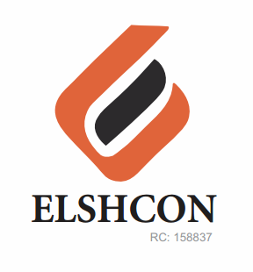

**ITEMS**

|  |  |  |  |  |
| --- | --- | --- | --- | --- |
| **S/N** | **DESCRIPTION OF ITEMS** | **QTY** | **MARKET**  **PRICE PER ITEM** | **TOTAL**  **(N)** |
| 1. | AIR FRESHENER (AIR WICK BRAND) | 3 ROLL | 1.800 | 3,600 |
| 2. | |  |  |  |  | | --- | --- | --- | --- | | MAMA LEMON WASHING UP LIQUID (BIG SIZE) | 12 BTLS | 500.00 | 6,000.00 | | 1CTN | 12,400 | 12,400 |
| 3. | DETERGENT (big size) | 4 PKTS | 1,300 | 5.200 |
| 4. | HYPO BLEACH 450g | ½ CARTON | 11,200 | 11,200 |
| 5. | HARPIC TOILET CLEANER | ½ CARTON | 8,680 | 8,680 |
| 6. | HAND SANITIZER 200GM | 4 | 2,200 | 8,800 |
| 7 | EVAPORATED PEAK MILK (FOR WELDERS) | 24PCS | 310 | 7,600 |
| 8 | TISSUE | 3 ROLL | 4,200 | 12,600 |
| 9 | TOWELS FOR CLEANING CARS | 4 | 4,000 | 4,000 |
|  |  | **TOTAL** |  | **74,080** |
|  | **BOMADI** |  |  |  |
| 1 | MAMA LEMON | 6PCS | 900 | 5,400 |
| 2 | DETERGENT | 2 | 1,300 | 2,600 |
| 3 | TISSUE | 1 | 4,200 | 4,200 |
| 4 | HARPIC | 4 | 700 | 2,800 |
| 5 | HARPO | 6 | 360 | 2,160 |
|  |  |  |  |  |
|  | **TOTAL** |  |  | **17,160** |

***GRAND TOTAL #91,240***