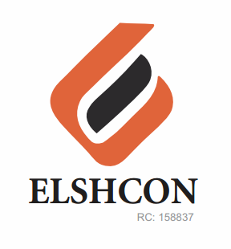

**SUNDRY (BREVAGES) FOR FOUR WEEKS ( SEPTEMBER 12TH –OCT 7TH)**

|  |  |  |  |  |
| --- | --- | --- | --- | --- |
| **S/N** | **DESCRIPTION OF ITEMS** | **QTY** | **MARKET**  **PRICE PER ITEM** | **TOTAL**  **(N)** |
| **12TH-16TH SEPT** | Sachet peak milk | 17 rolls | 800 | 13,600 |
|  | Sachet Milo | 17 rolls | 800 | 13,600 |
|  | Coffee can | 2 cans | 680 | 1,360 |
|  | lipton | 2 | 380 | 760 |
|  | sugar | 1 painter | 2,800 | 2,800 |
|  | 3 in one Nescafe | 5 pieces | 150 | 750 |
|  |  |  | **TOTAL** | **32,870** |
| **19TH-23RDSEPT** | Sachet peak Milk | 17 rolls | |  | | --- | | 800 | | 13,600 |
|  | |  | | --- | | Sachet Milo | | 17 Rolls | 800 | 13,600 |
|  | Coffee can | 2 can | 680 | 1,360 |
|  | lipton | 2 | 380 | 760 |
|  | sugar | 1 painter | 2,800 | 2,800 |
|  | 3 in one Nescafe | 5 pcs | 150 | 750 |
|  |  |  | **TOTAL** | **32,870** |
| **26TH-30 SEPT** | Sachet peak milk | 17 rolls | 800 | 13,600 |
|  | Sachet milo | 17 rolls | 800 | 13,600 |
|  | Coffee can | 2 can | 680 | 1,360 |
|  | lipton | 2 | 380 | 760 |
|  | sugar | 1 painter | 2,800 | 2,800 |
|  | 3 in one Nescafe | 5 | 150 | 750 |
|  |  |  | **TOTAL** | **32,870** |
|  |  |  |  |  |
| **3RD -7TH OCT** | Sachet peak milk | 17 rolls | 800 | 13,600 |
|  | Sachet milo | 17 rolls | 800 | 13,600 |
|  | Coffee can | 2 cans | 680 | 1,360 |
|  | lipton | 2 | 380 | 760 |
|  | sugar | 1 painter | 2,800 | 2,800 |
|  | 3 in one nescafe | 5 | 150 | 750 |
|  | Tray | 1 | 1,200 | 1,200 |
|  |  |  | **TOTAL** | **34.070** |

***GRAND TOTAL #132,680***