**GENERAL REQUISITION FORM**

|  |  |  |  |
| --- | --- | --- | --- |
| ***Requested by:*** | BRIGGS OLAWUMI | ***Position:*** | HR/ADMIN  OFFICER |
| ***Date of Request:*** | 23/8/22 | ***Location of need*** | ALL LOCATIONS |
| ***Purpose:*** | REFRESHMENT SEPTEMBER WORKOUT | | |
| ***Signature:*** |  | | |

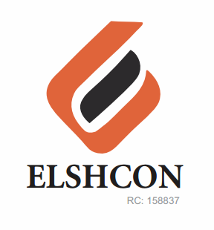

**ITEMS**

|  |  |  |  |  |
| --- | --- | --- | --- | --- |
| **S/N** | **DESCRIPTION OF ITEMS** | **QTY** | **MARKET**  **PRICE PER ITEM** | **TOTAL**  **(N)** |
|  | **REFRESHMENT FOR WORKOUT** |  |  |  |
| 1 | Snacks | 50 | 400 | 24,000 |
| 2 | Bottled water | 3 CARTONS | 1,500 | 4,500 |
| 3 | Instructor Fee |  |  | 5,000 |
|  | **TOTAL** |  |  | **#33,500** |

***GRAND TOTAL # 33,500***