**COST FOR OVER-HAULING OF PRINCESS DATA GENERATOR FOR INSPECTION OBSERVATION CLOSEOUT.**

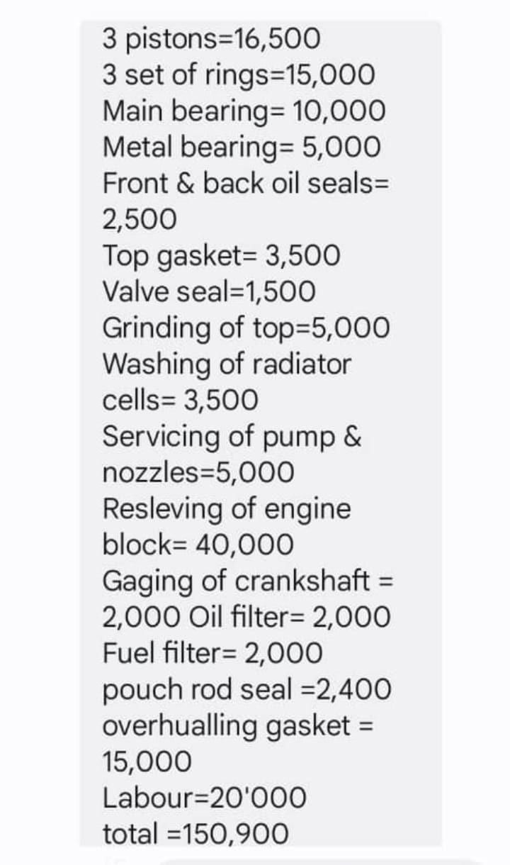

**Mr Goodnews : 07036918772**