16th November,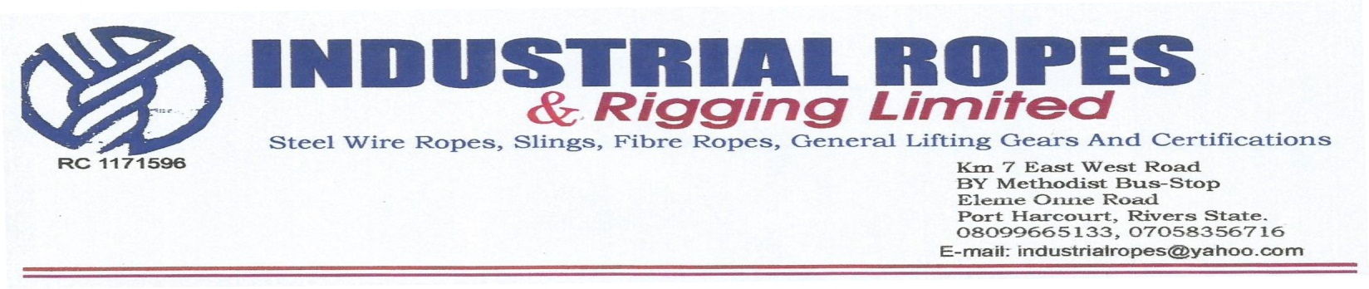 2022

**Elshcon Nigeria Limited,**

**Port Harcourt.**

**QUOTATION FOR STEEL WIRE ROPES**

|  |  |  |  |  |
| --- | --- | --- | --- | --- |
| **S/N** | **QTY** | **DESCRIPTION** | **UNIT PRICE** | **AMOUNT** |
| 1 | 1 set | X 60mtrs, 22mm dia steel wire rope | 4,000.00 | 240,000.00 |
|  |  | **TOTAL** |  | **240,000.00** |

**Amount in Words: Two hundred and forty Thousand niara only**

**TERMS:**

Add 7.5% VAT TIN: 17792697-0001 **Delivery:** Within 48 hours of your order