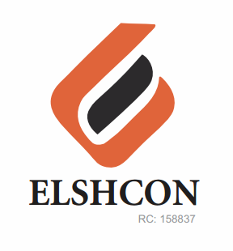

**SUNDRY (BREVAGES) FOR FOUR WEEKS (NOVEMBER 28TH –DEC 16 )**

|  |  |  |  |  |
| --- | --- | --- | --- | --- |
| **S/N** | **DESCRIPTION OF ITEMS** | **QTY** | **MARKET**  **PRICE PER ITEM** | **TOTAL**  **(N)** |
| **WEEK 1** | Sachet peak milk | 17 rolls | 880 | 14,960 |
|  | Sachet Milo | 17 rolls | 880 | 14.960 |
|  | Coffee can | 2 cans | 680 | 1,360 |
|  | lipton | 2 | 380 | 760 |
|  | sugar | 1 painter | 2,800 | 2,800 |
|  | 3 in one Nescafe | 5 pieces | 150 | 750 |
|  |  |  | **TOTAL** | **35,590** |
| **WEEK 2** | Sachet peak Milk | 17 rolls | |  | | --- | | 880 | | 14,960 |
|  | |  | | --- | | Sachet Milo | | 17 Rolls | 880 | 14,960 |
|  | Coffee can | 2 can | 680 | 1,360 |
|  | lipton | 2 | 380 | 760 |
|  | sugar | 1 painter | 2,800 | 2,800 |
|  | 3 in one Nescafe | 5 pcs | 150 | 750 |
|  |  |  | **TOTAL** | **35,590** |
| **WEEK 3** | Sachet peak milk | 17 rolls | 880 | 14,960 |
|  | Sachet milo | 17 rolls | 880 | 14,960 |
|  | Coffee can | 2 can | 680 | 1,360 |
|  | lipton | 2 | 380 | 760 |
|  | sugar | 1 painter | 2,800 | 2,800 |
|  | 3 in one Nescafe | 5 | 150 | 750 |
|  |  |  | **TOTAL** | **35,590** |
|  |  |  |  |  |
| **WEEK 4** | Sachet peak milk | 17 rolls | 880 | 14,960 |
|  | Sachet milo | 17 rolls | 880 | 14,960 |
|  | Coffee can | 2 cans | 680 | 1,360 |
|  | lipton | 2 | 380 | 760 |
|  | sugar | 1 painter | 2,800 | 2,800 |
|  | 3 in one nescafe | 5 | 150 | 750 |
|  |  |  |  |  |
|  |  |  | **TOTAL** | **35,590** |

***GRAND TOTAL #142,360***