**GENERAL REQUISITION FORM**

|  |  |  |  |
| --- | --- | --- | --- |
| ***Requested by:*** | BRIGGS OLAWUMI | ***Position:*** | HR/ADMIN  OFFICER |
| ***Date of Request:*** | 18/11/22 | ***Location of need*** | ALL LOCATIONS |
| ***Purpose:*** | **REFRESHMENT FOR SEMINAR AND WORKOUT FOR THE MONTH OF NOVEMBER** | | |
| ***Signature:*** |  | | |

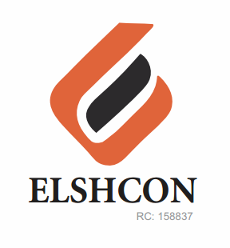

**ITEMS**

|  |  |  |  |  |
| --- | --- | --- | --- | --- |
| **S/N** | **DESCRIPTION OF ITEMS** | **QTY** | **MARKET**  **PRICE PER ITEM** | **TOTAL**  **(N)** |
| 1. | FRIED RICE,JOLLOF RICE AND CHICKEN | 50 | 1.000 | 50,000 |
| 2. | |  |  |  |  | | --- | --- | --- | --- | | AMSTEL CAN MALT | 12 BTLS | 500.00 | 6,000.00 | | 2 CARTONS | 5,040 | 10,080 |
| 3. | NESTLE TABLE WATER | 3 CARTONS | 1,900 | 5.700 |
| 4. | RENTING OF CHAIRS | 50 | 100 | 5,000 |
| 5 | FACILITATOR FEE |  |  | 10,000 |
|  |  |  |  | **#80,700** |
|  | **WORKOUT** |  |  |  |
| 1 | SNACKS | 40 | 250 | 10,000 |
| 2 | WATER | 2 CARTONS | 1,900 | 3,800 |
| 3 | INSTRUCTOR FEE |  |  | 5,000 |
|  |  |  |  |  |
|  |  |  |  | **18,800** |

***GRAND TOTAL # 99,500***