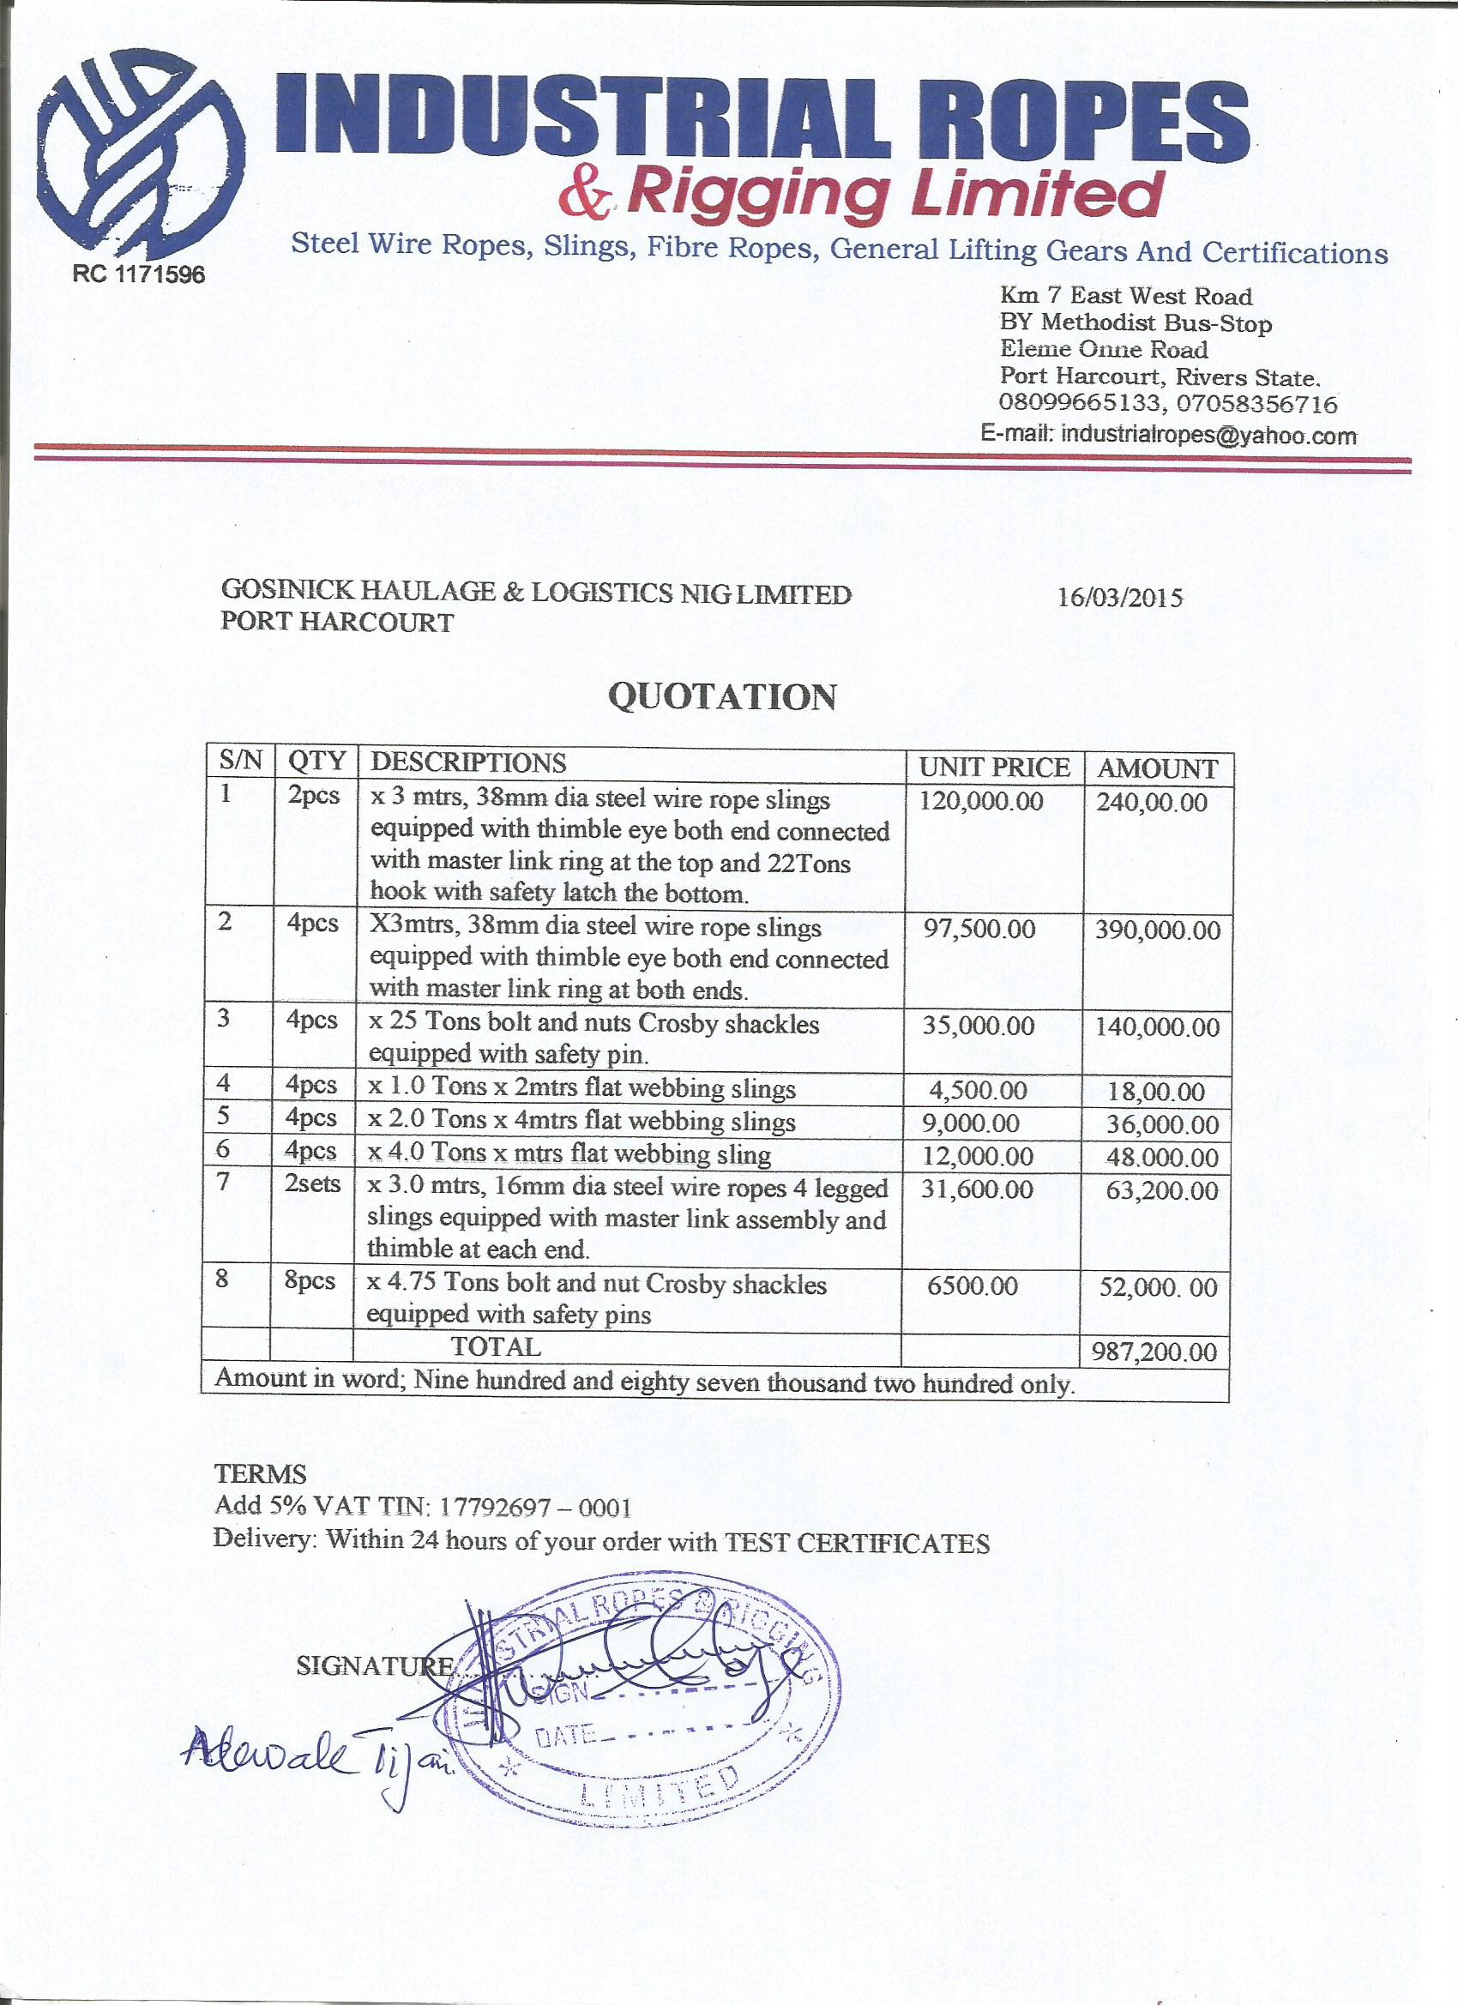21st November, 2022

**Elshcon Nigeria Limited,**

**Port Harcourt.**

**QUOTATION FOR SOCKETING**

|  |  |  |  |  |
| --- | --- | --- | --- | --- |
| **S/N** | **QTY** | **DESCRIPTION** | **UNIT PRICE** | **AMOUNT** |
| 1  2  3  4 | 1pc  3pcs  1hd  1pc | X cutting and boring of 52mm socket  X 500cc wire lock resin  X Socketing of 52mm dia wire rope  X Uncoilling and chilling of the 52mm X  750mtrs on board vessel  Total | 60,000.00  50,000.00  110, 000.00  200 000.00 | 60,000.00  150 000.00  110,000.00    200,000.00    520,000.00 |
|  |  | **TOTAL** |  | 520,000.00 |

**Amount in Words: Five hundred and Twenty Thousand niara only**

**TERMS:**

Add 7.5% VAT TIN: 17792697-0001

**Delivery:** Within 72 hours of your order