**GENERAL REQUISITION FORM**

|  |  |  |  |
| --- | --- | --- | --- |
| ***Requested by:*** | BRIGGS OLAWUMI | ***Position:*** | HR/ADMIN  OFFICER |
| ***Date of Request:*** | 12/12/22 | ***Location of need*** | ALL LOCATIONS |
| ***Purpose:*** | **REFRESHMENT FOR HSE GENERAL END OF YEAR GET TOGETHER** | | |
| ***Signature:*** |  | | |

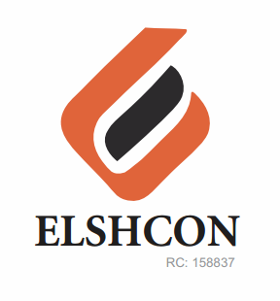

**ITEMS**

|  |  |  |  |  |
| --- | --- | --- | --- | --- |
| **S/N** | **DESCRIPTION OF ITEMS** | **QTY** | **MARKET**  **PRICE PER ITEM** | **TOTAL**  **(N)** |
| 1. | FRIED RICE,JOLLOF RICE AND CHICKEN/SALAD | 90 | 1.200 | 108,000 |
| 2. | |  |  |  |  | | --- | --- | --- | --- | | AMSTEL CAN MALT | 12 BTLS | 500.00 | 6,000.00 | | 5 CARTONS | 5,040 | 25,200 |
| 3. | NESTLE TABLE WATER | 5 CARTONS | 1900 | 9500 |
| 4. | RENTING OF CHAIRS | 70 | 100 | 7,000 |
| 5 | WINE FOR TOAST | 5 BOTTLES | 1800 | 16,200 |
|  |  | **TOTAL** |  | **#165,900** |

***GRAND TOTAL # 165,900***