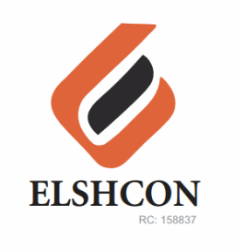

**REFRESHMENT FOR FINANCIAL MANAGEMENT TRAINEES AND TIN PEAK MILK FOR WELDERS & FITTERS FOR JANUARY 2023**

|  |  |  |
| --- | --- | --- |
| **S/N** | **DESCRIPTION OF ITEMS** | **AMOUNT** |
| 1 | Training fee for External Facilitator | N50,000 |
| 2 | Refreshment for 16 Trainees |  |
| - | Rice & Salad for 16 Trainees = 1,500 * 16 | N24,000 |
| - | One pack of Amstel malt (24 cans) | N5,000 |
| - | Two packs of Lasien bottle water (medium size) | N1,500 |
| 3 | Purchase of Two cartons of Tin peak milk for Welders & Fitters for the month of January 2023 at N10,00 * 2 | N20,000 |
| 4 | TOTAL | **N100,500** |