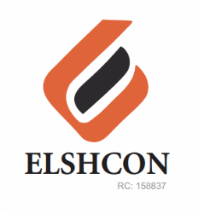

**REFRESHMENT FOR MANAGEMENT MEETING ON OPEN STRATEGY ON WEDNESDAY 25TH, MONTHLY WORKOUT (EXERCISE) ON FRIDAY 27TH AND TIN PEAK MILK FOR WELDERS & FITTERS FOR JANUARY 2023**

|  |  |  |
| --- | --- | --- |
| **S/N** | **DESCRIPTION OF ITEMS** | **AMOUNT** |
| 1 | MEAT PIE & DRINK = (N700 * 12) | N8,400 |
| 2 | TRANSPORT | N600 |
| - | MEAT PIE (N500 * 50 PERSONS) | N25,000 |
| - | 6 PACKS OF BOTTLE WATER (N800 * 6) | N4,800 |
| - | ONE CARTON OF PEAK MILK FOR WELDERS, FITTERS & COO | N10,000 |
| 4 | TOTAL | **N48,800** |