**GENERAL REQUISITION FORM**

|  |  |  |  |
| --- | --- | --- | --- |
| ***Requested by:*** | FELI TAMUNOEMI PRINCE | ***Position:*** | DC/ADMIN |
| ***Date of Request:*** | 2/1/23 | ***Location of need*** | BASE 1 AND 2 |
| ***Purpose:*** | SUNDRY ITEMS FOR BASE 1 & 2 USE | | |
| ***Signature:*** |  | | |

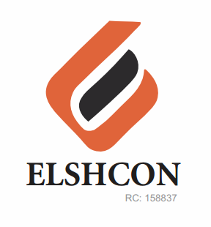

**ITEMS**

|  |  |  |  |  |
| --- | --- | --- | --- | --- |
| **S/N** | **DESCRIPTION OF ITEMS** | **QTY** | **MARKET**  **PRICE PER ITEM** | **TOTAL**  **(N)** |
| 1. | AIR FRESHENER (AIR WICK BRAND) | 3 ROLL | 2,000 | 6,000 |
| 2. | |  |  |  |  | | --- | --- | --- | --- | | MAMA LEMON WASHING UP LIQUID (BIG SIZE) | 12 BTLS | 500.00 | 6,000.00 | | 1CTN | 14,800 | 14,800 |
| 3. | DETERGENT (big size) | 4 PKTS | 1,600 | 6,400 |
| 4. | HYPO BLEACH 450g | ½ CARTON | 13,500 | 13,500 |
| 5. | HARPIC TOILET CLEANER | ½ CARTON | 10,200 | 10,200 |
| 6. | TISSUE | 4 ROLLS | 3,300 | 13,200 |
|  | **TOTAL** | **TOTAL** |  | **64,100** |

***GRAND TOTAL #64,100***