**GENERAL REQUISITION FORM**

|  |  |  |  |
| --- | --- | --- | --- |
| ***Requested by:*** | FELIX TAMUNOEMI PRINCE | ***Position:*** | DC/ADMIN  OFFICER |
| ***Date of Request:*** | 3/3/23 | ***Location of need*** | BOMADI |
| ***Purpose:*** | SUNDRY ITEMS FOR MARCH 2023 (BOMADI OFFICE USE) | | |
| ***Signature:*** |  | | |

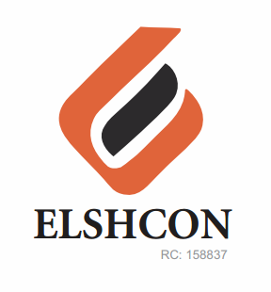

**ITEMS**

|  |  |  |  |  |
| --- | --- | --- | --- | --- |
|  | **BOMADI** |  |  |  |
| 1 | MAMA LEMON | 6PCS | 900 | 5,400 |
| 2 | DETERGENT | 2 | 1,000 | 2,000 |
| 3 | TISSUE | ½ pack (24pcs) | 2,000 | 2,000 |
| 4 | HARPIC | 4 | 700 | 3,200 |
| 5 | HARPO | 6 | 400 | 2,400 |
| 6 | AIR FRESHNER (BLOCK) | 4 pcs | 500 | 2,000 |
|  | **TOTAL** |  |  | **N17,000** |

***GRAND TOTAL #17,000***