**GENERAL REQUISITION FORM**

|  |  |  |  |
| --- | --- | --- | --- |
| ***Requested by:*** | FELIX TAMUNOEMI PRINCE | ***Position:*** | DC/ADMIN OFFICER |
| ***Date of Request:*** | 23/03/2023 | ***Location of need*** | BASE 1, 2, AND MOPOL |
| ***Purpose:*** | SUNDRY FOR OFFICIAL USE | | |
| ***Signature:*** |  | | |

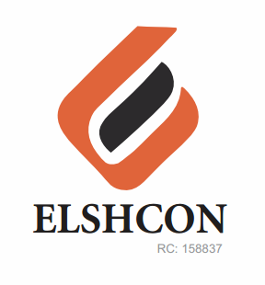

**ITEMS**

|  |  |  |  |  |
| --- | --- | --- | --- | --- |
| **S/N** | **DESCRIPTION OF ITEMS** | **QTY** | **MARKET**  **PRICE PER ITEM** | **TOTAL**  **(N)** |
| 1. | AIR FRESHENER (AIR WICK BRAND) | 2 ROLLS (12PCS) | 3,000 | 6,000 |
| 2. | |  |  |  |  | | --- | --- | --- | --- | | MAMA LEMON WASHING UP LIQUID (BIG SIZE) | 12 BTLS | 500.00 | 6,000.00 | | 1CTN | 14,400 | 14,400 |
| 3. | OMO DETERGENT (1KG BIG SIZE) | 4 PKTS | 1,450 | 5,800 |
| 4. | HYPO BLEACH 450g | 1 CARTON (12/24PCS) | 16,000 | 16,000 |
| 5. | HARPIC TOILET CLEANER | 1 CARTON | 19.500 | 19,500 |
| 6. | RAID INSECTICIDE (BIG) | 2 BOTTLE | 1800 | 3,600 |
|  | **TOTAL** | **TOTAL** |  | **65,300** |

***GRAND TOTAL: SIXTY FIVE THOUSAND THREE HUNDRED NAIRA ONLY. (N65, 300).***