**GENERAL REQUISITION FORM**

|  |  |  |  |
| --- | --- | --- | --- |
| ***Requested by:*** | JOSEPH O. NWEKE | ***Position:*** | C/P |
| ***Date of Request:*** | 02/05/2023 | ***Location of need*** | BASE I WORKSHOP |
| ***Purpose:*** | **REFRESHMENT FOR VENDOR MEETING ON THURSDAY 4TH MAY 2023.** | | |
| ***Signature:*** |  | | |

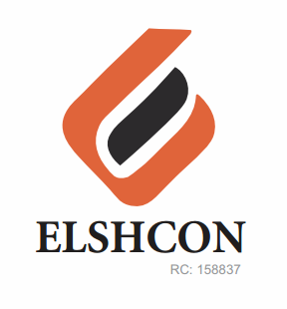

**ITEMS**

|  |  |  |  |  |
| --- | --- | --- | --- | --- |
| **S/N** | **DESCRIPTION OF ITEMS** | **QTY** | **MARKET**  **PRICE PER ITEM** | **TOTAL**  **(N)** |
|  | **VENDOR MEETING ON THURSDAY 4TH 2023** |  |  |  |
| 1. | RICE AND CHICKEN | 50 | 1.000 | 50,000 |
| 2. | |  |  |  |  | | --- | --- | --- | --- | | BETA CAN MALT | 12 BTLS | 500.00 | 6,000.00 | | 2½ CARTONS | 4,500 | 11,250 |
| 3. | LA SIEN BOTTLE WATER | 5 CARTONS | 1,000 | 5.000 |
| 4. | RENTING OF CHAIRS | 50 | 100 | 5,000 |
|  | **GRAND TOTAL SUM** |  |  | **#71,250** |

***GRAND* TOTAL IN WORD: SEVENTY ONE THOUSAND TWO HUNDRED AND FIFTY NAIRA ONLY.**