**GENERAL REQUISITION FORM**

|  |  |  |  |
| --- | --- | --- | --- |
| ***Requested by:*** | FELIX TAMUNOEMI PRINCE | ***Position:*** | DC/ADMIN  OFFICER |
| ***Date of Request:*** | 21/07/2023 | ***Location of need*** | ALL LOCATIONS |
| ***Purpose:*** | **REFRESHMENT FOR SEMINAR 27th and EXERCISE 28TH JULY 2023** | | |
| ***Signature:*** |  | | |

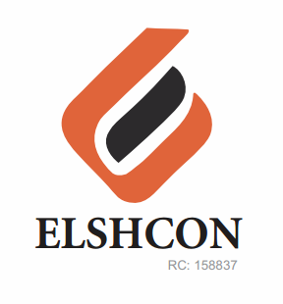

**ITEMS**

|  |  |  |  |  |
| --- | --- | --- | --- | --- |
| **S/N** | **DESCRIPTION OF ITEMS** | **QTY** | **MARKET**  **PRICE PER ITEM** | **TOTAL**  **(N)** |
|  | **SEMINAR FOR JULY 2023** |  |  |  |
| 1. | RICE AND CHICKEN | 60 | 1.200 | 72,000 |
| 2. | |  |  |  |  | | --- | --- | --- | --- | | BETA CAN MALT | 12 BTLS | 500.00 | 6,000.00 | | 2½ CARTONS | 4,800 | 12,000 |
| 3. | LA SIEN BOTTLE WATER | 5 CARTONS | 1,000 | 5.000 |
| 4. | RENTING OF CHAIRS | 60 | 100 | 6,000 |
|  |  |  |  | **#95,000** |
|  | **WORKOUT FOR JULY 2023** |  |  |  |
| 1 | APPLE | 1 CARTON (110 PCS) |  | 25,000 |
| 2 | WATER | 3 PACKS (36 BOTTLES) | 1,000 | 3,000 |
| 4 | STOUT (CAN) | ½ CARTON (12 PCS) | 6,000 | 6,000 |
| 5 | HEINENKEN (CAN) | ½ CARTON (12 PCS) | 5,000 | 5,000 |
| 6 | SMIROFF ICE (CAN) | ½ CARTON (12 PCS) | 6,000 | 6,000 |
| 7 | HERO (CAN) | ½ CARTON (12 PCS) | 4,000 | 4,000 |
|  | INSTRUCTOR FEE |  |  | 5,000 |
|  |  |  |  | **#54,000** |

***GRAND* TOTAL: ONE HUNDRED AND FOURTY-NINE THOUSAND NAIRA (#149,000) ONLY.**