**GENERAL REQUISITION FORM**

|  |  |  |  |
| --- | --- | --- | --- |
| ***Requested by:*** | FELIX TAMUNOEMI PRINCE | ***Position:*** | DC/ADMIN OFFICER |
| ***Date of Request:*** | 06/09/2023 | ***Location of need*** | BASE 1, 2, MOPOL AND BOMADI |
| ***Purpose:*** | SUNDRY FOR OFFICIAL USE | | |
| ***Signature:*** |  | | |

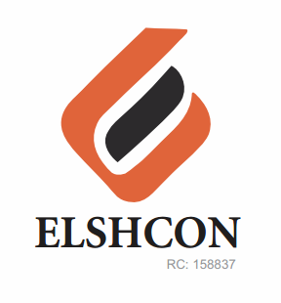

**SUNDRY ITEMS FOR BASE 1, 2, MOPOL AND BOMADI USE**

|  |  |  |  |  |
| --- | --- | --- | --- | --- |
| **S/N** | **DESCRIPTION OF ITEMS** | **QTY** | **MARKET**  **PRICE PER PACK** | **TOTAL**  **(N)** |
| 1. | AIR FRESHENER (AIR WICK BRAND) | 5 ROLLS (30 PCS) | 3,000 | 15,000 |
| 2. | MAMA LEMON WASHING LIQUID (BIG SIZE) | I CARTON (12 PCS) | 16,000 | 16,000 |
| 3. | OMO DETERGENT (1KG SIZE) | 15 PKTS | 1,200 | 18,000 |
| 4. | HYPO BLEACH 1KG | 1 CARTON (24 PCS) | 18,000 | 18,000 |
| 5. | HARPIC TOILET CLEANER | 1 CARTONS (12 PCS) | 20,000 | 20.000 |
| 6. | TISSUE | 2 ROLLS (96 PCS) | 4,500 | 9000 |
| 7. | TRANSPORT |  |  | 2,000 |
|  |  | **TOTAL** |  | **98,000** |

***GRAND TOTAL: NINETY EIGHT THOUSAND NAIRA ONLY. (N98,000).***