**GENERAL REQUISITION FORM**

|  |  |  |  |
| --- | --- | --- | --- |
| ***Requested by:*** | FELIX TAMUNOEMI PRINCE | ***Position:*** | DC/ADMIN  OFFICER |
| ***Date of Request:*** | 20/09/2023 | ***Location of need*** | ELSHCON BASE 2 & 1 |
| ***Purpose:*** | **REFRESHMENT FOR SEMINAR and EXERCISE FOR SEPTEMBER 2023** | | |
| ***Signature:*** |  | | |

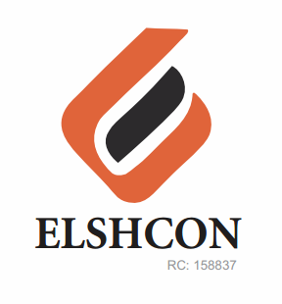

**ITEMS**

|  |  |  |  |  |
| --- | --- | --- | --- | --- |
| **S/N** | **DESCRIPTION OF ITEMS** | **QTY** | **MARKET**  **PRICE PER ITEM** | **TOTAL**  **(N)** |
|  | **SEMINAR FOR SEPTEMBER 2023** |  |  |  |
| 1. | RICE AND CHICKEN | 70 | 1.200 | 84,000 |
| 2. | BETA MALT CAN | 3 CARTONS (72 CANS) | 4,800 | 14,400 |
| 3. | LA SIEN BOTTLE WATER | 6 CARTONS | 1,000 | 6.000 |
| 4. | RENTING OF CHAIRS | 60 | 100 | 6,000 |
|  |  |  |  | **#110,400** |
|  | **WORKOUT FOR SEPTEMBER 2023** |  |  |  |
| 1 | CHICKEN PIE OR APPLE | 70 PCS | 500 | 35,000 |
| 2 | WATER | 5 PACKS (60 BOTTLES) | 1,000 | 5,000 |
| 4 | STOUT (CAN) | ½ CARTON (12 PCS) | 6,000 | 6,000 |
| 5 | HEINENKEN (CAN) | ½ CARTON (12 PCS) | 5,000 | 5,000 |
| 6 | SMIROFF ICE (CAN) | ½ CARTON (12 PCS) | 6,000 | 6,000 |
| 7 | HERO (CAN) | ½ CARTON (12 PCS) | 4,000 | 4,000 |
| 8 | BETA MALT CAN | ½ CARTON (12 PCS) | 2,400 | 2,400 |
| 9 | INSTRUCTOR FEE |  |  | 7,000 |
|  |  |  |  |  |
|  |  |  |  |  |
|  |  |  |  | **#70,400** |

**GRAND TOTAL: ONE HUNDRED AND EIGHTY THOUSAND EIGHT HUNDRED NAIRA (#180,800) ONLY.**