18th September, 2023.

**Elshcon Nigeria Limited,**

**Port Harcourt.**

**PROFORMA INVOICE**

|  |  |  |  |  |
| --- | --- | --- | --- | --- |
| **S/N** | **QTY** | **DESCRIPTION** | **UNIT PRICE** | **AMOUNT** |
| 1 | 1coil | X 60mtrs 26mm 1" dia IWRC steel wire rope sling equipped with thimble eye one end, other end plain. | 580,000.00 | 580,000.00 |
|  |  |  |  |  |
|  |  | **TOTAL** |  | **580,000.00** |

**Amount in Words: Five hundred and eighty Thousand naira only**

**TERMS:**

Add 7.5% VAT TIN: 17792697-00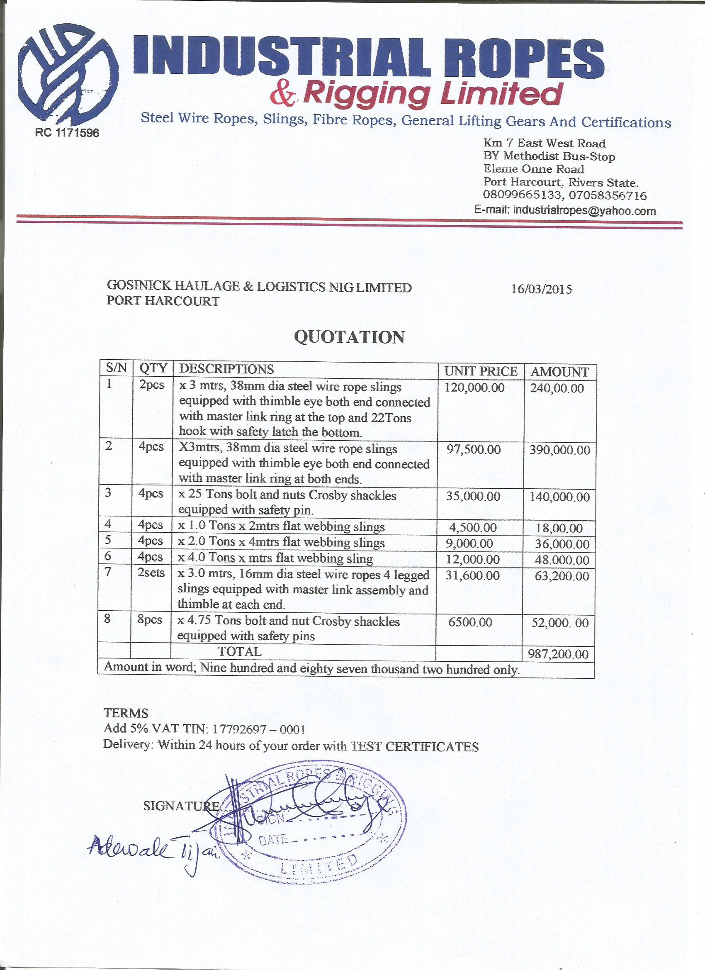01**Delivery:** Within 72 hours of your order