**GENERAL REQUISITION FORM**

|  |  |  |  |
| --- | --- | --- | --- |
| ***Requested by:*** | FELIX TAMUNOEMI PRINCE | ***Position:*** | DC/ADMIN  OFFICER |
| ***Date of Request:*** | 23/11/2023 | ***Location of need*** | ELSHCON BASE 1 |
| ***Purpose:*** | **EXERCISE REFRESHMENT FOR NOVEMBER 2023** | | |
| ***Signature:*** |  | | |

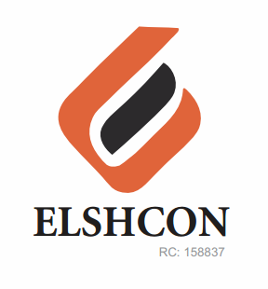

**ITEMS**

|  |  |  |  |  |
| --- | --- | --- | --- | --- |
| **S/N** | **DESCRIPTION OF ITEMS** | **QTY** | **MARKET**  **PRICE PER ITEM** | **TOTAL**  **(N)** |
|  | **WORKOUT FOR 24TH NOVEMBER 2023** |  |  |  |
| 1 | CHICKEN PIE OR APPLE | 70 PCS | 500 | 35,000 |
| 2 | WATER | 6 PACKS (72 BOTTLES) | 1,000 | 6,000 |
| 4 | STOUT (CAN) | 1 CARTON (24 PCS) |  | 12,000 |
| 5 | HEINENKEN (CAN) | 1 CARTON (24 PCS) |  | 10,000 |
| 6 | SMIROFF ICE (CAN) | 1 CARTON (24 PCS) |  | 12,000 |
| 7 | HERO (CAN) | 1 CARTON (24 PCS) |  | 7,000 |
| 8 | BETA MALT CAN | ½ CARTON (12 PCS) |  | 3,000 |
| 9 | INSTRUCTOR/TRAINER FEE |  |  | 7,000 |
|  |  |  |  |  |
|  |  |  |  |  |
|  |  |  |  | **#92,000** |

**GRAND TOTAL: NINETY TWO THOUSAND NAIRA (#92,000) ONLY.**