**GENERAL REQUISITION FORM**

|  |  |  |  |
| --- | --- | --- | --- |
| ***Requested by:*** | FELIX TAMUNOEMI PRINCE | ***Position:*** | DC/ADMIN OFFICER |
| ***Date of Request:*** | 27/12/2023 | ***Location of need*** | BASE 1, 2, MOPOL AND BOMADI |
| ***Purpose:*** | SUNDRY FOR OFFICIAL USE | | |
| ***Signature:*** |  | | |

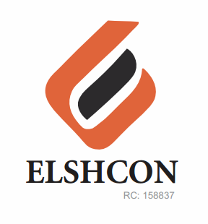

**SUNDRY ITEMS FOR BASE 1, 2, MOPOL AND BOMADI USE**

|  |  |  |
| --- | --- | --- |
| **S/N** | **DESCRIPTION OF ITEMS** | **QTY** |
| 1. | AIR FRESHENER (AIR WICK BRAND) | 2 ROLLS (12 PCS) |
| 2. | MAMA LEMON WASHING LIQUID (BIG SIZE) | I CARTON (12 PCS) |
| 3. | OMO DETERGENT (1KG SIZE) | 15 PKTS |
| 4. | HARPIC TOILET CLEANER | 1 CARTONS (12 PCS) |
| 5. | TISSUE | 3 ROLLS (96 PCS) |
| 6, | HYPO | 1 CARTON (24 PCS) |