**GENERAL REQUISITION FORM**

|  |  |  |  |
| --- | --- | --- | --- |
| ***Requested by:*** | FLORENCE EMEKA | ***Position:*** | BDO/ADMIN OFFICER |
| ***Date of Request:*** | 29/01/2024 | ***Location of need*** | LAGOS OFFICE |
| ***Purpose:*** | SUNDRY FOR OFFICIAL USE | | |
| ***Signature:*** |  | | |

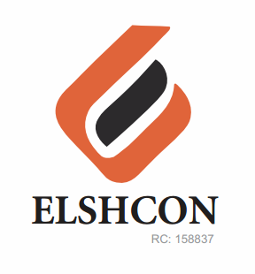

|  |  |  |  |  |
| --- | --- | --- | --- | --- |
| **S/N** | **DESCRIPTION OF ITEMS** | **QTY** | **MARKET**  **PRICE PER PACK** | **TOTAL**  **(N)** |
| 1. | AIR FRESHENER SPRAY | 2 CANS | 2,000 | 4,000 |
| 2. | OMO DETERGENT (BIG SIZE) | 1 PACKET | 2,000 | 2,000 |
| 3. | HYPO BLEACH (BIG SIZE) | 1 BOTTLE | 1,600 | 1,600 |
| 4. | HARPIC TOILET CLEANER (BIG SIZE) | 1 BOTTLE | 3,500 | 3,500 |
| 5. | MAMA LEMON LIQUID SOAP (BIG SIZE) | 1 BOTTLE | 1,500 | 1,500 |
| 6. | TISSUE PAPER (1/2 ROLL) | 24 PCS | 2,500 | 2,500 |
| 7. | SERVIETTE | 1 PACKET | 600 | 600 |
| 8. | SPONGE | 6 PCS | 1,500 | 1,500 |
| 9. | MORTEM INSECT KILLER (BAYGON-BIG SIZE) | 1 BOTTLE | 3,000 | 3,000 |
| 10. | HAND SANITIZER (ARMSTRONG) | 1 BOTTLE | 2,500 | 2,500 |
| 11. | WASTE BAG | 2 ROLL | 1,000 | 2,000 |
| 12. | PROVISION MILO | 2 ROLLS | 1,100 | 2,200 |
| 13. | PROVISION MILK | 2 ROLLS | 1,100 | 2,200 |
| 14. | REED DIFFUSER | 1 | 3,000 | 3,000 |
| 15. | LONG BROOM | 1 | 2.100 | 2,100 |
|  |  | **TOTAL** |  | **N34,200** |

***GRAND TOTAL: THIRTY-FOUR THOUSAND TWO HUNDRED NAIRA ONLY. (N34,200).***