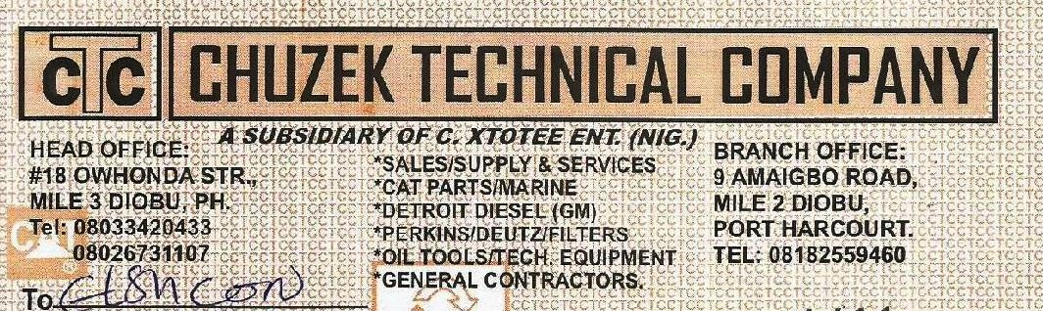

L.P.O No
To: ELSCON NIG LTD_ PORT HARCOURT

Date:
08/07/2019

PROFORMA INVOICE (CASH PRICE)
ITEM | QTY. | DESCRIPTION OF GOODS | RATE (N) | AMOUNT
 |  |  |  | N | K
 | 6 PCS | FUEL FILTER FS1280 | 4,000 | 24,000 | 00
 | 6 PCS | FUEL FILTER LF2000 | 5,000 | 30,000
 | 6 PCS | OIL FILTER LF3349 | 5,000 | 30,000
 | 4 PCS | HYDRAULIC FILTER BT137210 FOR 35 AND 50 TONS | 12,000 | 48,000
Received the above goods in Good Condition TOTAL N  No Refund of Money After Payment |  |  |  | 132,000 | 00




Customer’s Sign Manager’s Sign

