**Exploration and Analysis of the Canada Emergency Wage Subsidy Regional and Community Level Database**

Eric Baxter, Vicens Paneque, Bohan Gao

University of British Columbia

June 16, 2021

**Table of Contents**

**Part 1: Introduction** **2**

**Part 2: Overview of the CEWS Program, By Province and Industry** **3**

**Part 3: Mining and Oil and Gas Towns Received the Most CEWS Subsidies per Capita** **6**

3.1. The Urban Census Agglomerations Receiving the Most CEWS Subsidies per Capita are Oil and Gas Dependent 7

3.2. Rural Alberta Received the Largest Portion of Rural Subsidies per Worker 12

**Part 4: Rural Alberta Received Large CEWS Subsidizes Due to Oil and Gas, and Tourism** **16**

**Part 5: Some CSDs Received Their Largest Subsidies in Atypical Industries** **23**

**References** **24**

# Part 1: Introduction

The Canadian Employment Wage Subsidy (CEWS) program was introduced by the government of Canada as a means of supporting Canadian businesses who experienced a significant decline in revenue during the Covid-19 global pandemic. While the program is ongoing, data has currently been made public for the first eight four-week “claim periods”, between March 15 and September 27, 2020. According to the Canada Emergency Wage Subsidy Regional and Community-level Database (version 1), in total, over $55 billion in CEWS subsidies have been claimed in these eight months. However, data for the final two claim periods may be incomplete, as businesses still had time to report their claims at the time of dataset compilation.

The primary data source for this report is the **Canada Emergency Wage Subsidy Regional and Community-level Database[1]**. This dataset provides data on subsidy value, business counts, and supported employees, with both geographic and industry aggregation data. The Standard Geographical Classification 2016 (SGC) is used to partition geographic regions, and data is available at the granularity of Canada-wide, Provincial, census agglomeration/census metropolitan area (CA/CMA), and census subdivision (CSD). Industries are divided according to the North American Industry Classification System (NAICS), and data is available aggregated over all industries, by 2-digit NAICS codes, and by 3-digit NAICS codes. 2-digit codes refer to industry sectors, while 3-digit codes refer to industry subsectors. Each row also contains a flag labelling the geographic region as either urban or rural, with any region outside a CA or CMA labelled as rural, and any region within a CA or CMA labelled as urban. Some data is suppressed to meet the confidentiality requirements of the Statistics Act introducing some error into the more granular analysis.

Further public data was sourced from Statistics Canada to incorporate employment data within different levels of geographic granularity[2] [3]. These datasets all contain data from the 2016 census, and as such introduce some error into any analysis involving employment ratios.

# Part 2: Overview of the CEWS Program, By Province and Industry

Figure 1 provides a high-level overview of the CEWS first eight four-week claim periods, between March 15 and September 27, 2020.

**Figure 1. Overview of the CEWS Program.**

**Source:** Authors’ calculations based on the Canada Emergency Wage Subsidy Regional and Community-level database, January 4, 2021.

There was high variance in the amount of CEWS money given between both industries and provinces. In figure 2 below, we see that while aggregating over all of Canada, the “manufacturing” industry received the highest dollar value of subsidies approved through the CEWS program, followed by “construction”, and then “Professional, scientific and technical services”.

**Figure 2. Total CEWS Subsidies Given in Each Industry, March 15 Through October 24 2020.**

**Source:** Authors’ calculations based on the Canada Emergency Wage Subsidy Regional and Community-level database, January 4, 2021.

On a provincial level, Ontario received the most CEWS subsidies. However, when we control for total worker counts[4] Alberta received the most CEWS subsidies. Interestingly, Alberta received twice as much per worker compared to its neighboring province, Saskatchewan. Figure 3 summarizes the findings.

**Figure 3. Total CEWS Subsidies Given in Each Province/Territory, March 15 Through October 24 2020.**

**Source:** Authors’ calculations based on the Canada Emergency Wage Subsidy Regional and Community-level database, January 4, 2021 and the 2016 Census.

# Part 3: Mining and Oil and Gas Towns Received the Most CEWS Subsidies per Capita

The majority of CEWS subsidies in each claim period were given to businesses located in urban areas. Figure 4 shows the evolution and proportion of subsidies throughout Canada, split into urban and rural regions[5].

**Figure 4. Total CEWS Subsidies Given in Each Claim Period, Urban/Rural Split.**

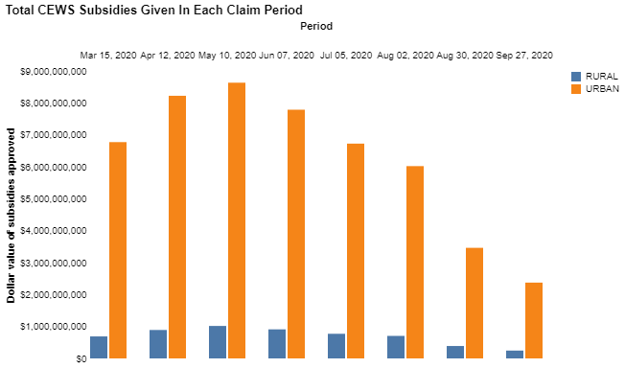

**Source:** Authors’ calculations based on the Canada Emergency Wage Subsidy Regional and Community-level database, January 4, 2021.

## 3.1. The Urban Census Agglomerations Receiving the Most CEWS Subsidies per Capita are Oil and Gas Dependent

When we examine urban areas, we see that the largest subsidies were given to various industries within Toronto and Montreal.

**Figure 5. The Ten Largest Industry Subsidies Given Within Urban Areas.**

**Source:** Authors’ calculations based on the Canada Emergency Wage Subsidy Regional and Community-level database, January 4, 2021.

When we look at the total subsidies given by CMA/CA, we see an approximate rank ordering by the cities' populations, summarized in figure 6.

**Figure 6. Total CEWS Subsidies Given Within The 15 Most Subsidized Urban Regions, March 15 Through October 24 2020.**

**Source:** Authors’ calculations based on the Canada Emergency Wage Subsidy Regional and Community-level database, January 4, 2021.

However, when regularized by the number of workers[6] we get a very different ordering (as shown in figure 7).

**Figure 7. Total CEWS Subsidies Given Within The 15 Most Subsidized Urban Regions per Worker, March 15 Through October 24 2020.**

**Source:** Authors’ calculations based on the Canada Emergency Wage Subsidy Regional and Community-level database, January 4, 2021 and the 2016 Census.

For the top three in figure 7, we look at the breakdown of which industries the subsidy money went to. In the below figures, we show the three most subsidized industries, and group the rest into "others". We see that all three of these regions have "mining, quarrying, and oil and gas extraction" as their most subsidized industry.

**Figure 8. Largest Industry Subsidies Given to the Three CMA/CA’s Which Received the Most CEWS Subsidies per Worker.**

**Source:** Authors’ calculations based on the Canada Emergency Wage Subsidy Regional and Community-level database, January 4, 2021.

When we examine the most subsidized industry in each city on our list of 15, we see that "mining, quarrying, and oil and gas extraction" is heavily represented on the top three, while "manufacturing" dominates the rest. There are only two cities with "mining, quarrying, and oil and gas extraction" as their most subsidized industry which don't appear at the top of this list. Those are North Bay, Ontario and Sylvain Lake, Alberta.

**Figure 9. The Industry Which Received the Most CEWS Subsidies in the 15 Most Subsidized CMA/CA’s.**

**Source:** Authors’ calculations based on the Canada Emergency Wage Subsidy Regional and Community-level database, January 4, 2021 and the 2016 Census, and Statistics Canada, 2016 Census of Population, Statistics Canada Catalogue no. 98-400-X2016320.

The outliers here are Gander, Newfoundland and Edmonton, Alberta. Gander is an important refueling stop for transatlantic flights and its main economic industry is transportation[7]. Travel restrictions due to Covid-19 most likely affected this region.

Figure 10 below provides an industry breakdown of subsidy money for urban centers in each province which received the most CEWS support. Note that according to the urban/rural definitions used, Nunavut has no urban areas.

**Figure 10. Total CEWS Subsidies Given Within the Most Subsidized Urban Area of Each Province/Territory.**

**Source:** Authors’ calculations based on the Canada Emergency Wage Subsidy Regional and Community-level database, January 4, 2021.

## 3.2. Rural Alberta Received the Largest Portion of Rural Subsidies per Worker[8]

When we look at the ten largest individual subsidies given to rural communities, we see that some of the largest went to "Accommodation and food services" in the tourist towns Banff, Whistler, and Jasper. "Mining, quarrying, and oil and gas extraction" is also heavily represented.

**Figure 11. Ten Largest Industry Subsidies Given Within Rural CSD, March 15 Through October 24 2020.**

**Source:** Authors’ calculations based on the Canada Emergency Wage Subsidy Regional and Community-level database, January 4, 2021.

We see that within rural Canada, manufacturing was given the most CEWS subsidies by a wide margin.

**Figure 12. Total CEWS Subsidies GIven Within Each Industry in Rural Canada, March 15 Through October 24 2020.**

**Source:** Authors’ calculations based on the Canada Emergency Wage Subsidy Regional and Community-level database, January 4, 2021.

When we look at the rural communities which received the most subsidy money, we see that the list is dominated by towns in Alberta. The story is similar when we control for the number of workers[9]. Note that only CSDs with a worker count greater than 500 are considered, to control the noise of small denominators.

**Figure 13. The 15 Rural CSDs Which Received the Most CEWS Subsidies, March 15 Through October 24 2020. CSDs with Worker Counts Less Than 500 Not Included.**

**Source:** Authors’ calculations based on the Canada Emergency Wage Subsidy Regional and Community-level database, January 4, 2021, and Statistics Canada, 2016 Census of Population, Statistics Canada Catalogue no. 98-400-X2016321

We see in Figure 14 below that within the rural parts of each province, Quebec received the most CEWS subsidies, with Alberta second.

**Figure 14. Total CEWS Subsidies Given Within the Rural Part of Each Province, March 15 Through October 24 2020.**

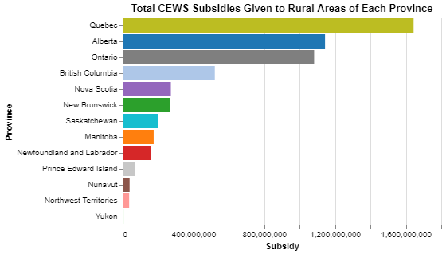

**Source:** Authors’ calculations based on the Canada Emergency Wage Subsidy Regional and Community-level database, January 4, 2021.

As in our analysis in urban areas, figure 15 shows the industry breakdown of subsidy money for the rural area in each province which received the most CEWS money.

**Figure 15. Total CEWS Subsidies Given to the Rural CSD Which Received the Most Subsidies Within Each Province/Territory. March 15 Through October 24 2020.**

**Source:** Authors’ calculations based on the Canada Emergency Wage Subsidy Regional and Community-level database, January 4, 2021.

# Part 4: Rural Alberta Received Large CEWS Subsidizes Due to Oil and Gas, and Tourism

Across all the analysis done so far, an obvious point is that Alberta, and in particular rural Alberta, has received a disproportionate amount of CEWS funding. On a provincial level, Alberta received the most funding per-capita. Three of the province's seven CMA/CAs were in the 15 most subsidized in Canada, with Wood Buffalo taking the top spot. However, most striking is the province's prevalence in the top of the list of most subsidized rural areas. When looking at total subsidies given to rural CSDs, Alberta holds 9 of the top 15 spots. When we normalize by worker count, Alberta holds 8 of the top 15 spots.

We can look at the industry distributions of subsidies given in some of the most heavily subsidized rural Albertan CSDs we discovered in **Part 3**. While we only show 5 breakdowns for the sake of space, the story is the same in all 13 Alberta CSDs that show up in Figure 13. The most heavily subsidized industry is either *mining, quarrying, and oil and gas extraction*, or *accommodation and food services*.

**Figure 16. Industry breakdown of subsidies given within highly affected rural Albertan CSDs.**

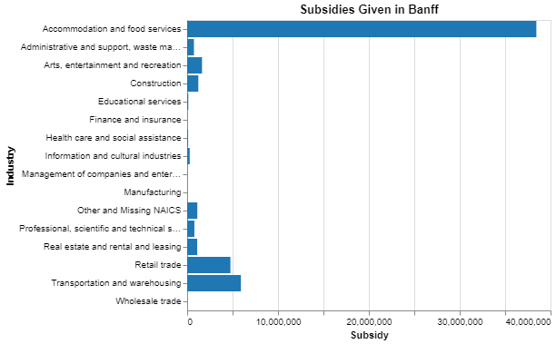

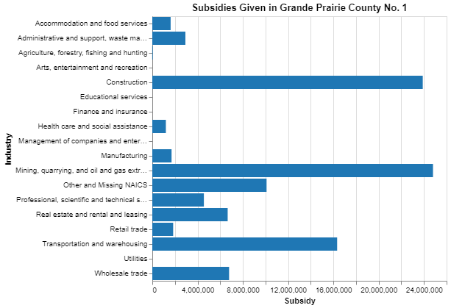

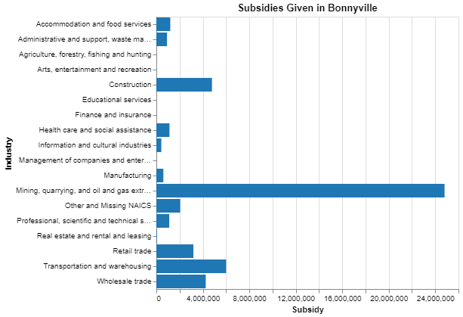

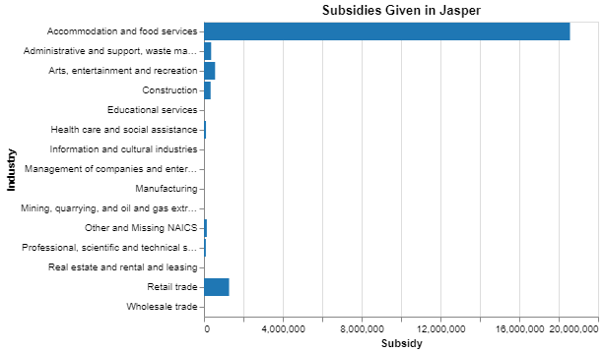

**Source:** Authors’ calculations based on the Canada Emergency Wage Subsidy Regional and Community-level database, January 4, 2021.

Next, we can look at the four industries in rural Alberta which received the most CEWS money. We see that rural Alberta received about half of the total mining, quarrying, and oil and gas extraction subsidies given out in all of Canada, while receiving proportionally less manufacturing money.

**Figure 17. Total CEWS Subsidies Given to Four Highly Subsidized Rural Industries, Within Alberta and Canada-wide. March 15 Through October 24 2020.**

**Source:** Authors’ calculations based on the Canada Emergency Wage Subsidy Regional and Community-level database, January 4, 2021.

**Figure 17. Analysis of CEWS Subsidies Given to Four Industries Within Rural Alberta.**

**Source:** Authors’ calculations based on the Canada Emergency Wage Subsidy Regional and Community-level database, January 4, 2021.

While rural proportions are smaller in general, the standout point is that over 90% of accommodation and food service workers were supported in Alberta. Rural Alberta also holds the largest proportion for construction workers, at about 30% supported.

**Figure 18. Comparison of Proportion of Workers Supported Within Industries, Between Provinces.**

*Note: Provincial urban/rural worker counts are not available for mining, quarrying, and oil and gas extraction, as that industry was aggregated with others in this dataset*

**Source:** Authors’ calculations based on the Canada Emergency Wage Subsidy Regional and Community-level database, January 4, 2021, and Statistics Canada table 14-10-0377-01 Employment by class of worker and Industry.

Rural Alberta was particularly affected by the Covid-19 pandemic due to its reliance on tourism and oil and gas. Industries related to tourism were heavily affected due to travel restrictions and stay at home orders, and places like Banff, Jasper, and Hinton sustain themselves on the money of people from out of province and out of country coming to see the Rockies. We see this in the staggering proportion of food and accommodation workers in rural Alberta who were supported by CEWS at over 90%. Aside from the tourism angle, a lot of hotels and restaurants in rural Alberta typically make money from remote workers in mining, oil and gas, and forestry who live in bush camps within the province. In typical years, these workers would travel to the local towns on their days off and spend money at hotels, bars, restaurants, and retailers. However, restrictions were put in place that prevented remote workers from travelling into town to prevent the spread of Covid-19 into bush camps, which lost local businesses the revenue they would have earned from this significant clientele.

Furthermore, we have seen earlier that mining, quarrying, and oil and gas extraction was the most expensive industry to subsidize on a per-worker basis. Over half of the subsidies given in this industry were in rural Alberta, and some of the largest rural subsidies were given to rural Alberta in this industry.

# Part 5: Some CSDs Received Their Largest Subsidies in Atypical Industries

We have seen that for most subdivisions, the largest subsidy given was in one of a select few industries. We see in the figure 21 below that of the approximately 1,700 census subdivisions which received at least one (non-suppressed) subsidy between March and October, about 1,100 had construction, manufacturing, or accommodation and food services as their most subsidized industry.

**Figure 19. Total Number of CSDs Which Received Their Largest CEWS Industry Subsidy in Each Industry.**

**Source:** Authors’ calculations based on the Canada Emergency Wage Subsidy Regional and Community-level database, January 4, 2021.

# References

1. Statistics Canada. (2021). Canada Emergency Wage Subsidy Regional and Community-level Database, Version 1.0. <https://www150.statcan.gc.ca/n1/pub/11-26-0003/112600032021001-eng.htm>

2. Statistics Canada. Table 14-10-0377-01 Employment by class of worker and industry, annual (x 1,000) DOI: <https://doi.org/10.25318/1410037701-eng>

3. Statistics Canada, 2016 Census of Population, Statistics Canada Catalogue no. 98-400-X2016321. <https://www150.statcan.gc.ca/n1/en/catalogue/98-400-X2016321>

4. Statistics Canada, 2016 Census of Population, Statistics Canada Catalogue no. 98-400-X2016320. [https://www150.statcan.gc.ca/n1/en/catalogue/98-400-X2016320](https://www150.statcan.gc.ca/n1/en/catalogue/98-400-X2016321)

1. Statistics Canada. (2021). Canada Emergency Wage Subsidy Regional and Community-level Database, Version 1.0. <https://www150.statcan.gc.ca/n1/pub/11-26-0003/112600032021001-eng.htm>
2. Statistics Canada. Table 14-10-0377-01 Employment by class of worker and industry, annual (x 1,000) DOI: <https://doi.org/10.25318/1410037701-eng>
3. Statistics Canada, 2016 Census of Population, Statistics Canada Catalogue no. 98-400-X2016321. <https://www150.statcan.gc.ca/n1/en/catalogue/98-400-X2016321>
4. Worker counts used as defined and reported in the 2016 census. A *worker* is anyone over the age of 15 who was employed during the reference period (at the time of the census).
5. Regions within census agglomerations and census metropolitan areas are considered urban, while any area not in a census agglomeration or census metropolitan area is considered rural.
6. Worker counts used as defined and reported in the 2016 census. A worker is anyone over the age of 15 who was employed during the reference period (at the time of the census).
7. <https://www.cafconnection.ca/Gander/In-My-Community/About-Gander.aspx#:~:text=The%20main%20economic%20industries%20for,driven%20by%20the%20service%20industry.&text=Health%20care%20and%20educational%20facilities,Gander's%20high%20standard%20of%20living>.
8. Worker counts used as defined and reported in the 2016 census. A worker is anyone over the age of 15 who was employed during the reference period (at the time of the census).
9. Worker counts used as defined and reported in the 2016 census. A worker is anyone over the age of 15 who was employed during the reference period (at the time of the census).