Create a domain and add Windows 10 Device

1-Download the ISO Windows Server 2019

2-Install the Windows Server Standard Edition with Graphics Mode in Virtual Box

2.1-Add an adapter in internal Network with any name for identify them.
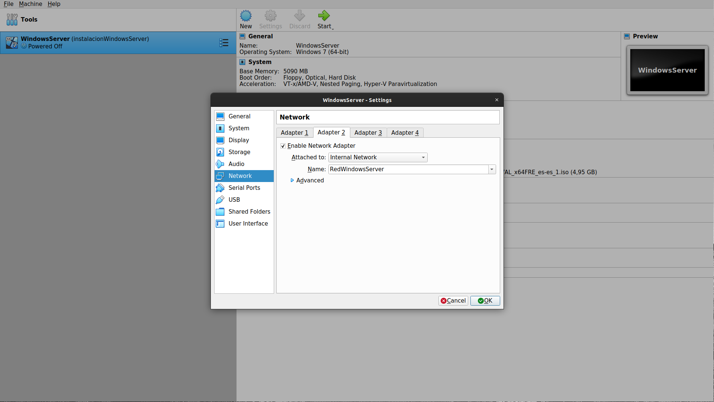
3-Do an Snapshot of the installation for not lose time if we do something wrong and for later do another machine with this Operative System
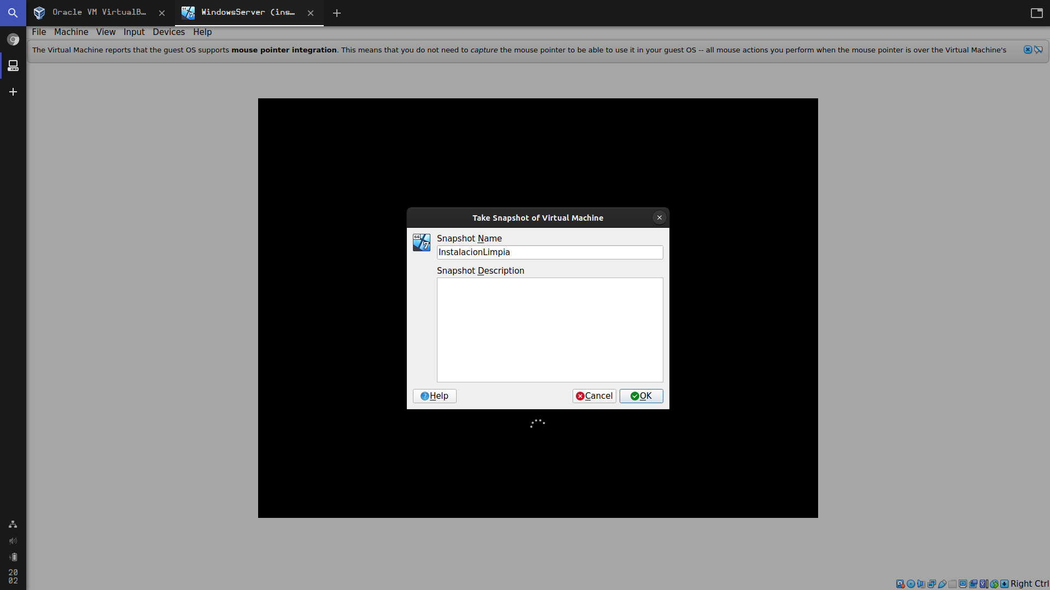

4-Put a password for the administrator user in this case is “Daw2021”

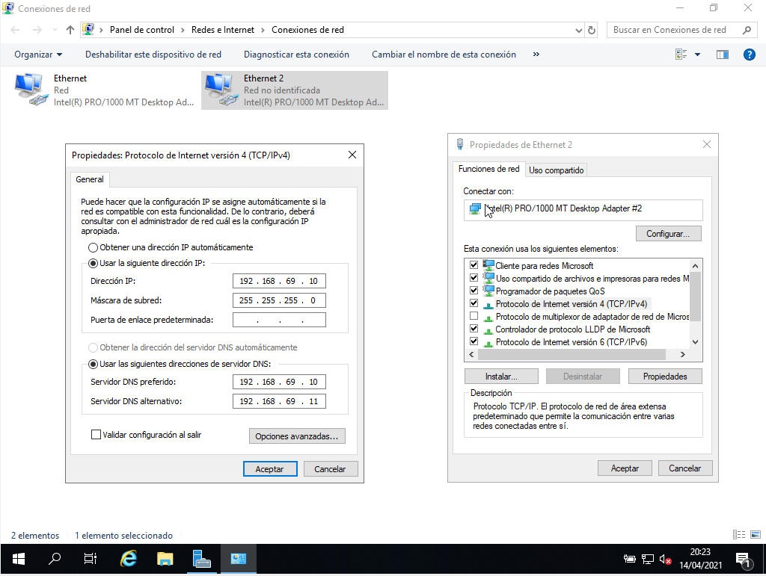
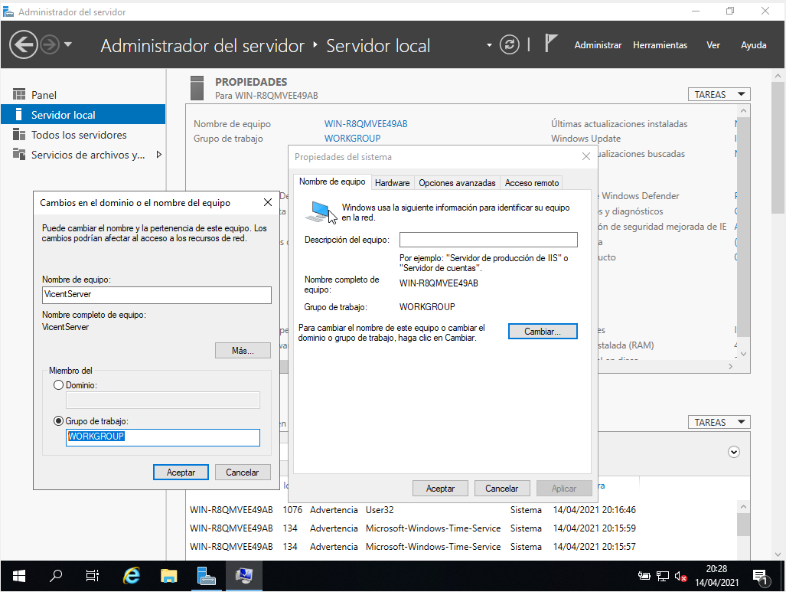
5-We put an ip address to the Second Adapter
6- Now we are going to change the name of the machine
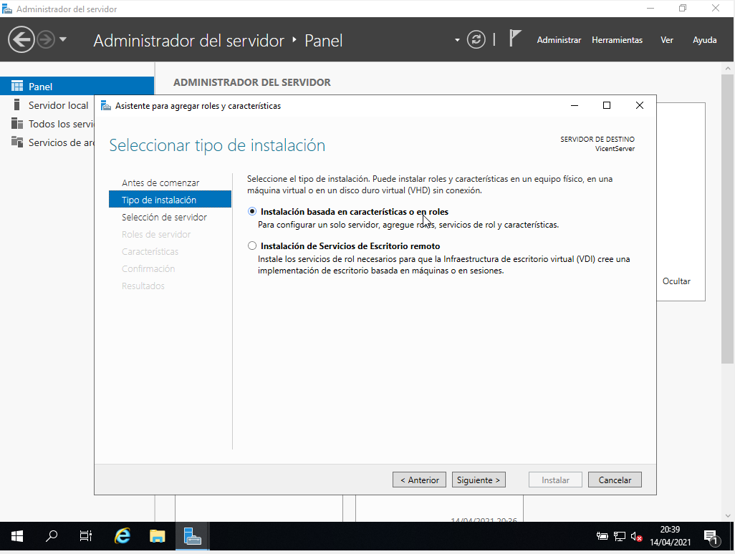
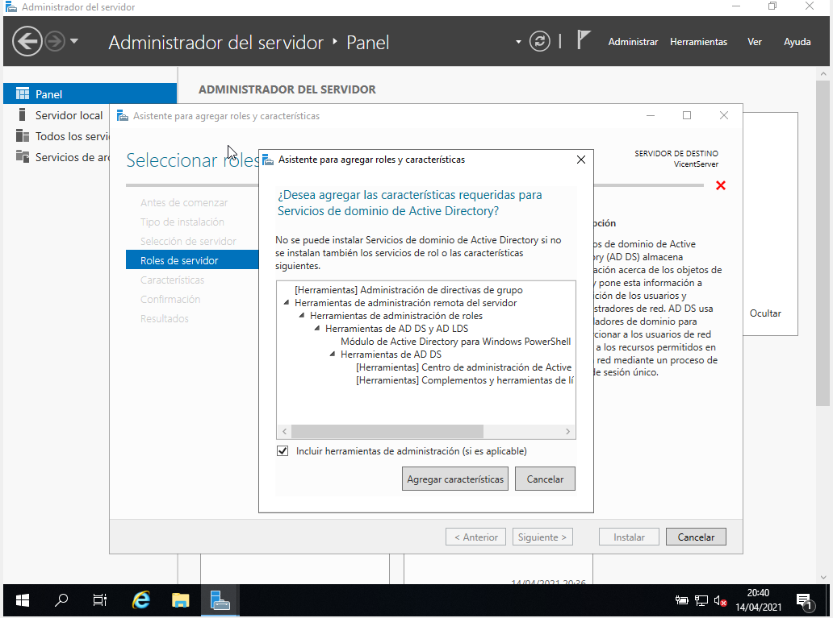
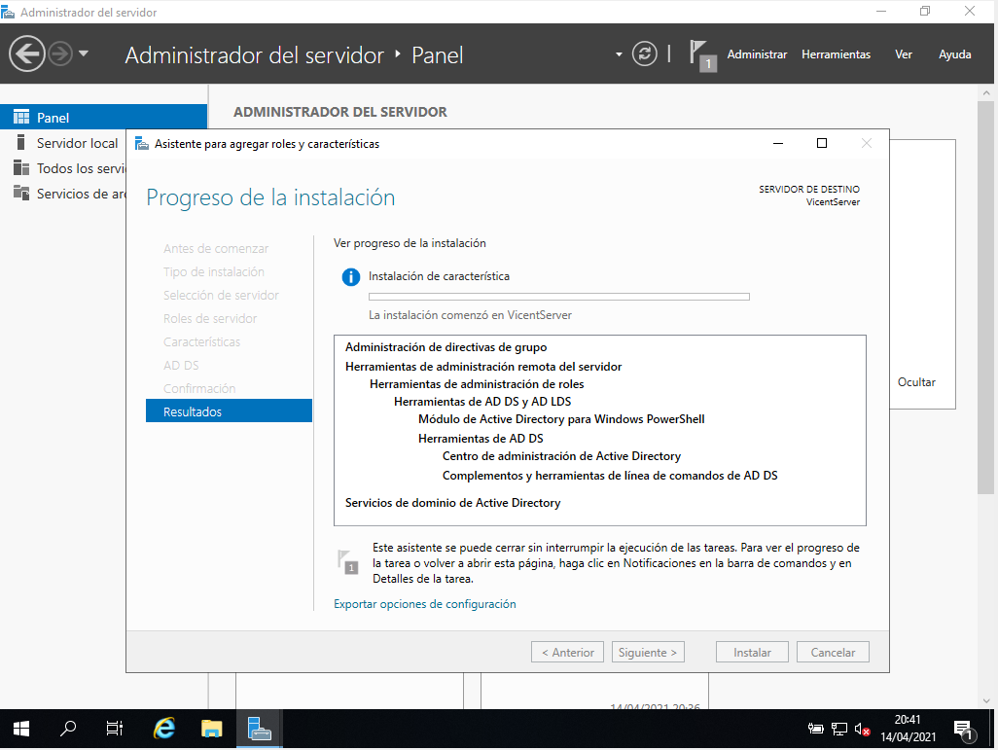
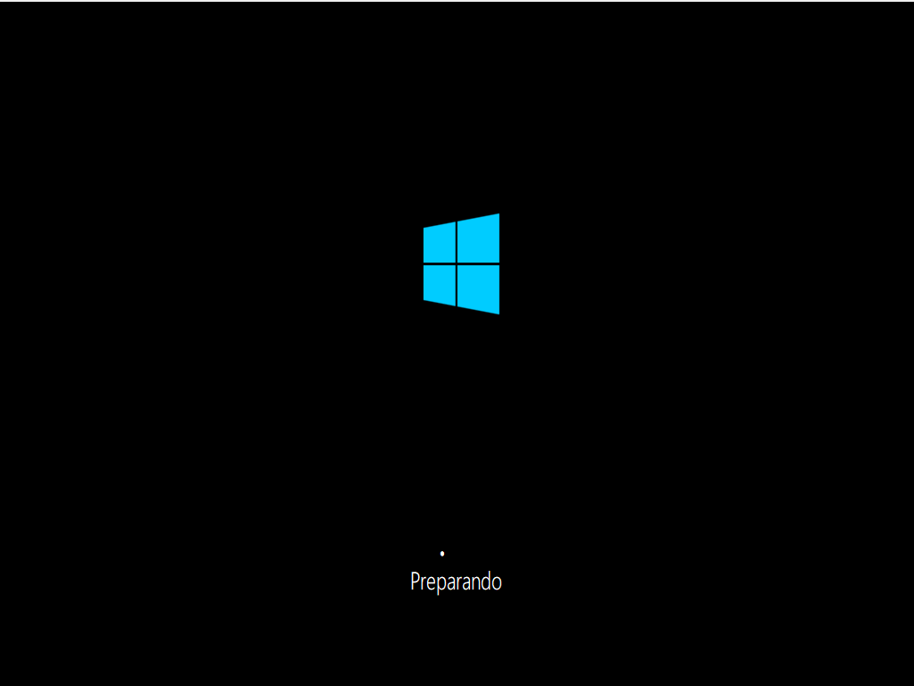
7-Add a Rol Active Directory
8-Instalamos un Windows (Cualquiera vale menos el home edition)

