**Task 1.**

Create a web page with two buttons. When one button is clicked, the normal function should be run, while when the other button is clicked, the arrow function should be run.

Note that Math.random() can be used for generating random number.

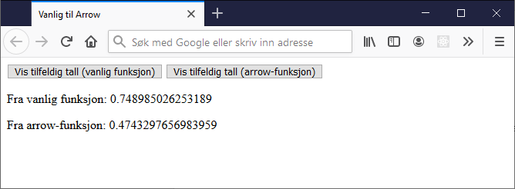

**Task 2.**

You will create a website where the user can enter two numbers and have them multiplied.

You should create arrow functions for add, subtract and divide operations.

Note: once you have created all the functions, try to think about whether you are repeating any code unnecessarily. Can you possibly create more functions to avoid repetition of code?

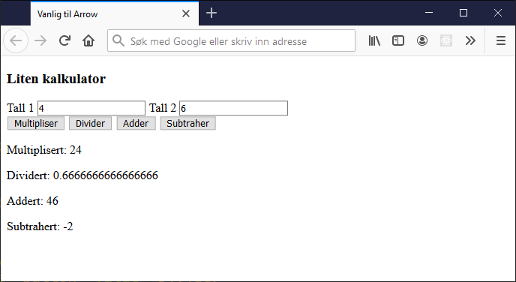

**Task 3. Countries in Europe (forEach and Object literals).**

You will create below webpage with a button. When click the button, the land list will show up.

Note that you shall use Object literals ({property: «value»}) to create an Array of objects, and use forEach to output information (country, capital, flag)

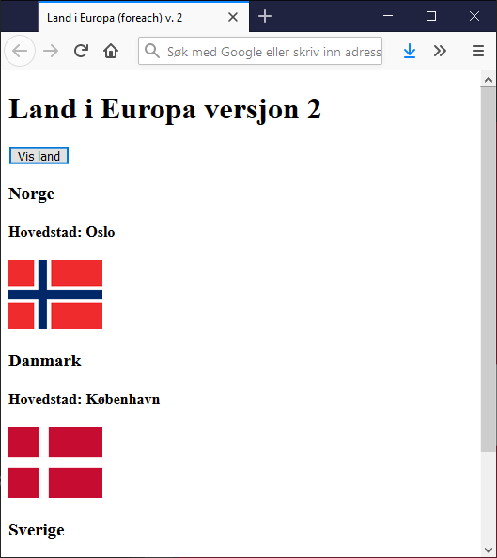

**Task 4. Employees in departments: filter**

You will create below webpage with a filter function.

Note that you shall use Object literals to create an Array that contain employees in a company. Each employee must have firstName, surName and department. And use filter() to create a new array to hold the filtered items.

