Shyam Bhat

Tata technologies

Proxican Help Document

ProxiCan GUI Help Document 2

Getting started with ProxiCan Tool. 2

Configuration panel 3

Steps to export the configuration 4

Steps to import the configuration from a config (pxi) file. 5

Connecting to CAN Hardware 5

Disconnecting from CAN hardware 6

UDS services panel 6

Steps to configure the required UDS services in the project 6

General structure of UDS service window 8

Status bar 9

Log files by ProxiCan GUI Tool 10

Types of Log files 10

Action Log 10

CAN Traffic Log 10

Transport Protocol Level Log 10

UDS Log 10

Configuring Log file location and name 11

# ProxiCan GUI Help Document

This document is guide for using the GUI tool for testing UDS services for ECUs. The GUI tool is running on top of Raspberry PI microcontroller in Linux platform interfaced with CAN or CAN FD hat. For more details on the hardware setup and usage please refer to the document “Raspberry Pi_CAN FD.docx”.

Below are the Features which the tool provides:

1. Configuring the hardware and CAN controller for communication with ECU
2. Customizing the UDS services available for testing
3. GUIs to test the UDS services. Dedicated window for each supported UDS services
4. Exporting and importing the configuration files (*.pxi)
5. Log files at level of can traffic, Transport Layer and UDS services.
6. Log of all the actions and interactions with the tool for easy tracing.
7. Configure the location and name of Log files

Below UDS services are supported in this tool till now:

1. Service 10: Diagnostic Session Control
2. Service 22: Read Data by Identifier
3. Service 2E: Write Data by Identifier

## Getting started with ProxiCan Tool.

When you open the tool, you get first the below window. This is the mainwindow and used to configure the CAN hardware and invoke various UDS service windows.

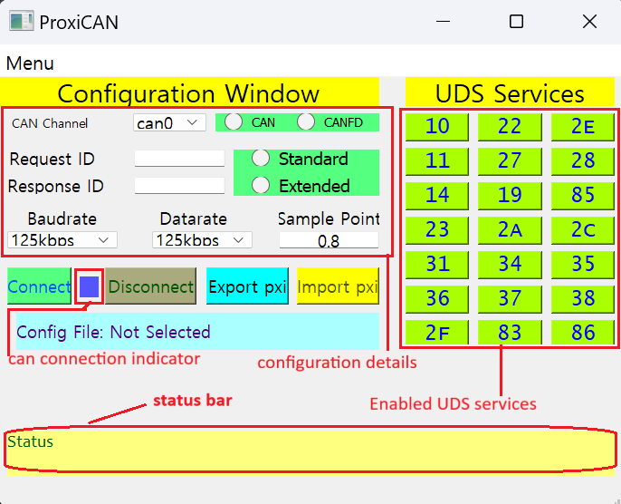

Figure 1. ProxiCAN mainwindow Snapshot

In Figure 1, You can see the snapshot of the ProxiCAN mainwindow. This mainly contains 3 sections:

Configuration panel

This is where you provide all the configuration parameters necessary to connect with CAN hardware and communicate with the ECU. If any of the parameters are missing, it is not possible to connect with the hardware and communicate with ECU.

Below configuration parameters are necessary to be provided.

1. **CAN Channel** : This is a dropdown box with 2 options [can0 and can1]. Our hardware has 2 CAN channels. Therefore, we have provided 2 options. Please select the channel which is connected with the ECU.
2. **CAN Type** : This is selection panel with 2 radio button options [CAN or CANFD] select the correct option. Select CAN if CAN protocol is used and CANFD if CAN FD is used for communication.
3. **Request ID** : This is the CAN message ID for Diagnostic Request message transmitted to ECU for UDS request. The value needs to be provided in Hexadecimal number.
4. **Response ID** : This is the CAN message ID for Diagnostic Response message received from ECU for UDS response. The value needs to be provided in Hexadecimal number.
5. **Message ID Type** : CAN has two message ID types [Standard and Extended] If the request and response IDs are in standard message type [11 bits] then select the option Standard. On the other hand, if the IDs are extended type [29 bits] then select the option Extended.
6. **Baudrate** : This is a dropdown box. Here you select the baudrate of the CAN network connected. This value must be same as the baudrate configured for the ECU, otherwise the communication doesn’t happen properly.
7. **Datarate** : This is a dropdown box. This is needed only of the CAN Type is CANFD. Here you select the bit rate used for payload on CAN FD frame. This value must be same as the datarate configured for the ECU, otherwise the communication doesn’t happen properly.
8. **Sample Point** : This is a text box. Here provide the sample point ratio. if you want 75% then enter 0.75. This is also an important configuration done in ECU and here the same value needs to be provided as ECU configuration.

These configuration parameters can either be entered manually or imported from configuration file (*.pxi) file. You can create the configuration file by entering the values once and exporting it in a pxi file and keeping it for future usage. The steps to export and import the configuration is given below

#### Steps to export the configuration

1. Enter the above mentioned configuration parameters in configuration panel manually.
2. Click on **Export pxi** button.
3. If the configuration parameters are invalid, then a error would be shown in status bar.
4. If the configuration parameters are valid then a File Dialog Box would open to select the location and name of configuration file as shown below:

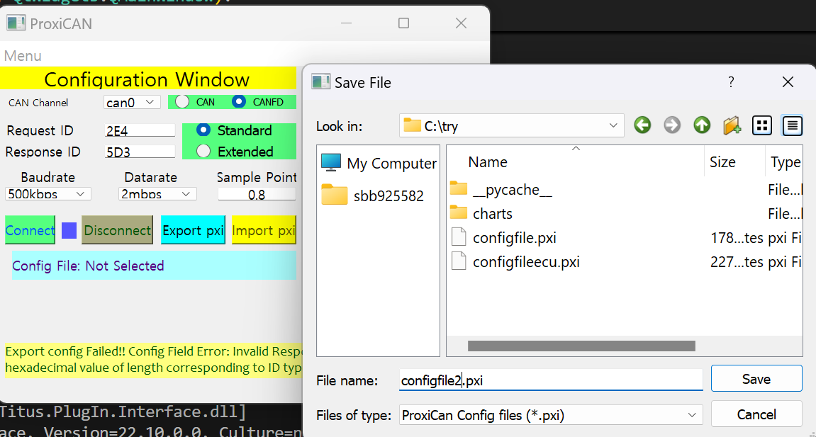

1. Please navigate to the proper location and provide the name for configuration file.
2. Click on **save** button.
3. The configuration file would be exported with configuration values and the path would be displayed in the sky-blue window.

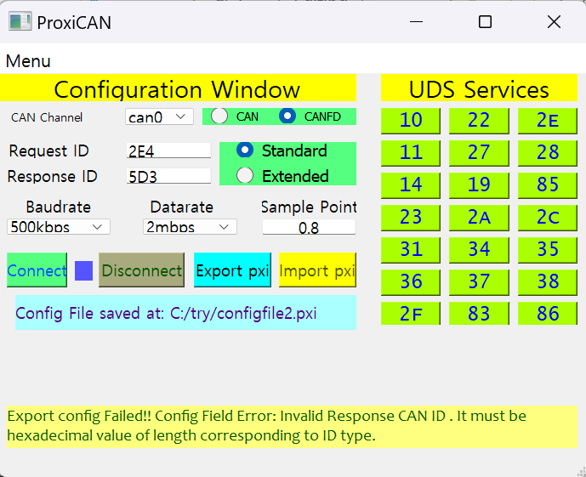

#### Steps to import the configuration from a config (pxi) file.

* 1. Click on **Import pxi** button.
  2. A file dialog box would open to select the configuration file. Select the configuration file (*.pxi) and click on open as shown below:

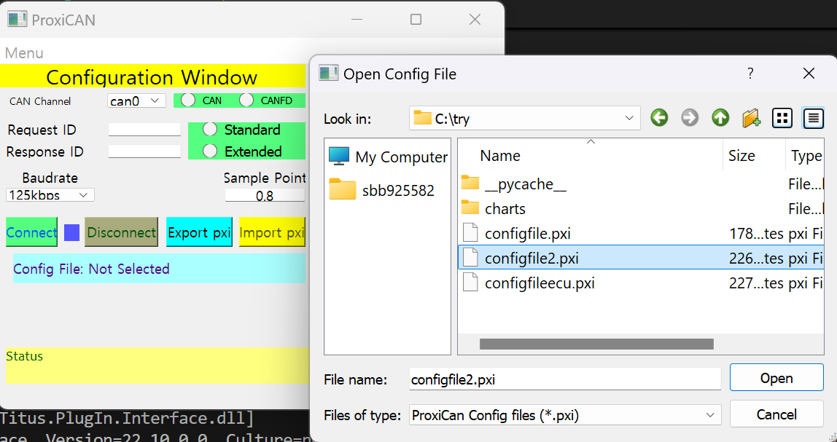

* 1. If the configuration file is valid then the configurations would be imported properly. Otherwise, the error would be displayed in the status bar

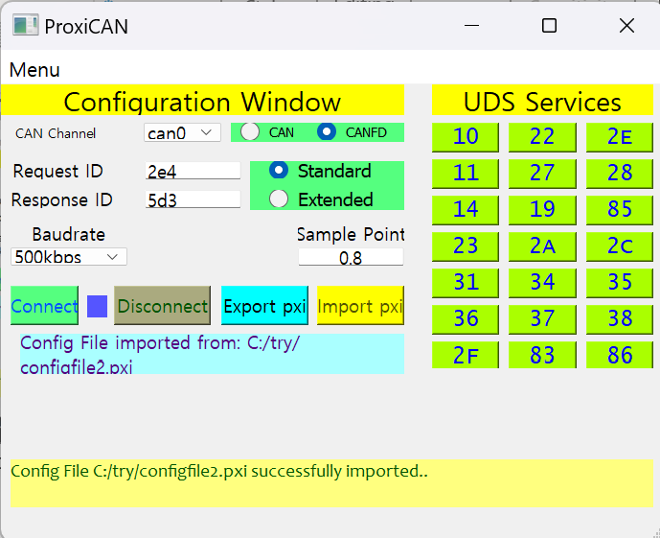

#### Connecting to CAN Hardware

Once you have proper configuration parameter values in the fields, you can connect with the CANB Hardware by clicking on the **Connect** button on the configuration panel. If the CAN connection is successful, then the **CAN connection indicator** turns **Green** as shown below:

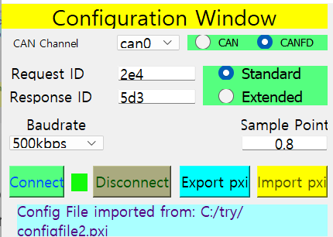

If the CAN connection is unsuccessful then it remains blue itself and the error is displayed on the status bar.

Note that all the UDS services would have to be performed while the Can is connected only.

#### Disconnecting from CAN hardware

Once all your tasks are done, you can disconnect from the Can hardware by clicking on the **Disconnect** button. When you disconnect from CAN the **CAN connection indicator** turns **Red** as shown below:

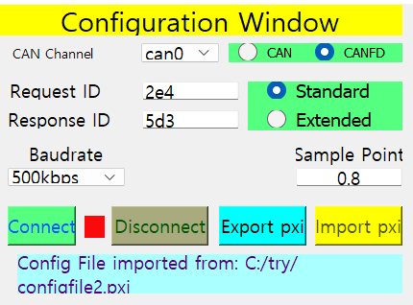

So the CAN connection indicator shows the current status of CAN connection.

UDS services panel

Next we have the UDS services panel which contains the buttons corresponding to various UDS services. Each button is for one UDS service and this panel contains all the enabled UDS services. The tool provides provision to configure and display only those UDS services in the panel which are needed or supported in the project. This can be done by following below steps

#### Steps to configure the required UDS services in the project

* 1. In the mainwindow, go to **menu** 🡪 **UDS Service Settings** option and **click** on it as shown below.

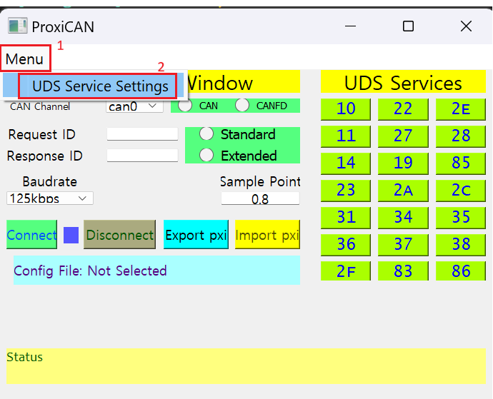

* 1. A pop up window with title “**Enabling or Disabling UDS Services**” opens up as shown below:

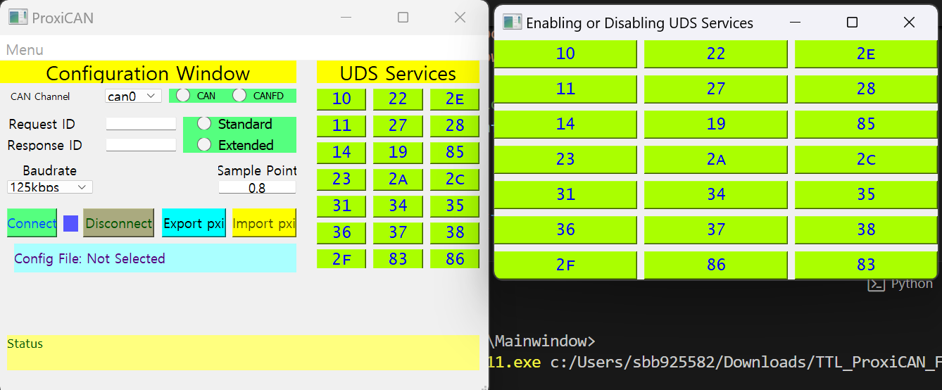

* 1. This pop up window consists of all the UDS services which can be either enabled or disabled. These are toggle button. If you click them, They get enabled and disabled. Click on the enabled services which you want to disable in the tool by making them red. And click on disabled services to enable them in the project if you want by making them green. Just remember. All service buttons which will be red will not be shown in mainwindow’s UDS services panel and only green ones will be shown. So configure them according to your project needs. A sample selection is as shown below:

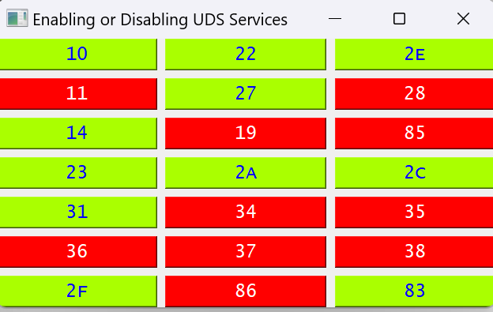

* 1. Then close the popup window. You can see that no change would be visible in UDS Services panel of mainwindow. This is because when you either enable or disable any services in the tool, you need to restart the app for it to take effect. So close the mainwindow as well and reopen it. Then you can see only enabled services visible for use in the UDS services panel as shown below:

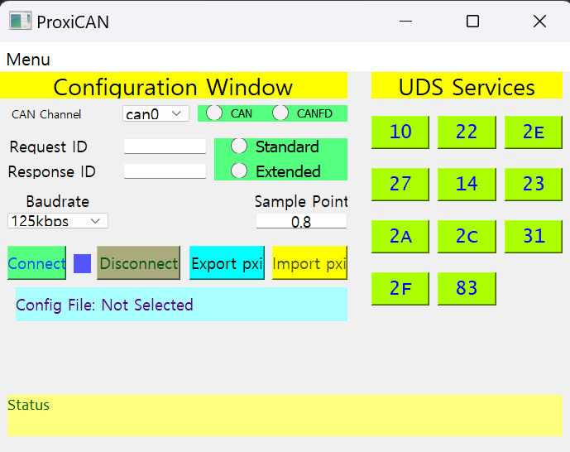

* 1. So we have disabled the unwanted services for the project and only retained the needed services in the UDS panel arranged properly and looking good too.

#### General structure of UDS service window

In the UDS Services panel when you click on any button, then a window for that corresponding UDS service opens up. This happens only if the CAN is connected, otherwise a error message would be shown in the status bar and the service window doesn’t open.

But when the service window opens, you can test the UDS service and get the results. The general structure of the service window is as shown below:

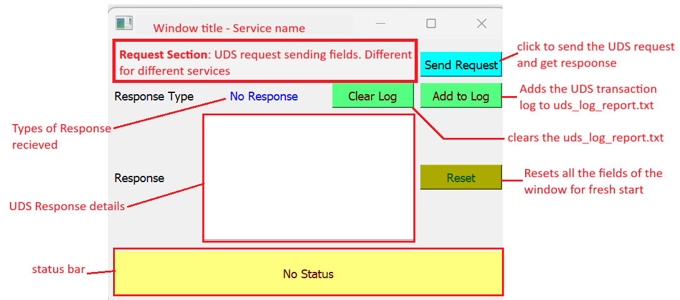

Figure 2: General structure of UDS service window

The Types of response which the tool supports is listed below

|  |  |
| --- | --- |
| Response Type | Response Content |
| Positive Response | The positive response bytes are shown along with custom values in data record. |
| Negative Response | The negative response bytes along with the NRC received and the explanation of NRC is shown |
| No Response | When no Response message is received within the timeout value then this response type is shown. One use case can be when you request for suppressing positive response message in UDS request. |
| Unknown Response | If a response is received which doesn’t match any of above types then it will be shown as this type. Ideally, we should not receive this Response type until something has really gone wrong. |

Status bar

The status bar is at the bottom of the window. It can be mainwindow or any service window. This status bar gives information on current status and some status message which the tool wants to communicate with the user.

## Log files by ProxiCan GUI Tool

### Types of Log files

The ProxiCan tool provides 4 types of logs. They are listed below:

#### Action Log

The Action Log captures and logs all the action performed by the user in the GUI. If a button is clicked. It will be logged. If CAN connection occurs, it will be logged. If UDS request is sent, then it will be logged. The format of logging the action is as shown below:

<User> [timestamp] action_type: action details

This log file can be used to trace the actions performed by the user in case he encounters some problem with the tool. It helps in debugging the issues with the tool and also to identify if something wrong was performed by the user which led to this problem as well.

#### CAN Traffic Log

The CAN Traffic log captures the transmit and receive CAN/CANFD messages related to UDS service between the tool and the ECU connected. This log file captures the communication at the CAN protocol level.

#### Transport Protocol Level Log

The Transport Protocol Level log or TP log captures the UDS service transaction between the tool and ECU at the TP layer level. That means the communication of single frame, first frame, consecutive frames and flow control frames are captured here. This is in accordance with ISO15765 protocol document.

#### UDS Log

The UDS log contains the log of UDS transactions between the tool and ECU. This is at the UDS level. Here the log file is not appended with the transaction automatically like the other log files. It will be added only for those transactions for which the user clicks on **Add to Log** button on the service window.

|  |
| --- |
| *Note: The log files for action, can traffic and Transport protocol gets cleared automatically every time you launch the mainwindow and logs from fresh. If you need the logs, please make sure to save them separately in a different location whenever you close the tool. However the UDS log doesn’t get erased unless you click on* ***Clear log*** *button on any of the service windows*. |

### Configuring Log file location and name

The ProxiCan tool allows the user to choose the location and the name of the log files. For choosing the location and the name of the Log files please follow the below steps:

1. In the mainwindow of the tool, go to **Menu** 🡪 **Log Files Location** option and click on it as shown below:

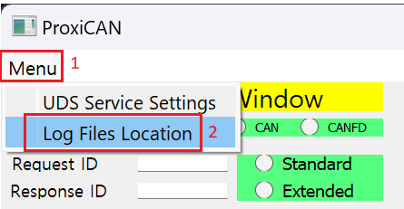

1. A popup window with the title **Log File Selector** opens up as shown below. Here you can see 4 fields for 4 log files location and name and 4 corresponding buttons to browse and a button to **Save Log Paths**.

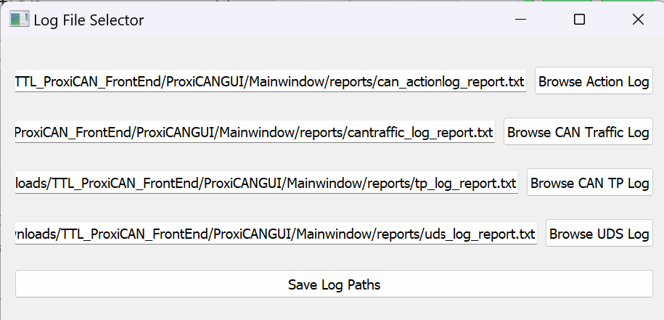

1. If you want to change the log file name or location then click on corresponding Log files’ Browse button. For example, if you want to change the UDS Log file then click on **Browse UDS Log** button. Then a File dialog window opens. Please navigate to the location where you want to save the log file and provide a name for the log and click on **Save** Button as shown below:

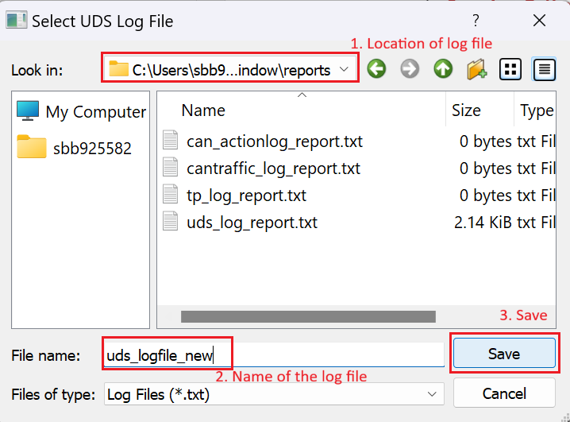

1. You can see that the location and the file name would have been updated in the **Log File Selector** window for the corresponding log file as shown below:

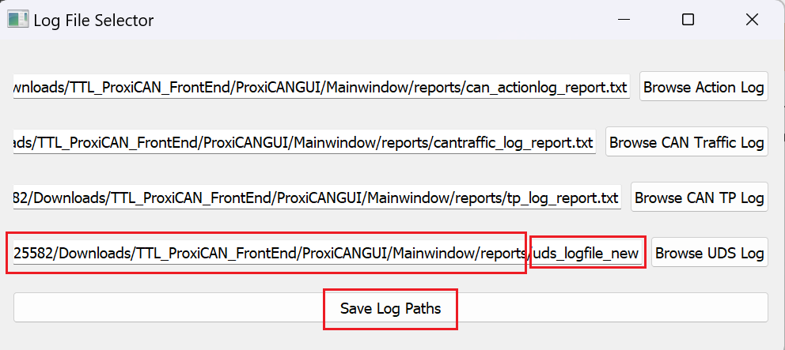

1. Then click on the Save Log Paths button. A success window pops up if the path and names were updated successfully as shown below:

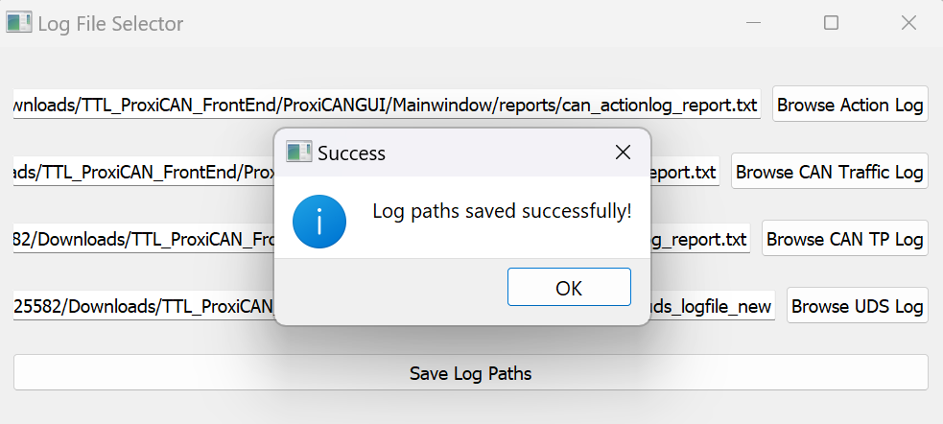

1. Click on **OK** button and close the **Log File Selector** window. Your Log file location and names are configured or updated successfully. Now when you use the tool for testing all the log files would be creat4ed and updated in the location provided by you here.