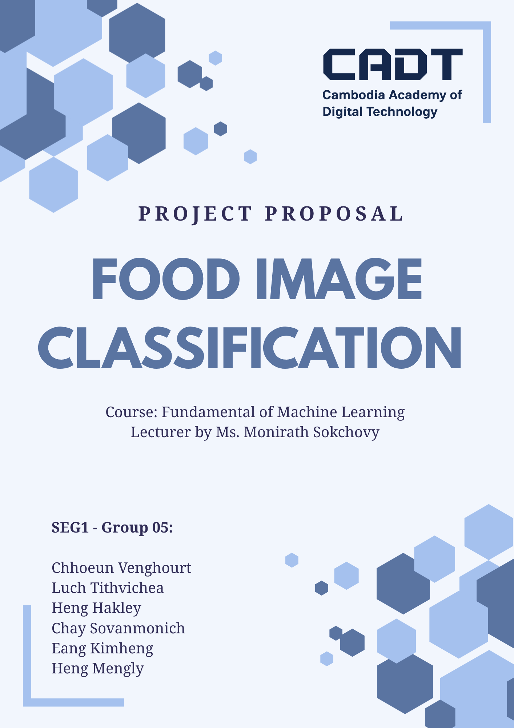
Project Proposal
Food Image Classification: Recognising Dishes from Photos with Deep Learning

1. Problem Statement
People often see a dish on social media, in a restaurant or at a market without knowing its name. Without the name, they cannot search for it, find a place that serves it, or learn how to cook it. Search engines, including our food search app for Cambodia (Klean Nham), need words. A photo is the most natural way to ask about food, but a search engine cannot use a photo directly.
Recognising food in photos is hard for a computer:
- Large differences within one dish. The same dish looks different from one cook, plate, light and camera angle to another.
- Small differences between dishes. Steak and filet mignon, ramen and pho, or chocolate cake and chocolate mousse can look almost the same.
- Messy real photos. Photos contain other dishes, hands and background, and the Food-101 training photos even contain some wrong labels on purpose.
This project addresses the problem by training a model that names the dish in a photo. The app then uses that name to give useful information: the recipe with its cooking time, and restaurants in Cambodia that serve the dish. A user uploads a photo and can go straight to a place to eat it.

2. Objective
Main goal: build and evaluate a deep learning model that recognises the dish in a food photo among the 101 Food-101 dish types and the Khmer dishes of the public kh-food image dataset, and use it so that users can upload a food photo, see the dish, and find restaurants in Cambodia that serve it.
Specific objectives:
- Train a convolutional neural network (CNN) from scratch on Food-101 and the Khmer food images as a baseline.
- Fine-tune a pretrained EfficientNet-B0 (transfer learning) and compare it with the baseline.
- Evaluate CLIP zero-shot classification, which needs no training, as a third approach.
- Compare the three models on the same test photos (top-1 and top-5 accuracy, macro F1, confusion matrix, model size and prediction time) and analyse their mistakes.
- Connect the best model to the Klean Nham app: uploaded photo, then dish, then restaurants in Cambodia that serve it, and the recipe (ingredients, steps, cooking time).
Target: at least 80% top-1 accuracy on the Food-101 test set for the best model. Published results show that this is realistic with transfer learning (Section 3). The Khmer test images are reported separately, because that set is much smaller.

3. Literature Review

3.1 Food image datasets
Food-101 is the standard benchmark for food recognition. It has 101 dish types with 1,000 photos each, collected from the foodspotting.com website: 750 training and 250 test photos per dish. The test photos were checked by hand, while the training photos were left with some noise (wrong labels, strong colours) to make models robust. Other datasets focus on one cuisine, such as UEC-Food256 for Japanese dishes, or link photos to recipes, such as Recipe1M with over one million recipes. Min et al. give an overview of this research area, called food computing. For Khmer food we found no large public dataset, only small collections such as the kh-food image dataset on Roboflow Universe.

3.2 From hand-made features to deep learning
In the original Food-101 paper, Bossard et al. used random forests to find the most typical image parts of each dish and reached 50.76% accuracy. In the same paper a CNN trained from scratch reached 56.40%, which already showed the value of deep learning. Since then, deep CNNs have been the main approach.

3.3 Transfer learning and EfficientNet
Training a large network from scratch needs much more data than Food-101 offers. Transfer learning starts from a network trained on ImageNet (1.28 million photos of 1,000 objects) and adapts it to food. Kornblith et al. showed that fine-tuning ImageNet models works better than training from scratch, and that better ImageNet models usually transfer better. Hassannejad et al. fine-tuned Inception-v3 on Food-101 and reached 88.28% top-1 accuracy.
EfficientNet scales the depth, width and input resolution of a network together (compound scaling). The smallest version, EfficientNet-B0, has only about 5.3 million parameters and reaches 77.1% top-1 accuracy on ImageNet, so it is fast enough for a web app. The authors report 93.0% on Food-101 with their largest model, EfficientNet-B7. We use B0, so we expect a lower but still strong result.

3.4 Zero-shot classification with CLIP
CLIP learns from image and caption pairs collected from the internet instead of fixed labels. It puts photos and text in the same vector space, so it can classify a photo by comparing it with sentences such as “a photo of pizza, a type of food”, without any training on the target dataset (zero-shot). Food-101 is one of the datasets where the authors found zero-shot CLIP to be strong. We use the open-source OpenCLIP ViT-B/32 model trained on the LAION-2B image-text dataset, the same CLIP model our app already uses for photo search.

3.5 From the dish name to recipes
Salvador et al. linked food photos to recipes in Recipe1M. Public recipe collections from Food.com and RecipeNLG give ingredients, steps and preparation times, which we use to answer questions such as “how do I make it?” and “how long does it take?”.
Table 1: Published top-1 accuracy on the Food-101 test set
Method | Source | Top-1 accuracy
Random forests on typical image parts | Bossard et al., 2014 | 50.76%
CNN trained from scratch | Bossard et al., 2014 | 56.40%
Inception-v3, fine-tuned | Hassannejad et al., 2016 | 88.28%
EfficientNet-B7, transfer learning | Tan and Le, 2019 | 93.0%

Gap: most studies report only accuracy on the benchmark. Few connect the recognised dish to practical information such as cooking time, ingredients or local restaurants, and Food-101 contains no Cambodian dishes, so we add the public kh-food image dataset. Our project compares three model types on the same data and uses the best one in a real search app.

4. Methodology
Figure 1 shows the whole system. The models are trained and compared offline on a GPU; the best model is then used by the app to answer photo questions.
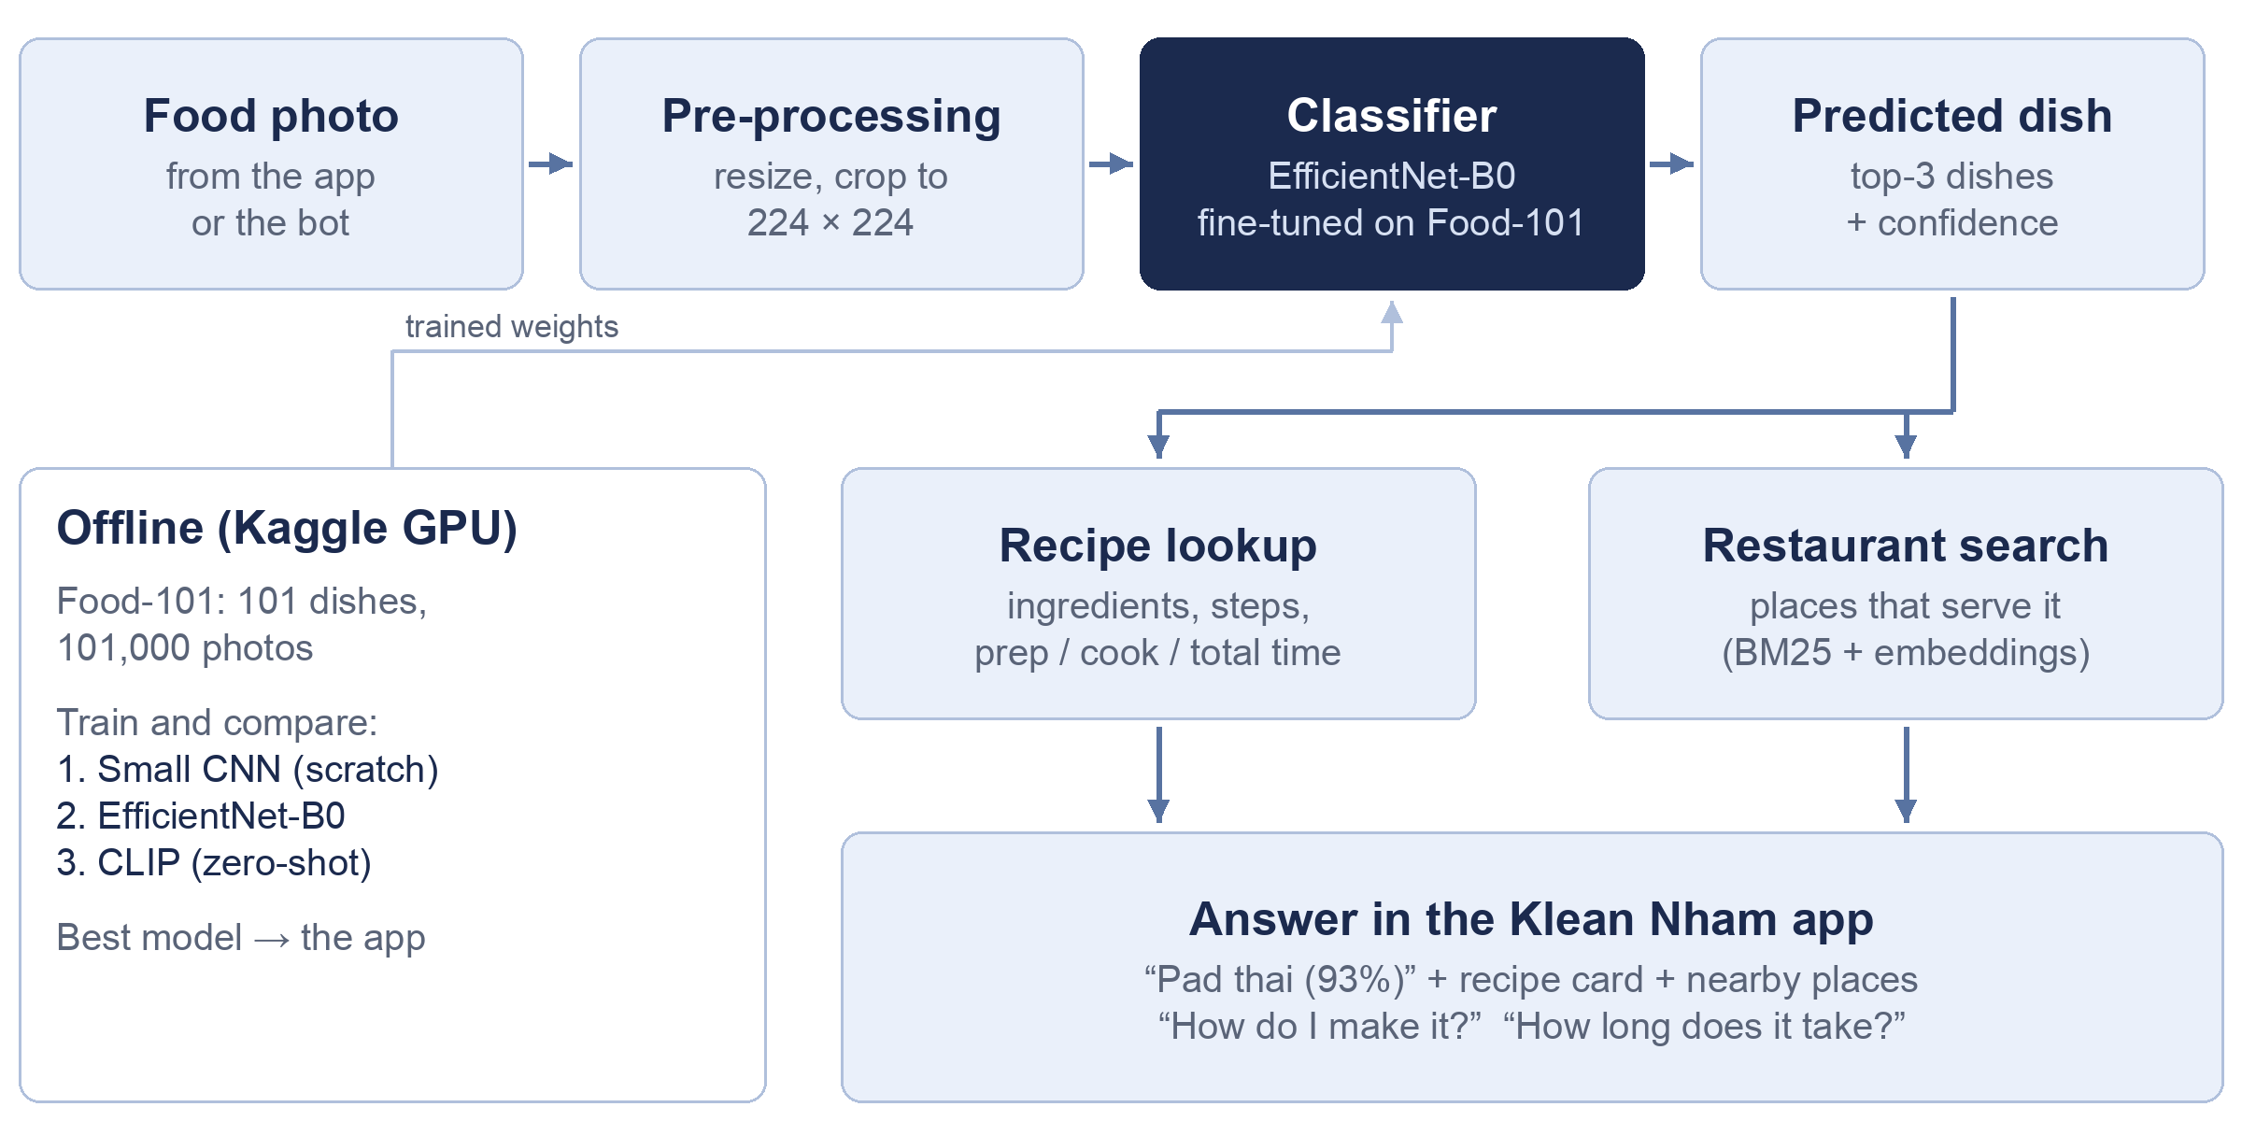
Figure 1: System overview, from a food photo to the dish, its recipe and nearby restaurants

4.1 Dataset and pre-processing
Table 2: Datasets used in this project (Food-101 and kh-food image)
Item | Value
Dishes (classes) | 101 Food-101 dishes (e.g. pizza, tacos, sushi, pho, ramen) plus all Khmer dishes of kh-food image
Photos | Food-101: 101,000 (1,000 per dish, longest side up to 512 pixels). Khmer: all images of kh-food image
Training set | Food-101: 68,175 (90% of the official 750 per dish). Khmer: 80% of each dish
Validation set | Food-101: 7,575 (10% of the training photos). Khmer: 10% of each dish. Used to choose the best epoch
Test set | Food-101: 25,250 (official 250 per dish, checked by hand). Khmer: 10% of each dish
Source | Kaggle “food41” (copy of the official Food-101 release); Roboflow Universe “kh-food image” (CC BY 4.0)

- Training photos: random crop (35–100% of the photo), random horizontal flip and TrivialAugment (one random colour or shape change), so the model sees a slightly different photo every epoch.
- Validation and test photos: resized, then centre-cropped, always in the same way.
- Pixel values are normalised with the ImageNet mean and standard deviation.

4.2 Models
Table 3: The three models we compare
Model | Idea | Input | Parameters | Training
Small CNN | 5 blocks of convolution, batch norm, ReLU and max-pooling; random start | 128 × 128 | ≈ 3.4 M | 15 epochs, all layers
EfficientNet-B0 | ImageNet-pretrained; new output layer for the Food-101 and Khmer dishes | 224 × 224 | ≈ 4.1 M | 2 epochs new layer only, then 6 epochs all layers
CLIP ViT-B/32 | Compare the photo with “a photo of <dish>” sentences | 224 × 224 | ≈ 88 M (image part) | None (zero-shot)

4.3 Training setup
- Loss: cross-entropy with label smoothing 0.1, which helps with the noisy training labels.
- Optimiser: AdamW (weight decay 0.0001) with a one-cycle learning rate schedule; batch size 64.
- EfficientNet in two steps: first only the new output layer is trained (pretrained layers frozen), then all layers are fine-tuned with a smaller learning rate, so the random new layer cannot damage the pretrained features.
- Model selection: after each epoch we measure validation accuracy and keep the best epoch. The test set is used only once, at the end.
- Tools: Python, PyTorch and torchvision, OpenCLIP, scikit-learn and Matplotlib, on a free Kaggle GPU (NVIDIA T4) with mixed precision.

4.4 Evaluation
- Top-1 accuracy (the first guess is right) and top-5 accuracy (the right dish is among the five best guesses).
- Macro F1 score, so every dish counts the same.
- Confusion matrix and the list of dish pairs that are mixed up most often.
- Error analysis: the most confident mistakes, and the easiest and hardest dishes.
- Learning curves (training and validation loss) to check for overfitting.
- Model size and prediction time per photo, which matter for the app.
Based on the published results in Table 1, we expect roughly 50–60% top-1 accuracy for the small CNN, above 80% for EfficientNet-B0, and a competitive result for CLIP without any training. Because the Khmer set is small, we expect lower and less stable accuracy there, so we report it separately.

4.5 Application in the Klean Nham food search app
The best model is added to our existing food search app (website, Telegram Mini App and Telegram bot). When a user sends a photo, the app shows the top dish and its confidence. Below 50% confidence it also offers the next best guesses to choose from. For the dish, the app shows:
- The recipe: ingredients with amounts, steps, preparation, cooking and total time, servings and calories, for 99 of the 101 Food-101 dishes, chosen from Food.com recipes. Khmer dishes have no recipes in Food.com, so we add them by hand where time allows.
- Restaurants in Cambodia that serve it (name, area, distance, price, opening hours, phone and map link), found by the app’s hybrid search (BM25 and multilingual embeddings) over about 15,700 food places in Cambodia.
- Answers to follow-up questions such as “how do I make it?”, “how long does it take?” or “where can I eat it?”.

4.6 Timeline
Table 4: Project plan
Week | Work
1 | Proposal; set up the Food-101 and Khmer food data and the notebook on Kaggle
2 | Train and evaluate the small CNN baseline
3 | Fine-tune EfficientNet-B0; run CLIP zero-shot
4 | Compare the models: metrics, confusion matrix, error analysis
5 | Add the best model to the app; test it with real photos
6 | Final report and presentation

5. Discussion and Conclusion

5.1 Discussion
The three models show three different ways to use data. The small CNN learns everything from Food-101 alone, so it shows how far 75,000 photos can go without prior knowledge. EfficientNet-B0 reuses what it learned from ImageNet, and we expect it to give the best accuracy with a small and fast model. CLIP needs no labelled food photos at all, and a new dish can be added just by writing its name. However, it is larger and may confuse similar dishes more often.
Limitations:
- Food-101 contains no Cambodian dishes, so we add the public kh-food image dataset. It is much smaller than Food-101, covers only some Khmer dishes and may be unbalanced between dishes, so Khmer accuracy will be lower and less reliable. For any dish outside the data, the app shows the confidence and lets the user correct the answer.
- Each photo gets one label, so a photo with several dishes is hard.
- Some training labels are wrong, and some dishes look very similar.
- Recipe times come from Food.com and may not include waiting time such as chilling or marinating.
Future work: collect more photos of Cambodian dishes such as amok, lok lak and kuy teav and fine-tune the model on them, use CLIP to add new dishes quickly, and detect several dishes in one photo.

5.2 Conclusion
This project builds a food image classifier on Food-101 and the public kh-food image dataset of Khmer dishes, and compares a CNN trained from scratch, a fine-tuned EfficientNet-B0 and CLIP zero-shot on the same test photos. The comparison shows how much pretraining and language supervision help in food recognition. The best model is then used in a real application, where a photo becomes a dish name, a recipe with cooking time, and a list of places to eat it. This makes food search possible for users who do not know the name of what they see.

