**Output Screenshots**

**/tmpdata/train128/snp/scripts**



Base.Depth1.BasicCount.pl输出为output.depth1

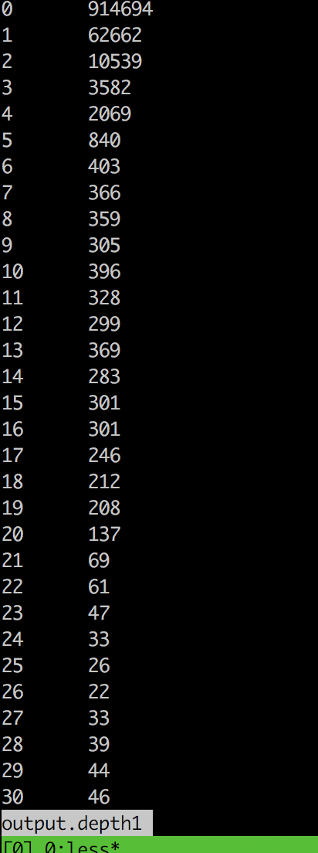

Base.Depth2.HistoGram.pl 输出为 output.depth2

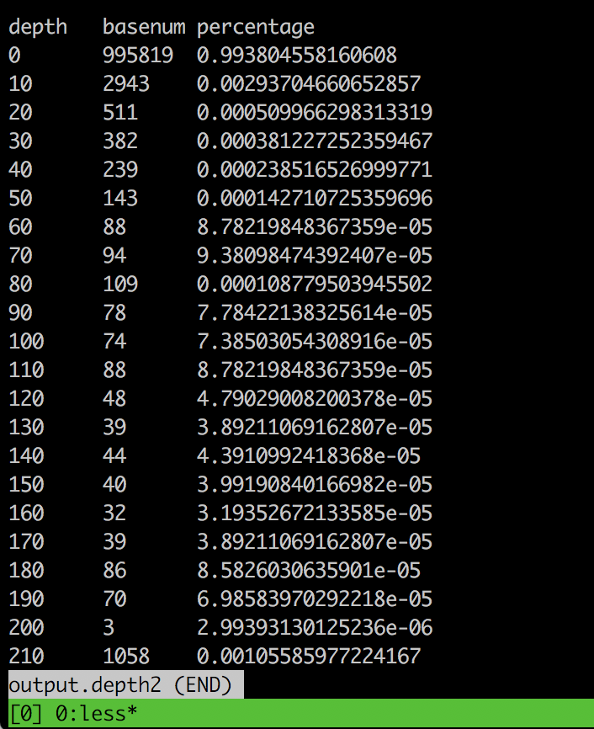

Base.Depth3.Mean.Depth.pl 输出为 genome_average_depth.txt

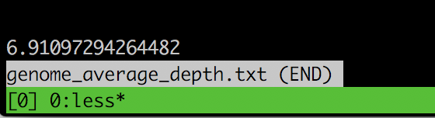

GC.Depth.pl 输出为 output.gc.depth

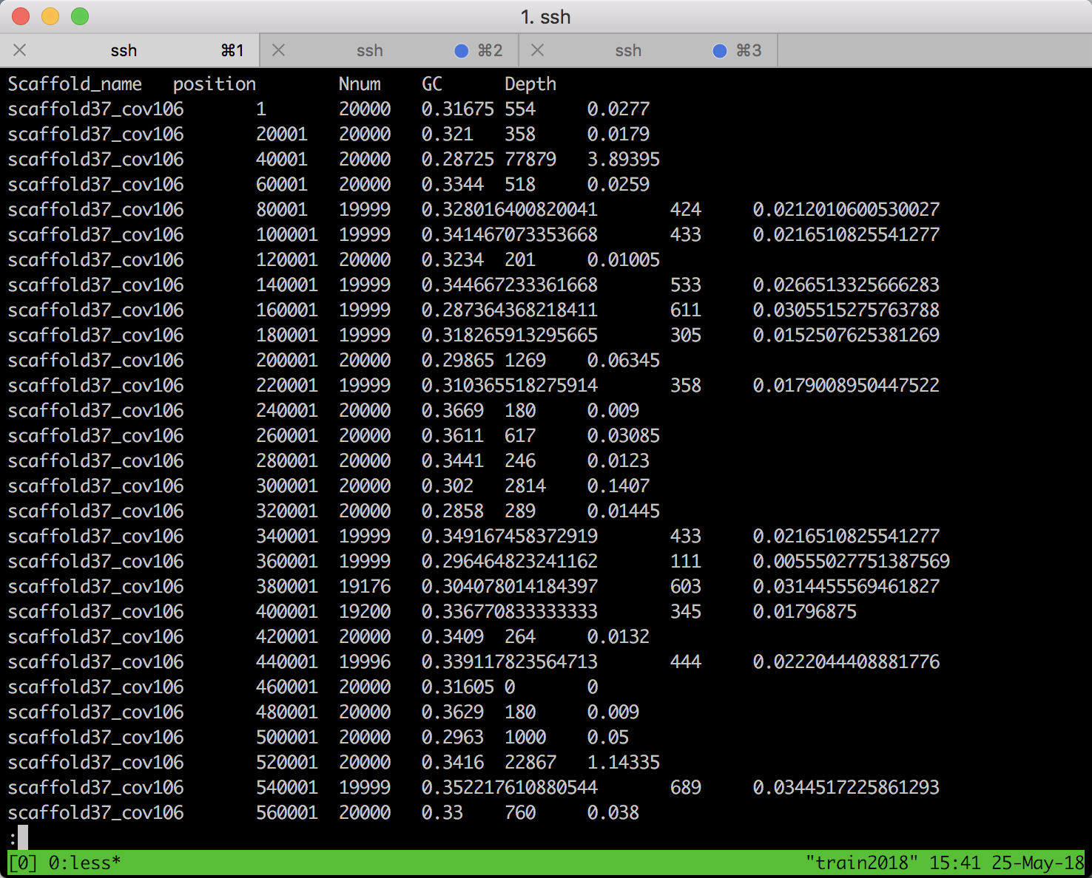

GC.contant.pl 输出为 gc.content.count

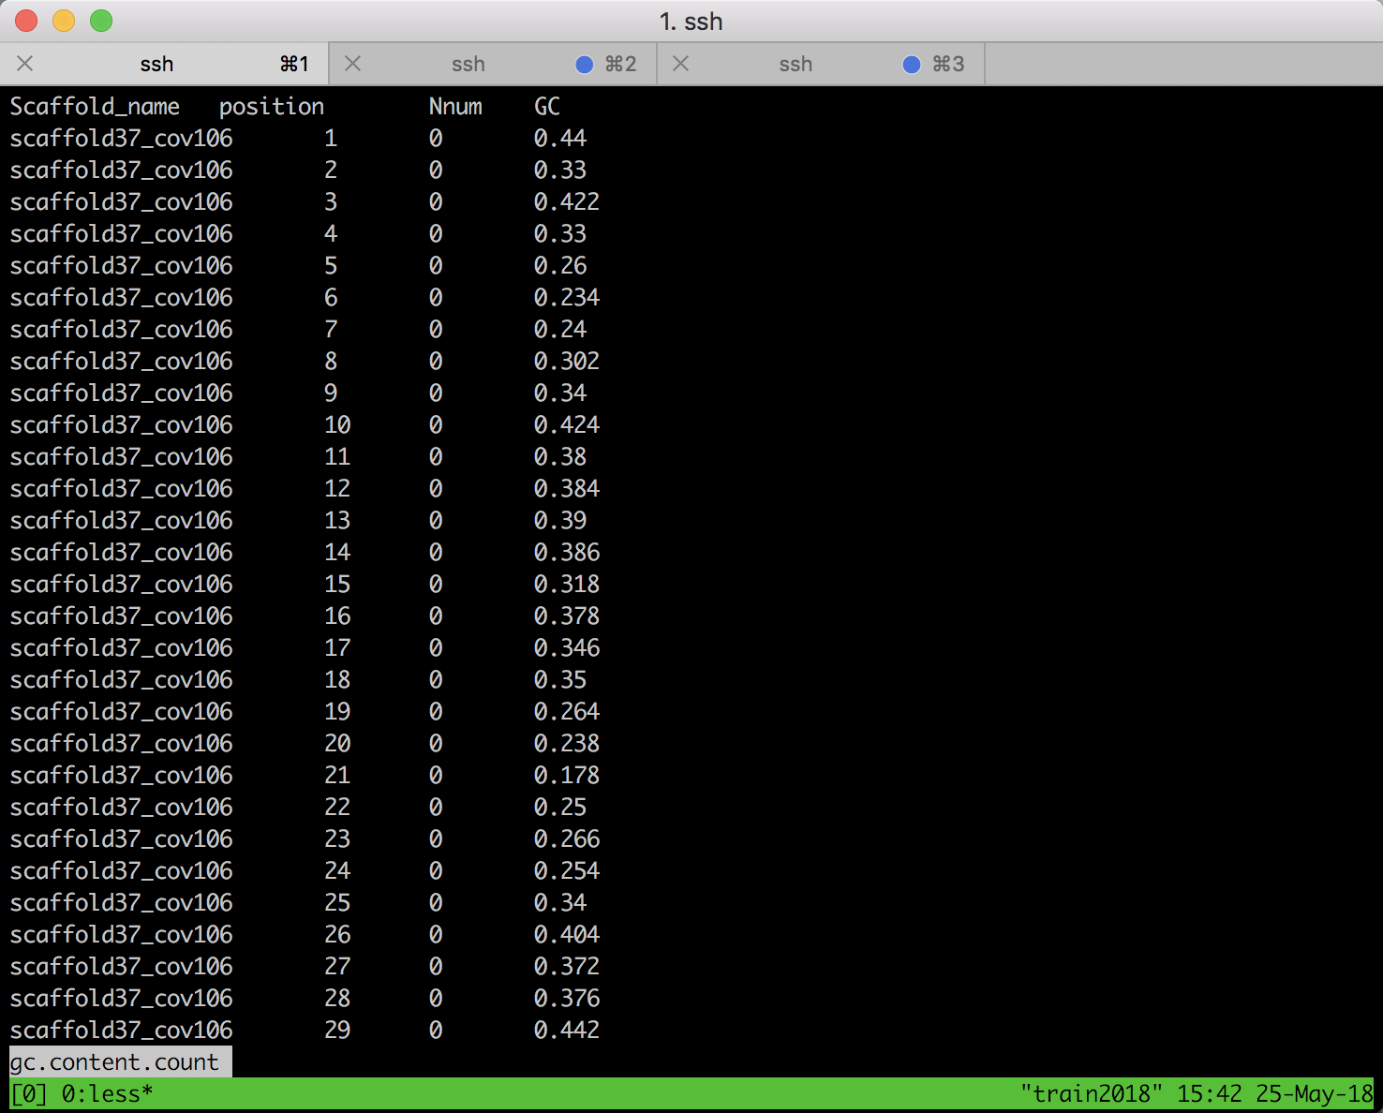

GenomeSize.pl 输出为 output.genomesize

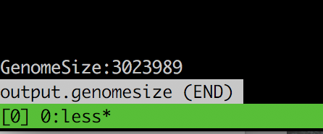

**/tmpdata/train128/snp**

DepthCoverage.pl 输出为 DepthCoverage.pl.count

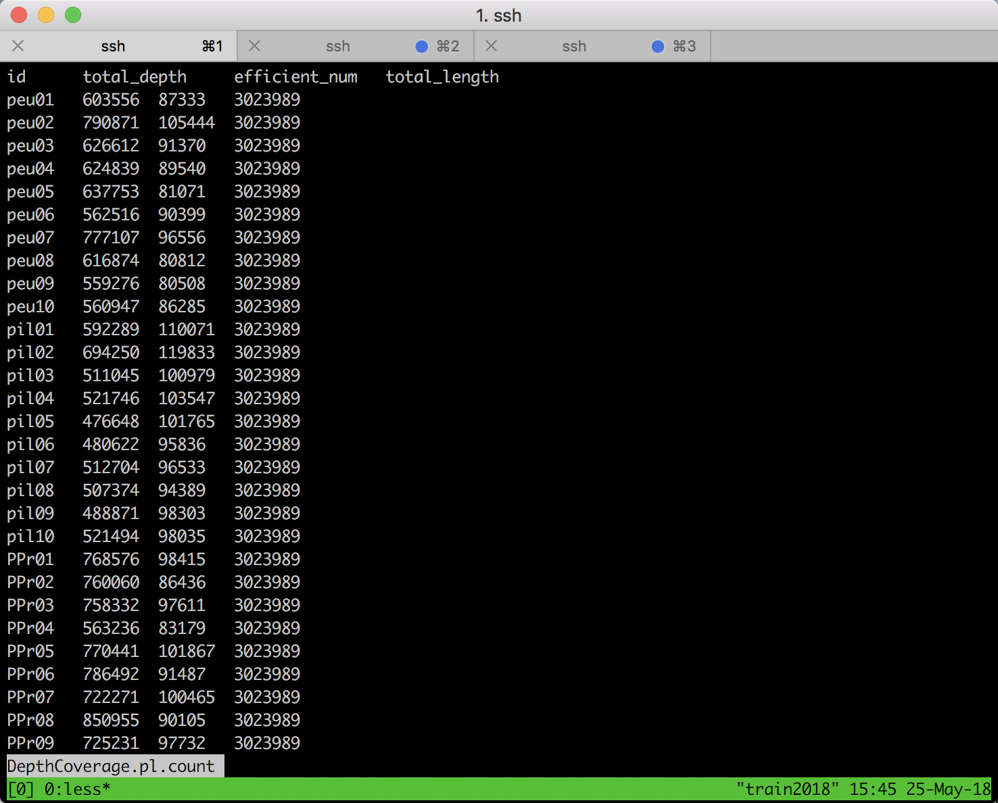

MapRatio.count.pl 输出为 MapRatio.count.pl.count

