第14周作业

袁梦 2015141494141

1. PCA分析

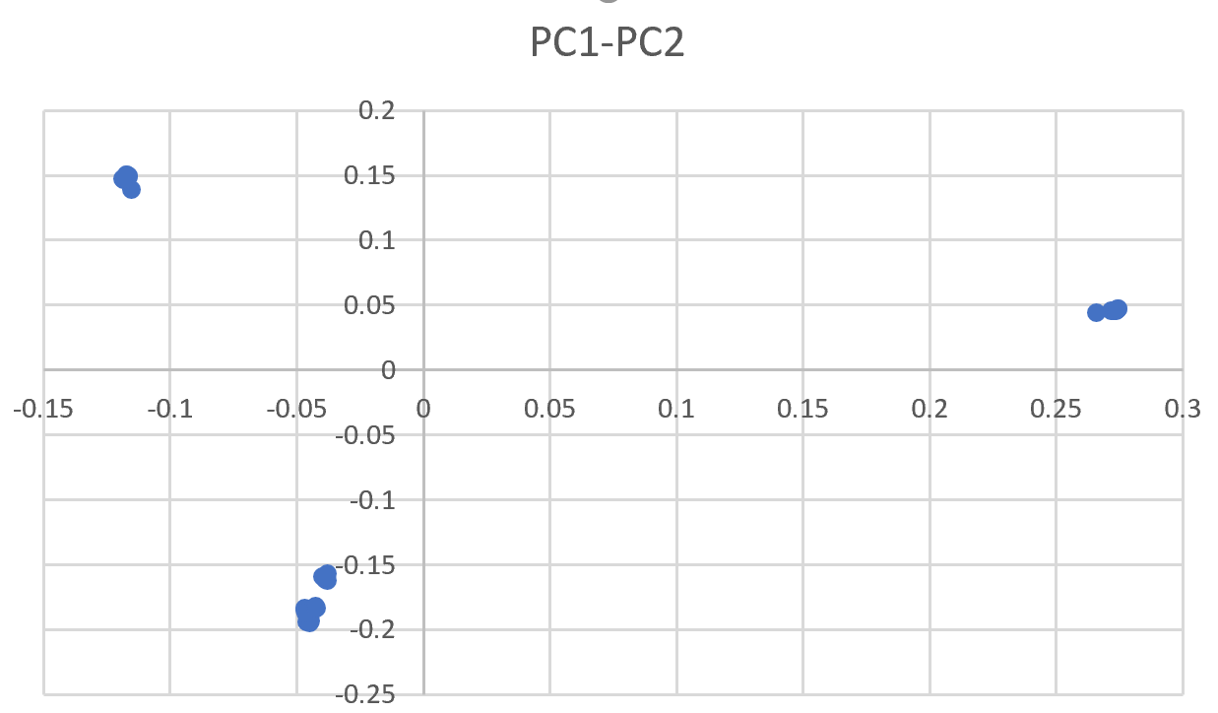

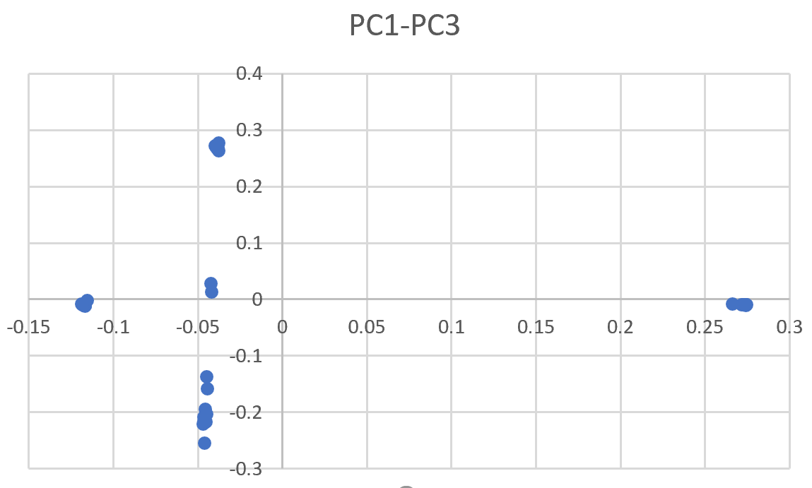

1. 结构分析

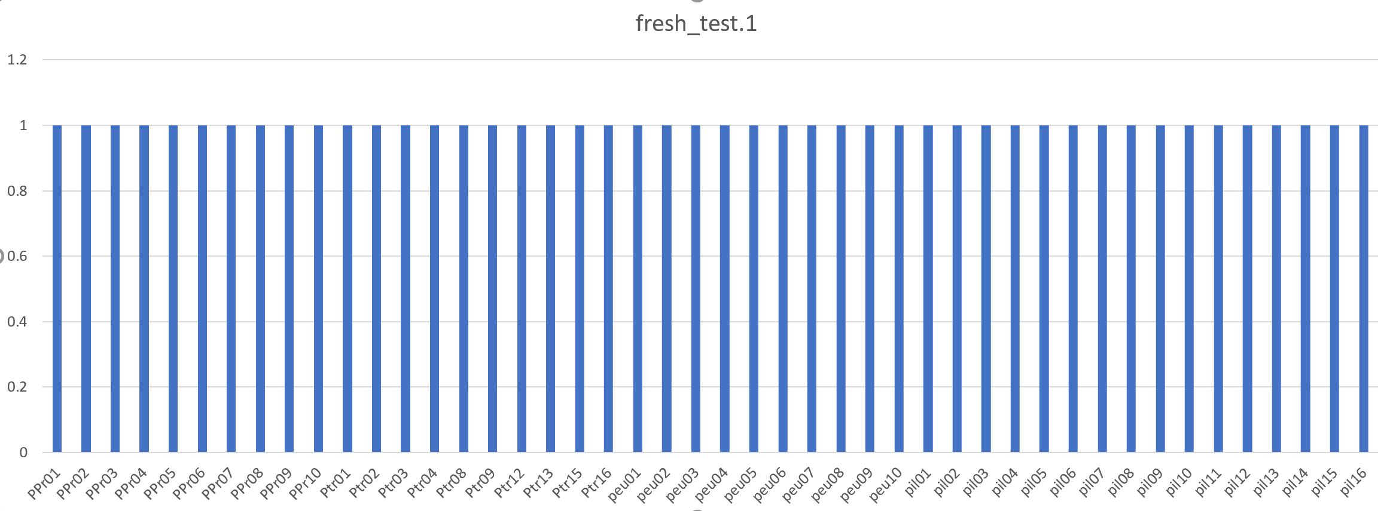

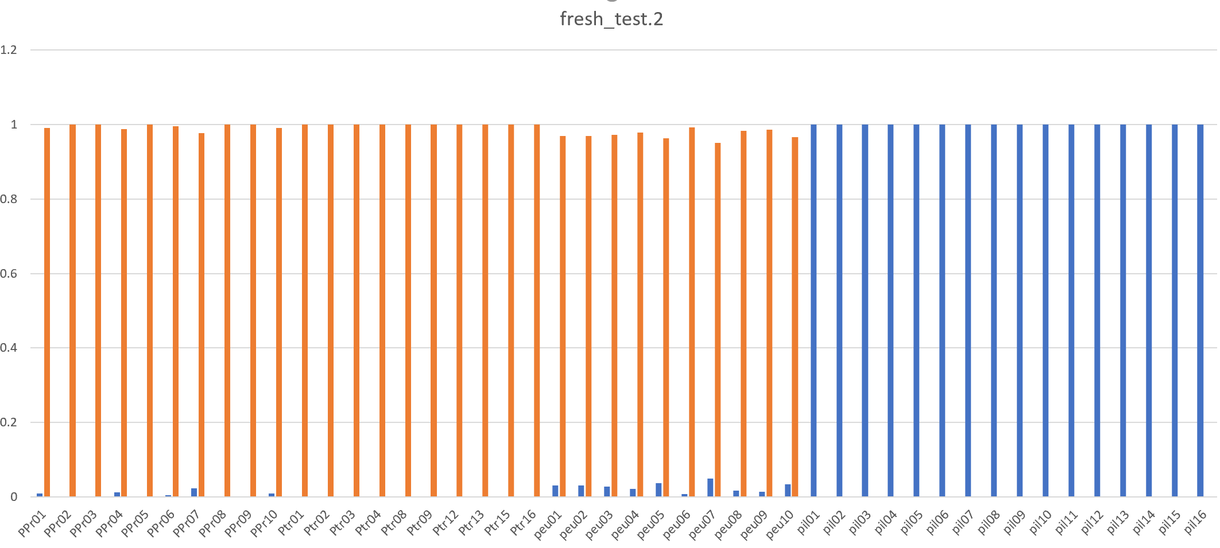

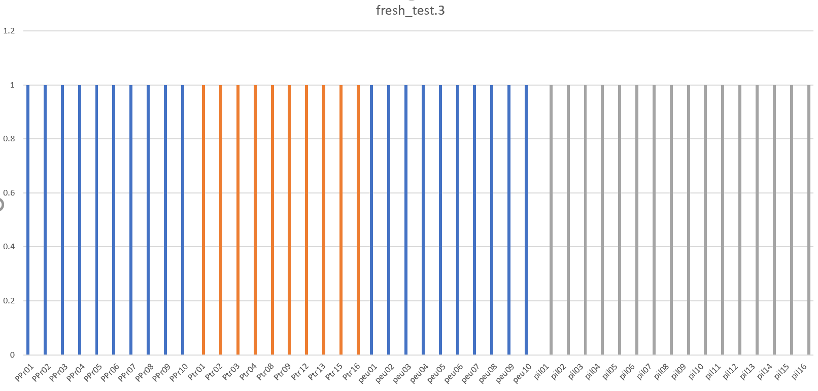

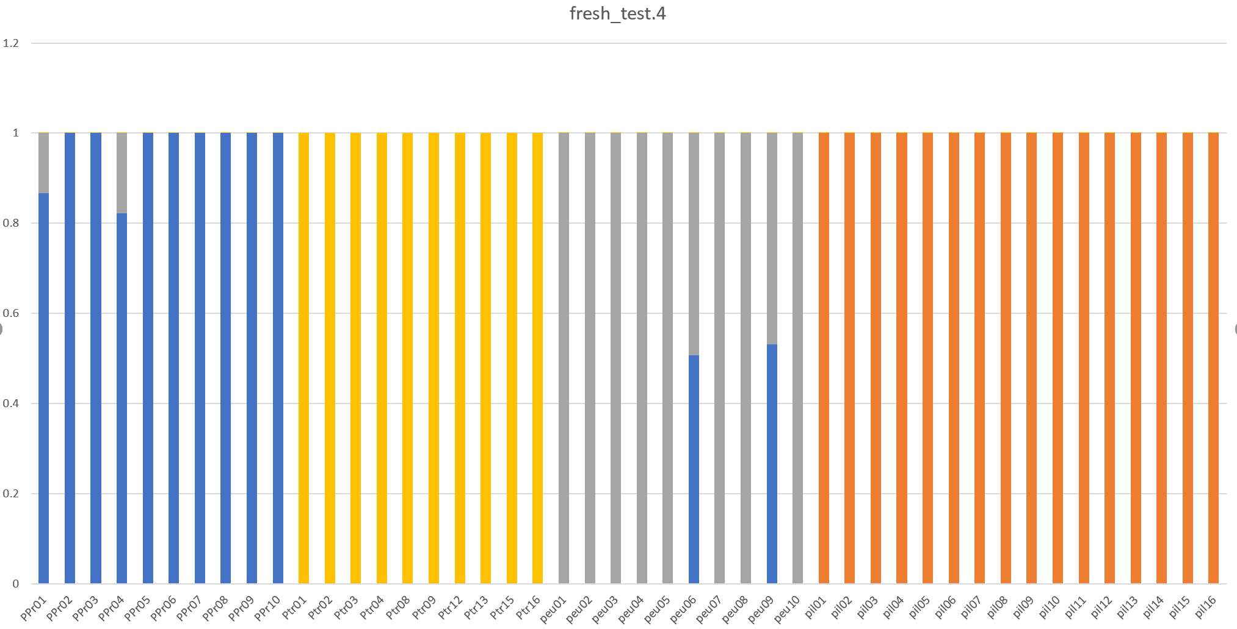

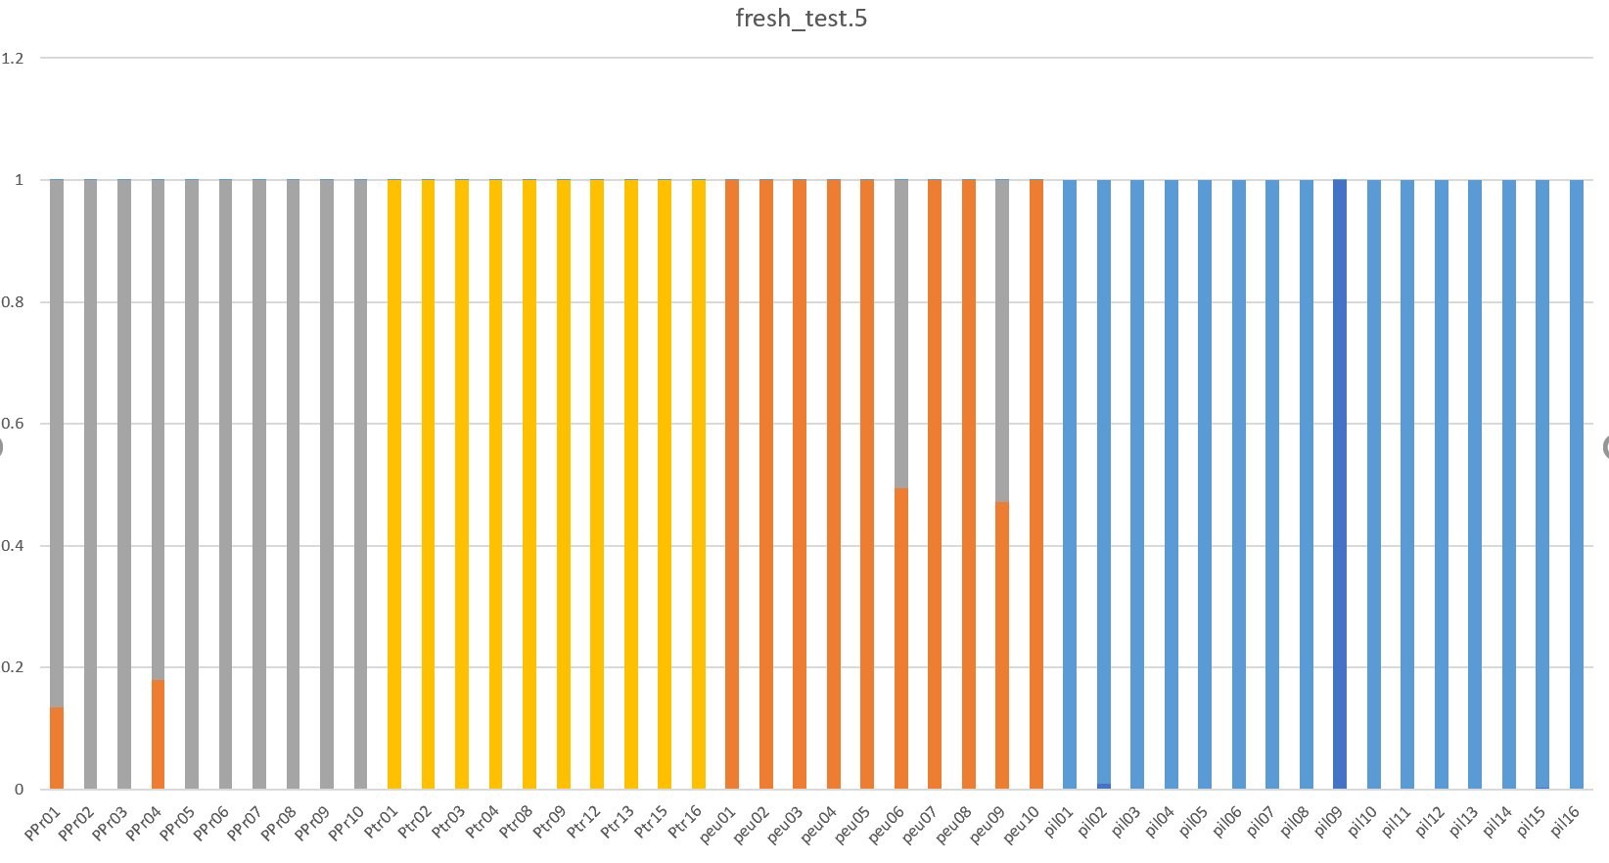

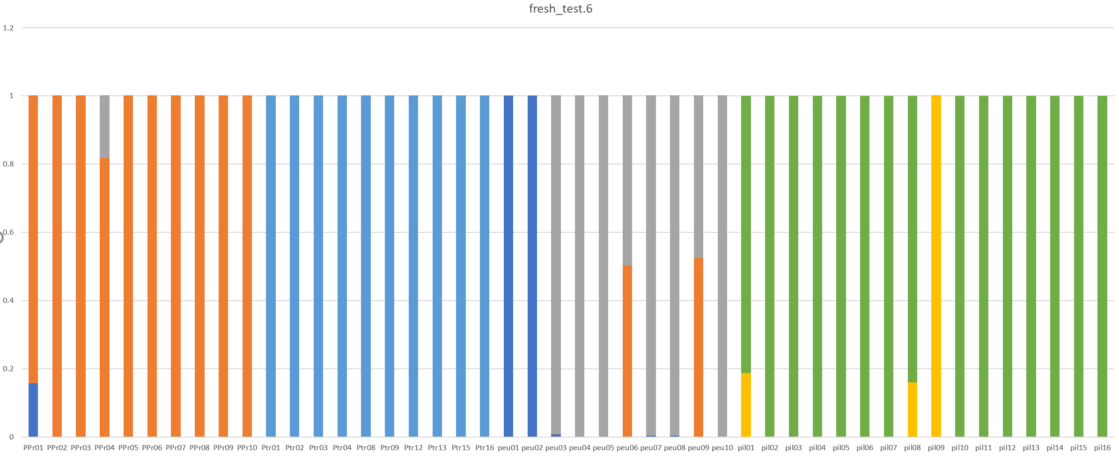

1. 构建NJ树

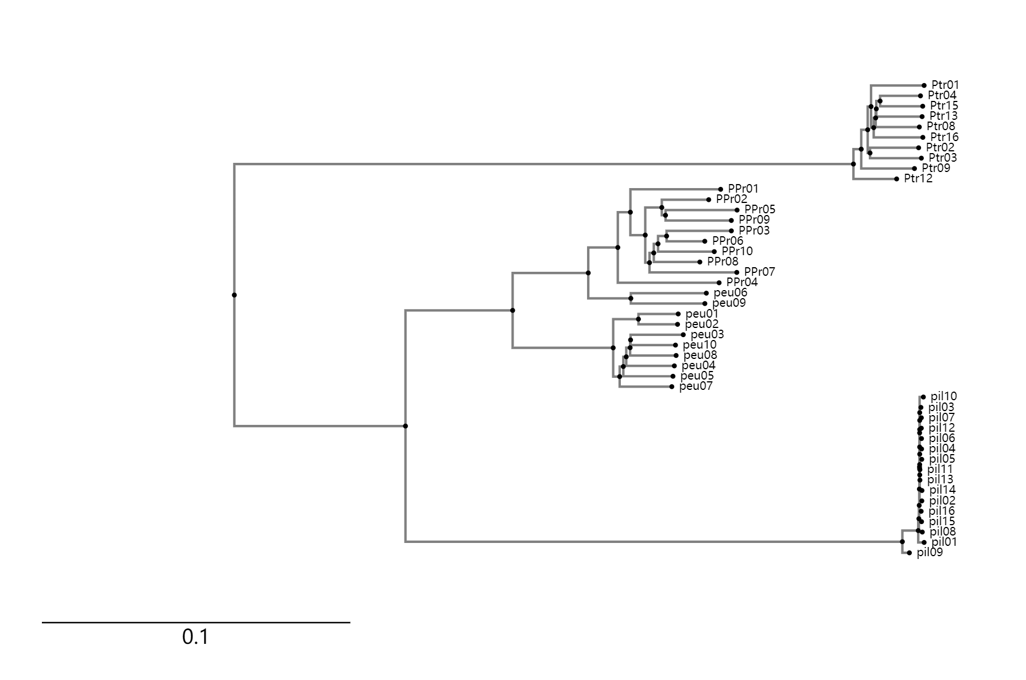

1. 计算Fst值

|  |  |  |  |  |
| --- | --- | --- | --- | --- |
| fst | ppr | ptr | peu | pil |
| ppr | - | 0.6659 | 0.3248 | 0.6876 |
| ptr | 0.6659 | - |  | 0.8366 |
| peu | 0.3248 | 0.6269 | - | 0.6412 |
| pil | 0.6876 | 0.8366 | 0.6412 | - |