
THE MEN OF ISSACHAR VISION INC.
presents

MIV STRATEGIC INITIATIVE
Institutional Profile & Strategic Operations Manual
Influencing Strategic Sectors for National Transformation

Academic Transformation · Business & Economic Development
Security & Uniformed Officers · Leadership & Governance
Leadership and Mission Centre, Olororo Junction, Ojoo, Ibadan, Oyo State, Nigeria
Edition One · 2026 · Prepared for Institutional & Partnership Use

TABLE OF CONTENTS
SECTION ONE — About MIV Strategic Initiative 5
1.1 Mission 5
1.2 Vision 5
1.3 Mandate 5
1.4 Core Values 5
1.5 Objectives 6
1.6 Strategic Philosophy 6
1.7 Kingdom Perspective 6
1.8 Why the Strategic Initiative Exists 7
1.9 The Societal Problems It Seeks to Solve 7
1.10 Why the Church Must Influence National Institutions 7
1.11 Our Long-Term Vision (A Ten- to Twenty-Year Horizon) 7
1.12 Strategic Pillars 7
1.13 Theory of Change 8
SECTION TWO — Men of Issachar Vision Inc. 9
2.1 Brief History 9
2.2 Founder and Spiritual Oversight 9
2.3 Vision and Mission 9
2.4 Core Ministry Expressions 10
2.5 National and International Impact 10
2.6 Why the Strategic Initiative Was Birthed 10
2.7 Relationship Between the Parent Ministry and the Initiative 10
SECTION THREE — The Story Behind the Vision 11
3.1 Leadership & Governance Engagement 11
3.2 Armed Forces & Security Leadership Vision 11
3.3 Expansion into Sector-Based Transformation 11
3.4 Armed Forces & Uniformed Officers Outreach (2025) 12
3.5 Academic Summit & Banquet (2025) 12
3.6 Business Summit 13
3.7 The Future 13
SECTION FOUR — Our Strategic Pillars 14
4.1 Academic Transformation 14
4.2 Business & Economic Development 14
4.3 Security & Uniformed Officers 14
4.4 Traditional & Royal Leadership 15
4.5 Leadership & Governance Engagement 15
4.6 Future Strategic Sectors 16
SECTION FIVE — Major Programmes 17
5.1 Royal Fathers' (Oba's) Conference 17
5.2 Armed Forces & Uniformed Officers Outreach 18
5.3 Academic Summit & Banquet 20
5.4 MIV Business Summit 21
SECTION SIX — Impact Reports 23
6.1 Impact at a Glance 23
6.2 Security & Uniformed Officers — Impact 23
6.3 Academic Transformation — Impact 24
6.4 Business & Economic Development — Impact 24
6.5 Traditional & Royal Leadership — Impact 25
6.6 Spiritual and Economic Outcomes 25
SECTION SEVEN — Organisational Structure 26
7.1 Governance Model 26
7.2 Leadership Organogram 26
7.3 Roles & Responsibilities 26
7.4 Strategic Outreach Committee — Membership 27
7.5 Decision-Making & Reporting Structure 27
SECTION EIGHT — Operations Manual 28
8.1 The Event Planning Cycle 28
8.2 Project & Programme Management 28
8.3 Risk Assessment & Safeguarding 28
8.4 Volunteer & Committee Management 28
8.5 Budgeting & Financial Requests 29
8.6 Media & Protocol 29
8.7 Correspondence Templates 29
8.8 Registration & Participant Management 29
8.9 Follow-Up & Continuing Engagement 29
8.10 Monitoring, Evaluation & Post-Event Reporting 29
8.11 Documentation & Knowledge Management 30
SECTION NINE — Communication & Mobilisation Strategy 31
9.1 Digital Presence 31
9.2 Direct & Institutional Channels 31
9.3 Brand Storytelling 31
9.4 Annual Communication Calendar 32
SECTION TEN — Financial Sustainability & Partnership Model 33
10.1 Current Financing Model 33
10.2 Long-Term Sustainability Strategy 33
10.3 Become a Strategic Partner 34
SECTION ELEVEN — Knowledge Base 36
11.1 Archive Index 36
11.2 Lessons Learned & Best Practices 36
11.3 Frequently Asked Questions 37
11.4 Institutional Memory 37

SECTION One
About MIV Strategic Initiative
The MIV Strategic Initiative exists to place transformed, discerning, Kingdom-minded influence at the tables where society's decisions are made — in classrooms and council chambers, in barracks and boardrooms — so that the institutions shaping Nigeria's future are shaped, in turn, by leaders of integrity.

1.1 Mission
To intentionally influence strategic sectors of society — academia, security, business, and governance — through Christ-centred transformation, ethical leadership development, and practical capacity building, so that institutions are strengthened, integrity is restored, and communities are positioned for sustainable development.

1.2 Vision
A society where the men and women who teach the next generation, defend the nation, build enterprise, and shape public policy are equipped in both character and competence — producing institutions of integrity, communities of dignity, and a nation that reflects excellence in every sphere of public life.

1.3 Mandate
The Men of Issachar Vision Inc. draws its name and calling from the sons of Issachar, described in Scripture as “men that had understanding of the times, to know what Israel ought to do” (1 Chronicles 12:32). The Strategic Initiative carries a specific expression of that same mandate: to understand the times confronting our nation's key institutions, and to provide the strategic engagement — spiritual, intellectual, and practical — that equips their leaders to fulfil their God-given responsibility to society.

1.4 Core Values
- Integrity. — We hold ourselves and our processes accountable to truth, transparency, and consistency, whether observed or unobserved.
- Excellence. — Every programme, document, and engagement is prepared with excellence, reflecting the seriousness of the audiences we serve.
- Discernment. — We approach every sector with wisdom, listening before we speak, and serving before we ask to be heard.
- Service. — Our influence is expressed first through service — practical support, welfare, and capacity building — before it is expressed in words.
- Compassion. — We hold the wellbeing of those we serve, including the vulnerable connected to strategic sectors, as a direct expression of our faith.
- Unity & Collaboration. — We work across denominational, institutional, and sectoral lines in pursuit of a shared national good.
- Innovation. — We continually adapt our strategies to reach each sector in the language, format, and rhythm that sector understands.

1.5 Objectives
- To convene strategic-sector leaders in settings of dignity, dialogue, and shared purpose.
- To model and mentor ethical leadership within academia, business, governance, and security institutions.
- To provide practical capacity building — leadership training, professional development, funding access, and vocational skills — that strengthens professional practice.
- To extend structured, compassionate welfare support to underserved groups connected to strategic sectors, such as widows of fallen security officers.
- To build sustainable, recurring platforms of engagement rather than isolated, one-off events.
- To cultivate a growing network of values-driven professionals who carry integrity into their institutions long after each programme ends.
- To document, measure, and transparently report the societal impact of every intervention.

1.6 Strategic Philosophy
The Strategic Initiative operates on a simple conviction: sustainable national transformation is not achieved by drawing society into the church, but by carrying the church's best values — integrity, service, excellence, and hope — into the rooms where society's decisions are already being made. Rather than organising general, open-audience crusades, the Initiative deliberately convenes specific, strategic constituencies — traditional rulers, security commanders, university leadership, and business professionals — in formats appropriate to each: banquets, summits, retreats, and welfare interventions.
This engagement is always substantive first. Every gathering delivers genuine professional value — leadership insight, institutional dialogue, funding access, or welfare support — so that participation is never merely tolerated, but sought after. Spiritual encounter is then offered generously, but never forced: through the personal testimony of the Convener and invited speakers, through dignified worship, and through the quiet witness of a well-run, excellently delivered programme.

1.7 Kingdom Perspective
We hold that no sector of society lies outside the concern of the Gospel. The counsel Joseph gave Pharaoh, and the wisdom Daniel brought to the courts of Babylon, models a Kingdom presence that serves at the highest levels of national life without compromise or fanfare. In the same spirit, the Strategic Initiative understands its work in the academy, the barracks, and the marketplace as a legitimate and necessary expression of ministry — not a departure from it.

1.8 Why the Strategic Initiative Exists
For over three decades, Men of Issachar Vision Inc. has laboured to reawaken the Church to her responsibility. In the course of that work, it became evident that reawakening within the four walls of the church, while foundational, does not by itself reach the tables where laws are written, curricula are set, budgets are allocated, and national security decisions are made. A nation's transformation requires that the Church's presence and values be carried directly to those tables. The Strategic Initiative was raised to do precisely that.

1.9 The Societal Problems It Seeks to Solve
- The erosion of integrity in public life and the institutions that depend on it.
- A widening disconnect between personal faith and professional practice across leadership sectors.
- Insufficient structured spiritual, moral, and welfare support for high-stress, high-sacrifice professions such as the armed and uniformed services.
- Underdeveloped entrepreneurial and economic capacity, limiting employment creation and national productivity.
- The absence of dignified, non-partisan spaces where leaders across sectors can be strengthened in character without political agenda.

1.10 Why the Church Must Influence National Institutions
Institutions reflect the character of the people who lead them. Where those who teach, judge, command, govern, and trade carry integrity, institutions endure; where they do not, institutions decay regardless of how well they are designed on paper. As custodian of biblical values concerning honesty, service, and the dignity of every person, the Church carries a responsibility that extends beyond her own congregation to the raising of leaders of integrity across every sphere of national life — not only within the clergy.

1.11 Our Long-Term Vision (A Ten- to Twenty-Year Horizon)
The Strategic Initiative envisions growing from an Oyo State-anchored platform into a nationally recognised convening ground where government institutions, academia, business leaders, security agencies, development partners, and faith communities collaborate toward a more ethical, prosperous, and transformed society. This includes the eventual establishment of dedicated scholarship and vocational-empowerment funds, an expanding footprint across additional Nigerian states, and structured, ongoing relationships — rather than single annual events — with each of the sectors we serve.

1.12 Strategic Pillars
At present, the Initiative concentrates its engagement across four confirmed pillars, with a fifth, cross-cutting emphasis on leadership and governance:
- Academic Transformation. — Reaching lecturers, administrators, and institutional leadership across tertiary institutions.
- Business & Economic Development. — Equipping Christian entrepreneurs and professionals with mentorship, funding access, and Kingdom business principles.
- Security & Uniformed Officers. — Ministering to and honouring officers across the armed and uniformed services, including structured welfare support for their families.
- Traditional & Royal Leadership. — Engaging traditional rulers, whose Royal Fathers' Conference calls custodians of culture to humility and dependence on God for wisdom in leadership.
Looking ahead, the Initiative anticipates the gradual, deliberate expansion of this model into further strategic sectors — including healthcare, technology, media, youth leadership, and public service — as capacity, partnership, and resourcing allow.

1.13 Theory of Change
The Initiative's model of impact follows a deliberate sequence, repeated across every sector it engages:
- Convene. — Bring sector leaders together in settings that honour their standing and invite genuine dialogue.
- Equip. — Deliver real professional and institutional value: leadership training, funding access, policy dialogue, and vocational skills.
- Encounter. — Offer, without coercion, the spiritual truth of the Gospel — through testimony, teaching, and worship woven naturally into the programme.
- Support. — Extend structured, verified compassionate assistance to those in genuine need within the sector, such as bereaved families.
- Sustain. — Maintain the relationship beyond the event through networks, follow-up, and recurring engagement.
- Multiply. — Trust that equipped, transformed leaders will carry integrity and renewed purpose back into the institutions they lead.
“We do not ask a nation's institutions to come to church. We bring the character of Christ to where those institutions already meet.”
— The guiding conviction of the MIV Strategic Initiative

SECTION Two
Men of Issachar Vision Inc. — An Overview
The MIV Strategic Initiative is not a stand-alone project. It is the strategic outreach expression of a ministry with more than three decades of history — Men of Issachar Vision Inc.

2.1 Brief History
Men of Issachar Vision Inc. was founded in January 1989 in Ojoo, Ibadan, Nigeria, under the leadership of Rev. Samson Ajetomobi, as a small community of believers committed to missions and the reawakening of the Church to her responsibility. Taking its name from the sons of Issachar — men “that had understanding of the times, to know what Israel ought to do” (1 Chronicles 12:32) — the ministry has grown over more than three decades into a multifaceted movement headquartered at the Leadership and Mission Centre, Olororo Junction, Ojoo, Ibadan, with active work spanning over nineteen countries across Africa, the Middle East, South America, North America, and Europe.

2.2 Founder and Spiritual Oversight
 | Rev. Samson Ajetomobi  Founder & President, Men of Issachar Vision Inc.  A trained Agricultural Engineer and certified Professional Manager (International Professional Managers Association, UK), Rev. Ajetomobi is also an alumnus of the Haggai Institute (Maui, U.S.A.) and Overseer of the Redemption Faith Churches. Since 2023 he has served as Chairman of the Pentecostal Fellowship of Nigeria (PFN), Oyo State Chapter. He is the author of Not Offended, Running Well, and The Light Bearers.

 | Rev. (Mrs) Stella Ajetomobi  Vice President, Men of Issachar Vision Inc.  Rev. Stella holds a Master's degree in Personnel Psychology and hosts Back to Bethel Retreats for ministers' wives and elect ladies. She coordinates the Divine Well Global Foundation and is the author of Dressing for Your Destination, Solitude, and Bridging the Gap.

2.3 Vision and Mission
Men of Issachar Vision Inc. exists to reawaken the Church to her responsibility, especially through her leaders, and to reach the unreached at all cost. Its work is anchored on two enduring themes — awakening and missions — reflecting an understanding of the times the Church now finds herself in, and a conviction about what she ought to do in response.

2.4 Core Ministry Expressions
Over three decades, the ministry has developed a range of expressions in pursuit of this vision, including Leadership and Mission Conferences, the Family Life Conference, Alone with God prayer retreats, Back to Bethel Retreats, and Campus and Corpers' Repositioning outreaches (CaRe and CoRe) to Christian communities in institutions of higher learning and among national youth service corps members. The ministry's commitment to holistic community impact is further reflected in the establishment of the Issachar Medical Center and the Issachar Vision International Schools.

2.5 National and International Impact
From its beginnings as a small gathering of believers in Ojoo, Ibadan, the ministry's reach now extends to active work in more than nineteen nations across Africa, the Middle East, South America, North America, and Europe, with decades invested in raising ministers, missionaries, and leaders across denominational lines.

2.6 Why the Strategic Initiative Was Birthed
As the ministry's reawakening work matured, its leadership recognised that sustainable transformation required more than gathering believers — it required deliberately engaging the specific sectors and institutions that shape national life. This recognition, developed over years of engaging professionals and leaders beyond the four walls of the church, gave rise to what is now the MIV Strategic Initiative.

2.7 Relationship Between the Parent Ministry and the Strategic Initiative
The MIV Strategic Initiative operates as the strategic outreach arm of Men of Issachar Vision Inc., carrying the same values, spiritual covering, and ultimate vision as the parent ministry, while focusing specifically on strategic-sector engagement. Rev. Samson Ajetomobi, Founder and President of Men of Issachar Vision Inc., remains the Visioneer and provides continued spiritual oversight and strategic direction for the Initiative, which is coordinated day-to-day by a dedicated leadership team led by Arch. Lola Olufemi Oyenekan (General Supervising Leader) and Mr Victor Idowu (MIV Strategic Initiative Coordinator), supported by a broader Strategic Outreach Committee.

SECTION Three
The Story Behind the Vision
The story of the MIV Strategic Initiative did not begin in 2025. It is the outworking of a burden that God laid upon the Founder of Men of Issachar Vision Inc., Rev. Samson Ajetomobi, many years ago — to intentionally influence strategic sectors of society beyond the four walls of the church.
From its earliest expressions, the vision has always been to combine spiritual transformation with practical national development, by engaging the leaders, professionals, and institutions whose decisions shape society.

3.1 Leadership & Governance Engagement
Several years before the current Strategic Initiative structure was established, Men of Issachar Vision Inc. convened Leadership Development gatherings that brought together legal practitioners, public office holders, and professionals to discuss ethical leadership, governance, and nation-building from a Kingdom perspective.
One of these gatherings featured Prof. Yemi Osinbajo (SAN), who participated as a speaker and contributor to conversations on leadership and national transformation. The purpose of these meetings was never political engagement, but the encouragement of principled leadership, integrity, and national development through Biblical values.

3.2 Armed Forces & Security Leadership Vision
Around six years before the 2025 Armed Forces & Uniformed Officers Outreach, Men of Issachar Vision Inc. organised a strategic summit for senior officers of the Armed Forces and other security institutions at Premier Hotel, Ibadan.
According to Rev. Samson Ajetomobi's account, General Henry coordinated the participation of senior military officers, while General Christopher Kolade shared his personal experience of leadership, service, and God's faithfulness throughout his career. The gathering encouraged officers to remain committed to integrity, national service, and godly leadership.
This earlier programme became the foundation upon which the present Armed Forces & Uniformed Officers Outreach was later built.

3.3 Expansion into Sector-Based Transformation
Having witnessed the impact of engaging leaders within government and the security sector, the ministry recognised that sustainable national transformation required intentional engagement across multiple sectors. Rather than organising general conferences, the ministry adopted a sector-based strategy, focused on influencing the specific institutions that shape society.
This is what eventually evolved into what is now known as the MIV Strategic Initiative, presently focused on strategic engagement in:
- Academia and Higher Education
- Security and Uniformed Services
- Business and Entrepreneurship
- Leadership Development
- Public Policy and Governance
— with future plans to expand into additional strategic sectors as capacity and partnership allow.

3.4 Armed Forces & Uniformed Officers Outreach (2025)
In 2025, the ministry relaunched this vision through the Armed Forces & Uniformed Officers Outreach, bringing together officers from multiple security agencies for spiritual encouragement, leadership development, welfare appreciation, and practical support.

Official event flyer — Exclusive Event for Men of the Armed Forces and Uniform Officers, showing the participating security agencies.
The programme affirmed the ministry's commitment to serving those who dedicate their lives to national security, while also introducing long-term welfare initiatives — including a Widows of Fallen Officers Support & Empowerment Project, providing verified, needs-based financial assistance and vocational training toward sustainable livelihoods for the bereaved families of officers who paid the ultimate price in service to the nation.

3.5 Academic Summit & Banquet (2025)
Building on the momentum of the security outreach, the ministry inaugurated the Academic Summit & Banquet, under the theme Building Extraordinary Legacy Towards Academic Excellence. The summit brought together Vice-Chancellors, Professors, academic administrators, lecturers, and management staff from tertiary institutions across Oyo State to discuss leadership excellence, educational policy, institutional transformation, and global competitiveness.
The gathering marked the beginning of the ministry's long-term commitment to strengthening Nigeria's higher-education sector through values-based leadership and strategic collaboration.

3.6 Business Summit
Recognising that economic transformation is essential to societal development, the ministry established the MIV Business Summit. The Summit seeks to equip entrepreneurs, professionals, and business leaders with practical knowledge, mentorship, funding opportunities, and strategic networks, while integrating Biblical principles of stewardship, integrity, and enterprise.
Its vision extends beyond wealth creation, toward building businesses that generate employment, strengthen communities, and contribute meaningfully to national development.

3.7 The Future
Today, the MIV Strategic Initiative exists as the strategic outreach expression of Men of Issachar Vision Inc., carrying a long-term vision of influencing strategic sectors through leadership development, spiritual transformation, policy engagement, entrepreneurship, and collaborative partnership.
The Initiative seeks to become a nationally recognised platform where government institutions, academia, business leaders, security agencies, development partners, and faith communities collaborate to build a more ethical, prosperous, and transformed society.

SECTION Four
Our Strategic Pillars
Each pillar represents a distinct strategic sector — chosen not at random, but because of the disproportionate influence its leaders hold over the character of the nation.

4.1 Academic Transformation
Universities, polytechnics, and colleges of education shape the convictions of every future professional who passes through them. A generation is only as strong as the integrity of those who teach and administer its institutions of learning. Scripturally, this reflects the calling of the teacher and the elder to “train up a child in the way he should go” (Proverbs 22:6) — a mandate that extends from the home to the lecture hall. Nationally, the strength of Nigeria's higher-education sector directly determines the quality of the doctors, engineers, administrators, and thinkers it produces for decades to come.
Through the Academic Summit & Banquet, the Initiative engages lecturers and non-academic management staff of tertiary institutions in a strategic, dignified setting — addressing leadership, legacy, and institutional excellence.

4.2 Business & Economic Development
Entrepreneurship and enterprise are the engine of employment and national productivity. Where business leaders operate with integrity, stewardship, and vision, communities are strengthened economically and socially. This reflects the Biblical model of the diligent steward who multiplies what is entrusted to them (Matthew 25:14-30) for the benefit of others, not only themselves. Nationally, a growing base of ethical, Kingdom-minded entrepreneurs directly addresses unemployment, capital flight, and the erosion of business ethics.
Through the MIV Business Summit, the Initiative equips Christian entrepreneurs and professionals with mentorship, funding access, and Kingdom business principles, including a dedicated Pitch Competition and Vendor Exhibition designed to translate inspiration into practical, fundable enterprise.

4.3 Security & Uniformed Officers
Those who serve in the armed and uniformed services carry the weight of national security, often at extraordinary personal cost. Their moral discipline, courage, and sense of justice directly shape public safety and civic order. Scripturally, this reflects honour due “to whom honour” is owed (Romans 13:7), and God's own concern for the defence of the vulnerable through those who bear the sword in service of justice (Romans 13:4). Nationally, a security sector strengthened in integrity and morale directly improves public trust and safety.
Through the Armed Forces & Uniformed Officers Outreach, the Initiative ministers to and honours officers across multiple security agencies, extending discipleship, leadership training, and structured welfare support — including a dedicated empowerment project for widows of fallen officers.

4.4 Traditional & Royal Leadership
Nigeria's traditional institutions remain custodians of culture, land, and community cohesion, wielding moral authority that often outlasts political administrations. Traditional rulers who lead with humility before God model a form of leadership rooted in service rather than self-interest — echoing the Biblical picture of the king who “shall not multiply... nor greatly multiply to himself silver and gold” but shall govern in the fear of the Lord (Deuteronomy 17:16-20). Nationally, traditional rulers remain uniquely positioned to influence peace, unity, and community development at the grassroots.
Through the Royal Fathers' (Oba's) Conference, the Initiative convenes traditional rulers in an atmosphere of worship and humility, where they set aside the symbols of office to pray for wisdom to lead their people with integrity, peace, and compassion.
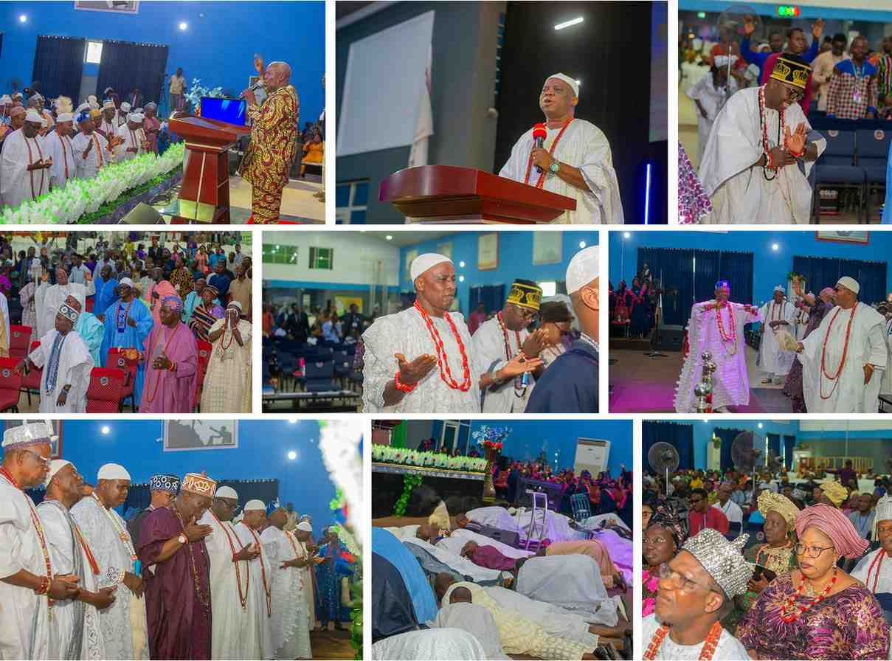
Traditional rulers in worship and prayer at the Royal Fathers' (Oba's) Conference.

4.5 Leadership & Governance Engagement
Threading through every pillar is a deeper, cross-cutting concern: the character of those who govern. Long before the present four pillars took shape, Men of Issachar Vision Inc. convened Leadership Development gatherings bringing together legal practitioners, public office holders, and professionals to discuss ethical leadership, governance, and nation-building from a Kingdom perspective — including a gathering that featured Prof. Yemi Osinbajo (SAN) as a speaker and contributor. This continuing conviction — that principled leadership is the single greatest lever for national transformation — remains foundational to how the Initiative approaches every sector it engages.

4.6 Future Strategic Sectors
As the Initiative matures and partnerships deepen, its leadership anticipates the deliberate, gradual expansion of this sector-based model into further strategic spheres of national life, including:
- Healthcare. — strengthening ethical practice and compassionate service among medical professionals and institutions.
- Technology & AI. — engaging innovators and technologists shaping how the nation works, learns, and communicates.
- Media. — partnering with journalists, broadcasters, and content creators who shape public narrative and discourse.
- Youth Leadership. — raising the next generation of leaders before they inherit positions of national influence.
- Public Service. — encouraging integrity and service excellence among civil servants and public institutions.
- International Partnerships. — forging relationships with like-minded ministries, foundations, and development partners beyond Nigeria's borders.
PLACEHOLDER — TO BE COMPLETED BY MIV STRATEGIC INITIATIVE Specific launch timelines, target institutions, and programme formats for these future sectors are to be developed as the Initiative's capacity and partnerships expand.

SECTION Five
Major Programmes
Each of the following programmes is the practical, on-the-ground expression of a strategic pillar — where vision becomes a gathering, a conversation, and a measurable act of service.

5.1 Royal Fathers' (Oba's) Conference
Pillar | Traditional & Royal Leadership
Target Audience | Traditional Rulers (Obas) and their chiefs
Format | Conference gathering centred on worship, prayer, and teaching
History / Frequency | [to be confirmed]
Attendance | [to be confirmed]

Purpose & Objectives
To create a dignified, reverent space in which traditional rulers set aside the symbols of title and earthly authority to worship God, express dependence on Him as the true source of wisdom, and pray for grace to lead their people with integrity, peace, and compassion.

Key Sessions
Corporate worship, times of prayer and consecration, and a teaching session addressing godly leadership from a traditional-ruler's perspective. Photographic records show royal fathers, in full regalia, standing in postures of humility, prayer, and personal consecration before God.

Scenes from the Royal Fathers' (Oba's) Conference — worship, prayer, and fellowship among traditional rulers.

Impact
PLACEHOLDER — TO BE COMPLETED BY MIV STRATEGIC INITIATIVE exact attendance figures, list of represented royal domains, and any recorded testimonies or outcomes from the Conference.

Media Coverage
PLACEHOLDER — TO BE COMPLETED BY MIV STRATEGIC INITIATIVE press or media coverage references, if any, for this programme.

Lessons Learned & Future Improvements
PLACEHOLDER — TO BE COMPLETED BY MIV STRATEGIC INITIATIVE post-event review notes and plans for future editions.

5.2 Armed Forces & Uniformed Officers Outreach
Pillar | Security & Uniformed Officers
Target Audience | Officers of the Armed Forces and uniformed security agencies, Oyo State and beyond
Coordinator | Mr Victor Idowu
1st Edition — Agencies Represented | 9 security agencies
2nd Edition (2025) — Agencies Represented | 17 security agencies
Most Recent Attendance | 400+ participants
Special Initiative | Widows of Fallen Officers Support & Empowerment Project

History
This outreach traces its roots to a strategic summit for senior Armed Forces and security officers held at Premier Hotel, Ibadan, several years prior, coordinated with the support of General Henry and featuring the testimony of General Christopher Kolade. It was relaunched in its present form in 2025 as an annual Armed Forces & Uniformed Officers Outreach.

Purpose & Objectives
To bring the Gospel, discipleship, leadership training, and dignified appreciation to men and women who serve in the Armed Forces and uniformed security agencies — strengthening their faith, moral discipline, and commitment to justice, while extending practical support to their families.

Programme Structure & Key Sessions
The outreach combines a ministry-of-the-Word session, discipleship and leadership content, and a formal welcome and honouring of Chaplains, Commanders, and Officers in attendance. It is followed by continuing, structured engagement — most notably the Widows of Fallen Officers Support & Empowerment Project, which extends verified, needs-based financial assistance and up to three months of vocational training (tailoring, catering, confectioneries, fascinator making, caregiving, and knitting) to selected widows, following a formal nomination, interview, and monitoring process designed to ensure support reaches those in genuine need.

Official flyer for the Armed Forces & Uniformed Officers Outreach, showing the participating security agencies.

Impact
Growth from 9 security agencies represented at the outreach's first edition to 17 agencies at its 2025 edition reflects both increasing institutional trust and the widening reach of the programme, alongside the introduction of the Widows' Empowerment Project as a tangible, sustained form of care beyond the event itself.

Testimonials / Budget Summary / Media Coverage
PLACEHOLDER — TO BE COMPLETED BY MIV STRATEGIC INITIATIVE officer and widow testimonials, a formal budget summary for the outreach, and any press or media coverage references.

Lessons Learned & Future Improvements
The Widows' Empowerment Project's rigorous, interview-based verification process was itself shaped by an important lesson learned: an earlier instance in which a donated sewing machine intended for a widow's livelihood was resold rather than used. This has informed a deliberately more practical, accountable, and monitored approach to future welfare support.

5.3 Academic Summit & Banquet
Pillar | Academic Transformation
Theme | Building Extraordinary Legacy Towards Academic Excellence
Maiden Edition | 16 August 2025, 10:00 a.m. – 1:00 p.m.
Venue | Leadership Conference Centre, Olororo Junction, Ojoo, Ibadan
Target Audience | Lecturers and non-academic management staff of tertiary institutions
In-Person Attendance | 200+ academic leaders across Oyo State and beyond
Online Reach | 800+ viewers via Facebook and YouTube livestream

Purpose & Objectives
To address pressing challenges in leadership, legacy, and institutional excellence facing Nigeria's tertiary institutions, equipping educators and administrators to thrive both professionally and spiritually as gatekeepers of society, shaping the next generation for Christ and for national development.

Speakers
- Mrs Didi Walson-Jack — Head of Civil Service of the Federation
- Emeritus Prof. A.O. Ogunkunle — Chairman, Governing Council, Emmanuel Alayande University
- Prof. Kayode Adebowale — Vice-Chancellor, University of Ibadan
- Prof. Razzaq Rom Kalilu — Vice-Chancellor, Ladoke Akintola University of Technology (LAUTECH)
- Prof. O.S. Olufemi — Nanotechnology expert, University of Johannesburg

Programme Positioning
The Summit has been deliberately positioned as purpose-driven rather than political: “Is this event political? No. This summit is purpose-driven and policy-free.” This framing has been central to its ability to draw senior academic leadership across institutional and denominational lines.

Impact
The maiden edition drew over 200 academic leaders in person, drawn from tertiary institutions across Oyo State and beyond, with a further 800-plus reached through Facebook and YouTube — a combined footprint of over 1,000 members of the academic community engaged in a single edition.

Testimonials / Budget Summary / Media Coverage
PLACEHOLDER — TO BE COMPLETED BY MIV STRATEGIC INITIATIVE participant testimonials, a formal budget summary, and detailed press or media coverage references beyond the official livestream.

Lessons Learned & Future Improvements
PLACEHOLDER — TO BE COMPLETED BY MIV STRATEGIC INITIATIVE post-event review notes and specific plans for the next edition.

5.4 MIV Business Summit
Pillar | Business & Economic Development
Edition | MBS 1.0 — an in-house edition for ministry members, preceding a planned MBS 2.0 open to the wider public
Dates | Friday 5 – Saturday 6 December 2025
Target Audience | Christian entrepreneurs, professionals, business owners, and young business leaders
Exhibition Reach | Positioned before 1,500+ Christian entrepreneurs, investors, and professionals
Pitch Competition Prize | Seed funding of up to ₦1,000,000

Purpose & Objectives
To activate and establish a generation of Kingdom-minded wealth creators — equipping Christian entrepreneurs, professionals, and business owners with strategic insight, practical skills, mentorship, and funding access needed to thrive in today's economy, while integrating Biblical principles of stewardship, integrity, and enterprise.

Speakers & Hosts
- Rev. Samson Ajetomobi — Host
- Rev. (Mrs) Stella Ajetomobi — Co-Host
- Dr Oluwole Ajayi — CEO, Omak Group
- Mr Makinde Olaolu — Managing Director, Adebisi Foods Ventures
- Mr Bimbo Olatunji — Keynote Speaker

Programme Structure
Day One (Friday, 5 December 2025): Arrival, Registration & Red Carpet; Welcome Address; Keynote Presentation; Panel Session; Cultural Dance; Business & Finance Management Workshop; Networking & Business Card Exchange.
Day Two (Saturday, 6 December 2025): Keynote Presentation — Spiritual Keys for Kingdom Wealth; Masterclass on Loan, Funding & Investment Opportunities; Highlife Music by the MIV Choir; Breakout Sessions; Panel Discussions; Pitch Competition Grand Finale; Awards & Recognition of Impactful Business Leaders; Prophetic Impartation for Kingdom Wealth, ministered by Rev. (Mrs) Stella Ajetomobi.

Supporting Components
- Pitch Competition. — a mentorship-driven pitching platform connecting entrepreneurs directly with investors, offering seed funding of up to ₦1,000,000.
- Vendor Exhibition. — a business exhibition positioning vendors' brands and products before a highly motivated audience of 1,500-plus Christian entrepreneurs, investors, and professionals.
- Webinar Series. — ongoing webinars/seminars extending the Summit's business teaching beyond the two-day event.

Impact
PLACEHOLDER — TO BE COMPLETED BY MIV STRATEGIC INITIATIVE verified attendance, speaker/mentor counts, exhibition booth numbers, and pitch competition outcomes for MBS 1.0 (the Summit's own published statistics are not yet finalised).

Testimonials / Budget Summary / Media Coverage
PLACEHOLDER — TO BE COMPLETED BY MIV STRATEGIC INITIATIVE participant testimonials, a formal budget summary, and press or media coverage references.

Lessons Learned & Future Improvements
MBS 1.0 was deliberately run as an in-house edition for ministry members, to test and refine the Summit's format ahead of a planned MBS 2.0 open to the wider public — a staged approach intended to strengthen execution before expanding audience and scale.

SECTION Six
Impact Reports
Impact is reported here exactly as it is verified — no figure in this section has been estimated or rounded upward for effect. Where a number is not yet available, that is stated plainly rather than filled in.

6.1 Impact at a Glance
Security Agencies Engaged | Grown from 9 (1st Edition) to 17 (2nd Edition, 2025)
Armed Forces Outreach Attendance | 400+ officers (most recent gathering)
Academic Summit — In-Person | 200+ academic leaders (maiden edition, Aug 2025)
Academic Summit — Online Reach | 800+ via Facebook and YouTube
Business Summit Exhibition Reach | Positioned before 1,500+ Christian entrepreneurs, investors, and professionals
Widows' Empowerment Project | Launched 2025 — verified nomination and vocational-training process now active

6.2 Security & Uniformed Officers — Impact
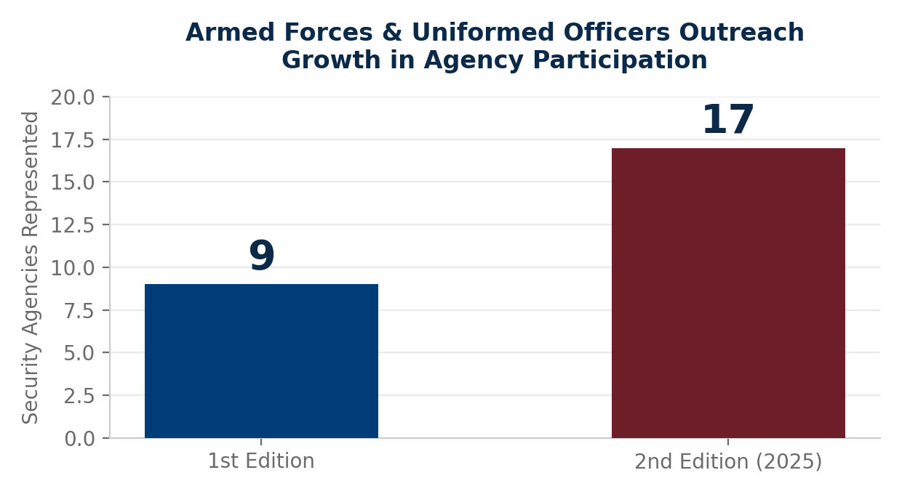
Growth in the number of security agencies represented at the Armed Forces & Uniformed Officers Outreach.
Participation has grown from 9 security agencies at the outreach's first edition to 17 agencies represented at its 2025 edition — nearly doubling institutional representation in a single cycle. The Widows of Fallen Officers Support & Empowerment Project has since introduced a second, ongoing form of measurable impact: verified households receiving needs-based support and vocational training toward sustainable livelihood.
PLACEHOLDER — TO BE COMPLETED BY MIV STRATEGIC INITIATIVE the exact number of widows nominated, verified, and enrolled in vocational training to date, along with any available testimonies from beneficiaries.

6.3 Academic Transformation — Impact
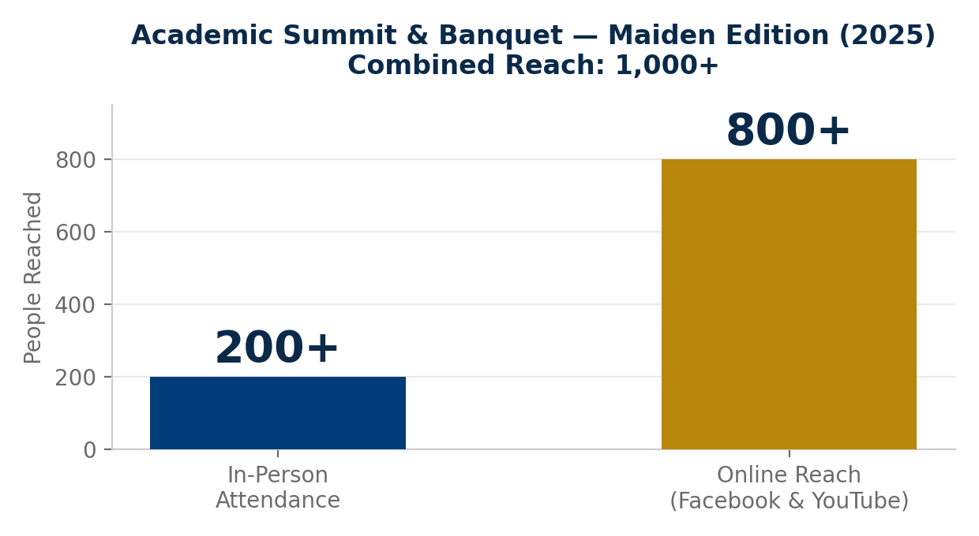
Combined in-person and online reach of the maiden Academic Summit & Banquet, August 2025.
The maiden Academic Summit & Banquet reached a combined audience of over 1,000 members of the academic community. Beyond the event itself, the Strategic Outreach Committee has mapped a target field of 22 tertiary and specialised institutions across Ibadan and the wider Oyo State for ongoing engagement, spanning universities, polytechnics, colleges of education, colleges of agriculture and forestry, and other specialised institutions — including the University of Ibadan, Ladoke Akintola University of Technology, Lead City University, Kola-Daisi University, Dominion University, Precious Cornerstone University, Dominican University, Ajayi Crowther University, Atiba University, First Technical University Ibadan, Emmanuel Alayande University of Education, The Polytechnic Ibadan, The Polytechnic Eruwa, Oke Ogun Polytechnic Saki, Adeseun Ogundoyin Polytechnic, Federal College of Education (Special) Oyo, Oyo State College of Education Lalante, Federal College of Agriculture Moor Plantation, College of Agriculture and Technology Igbo-Ora, Federal College of Forestry Ibadan, the Federal School of Statistics, and Cooperative College Ibadan.
PLACEHOLDER — TO BE COMPLETED BY MIV STRATEGIC INITIATIVE year-on-year attendance trends beyond the maiden edition, and any documented testimonies from participating academic leaders.

6.4 Business & Economic Development — Impact
MBS 1.0 was deliberately convened as an in-house edition to test the Summit's format before a planned public-facing MBS 2.0. Its exhibition and pitch competition components were designed to reach an audience of 1,500-plus Christian entrepreneurs, investors, and professionals, with seed funding of up to ₦1,000,000 available through the Pitch Competition.
PLACEHOLDER — TO BE COMPLETED BY MIV STRATEGIC INITIATIVE verified attendance, number of exhibition booths sold, pitch competition entrants and outcomes, and any funding disbursed as a result of MBS 1.0.

6.5 Traditional & Royal Leadership — Impact
PLACEHOLDER — TO BE COMPLETED BY MIV STRATEGIC INITIATIVE attendance figures, list of royal domains represented, and any documented outcomes from the Royal Fathers' (Oba's) Conference.

6.6 Spiritual and Economic Outcomes
Men of Issachar Vision Inc. and the Strategic Initiative hold that the most important outcomes of this work are often the least visible in a statistics table — decisions for Christ, quiet rededications, restored marriages, and renewed integrity in how a leader exercises their office. Where such outcomes can be responsibly documented and disclosed, they will be recorded here in future editions of this manual.
PLACEHOLDER — TO BE COMPLETED BY MIV STRATEGIC INITIATIVE documented decisions for Christ, rededications, and other spiritual outcomes; and documented economic outcomes such as jobs created, businesses launched, or funding secured as a direct result of Strategic Initiative programmes.

SECTION Seven
Organisational Structure
The Strategic Initiative is governed by a lean, accountable leadership structure, anchored in the spiritual oversight of the Founder and executed through a dedicated coordinating team and a broader Strategic Outreach Committee.

7.1 Governance Model
Ultimate spiritual oversight and strategic direction for the MIV Strategic Initiative rest with Rev. Samson Ajetomobi, Founder and President of Men of Issachar Vision Inc. Day-to-day coordination is delegated to a General Supervising Leader and a Strategic Initiative Coordinator, who work with a small team of officers responsible for administration, finance, secretariat, and special duties. Beneath this coordinating team sits the Strategic Outreach Committee — a broader body of members drawn from across the ministry, each aligned to the sectors the Initiative engages.

7.2 Leadership Organogram
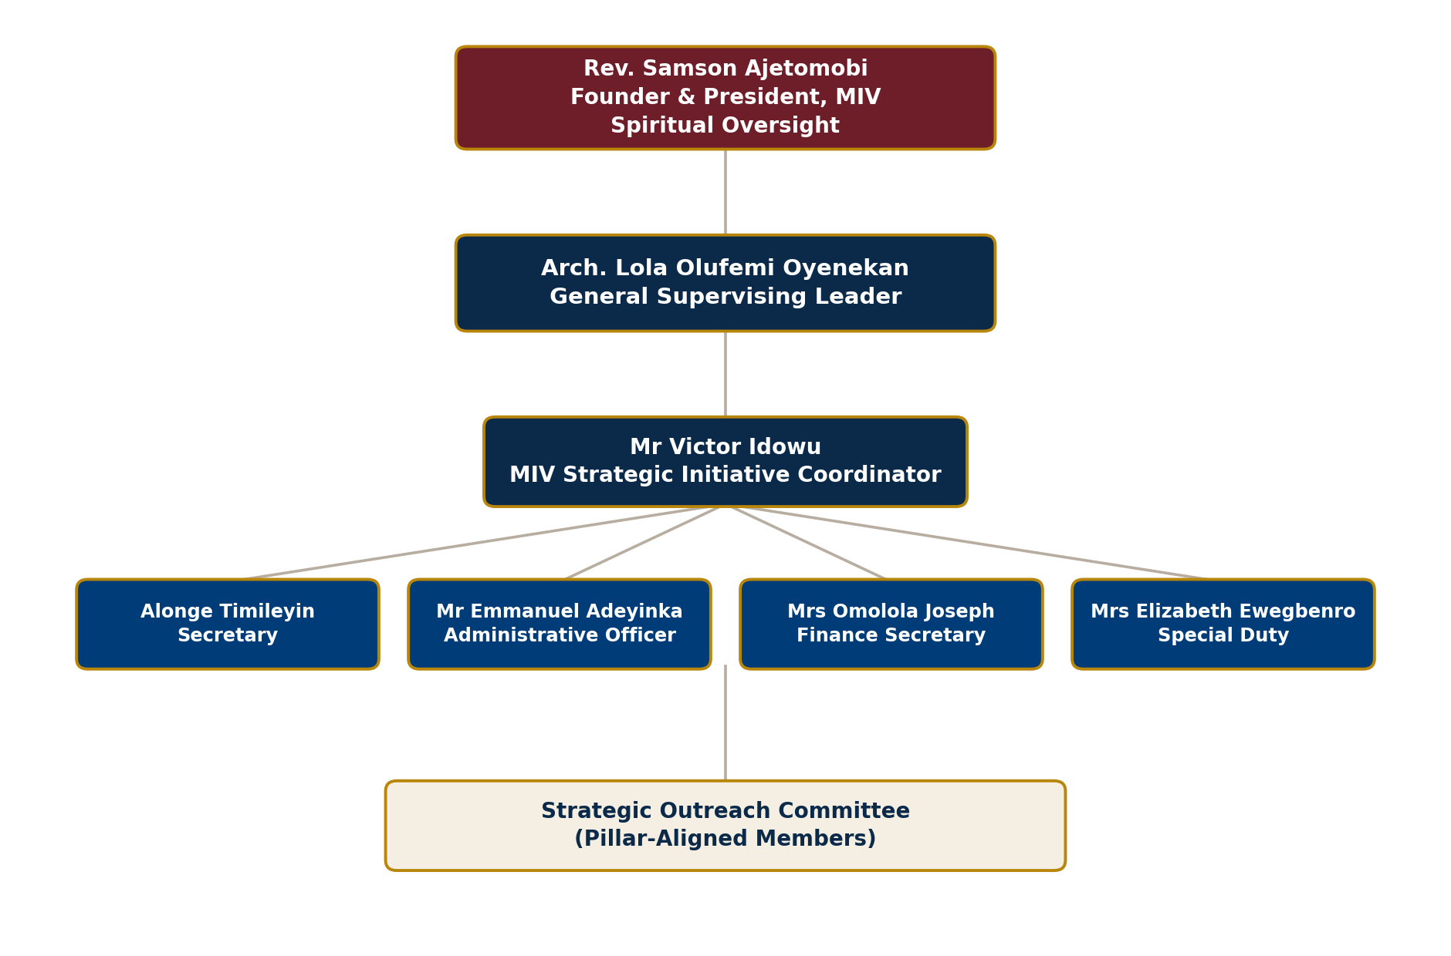
Leadership structure of the MIV Strategic Initiative.

7.3 Roles & Responsibilities
Founder & President | Rev. Samson Ajetomobi — spiritual oversight and strategic direction, Men of Issachar Vision Inc.
Vice President | Rev. (Mrs) Stella Ajetomobi — Men of Issachar Vision Inc.; ministers directly within Strategic Initiative programmes (e.g. Business Summit)
General Supervising Leader | Arch. Lola Olufemi Oyenekan
MIV Strategic Initiative Coordinator | Mr Victor Idowu
Secretary | Alonge Timileyin
Administrative Officer | Mr Emmanuel Adeyinka
Finance Secretary | Mrs Omolola Joseph
Special Duty | Mrs Elizabeth Ewegbenro
PLACEHOLDER — TO BE COMPLETED BY MIV STRATEGIC INITIATIVE Mrs Bukunmi Olatunde-Moore's specific title/role within the coordinating team, to be added to the table above.

7.4 Strategic Outreach Committee — Membership
The Strategic Outreach Committee draws members from across the ministry's branches, aligned in practice to the Initiative's pillars, though presented here as a single unified body of membership:
Arch. Lola Olufemi Oyenekan · Mr Victor Idowu · Alonge Timileyin · Mr Emmanuel Adeyinka · Mrs Omolola Joseph · Mrs Elizabeth Ewegbenro · Mrs Bukunmi Olatunde-Moore · Pst Lola Oyenekan · Mrs Ajayi · Mrs Titilola Joseph · Pst Ilesanmi Gabriel Oluwamayowa · Mr Tunji Ogunjimi · Mr Adigun Tunmise · Deacon Daniel Omawumi Afejuku · Olatunde Bukunmi Bolaji · Ogundiya Oluwakemi · Oyeniyi Yetunde · Bro Ojo Adebayo · Bro Ogunkoya Tade · Bro Joy Nelson · Mrs Esther Adigun · Sis Oyindamola · Bro Chris Ogbenna · Mr Mark Integrity · Mrs Bola Ige · Deaconess Isijola Peculiar Aarinola · Bro Ogunjimi Shola · Mrs Mary Mamshep · Mrs Lovelyn Okeh · Sis Titilayo Adegboyega · Sis Ekong Abosede · Bro Emmanuel Reginald · Bro Edamisan J. Omoyeni · Ephraim Babatunde Joseph · Ilesanmi Gabriel Olumayowa · Pst Wole Ajayi · Ejemai David · Abiodun Olawuyi · Adeagbo Ayobami A. · Mrs Akinwale Felicia · Dr Nosa Udusuyi · Sis Oluwatimilehin Alonge · Sis Gloria · Mr Ojo Samuel · Evang Awokson Dilan · Dare Ige · Paul G Alabi · Femi Dairo

7.5 Decision-Making & Reporting Structure
Each programme follows a consistent planning cycle — prayer and vision-casting, proposal and budgeting, mobilisation and publicity, execution, and post-event review — with outcomes reported back through the Coordinator to the General Supervising Leader and the Founder. This structure is intended to ensure that every outreach, regardless of scale, is executed with consistency, accountability, and a clear record for institutional memory.

SECTION Eight
Operations Manual
Consistency is what allows an outreach to be repeated, improved, and trusted year after year. This section sets out the standard procedures that govern how every MIV Strategic Initiative programme is planned, executed, and reviewed.

8.1 The Event Planning Cycle
Every Strategic Initiative programme, regardless of pillar or scale, follows the same five-stage planning cycle:
- 1. Prayer & Vision-Casting. — the programme begins in prayer, with leadership seeking clarity on God's specific direction for that edition.
- 2. Programme Proposal & Budgeting. — objectives, target audience, format, speakers, and a working budget are documented and approved.
- 3. Mobilisation & Publicity. — invitations, registration, publicity, and logistics are activated across relevant channels.
- 4. Execution. — the programme is delivered according to plan, with a designated coordinator accountable for the day's proceedings.
- 5. Post-Event Review & Reporting. — attendance, outcomes, challenges, and recommendations are documented for institutional memory and future improvement.

8.2 Project & Programme Management
Each major programme is assigned a designated Coordinator, accountable to the MIV Strategic Initiative Coordinator and, ultimately, the General Supervising Leader. Programme sub-teams are drawn from the Strategic Outreach Committee according to the pillar being engaged, with clear ownership of registration, welfare, logistics, media, and follow-up workstreams.

8.3 Risk Assessment & Safeguarding
Welfare-based interventions, in particular, require deliberate safeguards to ensure support reaches those in genuine need. The Widows of Fallen Officers Support & Empowerment Project illustrates this principle: nominees are subject to a formal nomination form, an in-person interview, and ongoing monitoring of any support or equipment provided, following an earlier lesson in which a beneficiary's donated equipment was resold rather than used. This standard — verify before you give, and monitor after you give — is applied as the baseline safeguard for all welfare and empowerment interventions going forward.

8.4 Volunteer & Committee Management
New members of the Strategic Outreach Committee are received through an orientation that sets out the Initiative's vision, values, and expectations of commitment and participation. Committee members are encouraged toward active attendance at planning meetings and are typically attached to at least one programme sub-committee aligned to their gifting or professional background.

8.5 Budgeting & Financial Requests
Programme budgets are proposed in advance by the relevant Coordinator and routed through the Finance Secretary for review and formal request to ministry leadership, following a consistent letter format that specifies purpose, itemised cost, and expected impact of the requested support.

8.6 Media & Protocol
Every programme observes appropriate protocol for the dignitaries in attendance — Chaplains, Commanders, Vice-Chancellors, traditional rulers, and other guests are formally welcomed and, where appropriate, honoured with tokens of appreciation. Media capture (photography and videography) is standard practice at every event, both for institutional record and for onward use in communication and reporting.

8.7 Correspondence Templates
Standardised templates exist for common correspondence needs, including formal requests for financial or logistical support, welcome speeches for programme conveners and coordinators, and invitation letters to dignitaries and institutional partners — ensuring a consistent, professional voice across every touchpoint.

8.8 Registration & Participant Management
Participant registration is managed per-programme, appropriate to its audience and format — from open online registration for the Academic and Business Summits, to formal nomination and interview processes for welfare interventions such as the Widows' Empowerment Project.

8.9 Follow-Up & Continuing Engagement
The Initiative's model deliberately treats each programme as the beginning of an ongoing relationship rather than a closed, one-off event — reflected in the continuing, multi-month vocational training extended through the Widows' Empowerment Project, and in the planned progression from an in-house MBS 1.0 toward a public-facing MBS 2.0.

8.10 Monitoring, Evaluation & Post-Event Reporting
Following each programme, a standard post-event report is compiled, capturing the name of the outreach, date and venue, team members involved, attendance figures, decisions and other outcomes, challenges encountered, and recommendations for future editions. These reports form the primary evidence base for the Impact Reports presented in Section Six of this manual.

8.11 Documentation & Knowledge Management
Planning documents, budgets, correspondence, registration data, and post-event reports are retained centrally, forming the institutional memory referenced throughout this manual and catalogued further in the Knowledge Base outlined in Section Eleven.

SECTION Nine
Communication & Mobilisation Strategy
An outreach that is not communicated well never reaches the people it was designed for. The Initiative treats communication as a deliberate strategy, not an afterthought.

9.1 Digital Presence
Website | mivstrategicinitiative.com.ng
Facebook / Instagram / YouTube | @mivstrategicinitiative
Livestreaming | Facebook and YouTube livestream used for major summits (e.g. Academic Summit & Banquet)

The Initiative's website serves as the primary hub for programme information, registration, and partnership engagement, with dedicated pages per major programme (such as the Business Summit's Pitch Competition, Vendor Exhibition, and Webinar pages). Social channels extend the Initiative's reach beyond physical attendance, most notably through livestreaming, which more than tripled the effective audience of the maiden Academic Summit & Banquet.

9.2 Direct & Institutional Channels
- WhatsApp & Email. — for coordination among the Strategic Outreach Committee and rapid mobilisation ahead of programmes.
- Church Mobilisation. — announcements and mobilisation communicated through Men of Issachar Vision Inc.'s congregational network.
- Institutional Partnerships. — formal invitations and correspondence with universities, security agencies, traditional councils, and business networks, following the Initiative's standard correspondence templates.
- Government Relations. — continued cultivation of relationships with public office holders and government agencies engaged through the Leadership & Governance thread and the Armed Forces Outreach.

9.3 Brand Storytelling
Every programme is documented photographically and, where possible, on video, generating a growing library of testimony, imagery, and highlights used to communicate impact to partners, prospective attendees, and the wider public — including flyers, recap videos, and livestream recordings.

9.4 Annual Communication Calendar
PLACEHOLDER — TO BE COMPLETED BY MIV STRATEGIC INITIATIVE a finalised annual communication calendar mapping specific publicity windows, press engagements, and digital campaigns to each programme's planning cycle.

SECTION Ten
Financial Sustainability & Partnership Model
National transformation is not a project any single ministry, family, or donor can fund alone. It requires a coalition of the willing — and the Strategic Initiative is structured to make that coalition possible.

10.1 Current Financing Model

1. Ministry Funding
Men of Issachar Vision Inc. provides direct financial and institutional support to the Strategic Initiative, reflecting the parent ministry's conviction that this outreach is a legitimate and priority expression of its mission. This funding underwrites core costs and provides the stable institutional foundation from which every programme is launched. Its principal limitation is scale: ministry resources alone cannot sustain the Initiative's growing ambitions across four pillars and an expanding number of future sectors.

2. Ministry Members' Support
Committed members and volunteers contribute directly and sacrificially — in giving, time, and skill — enabling programmes to proceed even where budgets are tight. This grassroots support has repeatedly made possible outreaches that would otherwise have been financially out of reach, and remains a vital, values-affirming pillar of the Initiative's funding base.

3. Business & Institutional Partners
A growing circle of Kingdom-minded businesses, corporate organisations, foundations, and individuals who believe in societal transformation extend financial and in-kind partnership to specific programmes. Strategic partnership of this kind is what allows the Initiative to expand its reach, quality, and welfare impact beyond what ministry and member giving alone could sustain.

10.2 Long-Term Sustainability Strategy
As the Initiative matures, it intends to diversify and formalise its funding base to include:
- Strategic and corporate sponsorship arrangements
- Corporate Social Responsibility (CSR) partnerships
- Foundation and grant funding
- International donor and development-partner relationships
- Academic institution collaborations
- Government collaboration on shared-interest programmes
- An endowment fund for long-term programme stability
- Structured annual giving and legacy partnership arrangements
- A growing business network of Kingdom-minded entrepreneurs
- Impact investors and Kingdom philanthropists
PLACEHOLDER — TO BE COMPLETED BY MIV STRATEGIC INITIATIVE specific, active agreements currently in place under each of the above categories, as they are formalised.

10.3 Become a Strategic Partner
Societal transformation is not the responsibility of any one institution. It requires universities willing to open their halls, security agencies willing to open their gates, businesses willing to open their networks, and partners willing to open their hands. Every contribution — however it is given — becomes part of a measurable, generational work: a widow trained into a trade, an entrepreneur funded into a business, a young officer strengthened in integrity, a lecturer renewed in purpose.

Ways to Partner
- Financial giving toward general programme costs
- Sponsorship of a specific project or programme edition
- Scholarships for students or emerging professionals
- Business grants and vocational empowerment funding
- Event sponsorship (venue, catering, materials, souvenirs)
- Equipment donations
- Professional expertise and mentorship
- Strategic advisory support
- Research collaboration
- Media partnership
- International collaboration
- Volunteer service
- Prayer support

Partnership Levels
Vision Partner | Entry-level giving that sustains the Initiative's ongoing operations and core programmes
Impact Partner | Sponsorship tied to a specific project, programme edition, or welfare intervention
Institutional Partner | Universities, security agencies, traditional councils, and similar bodies partnering formally as institutions
Corporate Partner | Businesses and corporate organisations extending CSR or sponsorship support
Legacy Partner | Long-term, recurring commitment supporting the Initiative's multi-year vision
Strategic Alliance Partner | Foundations, development agencies, and international partners engaged at a strategic, collaborative level

Partners can expect periodic impact reports, appropriate recognition where desired, invitations to strategic programmes, relevant networking opportunities, and the enduring satisfaction of contributing directly to national transformation.

SECTION Eleven
Knowledge Base
This manual draws from, and points to, a wider institutional archive maintained by the MIV Strategic Initiative. That archive is catalogued here for reference, even where individual documents are maintained separately rather than reproduced in full within this manual.

11.1 Archive Index
Programme Reports | Post-event reports per programme, per the format set out in Section 8.10
Templates | Correspondence, welcome speeches, invitation letters, budget request formats
Letters | Formal requests for support, institutional invitations, partnership correspondence
Budgets | Programme-level budget proposals and financial requests
Planning Documents | Committee assignments, institutional target lists, programme proposals
Award & Certificate Templates | Recognition materials for honoured guests, speakers, and awardees
Checklists | Event planning, registration, and logistics checklists
Policies | Safeguarding and verification standards (e.g. welfare intervention vetting)
Brand Guidelines | Logo usage, colour palette, and visual identity standards
Media Assets | Event photography, videography, flyers, and livestream recordings
Communication Templates | Social media, press, and mobilisation message formats
Historical Records | Founding history and evolution of the Strategic Initiative (Section Three)

11.2 Lessons Learned & Best Practices
- Welfare and empowerment support must be preceded by verification and followed by monitoring — a standard adopted after an early setback involving a resold piece of equipment intended for a widow's livelihood.
- Positioning a programme as “purpose-driven and policy-free” has proven effective in drawing senior leadership across institutional and denominational lines without political entanglement.
- Testing a new format in-house (as with MBS 1.0) before a public-facing launch (MBS 2.0) allows execution to be strengthened before scale is added.

11.3 Frequently Asked Questions

Is the MIV Strategic Initiative a political organisation?
No. The Initiative's programmes are deliberately positioned as purpose-driven and policy-free, focused on leadership development, professional excellence, and practical welfare rather than partisan engagement.

Must a partner or participant be Christian to engage with the Initiative?
No. While the Initiative is a Christian ministry expression at its foundation, its programmes are open to leaders and professionals of any faith background, in keeping with its conviction that ethical leadership and national development are shared concerns across society.

How is the Initiative funded?
Through a combination of direct ministry funding, the sacrificial giving of ministry members, and a growing base of business and institutional partners, as set out in Section Ten.

How can I verify the impact of my partnership?
Partners receive periodic impact reports drawing on the post-event reporting standard described in Section 8.10 and the figures presented in Section Six.

11.4 Institutional Memory
This manual is intended to be a living document. As programmes are repeated, refined, and expanded, and as placeholders throughout this manual are filled with verified data, future editions will supersede this one — while the history, values, and conviction recorded here remain constant.

