Daniel Soto and Vicken Krikorian

CS480-03

Due: 3/15/2015

CS480 Project Documentation

1. Programming Environment

Eclipse Java Project

Version: Kepler Service Release 2

1. User Manual: How to compile and run your program etc.
   1. Create a Java Project in Eclipse
   2. Create a Package called “project.”
   3. Add ChangeByte.java, DigitalSignature.java, KeyGen.java, and Main.java to that package.
   4. Save test.txt into the main Java Project folder.
   5. Run Main.java through Eclipse. (All of the other java files work off that one including ChangeByte.java)
2. Screenshots of your testing.

Below, the menu is displayed and the user presses 1 to generate keys, which are then displayed.

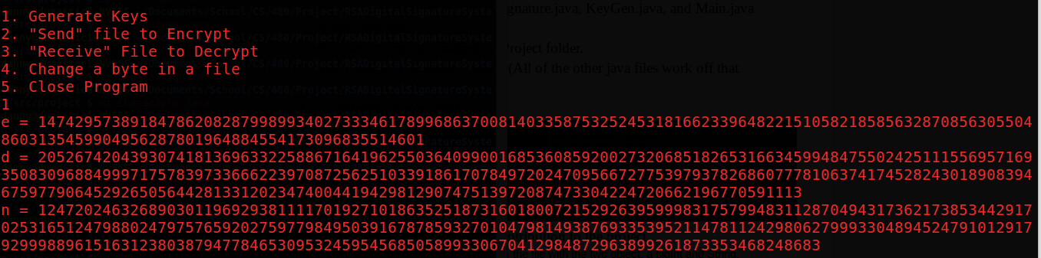

Below, the user enters 2 to “send” files. The user is prompted for the name of the file to encrypt.

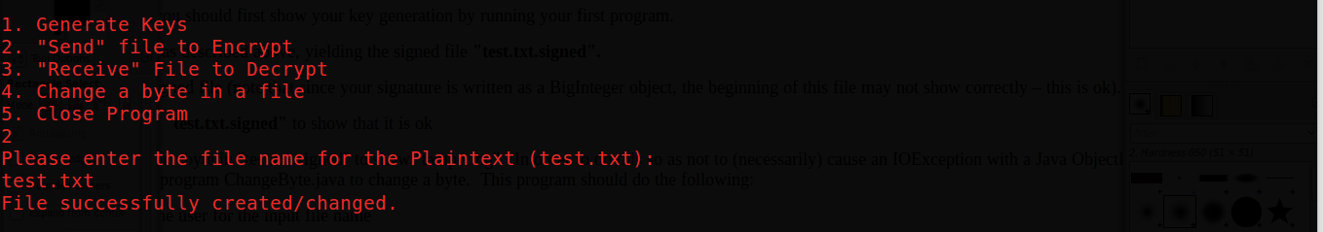

This is the signed document.

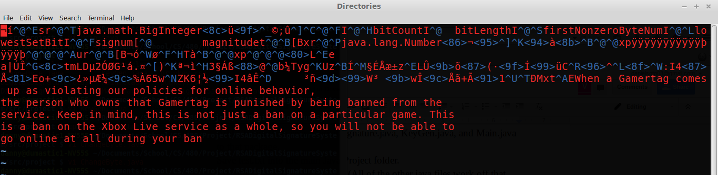

User executes the Receive command and inputs the name of the signed document

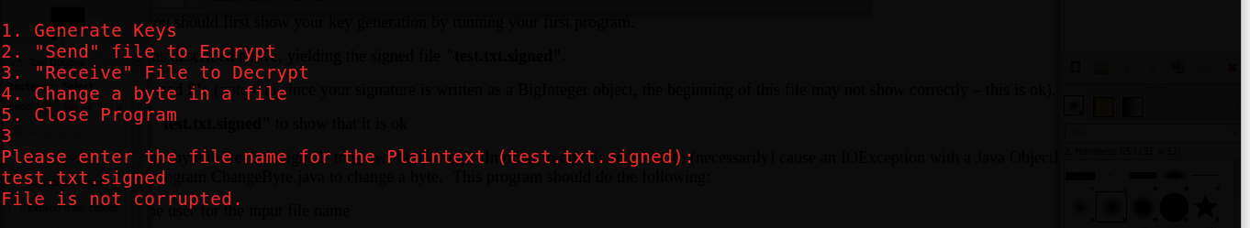

The user executes the Change command and then inputs which file to change as well as which byte to change to a random byte

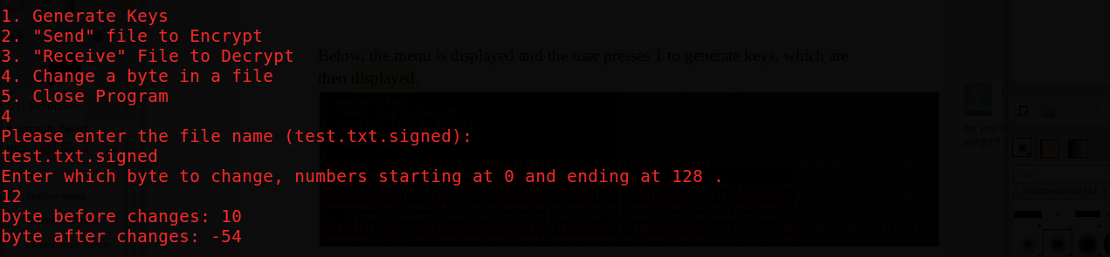

Executing the Receive command returns that the file is Corrupted now.

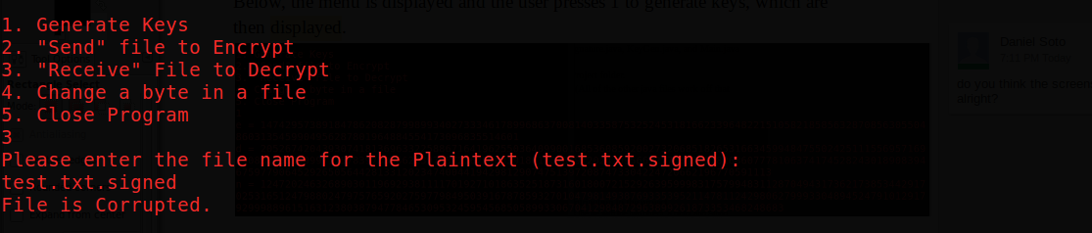

1. Percentage of each member’s contribution to the project.
   1. 50% Daniel Soto
   2. 50% Vicken Krikorian