**ABC Gaming Platform Case Study Report**

Submitted By,  
Name: Vigneshwaran S  
Email: vickeysparrow3@gmail.com  
Date: June 29, 2025

<https://github.com/Vickey-VJ/Vindiata-Consulting-Interview-Task/blob/main/ABC_Company.ipynb>

**Introduction**

This report explains the work I did to analyze user data for the ABC gaming platform in October 2022. I used a Python notebook to calculate loyalty points for specific time slots, rank players for the whole month, find key metrics, and suggest how to share a Rs 50,000 bonus among the top 50 players. The data came from three CSV files: User Gameplay Data, Deposit Data, and Withdrawal Data. The results are saved in CSV files, which are attached with this report.

**What I Did**

I created a Python notebook called ABC_Company.ipynb to process the data and complete the tasks. Here’s what I did:

* I downloaded the data from the Google Sheets link as an Excel file (.xlsx) and converted the multiple sheets into separate CSV files.
* Loaded data from three CSV files into tables using a Python tool called Pandas.
* Renamed columns to make them consistent, like changing User ID to User_ID and Games Played to Games_Played.
* Changed the Timestamp column to a date-time format so I could filter by date and time.
* Added a Date column and a Slot column (S1 for 12 AM to 12 PM, S2 for 12 PM to 12 AM) to help with calculations.
* Calculated loyalty points for specific slots and the whole month using a formula.
* Found key metrics like average deposits and games played.
* Suggested a way to share the bonus among the top 50 players.

**Part A: Loyalty Points and Metrics**

**1. Loyalty Points for Specific Slots**

I calculated loyalty points for four time slots and arranged it by who having highest loyalty points:

* 2nd October, Slot S1 (12 AM to 12 PM)

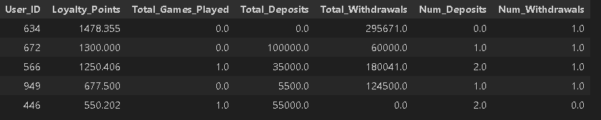

* 6th October, Slot S2 (12 PM to 12 AM)

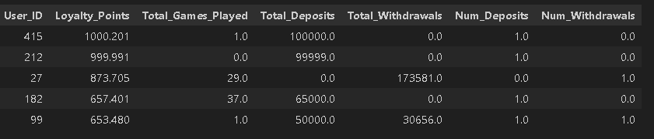

* 8th October, Slot S1 (12 AM to 12 PM)

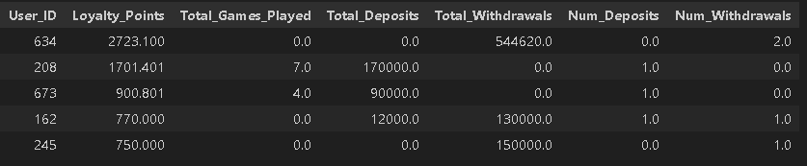

* 26th October, Slot S2 (12 PM to 12 AM)

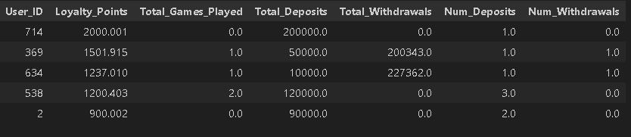

For each slot, I filtered the data by date and time slot, grouped it by User ID, and used this formula:

Loyalty Points = (0.01 × Deposit Amount) + (0.005 × Withdrawal Amount) + (0.001 × max(Number of Deposits - Number of Withdrawals, 0)) + (0.2 × Games Played)

**2. Overall Loyalty Points and Rankings**

I calculated loyalty points for all users in October 2022. I grouped gameplay, deposit, and withdrawal data by User ID for the whole month, applied the same formula, and ranked users based on their loyalty points. If two users had the same points, I used the number of games played to decide the ranking. The top 50 players are saved in Overall_Loyalty_Points_October.csv (attached).

**Output:**

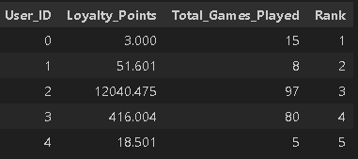

**3. What is the average deposit amount?**

* The average deposit amount from the provided data is: $5,492.19

**4. What is the average deposit amount per user in a month?**

* The average total deposit amount per user is: $104,669.65

**5. What is the average number of games played per user?**

* The average number of games played per user is: 355.27

These numbers show how active users were on the platform.

**Part B: Bonus Allocation**

I suggested sharing a Rs 50,000 bonus among the top 50 players based on their loyalty points. The method gives 70% of the bonus based on loyalty points and 30% based on games played. This makes it fair by rewarding both spending and playing. Each player’s share is calculated by comparing their points to the total points of the top 50. The results, including each player’s bonus amount, are saved in Top_50_Players_Bonus.csv (attached).

**Output:**

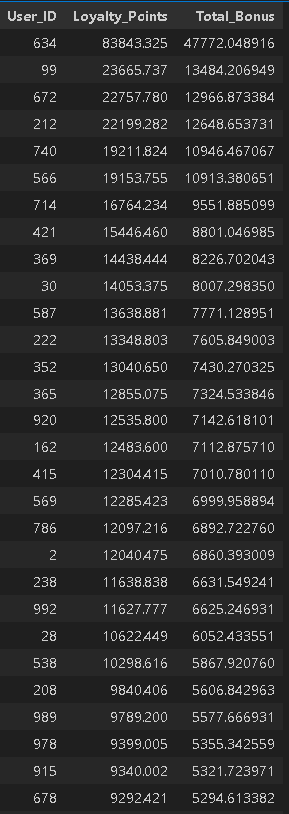

**Part C: Evaluating the Loyalty Points Formula**

**1. Would you say the loyalty point formula is fair or unfair?**

I think the loyalty point system is mostly fair because it looks at how active a user is like how much they add money, take out money, and how many games they play. It gives more value to people who play more and put in money, which makes sense for a gaming company.

But one part might feel a bit unfair. If someone takes out money more times than they add it, they don’t get any points from that part. Some users might be very active and still not get rewarded just because they withdrew more times. So while the system works well overall, that part could be made better to treat all active users more equally.

**2. Can you suggest any way to make the loyalty point formula more robust?**

One way to make the loyalty point system better is to include the net balance which means the difference between how much money a user adds and how much they take out. This can help reward users who actually keep money on the platform, not just those who make many small deposits.

We can also track play time, not just the number of games. Someone might play fewer games but for a longer time, which also shows strong engagement. Giving points for daily login streaks or playing every day for a week can also encourage users to stay active.

Adding a referral bonus where users earn points if someone they invite starts playing can help grow the user base while rewarding loyal players. These small changes can make the system more fair and better at showing who the truly active users are.

**Conclusion**

This report shows the loyalty points for specific slots, overall rankings, key metrics, and bonus allocation for October 2022. I used a Python notebook to process the data, and the results are saved in CSV files (attached). The loyalty points formula could be improved to make it fairer and encourage more user activity.

Vigneshwaran S ([vickeysparrow3@gmail.com](mailto:vickeysparrow3@gmail.com))

<https://github.com/Vickey-VJ/Vindiata-Consulting-Interview-Task>