MediQuick AI
Knowledge-Transfer Document
An onboarding guide to the multimodal medical triage assistant · June 2026
Developer: Vignesh V · Dissertation: Rishwanth [Last Name] · BITS ZG628T

1. What It Is and Why It Exists
MediQuick AI is a web application that helps a person make sense of a new health symptom. The user describes what they feel in plain language — and, if useful, uploads a photo of something visible such as a rash or wound. The system replies with a structured assessment: what the symptom might be, how urgent it is, which kind of doctor to see, and a few clarifying questions.
The pain point it solves is uncertainty about urgency. When something feels wrong, the hardest question is not the exact diagnosis but “how seriously should I take this, and who should I see?” Web searches are noisy and often frightening, and seeing a doctor for every small concern is impractical. MediQuick AI gives calm, structured, first-line guidance. Importantly, it triages rather than diagnoses, and it shows a medical disclaimer on every answer.

2. How It Works
The application is built in clear layers. A request flows from the browser to the backend API, through a set of focused services, to the AI model and the database, and back. The table below lists each component and whether it is finished or still planned.
Component | What it does | Status
FastAPI app (main.py) | Entry point, CORS, auth, starts the database | Done
Security (security.py) | Password hashing + JWT issue / verify | Done
NIM client (nvidia_nim.py) | Calls NVIDIA NIM for text and image inference | Done
Prompt engine (prompt_engine.py) | System prompt; gather→conclude; JSON schema | Done
Specialists (specialists.py) | 10 agent personas + routing / handoff | Done
Context manager (context_manager.py) | Assembles multi-turn history for the model | Done
Image pipeline (image_pipeline.py) | Validates, resizes, and base64-encodes photos | Done
Routers (auth/chat/sessions/upload/dashboard) | REST endpoints the front end calls | Done
Database (SQLite + SQLAlchemy) | Stores users, sessions, and messages | Done
React front end | Login, chat, triage card, sidebar, dashboard | Done
Evaluation harness | 30 scenarios, accuracy report | Done — 100%
Each component is small and independently testable. All components above are complete and were validated live.

3. Architecture at a Glance
Figure 1 shows how the pieces fit together. All components shown in green are complete and were validated live.
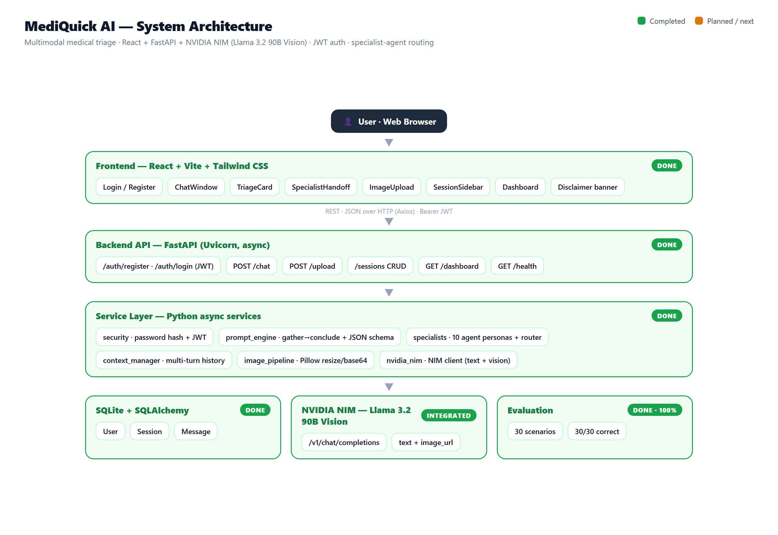
Figure 1: MediQuick AI system architecture (green = complete and validated).

4. How It Handles Symptoms, Photos, and Summaries

4.1 Text symptoms
When the user types a symptom, the backend combines the active specialist’s system prompt, the earlier turns in the session, and the new message, then asks the model for a structured assessment. The assistant first asks a few focused follow-up questions; once it has enough detail it concludes, and the interface renders a colour-coded triage card. If a clear specialty emerges, the session is handed from the General Physician to that specialist agent, carrying the full context. Figure 2 shows a real consultation.
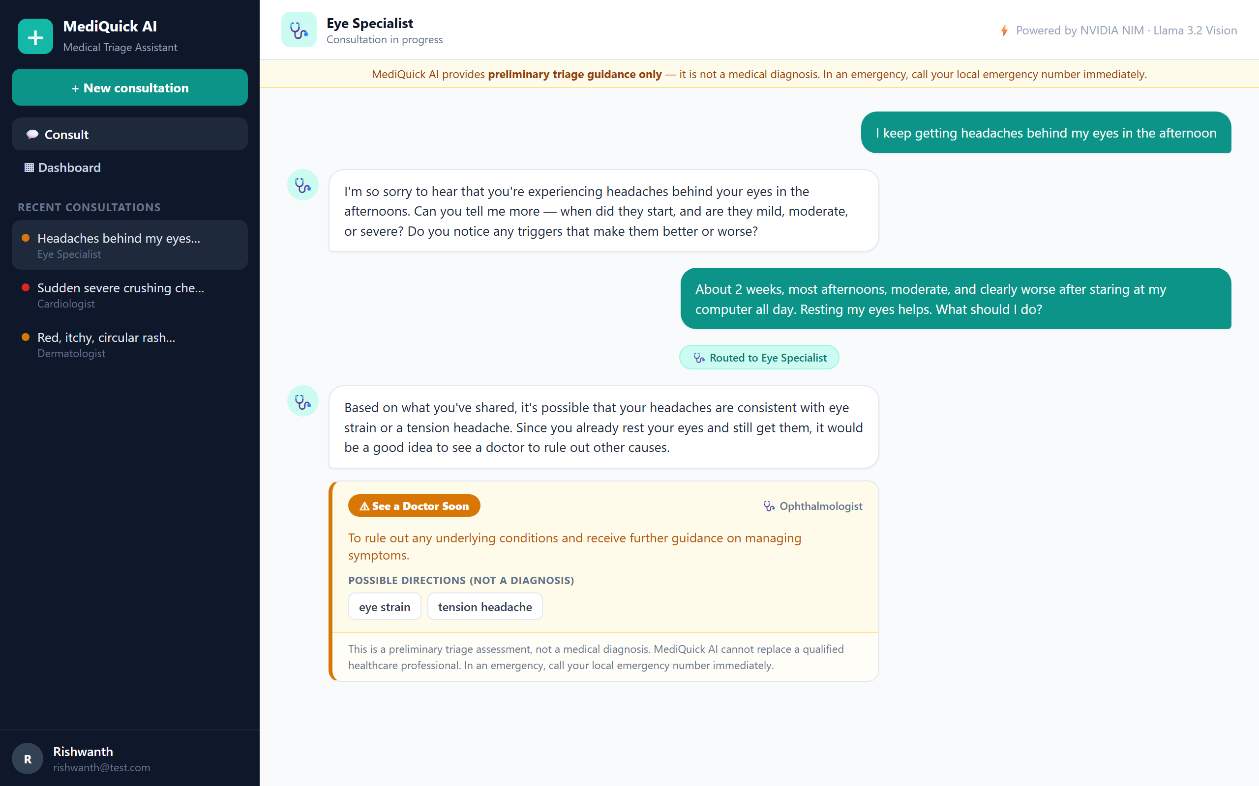
Figure 2: A real consultation — the assistant gathers detail, hands off to the Eye Specialist, and concludes with a triage card.

4.2 Photographs
If a photo is attached, it is first sent to the /upload endpoint, which checks the file type and size, shrinks it to a sensible resolution, and converts it to a compact form the model can read — all in memory, so the image is never saved to disk. The photo is then analysed together with the text in a single multimodal request to the Vision-Language Model.

4.3 The dashboard
Every concluded consultation is summarised on a dashboard as a colour-coded card showing the possible directions, the urgency tier, and the recommended specialist — with no medication content. Figure 3 shows the dashboard.
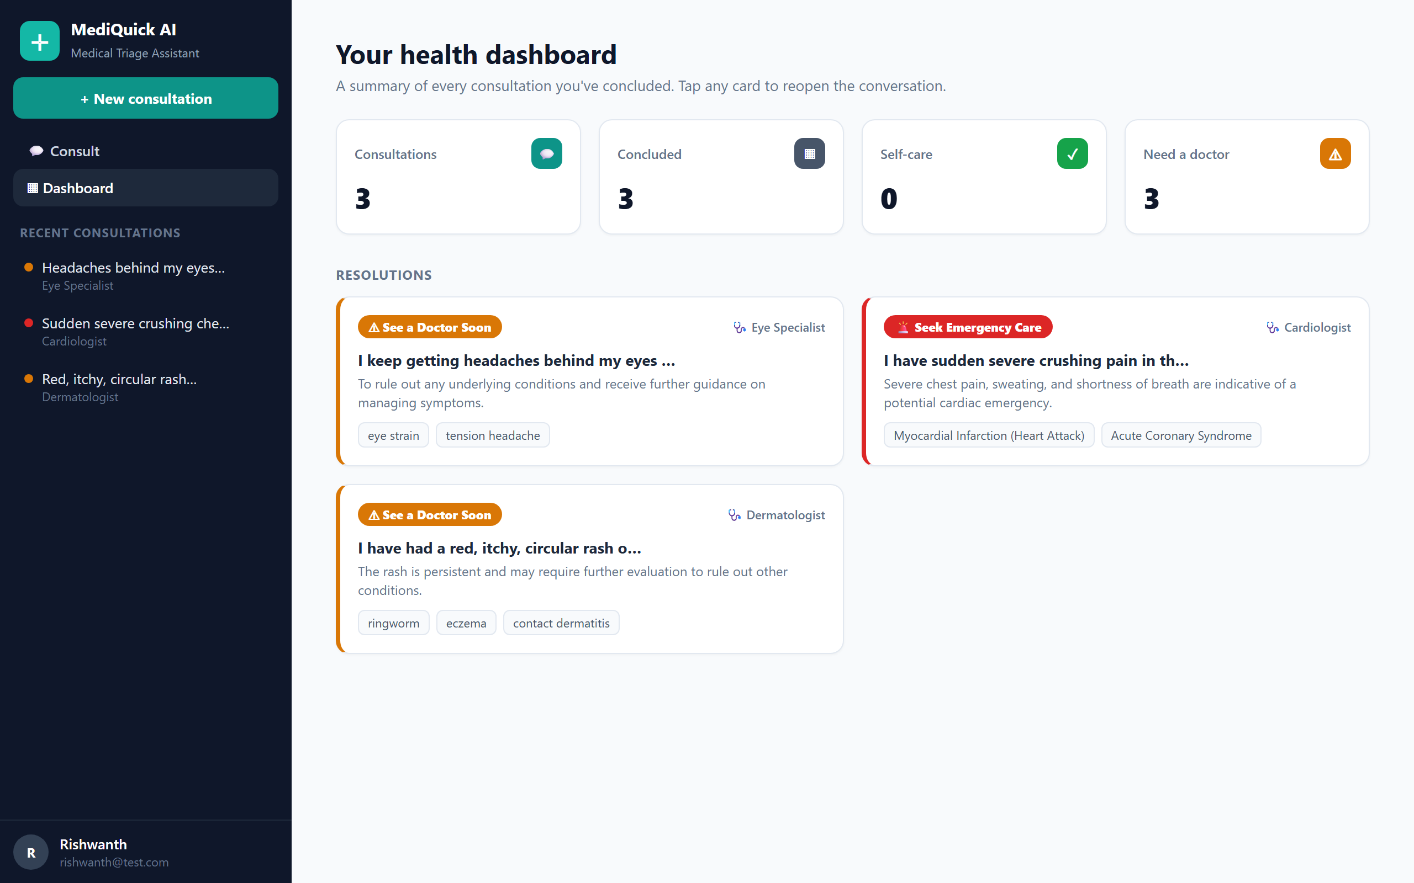
Figure 3: The health dashboard summarising concluded consultations by urgency and specialist.

5. Project and File Structure
The repository separates the backend from the front end. The most important files are listed below.
Path | Purpose
backend/main.py | FastAPI app, CORS, router wiring, startup
backend/models.py | User, Session, and Message database models
backend/services/security.py | Password hashing + JWT issue / verify
backend/services/nvidia_nim.py | NVIDIA NIM API client (text + vision)
backend/services/prompt_engine.py | System prompt, gather→conclude, JSON parser
backend/services/specialists.py | 10 specialist personas + routing
backend/services/image_pipeline.py | Image validation and preprocessing
backend/routers/ | auth, chat, sessions, upload, dashboard
backend/evaluation/ | scenarios.json, run_eval.py, eval_report.csv
frontend/src/pages/ | Login, Register, Chat, Dashboard
frontend/src/components/ | Sidebar, TriageCard, ImageUpload, banner
frontend/src/api/client.js | Axios client with JWT handling
Table: key files in the MediQuick AI repository.

6. Current Status (≈88% Complete)
The full application — backend, authentication, specialist routing, the React interface, the dashboard, and the evaluation — is finished and was tested live in the browser. Only final polish and handover documentation remain.
Done | Remaining
FastAPI backend + SQLite (User/Session/Message) | Error-handling and empty-state polish
JWT auth, login / register, user profiles | Short automated backend test suite
NVIDIA NIM client (text + vision) | Responsive-layout review for small screens
Prompt engine, gather→conclude, JSON parser | Developer README and setup guide
10 specialist agents + routing / handoff
React UI: chat, triage card, sidebar, dashboard
30-scenario evaluation — 100% accuracy
Done-versus-remaining at the mid-semester milestone (≈88% complete).

7. How to Run It
The application runs locally with the backend and front end side by side.
- In the backend folder, create a virtual environment and install dependencies: pip install -r requirements.txt
- Create a file named .env (copy from .env.example) and set NVIDIA_NIM_API_KEY to your NVIDIA NIM key from build.nvidia.com (a JWT_SECRET is also set there).
- Start the API: uvicorn main:app --port 8001 (then open http://localhost:8001/docs to try the endpoints).
- In the frontend folder, run npm install, then npm run dev, and open http://localhost:5173.
- Register an account, then describe a symptom to begin a consultation; concluded consultations appear on the Dashboard.

8. Key Terms Glossary
Term | Meaning
Triage | Estimating how urgent a condition is and routing to the right care — not diagnosing.
VLM | Vision-Language Model: an AI that understands text and images together.
NVIDIA NIM | A hosted platform that serves models (here, Llama 3.2 90B Vision) over an API.
FastAPI | The Python web framework used to build the backend.
SQLAlchemy | The library that maps Python objects to SQLite database tables.
Pillow | The Python imaging library used to validate and resize photos.
Base64 | A text encoding for binary data, used to send images inside a JSON request.
Triage schema | The fixed JSON shape every assessment must follow.
Urgency tier | One of self_care, consult_doctor, or seek_emergency.
Emergency override | A safety rule that always escalates danger signs to emergency care.
Multimodal | Using more than one input type at once — here, text plus an image.
Specialist routing | Handing a session from the General Physician to the most relevant expert agent.
JWT | JSON Web Token — the signed token that keeps a user logged in securely.
Glossary of the main technical terms used in the project.

9. Next Steps
- Harden error handling and empty / loading states across the interface.
- Add a short automated test suite for the backend services.
- Review the responsive layout for smaller screens.
- Write a developer README and setup guide for handover.

