
MEDIQUICK AI — AN ADVANCED MULTIMODAL
MEDICAL TRIAGE ASSISTANT
BITS ZG628T: Dissertation
Mid-Semester Progress Report
by
Rishwanth [Last Name]
[Student ID]
Dissertation work carried out at
[Organization Name, Location]
Submitted in partial fulfilment of [Programme Name]
degree programme
Under the Supervision of
[Supervisor Name]
[Organization Name, Location]
BIRLA INSTITUTE OF TECHNOLOGY & SCIENCE
PILANI (RAJASTHAN)
June 2026

Abstract
MediQuick AI is an advanced multimodal medical triage assistant that lets a user describe symptoms in a natural, multi-turn chat and optionally upload a photograph of a visible condition such as a rash or wound. A hosted Vision-Language Model — Meta Llama 3.2 (90B) Vision served through the NVIDIA NIM platform — interprets the text and image together and returns a strictly structured triage assessment: a short list of possible conditions, an urgency tier (self-care, consult a doctor, or seek emergency care), the reasoning behind that tier, a recommended medical specialist, and clarifying follow-up questions. Crucially, the system triages rather than diagnoses, and every response carries a clinical disclaimer. This report documents the mid-semester milestone, at which a complete, working full-stack application has been built and validated end-to-end. The Python FastAPI backend — JWT authentication and user profiles, the NVIDIA NIM client, prompt-engineering with JSON-schema enforcement, a multi-turn context manager, a privacy-preserving image pipeline, a specialist-agent routing layer, and all REST endpoints — and a React with Tailwind CSS front end — registration and login, a conversational chat interface, colour-coded triage cards, image upload, a session sidebar, and a summary dashboard — are implemented and were exercised live in the browser. The assistant conducts a doctor-style conversation, gathering details before it concludes, and routes each case from a General Physician to the most appropriate specialist agent (for example Dermatology or Cardiology) while carrying the full prior context across the handoff. A structured evaluation across thirty curated scenarios spanning dermatology, general medicine, and minor injury achieved 100% urgency-classification accuracy with zero unsafe under-triage. The project is approximately 88% complete; only final error-handling polish and developer handover documentation remain.

Signature of the Student Signature of the Supervisor
Name: Rishwanth [Last Name] Name: [Supervisor Name]
Date: Date:
Place: Place:

Table of Contents

List of Figures
Figure 1 System architecture of MediQuick AI
Figure 2 Conversational triage interface with specialist handoff and triage card
Figure 3 Health dashboard — summarised resolutions across urgency tiers
Figure 4 Live FastAPI interactive API documentation (Swagger UI)

List of Tables
Table 1 Major technical specifications
Table 2 Implementation progress by phase (≈88% complete)
Table 3 REST API endpoints implemented
Table 4 Triage evaluation results across 30 scenarios

1. Introduction

1.1 Background
Access to timely and reliable first-line medical guidance remains uneven. When a non-specialist notices a new symptom — an unfamiliar rash, a persistent fever, or sudden chest discomfort — the immediate question is rarely “what exactly is this?” but rather “how urgent is this, and who should I see?” Search engines return undifferentiated and often alarming information, while booking a consultation for every minor concern is neither practical nor affordable. A growing class of Vision-Language Models (VLMs) can now reason jointly over text and images, opening the door to assistive tools that help people gauge urgency responsibly.

1.2 Problem Statement
There is a need for a responsible, accessible assistant that performs preliminary triage — estimating urgency and routing the user to the appropriate kind of care — without overstepping into diagnosis. Such a system must accept both written symptom descriptions and photographs, hold a natural conversation that gathers detail before concluding, produce consistent and machine-readable output, escalate genuine emergencies unconditionally, and make its non-diagnostic nature unmistakable at every step.

1.3 Objectives
The objectives of this dissertation are: (i) to design and build a multimodal triage assistant around a production-grade hosted VLM; (ii) to enforce a strict, validated JSON output schema so that every assessment is structured and auditable; (iii) to conduct a doctor-style multi-turn conversation and route each case to an appropriate specialist agent; (iv) to guarantee an emergency-override safety behaviour and an ever-present clinical disclaimer; and (v) to evaluate classification quality against a curated set of triage scenarios.

1.4 Scope
The system is delivered as a locally deployable web application comprising a Python FastAPI backend and a React front end, backed by a SQLite database, and using Meta Llama 3.2 (90B) Vision through NVIDIA NIM for inference. At the mid-semester milestone the application is a complete, working full stack — authentication, the conversational triage engine, specialist routing, the user interface, the dashboard, and the evaluation harness are all built and were verified live. Only final error-handling polish and developer handover documentation remain for the second half.

2. System Architecture and Modules
MediQuick AI follows a clean, layered architecture. The browser-based React front end communicates over HTTP (JSON, with a bearer JWT) with a FastAPI service, which delegates to a set of focused Python services: a security module for password hashing and token issue, a prompt engine that constructs the system instruction and enforces the output schema, a specialists module holding ten expert personas and the routing logic, a context manager that assembles multi-turn history, an image pipeline that validates and normalises uploads, and a NIM client that performs text and multimodal inference. Users, conversations, and their structured assessments are persisted in SQLite. Figure 1 shows the architecture; all layers shown in green are implemented and validated.
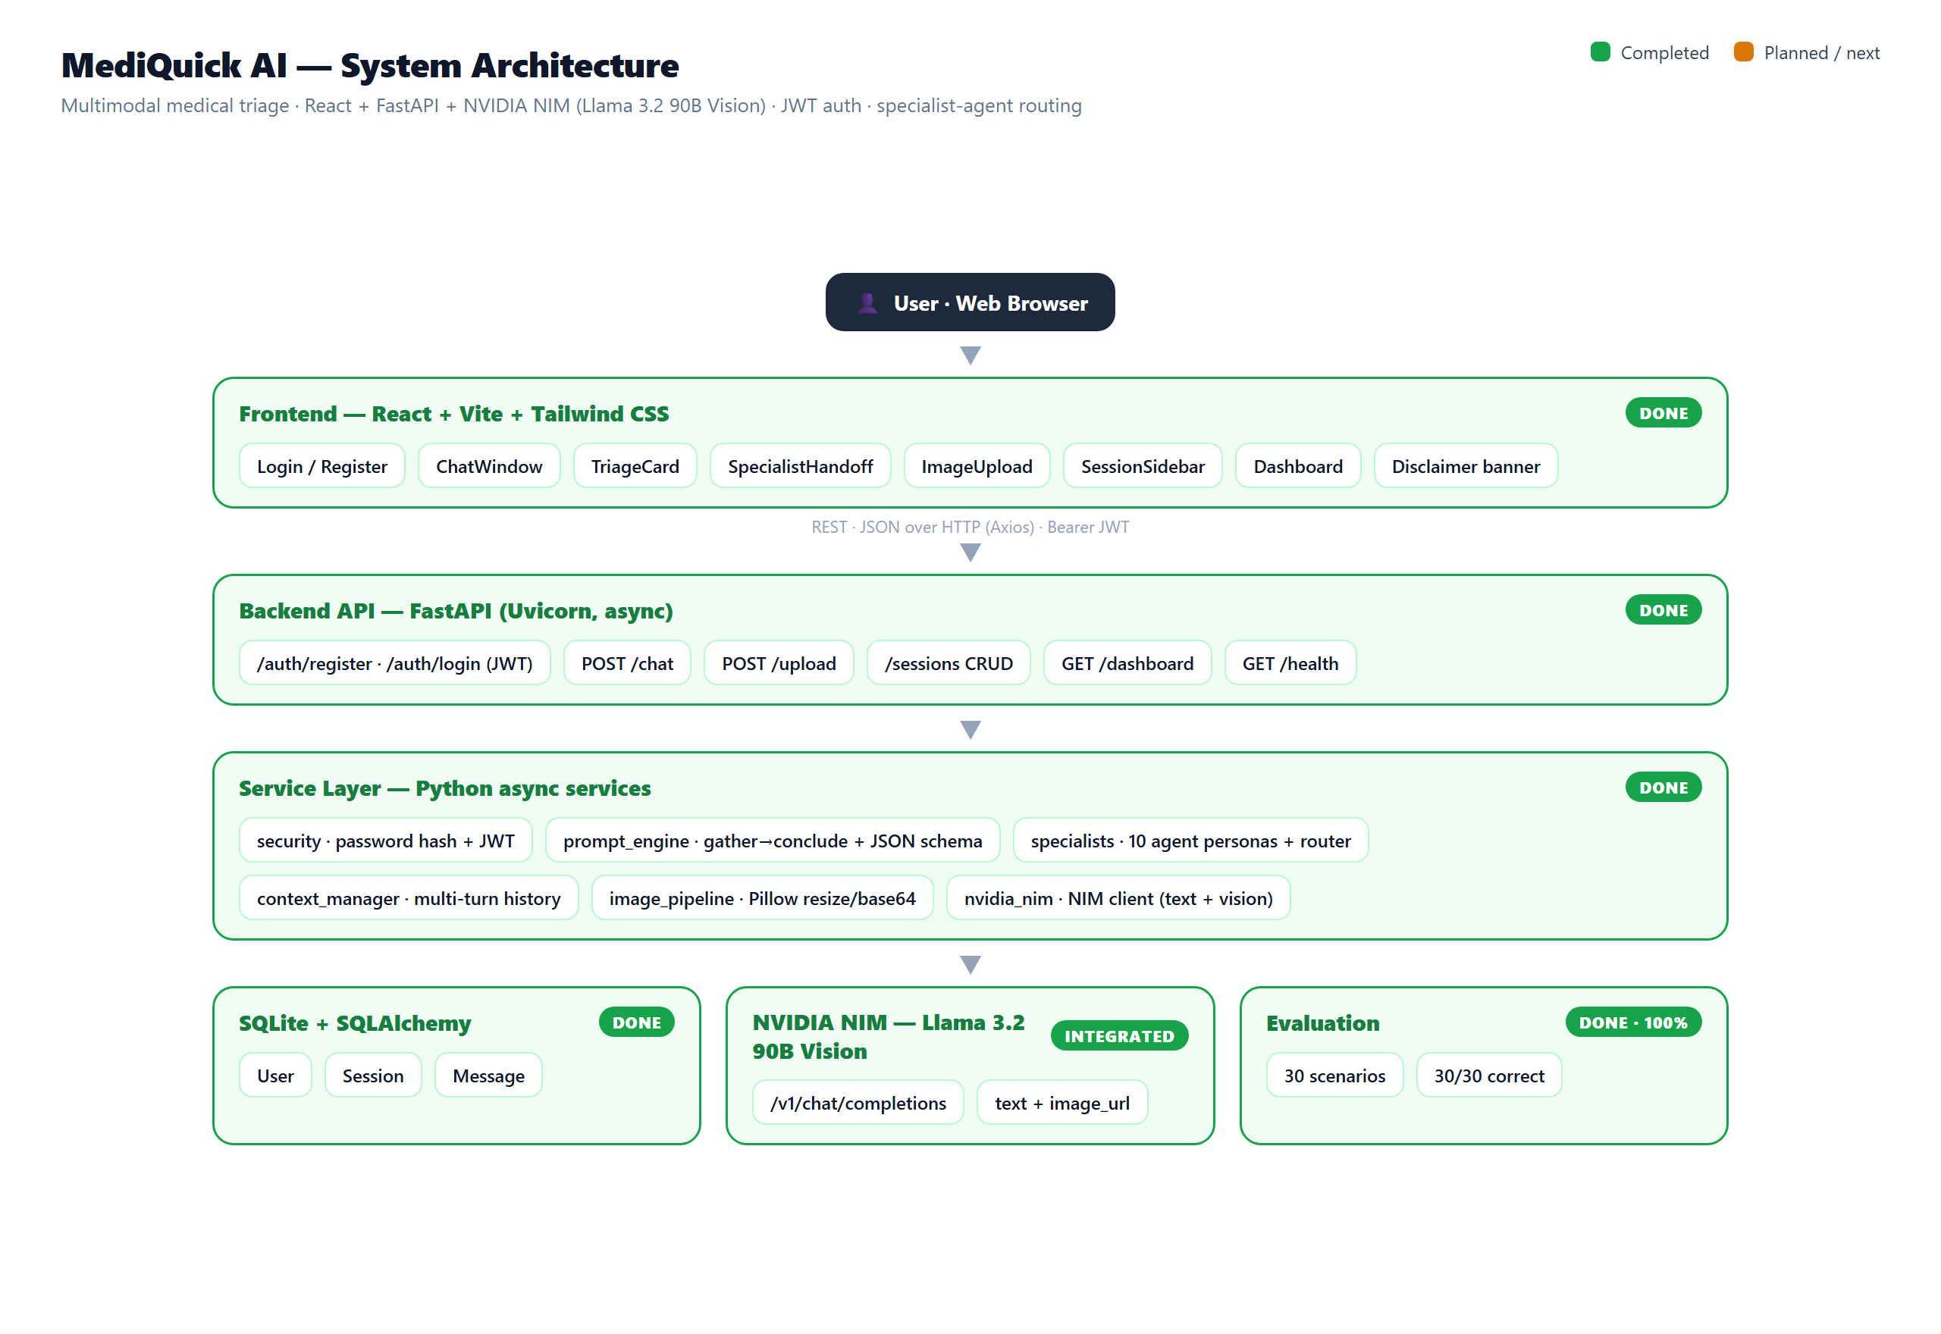
Figure 1: System architecture of MediQuick AI. Green denotes components completed and validated at this milestone.
The separation of concerns keeps each module independently testable. The backend never trusts model output blindly: every response is parsed and coerced into the canonical schema, a disclaimer is injected if missing, and any service failure is converted into a safe, user-facing message rather than an exception. Every data-bearing endpoint requires a valid token, so sessions and dashboards are strictly scoped to the authenticated user.

3. Methodology and Work Completed
Development followed the build order defined in the project plan, completing the backend services first and then the user-facing application. Each module was implemented with asynchronous Python or modern React, type hints, and concise docstrings, and secrets are read exclusively from environment variables.

3.1 Backend Foundation and Authentication
The FastAPI application was initialised with CORS configured for the development front end and a SQLAlchemy engine bound to SQLite. Three ORM models — User, Session, and Message — capture accounts, conversations, and individual turns. Authentication is provided by a security service that hashes passwords with PBKDF2-SHA256 and issues signed JSON Web Tokens; registration also captures an optional health profile (age, sex, height, weight). A dependency validates the bearer token on every protected route.

3.2 NVIDIA NIM Client and Prompt Engineering
An asynchronous client built on httpx calls the NIM chat-completions endpoint, exposing a text path and a multimodal path that attaches the image to the final user message as a base64 data URL. Inference uses a low temperature of 0.3 for clinical consistency. The prompt engine defines the assistant’s identity as a preliminary triage tool, mandates JSON-only output in the exact triage schema, and encodes the emergency-override rule; a robust parser recovers valid JSON from fenced blocks, surrounding prose, or a safe fallback object.

3.3 Conversational Flow and Specialist Routing
The triage schema was extended with a conversational reply and an assessment-status field so the assistant can gather information across turns before concluding — mirroring how a clinician takes a history — while the emergency-override always concludes immediately. A specialists module defines ten expert personas (General Physician, Dermatology, Cardiology, Orthopedics, Mental Health, Pediatrics, ENT, Ophthalmology, Gastroenterology, Neurology). Each turn the recommended specialty is resolved to a canonical agent; when a concrete specialty emerges, the session is handed over to that agent, which continues with the full prior context intact.

3.4 Image Pipeline and Multi-Turn Context
Uploaded images are validated for type and size, opened with Pillow, converted to RGB, resized so the longest side is at most 1024 pixels, re-encoded as JPEG at quality 85, and base64-encoded — entirely in memory, never written to disk. The context manager loads a session’s prior messages, formats them into the role-tagged array the model expects, and caps the history to bound token usage.

3.5 React Front End and Dashboard
The front end is a React, Vite, and Tailwind CSS single-page application. It provides registration and login screens, a conversational chat window with a typing indicator and example prompts, an image-upload control with preview, colour-coded triage cards that render only once an assessment concludes, a visible specialist-handoff indicator, a session sidebar with per-conversation urgency dots, and a persistent disclaimer banner. A dashboard summarises every concluded consultation as a colour-coded card — conditions, urgency, and recommended specialist only, with no medication or prescription content, consistent with the triage-not-diagnosis design.

4. Results and Testing
The full application was run locally (FastAPI on Uvicorn and the React app on Vite) and exercised end-to-end in the browser. A user registered, logged in, and held a multi-turn consultation: the assistant acknowledged the symptom, asked focused follow-up questions, handed the session from the General Physician to the appropriate specialist, and finally rendered a colour-coded triage card. Figure 2 shows a concluded consultation with the specialist-handoff indicator and triage card; Figure 3 shows the dashboard of summarised resolutions.
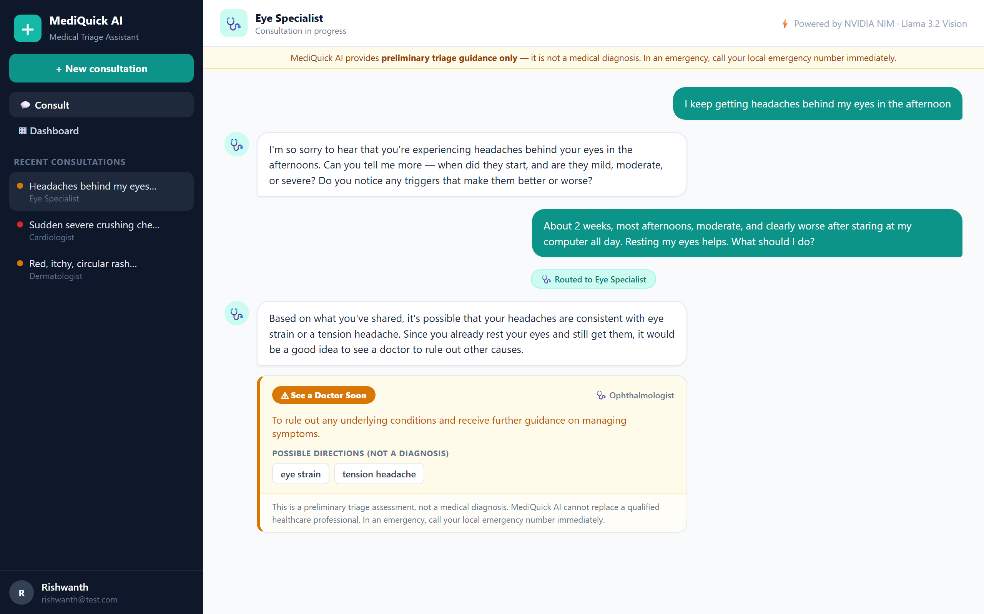
Figure 2: Conversational triage interface. The General Physician hands the session to an Eye Specialist and concludes with a colour-coded triage card. Output is from the running application against Llama 3.2 90B Vision.
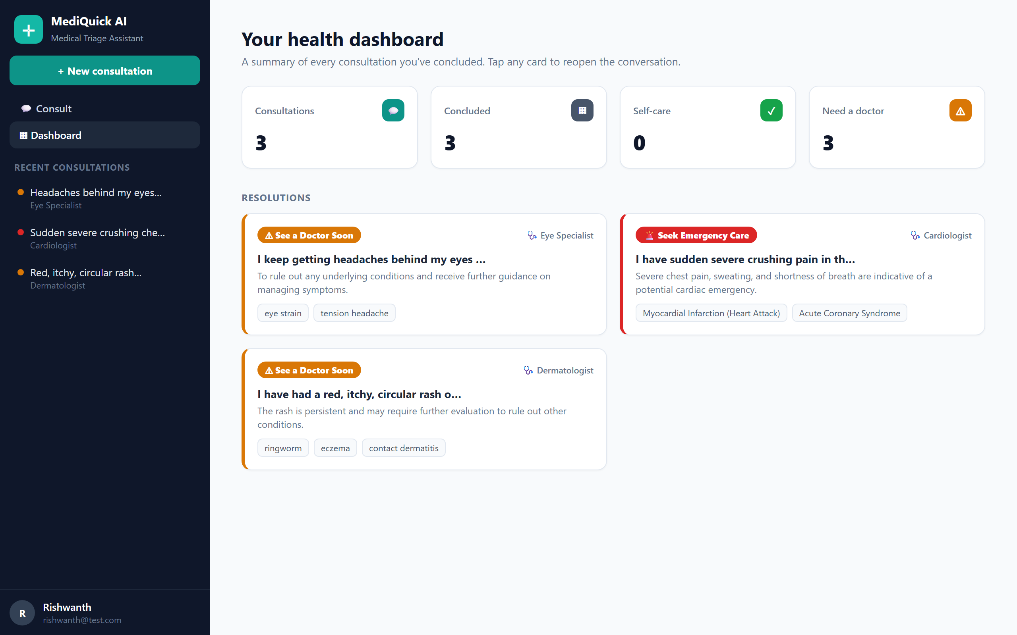
Figure 3: Health dashboard summarising concluded consultations by urgency tier and specialist — conditions only, with no medication content.
The interactive API documentation served by the running backend confirms that every endpoint — authentication, chat, upload, sessions, dashboard, and health — is registered and reachable. Figure 4 shows the live Swagger UI.
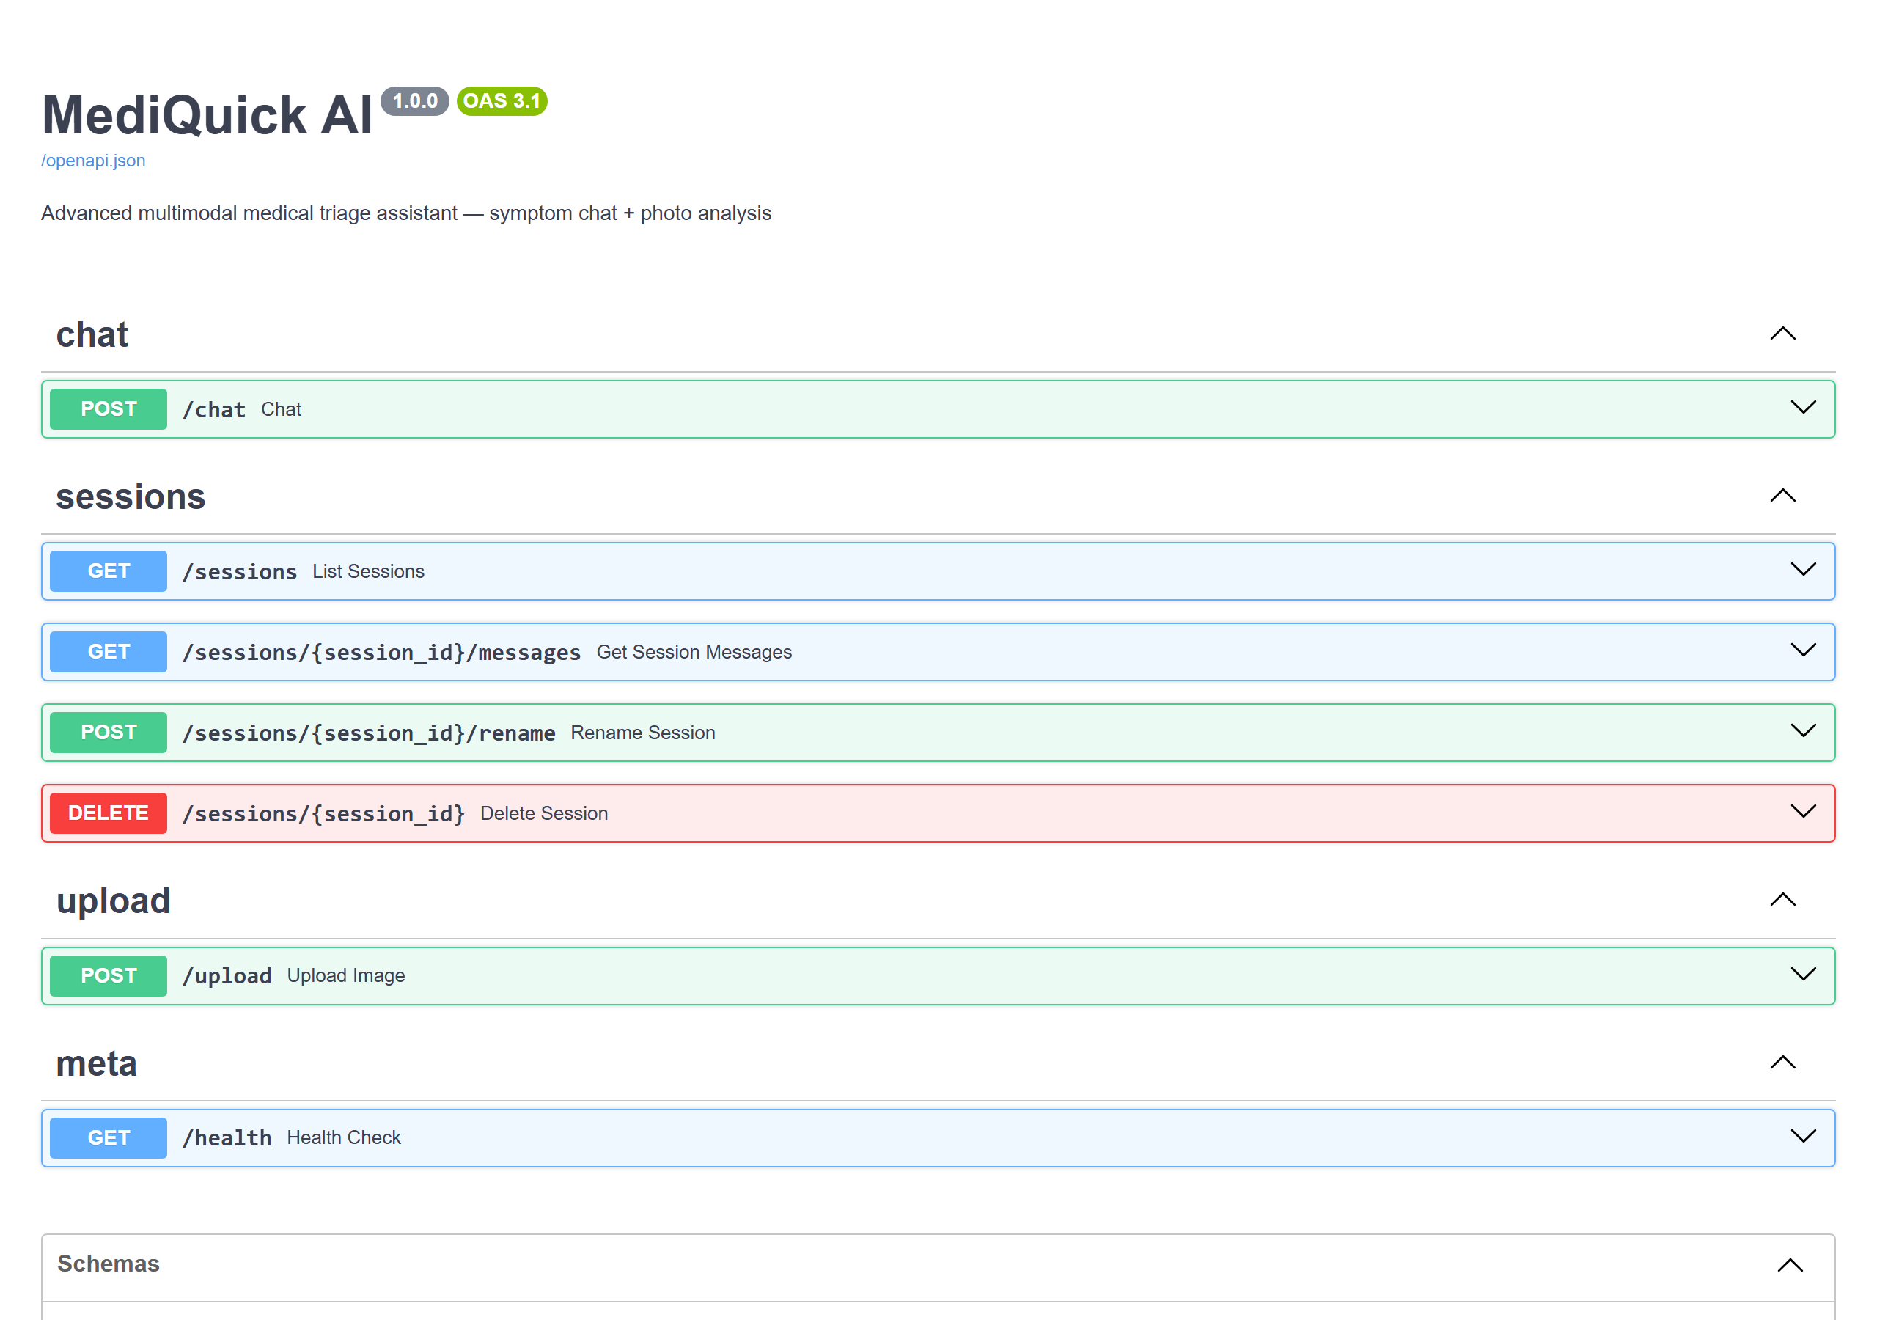
Figure 4: Live FastAPI Swagger UI from the running backend, showing the authentication, chat, sessions, upload, and dashboard endpoints.
To quantify triage quality, a structured evaluation harness submitted thirty curated scenarios — ten each in dermatology, general medicine, and minor injury, spread across all three urgency tiers — to the live model and compared the predicted urgency against ground-truth tiers derived from standard triage reference guidelines. The system classified all thirty correctly, with no unsafe under-triage (no case was rated less urgent than its true tier). Table 4 summarises the results.
Category | Scenarios | Correct | Accuracy
Dermatology | 10 | 10 | 100%
General medicine | 10 | 10 | 100%
Minor injury | 10 | 10 | 100%
Overall | 30 | 30 | 100%
Table 4: Triage evaluation results. Urgency classification was compared against standard triage reference guidelines; zero unsafe under-triage cases were observed.

5. Technical Specifications
Table 1 summarises the principal technical parameters of the system as implemented at this milestone.
Parameter | Value
Backend runtime | Python 3.11+ (asynchronous)
Web framework | FastAPI on Uvicorn
Front end | React + Vite + Tailwind CSS, Axios, React Router
Authentication | JWT (PyJWT), PBKDF2-SHA256 password hashing
AI model | meta/llama-3.2-90b-vision-instruct (configurable)
Inference platform | NVIDIA NIM — /v1/chat/completions
Inference parameters | temperature 0.3, max_tokens 1500
Database | SQLite via SQLAlchemy ORM (User, Session, Message)
Image processing | Pillow — ≤5 MB; JPEG/PNG/WEBP; resize 1024 px; JPEG q85; base64
Specialist agents | 10 expert personas with automatic routing
Output format | Strict JSON triage schema (gather → conclude)
Urgency tiers | self_care / consult_doctor / seek_emergency
Table 1: Major technical specifications of MediQuick AI.

6. Implementation Progress
The project is approximately 88% complete: the entire backend, the authentication and specialist-routing layers, the full React interface, the dashboard, and the evaluation harness are finished and were validated live. Only final polish and handover documentation remain. Table 2 details progress by phase.
Phase | Scope | Status
1. Scaffold & environment | FastAPI app, SQLite models, configuration | Completed
2. NVIDIA NIM client | Async text + vision client, error handling | Completed
3. Prompt & schema | System prompt, JSON enforcer, parser | Completed
4. Context manager | Multi-turn history, token capping | Completed
5. Image pipeline & /upload | Validate, resize, base64; endpoint | Completed
6. REST endpoints | /chat and /sessions CRUD | Completed
7. Auth & user profiles | Register, login, JWT, profile | Completed
8. Specialist-agent routing | 10 personas, handoff with context | Completed
9. React chat & triage UI | Chat window, triage card, handoff | Completed
10. Image upload, sidebar & dashboard | Upload UI, history, summaries | Completed
11. Evaluation module | 30 scenarios, accuracy report | Completed — 100%
12. Polish & handover docs | Tests, responsive pass, README | In progress
Table 2: Implementation progress by phase. All build phases are complete; only final polish and handover documentation remain.

7. Design Considerations
Several deliberate design decisions shape the system. Triage, not diagnosis, is the central ethical commitment: the prompt forbids definitive diagnoses and prescriptions, the dashboard deliberately contains no medication content, and a disclaimer is rendered on every response. Safety is enforced at two layers — the model is instructed to escalate danger signs, and the backend guarantees a safe fallback when output is malformed or the service is unavailable. Privacy is preserved by processing images only in memory and scoping all data to the authenticated user. The conversational gather-then-conclude flow makes the assistant feel like a clinician taking a history rather than a search engine, and the specialist-routing layer focuses each assessment through the most relevant expert persona. Finally, the model identifier is configurable, allowing the 90B and 11B Llama 3.2 Vision variants to be exchanged without code changes.

8. Future Plan
The remaining work is limited and constitutes final hardening rather than new capability. A closing pass will strengthen error handling and empty/loading states across the interface, add a short automated test suite for the backend services, conduct a responsive-layout review for smaller screens, and produce developer documentation — a README and setup guide — for handover. Optional enhancements under consideration include richer profile-aware context in the prompt and a printable consultation summary generated from the dashboard.

9. References
[1] FastAPI documentation. https://fastapi.tiangolo.com/
[2] NVIDIA NIM — build.nvidia.com. https://build.nvidia.com/
[3] Meta Llama 3.2 Vision models. https://ai.meta.com/llama/
[4] SQLAlchemy ORM documentation. https://docs.sqlalchemy.org/
[5] Pillow (Python Imaging Library) documentation. https://pillow.readthedocs.io/
[6] React documentation. https://react.dev/
[7] Tailwind CSS documentation. https://tailwindcss.com/
[8] JSON Web Tokens (JWT). https://jwt.io/
[9] Dunn, R., et al. (2018). The Emergency Medicine Manual (7th ed.).

