
Knowledge Transfer & Teaching Guide
How SmartEdit AI works — explained simply, with diagrams and examples
Prepared for: Shyam Sundar
June 2026

1. What is SmartEdit AI?
SmartEdit AI is a website where you can understand your money. You upload your monthly bank statement (a PDF or CSV file) — or type entries yourself — and the app reads every transaction, sorts each one into a category, shows you where your money went, and gives you smart, specific advice on how to save. There is also a chat assistant you can simply ask questions like "how much did I spend on Amazon?"
In one line: Upload your statement → see where every rupee went → get a plan for next month.

2. The big picture (architecture)
The app has a simple website on the front and a Python "brain" (Flask) at the back that stores everything in a small database. Six parts do the work: login, statement reader, category sorter, analytics, AI advisor, and the chat assistant. The picture below shows how they fit together.
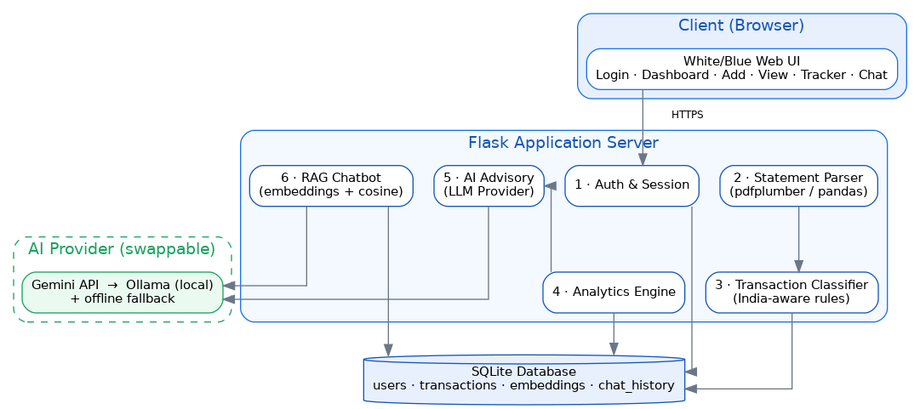
Figure 1: How the parts of SmartEdit AI fit together

3. What you can do (the five screens)
After you log in, there are five simple tabs on the left:
Screen | What you do there
Dashboard | See this month's income, expenses, savings, a category chart, and AI advice.
Add Entry | Manually add a credit (money in) or debit (money out).
View / Database | The full table of transactions; filter, change a category, or delete.
Tracker | Charts of money in vs out — daily, monthly, and by weekday.
AI Chat | Ask anything about your spending in plain language.
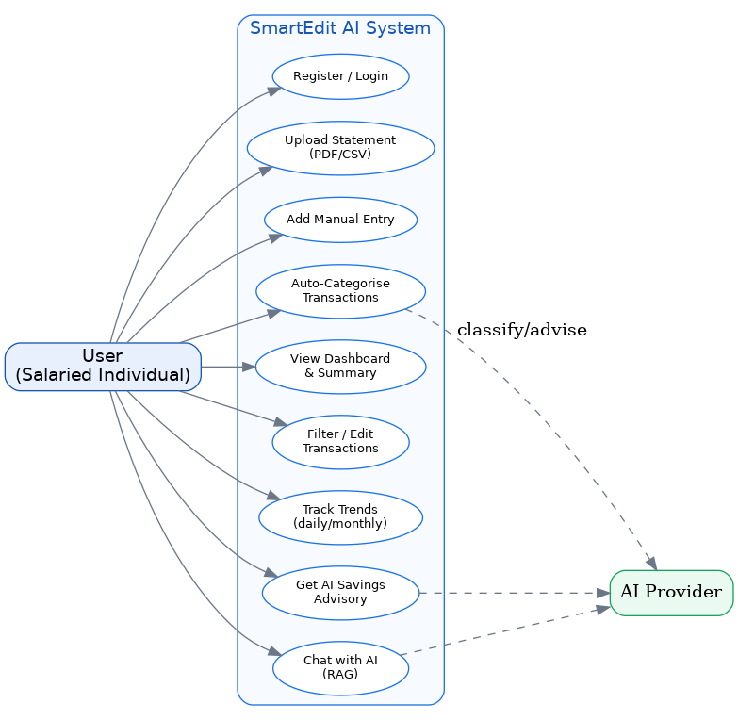
Figure 2: The things a user can do with SmartEdit AI

4. How it works behind the scenes

4.1 Reading your statement
When you upload a PDF or CSV, the app opens the file and pulls out each transaction — the date, the description, and the amount. Indian banks (SBI, HDFC, ICICI, Axis) format statements differently, so the app understands their different column styles automatically.

4.2 Sorting into categories
Bank descriptions are cryptic — like 'UPI-SWIGGY-OKAXIS-XXXX'. The app recognises keywords and files each transaction under the right category:
- SWIGGY / ZOMATO → Food & Dining
- LIC / PREMIUM → Insurance
- NETFLIX / SPOTIFY → Subscriptions
- AMAZON / FLIPKART → Shopping
If it isn't sure, it uses 'Others' and you can correct it in one click on the View screen.

4.3 The AI advice
The app summarises your spending and asks the AI for specific savings ideas — with real rupee amounts, not vague tips.

4.4 The chat assistant (RAG)
When you ask a question, the assistant finds the transactions most related to your question AND calculates exact totals from the database, then writes a clear, correct answer. The flow is shown below.
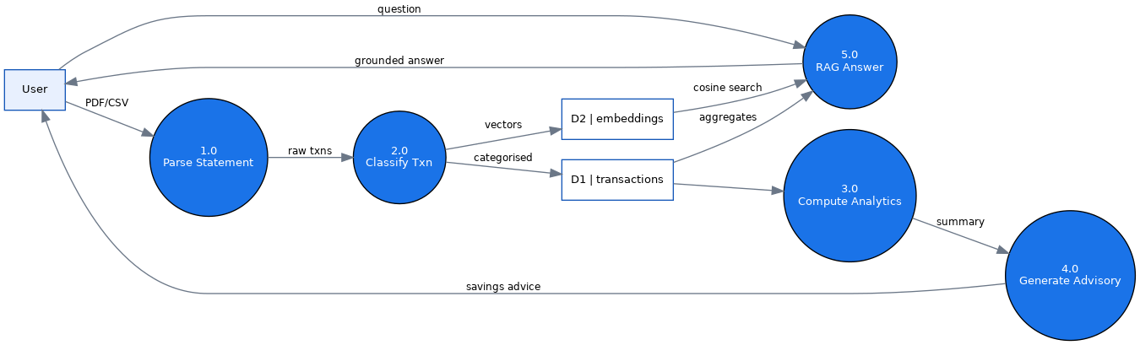
Figure 3: How data flows from upload to advice and answers

5. A worked example (start to finish)
Here is exactly what happens using the sample statement included with the app (sample_data/sample_statement.csv, one month of data).

Step 1 — Upload
You register, land on the empty dashboard, and upload the sample CSV. The app reads 30 transactions in a second.

Step 2 — Automatic sorting
Each cryptic row becomes a clean, categorised entry. A few examples from the sample:
Raw bank text | Becomes | Category
SALARY CREDIT ACME TECH PVT LTD | Salary Credit Acme Tech | Income
UPI-SWIGGY-OKAXIS-XXXX1234 | Swiggy | Food & Dining
NACH-LIC PREMIUM-AUTODEBIT | Lic Premium Autodebit | Insurance
POS-4521-RELIANCE FRESH | Reliance Fresh | Groceries
EMI HDB FINANCIAL CARLOAN | Hdb Financial Carloan | EMI / Loans
AMAZON PAY INDIA ORDER | Amazon Pay India Order | Shopping

Step 3 — Dashboard fills in
The dashboard now shows the month at a glance (from the sample data):
- Total income: about Rs.68,310
- Total expenses: about Rs.63,162
- Savings: about Rs.5,148 (an 8% savings rate)
- A doughnut chart of spending by category, and the AI advisory panel.

Step 4 — Ask the chat assistant
Now you can just ask questions. Real examples and the kind of answer you get:
You ask | SmartEdit AI answers
How much did I spend on Swiggy? | You spent Rs.1,348 on Swiggy across 3 transactions.
How much went to Amazon? | You spent Rs.3,998 on Amazon across 2 transactions.
How can I save more money? | A short plan: your biggest discretionary areas are Food and Shopping; capping food delivery to 3 orders/week frees roughly Rs.800/month, and you are about Rs.8,500 short of a 20% savings rate.
Because the numbers come straight from your database, the answers are accurate — the AI is not guessing.

6. How YOU add or edit entries
You are fully in control of your data:
- Add: Add Entry tab → choose Credit or Debit → type the amount and a short description → Save. The category is detected automatically (or pick one).
- Re-categorise: View / Database tab → use the dropdown in the Category column → choose the right category. It updates instantly.
- Delete: View / Database tab → click the X button on a row → confirm.

7. Setting it up and running it
On a Windows machine, it is two double-clicks:
- Double-click setup.bat — installs everything and creates a .env file.
- Open .env, paste your Gemini API key, and save.
- Double-click run.bat — starts the app and opens the browser.
Prefer the command line? From the project folder:
setup.bat
REM edit .env to add GEMINI_API_KEY
run.bat
The app opens at http://127.0.0.1:5000. Full step-by-step details are in SETUP_GUIDE.md.

8. About the AI model
Right now the app uses the Gemini API (a free key from Google). It is designed so we can later switch to a fully local model with Ollama — your financial data never leaves the computer. Changing it is a single setting (LLM_PROVIDER) in the .env file; nothing else changes. If there is ever no internet or no key, the app still works using a built-in offline advisor and search, so a demo never fails.
Setting in .env | Meaning
LLM_PROVIDER=gemini | Use the Gemini API (needs a free key)
LLM_PROVIDER=ollama | Use a local model on your own machine (private)
LLM_PROVIDER=fallback | Work fully offline with built-in logic

9. Quick glossary
Term | Simple meaning
PDF/CSV parsing | Reading transactions out of your statement file automatically
Category | The bucket a transaction goes into (Food, Travel, EMI, etc.)
Credit / Debit | Money coming in / money going out
Savings rate | What share of your income you kept this month
RAG | A method where the AI first looks up your real data, then answers
Embedding | Turning text into numbers so similar things can be matched
Cosine similarity | A way to measure how close two pieces of text are in meaning
Ollama | A tool to run an AI model privately on your own computer
You're all set. Upload a statement, explore the tabs, and ask the assistant anything.

