
SMARTEDIT AI – AN INTELLIGENT PERSONAL FINANCE WEB APPLICATION FOR INDIAN SALARIED USERS
BITS ZG628T: Dissertation
by
Shyam Sundar
(Insert Student ID Number)
Dissertation work carried out at
(Insert Organization Name, Location Name)
Submitted in partial fulfilment of (Insert Programme Name)
degree programme
Under the Supervision of
(Insert Supervisor Name)
(Insert Organization Name, Location Name)
BIRLA INSTITUTE OF TECHNOLOGY & SCIENCE
PILANI (RAJASTHAN)
June 2026

ABSTRACT
SmartEdit AI is an intelligent personal finance management web application designed for Indian salaried users. The system reads a user's bank statement — uploaded as a PDF or CSV — extracts every transaction, classifies cryptic Indian payment descriptions (UPI, NEFT, NACH, POS, IMPS) into meaningful expense categories, and presents a clear financial dashboard of income, expenses, savings and category-wise spending trends.
Indian bank statements are not standardised: SBI, HDFC, ICICI and Axis each issue statements in different layouts, and transaction descriptions are cryptic abbreviations that convey little to the user. SmartEdit AI addresses three gaps that no existing tool solves together — structured extraction of transactions from Indian bank statements, automatic India-aware classification, and an AI advisory layer that reads the user's actual financial pattern to generate specific, reasoned, rupee-level savings suggestions rather than generic tips.
The application is built with Flask and SQLite. Statement parsing uses pdfplumber and pandas; transaction classification uses an interpretable, India-aware rule engine. The AI advisory and a Retrieval-Augmented Generation (RAG) chatbot are powered by a large language model accessed through a swappable provider layer (Gemini API in the current build, with a fully local Ollama model planned for the privacy-first final version). The RAG chatbot embeds the user's transactions and uses cosine-similarity search together with exact SQL aggregates so that answers are grounded in real data and never hallucinated. This mid-semester report describes the system design, methodology, implementation status and plan of work to completion.

Signature of the Student  Name:  Date:  Place: | Signature of the Supervisor  Name:  Date:  Place:

CONTENTS
1. INTRODUCTION 1
2. MODULES IN SMARTEDIT AI 1
3. SYSTEM ARCHITECTURE / FUNCTIONAL BLOCK DIAGRAM 1
4. METHODOLOGY 1
5. DATABASE DESIGN 1
6. AI ADVISORY AND RAG CHATBOT 1
7. SYSTEM DESIGN DIAGRAMS 1
8. IMPLEMENTATION STATUS AND RESULTS 1
9. FUTURE PLAN 1
10. ABBREVIATIONS 1
11. REFERENCES 1

List of Figures
Figure 1: System Architecture
Figure 2: Entity-Relationship Diagram
Figure 3: Data-Flow Diagram
Figure 4: Sequence Diagram — RAG Chatbot Query
Figure 5: Use-Case Diagram
Figure 6: Class Diagram
Figure 7: Sequence Diagram — Statement Upload
Figure 8: Component Diagram
List of Tables
Table 1: Implementation Status
Table 2: Plan of Work (Future Plan)
Table 3: Abbreviations

1. INTRODUCTION
Almost every salaried person, at the end of the month, opens their bank account and wonders where the money went. The rent is remembered and a few grocery runs, but the rest — food delivery, random UPI transfers, forgotten subscriptions — is a blur. The statement exists as a PDF, but reading 80 rows of strings such as 'POS-4521-RELIANCE' or 'UPI-SWIGGY-OKAXIS-XXXX' communicates almost nothing useful.
SmartEdit AI is a web application that turns this raw statement into understanding. It reads the statement, classifies every transaction, shows where the money went, and provides AI-generated, data-grounded savings advice through both an advisory panel and a conversational chatbot. The objectives of the project are: to build a web app accepting PDF/CSV statements and manual entries; to parse Indian bank statement formats; to classify cryptic descriptions into categories; to present a finance dashboard; to generate explainable AI savings advice; to provide a RAG chatbot; and to support a fully local LLM for privacy in the final version.

2. MODULES IN SMARTEDIT AI
SmartEdit AI is organised as a modular client–server system. A lightweight white-and-blue web frontend communicates over HTTP with a Flask application server composed of six cooperating modules. The major components are listed below and illustrated in Figure 1.
- Authentication & Session — registration, login, hashed passwords and session management.
- Statement Parser — extracts transactions from uploaded PDF/CSV bank statements (pdfplumber, pandas).
- Transaction Classifier — India-aware rule engine mapping descriptions to 17 expense categories.
- Analytics Engine — computes monthly summaries, savings rate, category breakdowns and trends.
- AI Advisory — generates specific, rupee-level savings advice via a swappable LLM provider.
- RAG Chatbot — answers free-form questions using transaction embeddings, cosine search and SQL aggregates.

3. SYSTEM ARCHITECTURE / FUNCTIONAL BLOCK DIAGRAM
The frontend renders the Dashboard, Add-Entry, View/Database, Tracker and Chat screens, and communicates with the Flask server, which coordinates the six modules above. All data persists in a single SQLite database holding users, transactions, embeddings and chat history. The AI provider is abstracted behind a common interface, allowing the system to switch from the Gemini API (current build) to a local Ollama model (final build) without any other code change. The functional block diagram is shown in Figure 1.
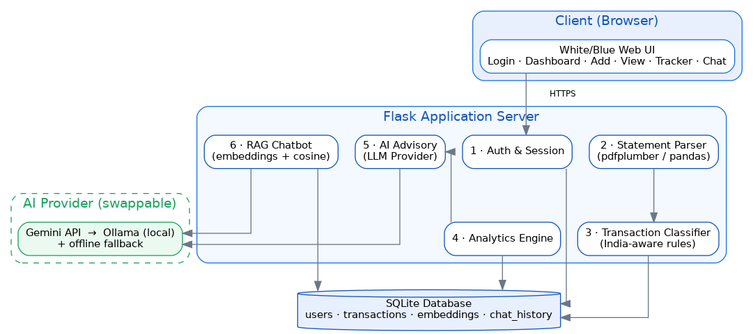
Figure 1: System Architecture of SmartEdit AI

4. METHODOLOGY

4.1 Statement Parsing
The parser dispatches by file type. CSV files are read with pandas, auto-mapping common Indian column names (Date, Narration/Particulars, Debit/Credit, Withdrawal/Deposit). PDF statements are parsed with pdfplumber, which extracts tables page by page. Each row is normalised into a (date, description, amount, type) tuple, handling mixed date formats, Indian thousands separators (e.g. 1,23,456.00), separate debit/credit columns and multi-line descriptions.

4.2 Transaction Classification
Classification uses an interpretable, India-aware rule engine that scans the raw description for keyword patterns and maps it to one of seventeen categories — for example SWIGGY/ZOMATO to Food & Dining, LIC/PREMIUM to Insurance, NETFLIX/SPOTIFY to Subscriptions, AMAZON/FLIPKART to Shopping. Payment-method markers (UPI, NEFT, NACH, POS, IMPS) are detected and stored separately for reporting. Descriptions matching no rule fall to 'Others' and can be re-categorised by the user; these flagged cases motivate the lightweight ML classifier planned for the next phase. The end-to-end data flow is shown in Figure 3.
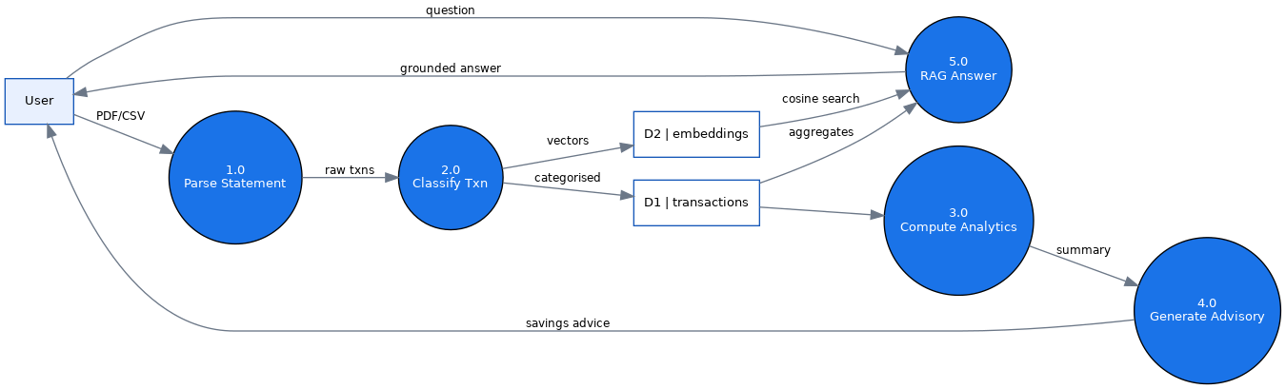
Figure 3: Data-Flow Diagram

5. DATABASE DESIGN
The schema comprises four tables. A user owns many transactions and chat messages; each transaction has exactly one embedding vector used by RAG retrieval. This normalised design keeps the data model simple while supporting analytics, full transaction history and semantic search. The entity-relationship diagram is shown in Figure 2.
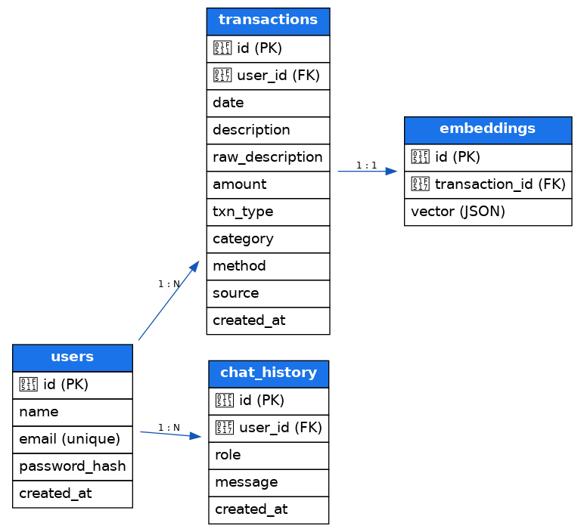
Figure 2: Entity-Relationship Diagram of the SmartEdit AI Database

6. AI ADVISORY AND RAG CHATBOT

6.1 AI Savings Advisory
The advisory module builds a chain-of-thought prompt from the categorised monthly summary and month-on-month trend, then calls the active LLM provider. The result is specific and quantified — for example, 'your Swiggy and Zomato spend this month is Rs.1,348; capping to three orders per week would save approximately Rs.800 next month' — rather than generic advice. When no provider is reachable, a deterministic rule-based advisor produces equivalent rupee-level guidance so demonstrations never fail.

6.2 Retrieval-Augmented Generation
The chatbot follows a classic RAG pipeline. The user's question is embedded with a sentence-transformers model (all-MiniLM-L6-v2, 384 dimensions); the same embeddings are pre-computed for every stored transaction. Cosine similarity performs a symmetric search to retrieve the most relevant transactions. In parallel, exact SQL aggregates are computed for any merchant or category the user names, so quantitative answers are precise and never hallucinated. Retrieved rows plus aggregates are injected into the LLM prompt to produce a grounded natural-language answer, as shown in Figure 4.
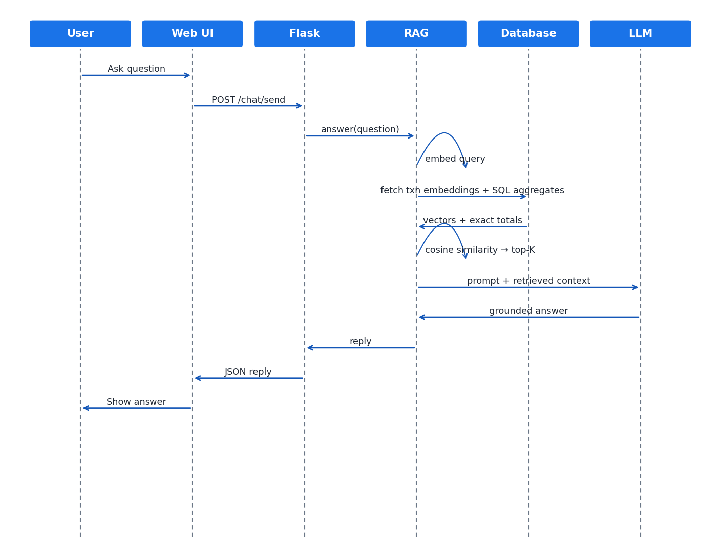
Figure 4: Sequence Diagram — RAG Chatbot Query

7. SYSTEM DESIGN DIAGRAMS

7.1 Use-Case Diagram
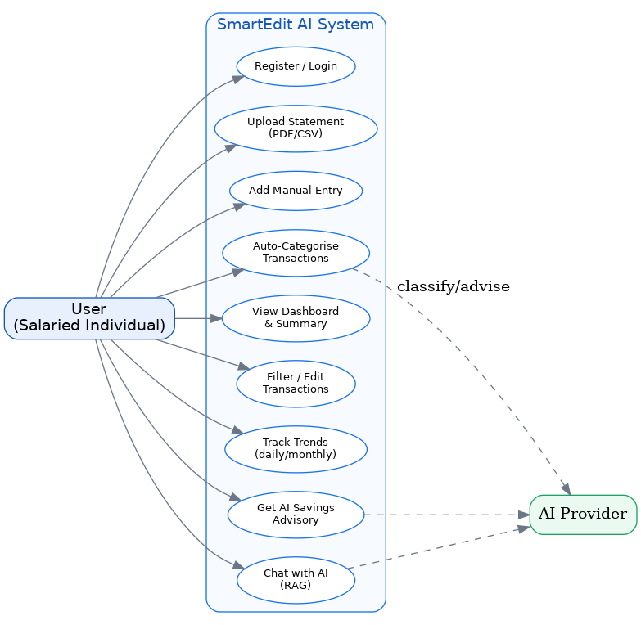
Figure 5: Use-Case Diagram

7.2 Class Diagram
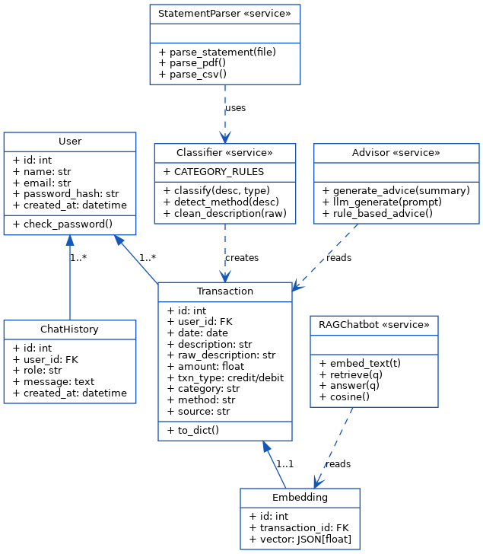
Figure 6: Class Diagram

7.3 Sequence Diagram — Statement Upload
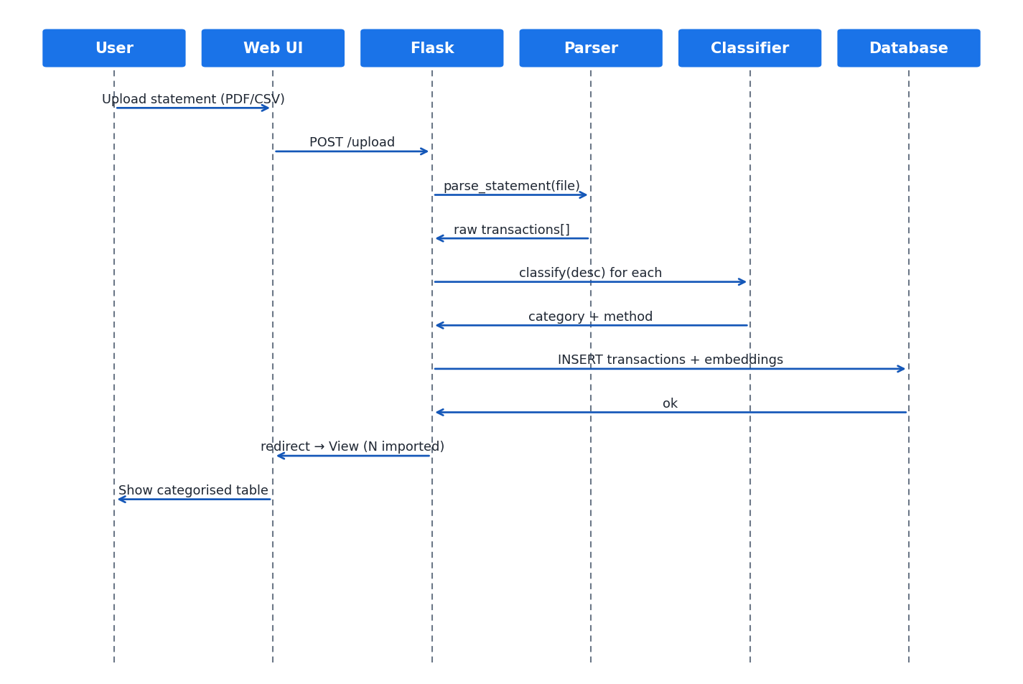
Figure 7: Sequence Diagram — Statement Upload

7.4 Component Diagram
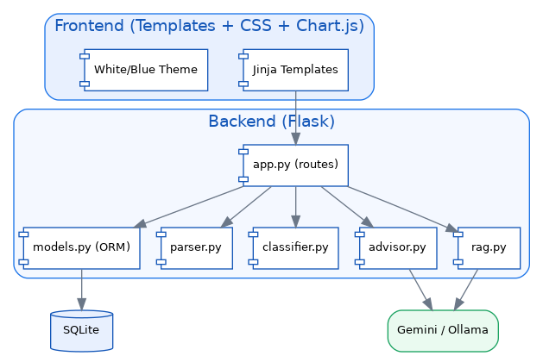
Figure 8: Component Diagram

8. IMPLEMENTATION STATUS AND RESULTS
The core application is implemented and verified end-to-end. The technology stack is Flask, SQLAlchemy over SQLite, pdfplumber and pandas for parsing, sentence-transformers for embeddings, and a provider-abstracted LLM layer. On a representative one-month sample statement of thirty transactions, the parser extracted all rows correctly, the classifier assigned them across categories including Income, Food & Dining, Groceries, Transport, Subscriptions, Shopping, Utilities, Insurance, EMI/Loans, Investments, Entertainment and Health, the dashboard computed total income, expenses, savings and savings rate, and the chatbot returned exact totals for merchant queries using the SQL-aggregate grounding.
Module | Status | Notes
Authentication | Complete | Register/login, hashed passwords, sessions
Statement parser | Complete | CSV + PDF; Indian column auto-mapping
Classifier | Complete | 17 categories; UPI/NEFT/NACH/POS aware
Dashboard & analytics | Complete | Income/expense/savings, category chart
Tracker | Complete | Daily/monthly/weekday charts
AI advisory | Complete | Gemini + deterministic fallback
RAG chatbot | Complete | Embeddings + cosine + SQL aggregates
Ollama local model | Pending | Provider swap in final phase
ML classifier | Pending | For ambiguous descriptions
Table 1: Implementation Status

9. FUTURE PLAN
Sl No | Phase | Start – End | Work to be done | Status
1 | Dissertation outline | Completed | Literature review; system design & outline | COMPLETED
2 | Core development | Completed | Parser, classifier, dashboard, advisory, RAG chat | COMPLETED
3 | Enhancement | Now – Wk 4 | More bank PDF formats; ML classifier for edge cases | IN PROGRESS
4 | Salary module | Wk 5 – 6 | Indian CTC/PF/HRA/TDS model and savings goals | PENDING
5 | Local AI | Wk 7 – 8 | Swap Gemini to local Ollama; evaluate advisory | PENDING
6 | Submission | Wk 9 – 10 | End-to-end testing, documentation, final demo | PENDING
Table 2: Plan of Work (Future Plan)

10. ABBREVIATIONS
Abbreviation | Expansion
AI | Artificial Intelligence
API | Application Programming Interface
CSV | Comma-Separated Values
CTC | Cost To Company
EMI | Equated Monthly Instalment
HRA | House Rent Allowance
IMPS | Immediate Payment Service
LLM | Large Language Model
NACH | National Automated Clearing House
NEFT | National Electronic Funds Transfer
NLP | Natural Language Processing
ORM | Object-Relational Mapping
PDF | Portable Document Format
PF | Provident Fund
POS | Point Of Sale
RAG | Retrieval-Augmented Generation
SQL | Structured Query Language
TDS | Tax Deducted at Source
UPI | Unified Payments Interface
Table 3: Abbreviations

11. REFERENCES
- Devlin, J. et al. (2019). BERT: Pre-training of Deep Bidirectional Transformers for Language Understanding. NAACL.
- Wei, J. et al. (2022). Chain-of-Thought Prompting Elicits Reasoning in Large Language Models. NeurIPS.
- Kang, S. & Ma, J. (2021). Automated Personal Finance Management Using NLP and Machine Learning. IEEE Big Data.
- Thaler, R. H. & Sunstein, C. R. (2008). Nudge: Improving Decisions About Health, Wealth, and Happiness. Yale University Press.
- Reserve Bank of India (2023). Annual Report on Digital Payments in India.
- pdfplumber — https://github.com/jsvine/pdfplumber ; sentence-transformers — https://www.sbert.net ; Ollama — https://ollama.com

