Regression Analysis Course Project

Vicki Cocco

June 24, 2017

## R Markdown

|  |
| --- |
| ## Synopsis: |
| > Part 2: Basic Inferential Data Analysis Instructionsless > The second part documents a basic inferential data analysis involving tooth growth. > Hypotheses regarding Vitamin C doses and delivery methods are tested. |
| ### Requirement 1. Load the ToothGrowth data and perform some basic exploratory data analysis. |
| ### Requirement 2. Provide some a basic summary of the data. |
| #### Organizing the required R libraries |
| r install.packages('dplyr', repos="http://cran.rstudio.com/") library(dplyr) install.packages('dtplyr', repos="http://cran.rstudio.com/") library(dtplyr) install.packages('ggplot2', repos="http://cran.rstudio.com/") library(ggplot2) ### Data Exploratory and Modifications |
| ####The data was obtained along with the requirement package #### The following information is given by the command ?toothgrowth in R |
| #### Example of the Raw Data after forming it to a table data structure |
| r knitr::kable(head(dtCars)) |
| mpg gears Transmission |

21.0 4 Manual  
21.0 4 Manual  
22.8 4 Manual  
21.4 3 Automatic  
18.7 3 Automatic  
18.1 3 Automatic

knitr::kable(head(dtManCars))

|  |  |  |
| --- | --- | --- |
| mpg | gears | Transmission |
| 21.0 | 4 | Manual |
| 21.0 | 4 | Manual |
| 22.8 | 4 | Manual |
| 32.4 | 4 | Manual |
| 30.4 | 4 | Manual |
| 33.9 | 4 | Manual |

knitr::kable(head(dtAutoCars))

|  |  |  |
| --- | --- | --- |
| mpg | gears | Transmission |
| 21.4 | 3 | Automatic |
| 18.7 | 3 | Automatic |
| 18.1 | 3 | Automatic |
| 14.3 | 3 | Automatic |
| 24.4 | 4 | Automatic |
| 22.8 | 4 | Automatic |

#### Showing the first regression analysis - MPG against both types of transmissions

#### All cars.

fitall <- lm(mpg ~Transmission, dtCars)  
  
 print(summary(fitall))

##   
## Call:  
## lm(formula = mpg ~ Transmission, data = dtCars)  
##   
## Residuals:  
## Min 1Q Median 3Q Max   
## -9.3923 -3.0923 -0.2974 3.2439 9.5077   
##   
## Coefficients:  
## Estimate Std. Error t value Pr(>|t|)   
## (Intercept) 17.147 1.125 15.247 1.13e-15 ***  
## TransmissionManual 7.245 1.764 4.106 0.000285 ***  
## ---  
## Signif. codes: 0 '***' 0.001 '**' 0.01 '*' 0.05 '.' 0.1 ' ' 1  
##   
## Residual standard error: 4.902 on 30 degrees of freedom  
## Multiple R-squared: 0.3598, Adjusted R-squared: 0.3385   
## F-statistic: 16.86 on 1 and 30 DF, p-value: 0.000285

#### Showing the first plot - MPG against both types of transmissions

#### All cars.

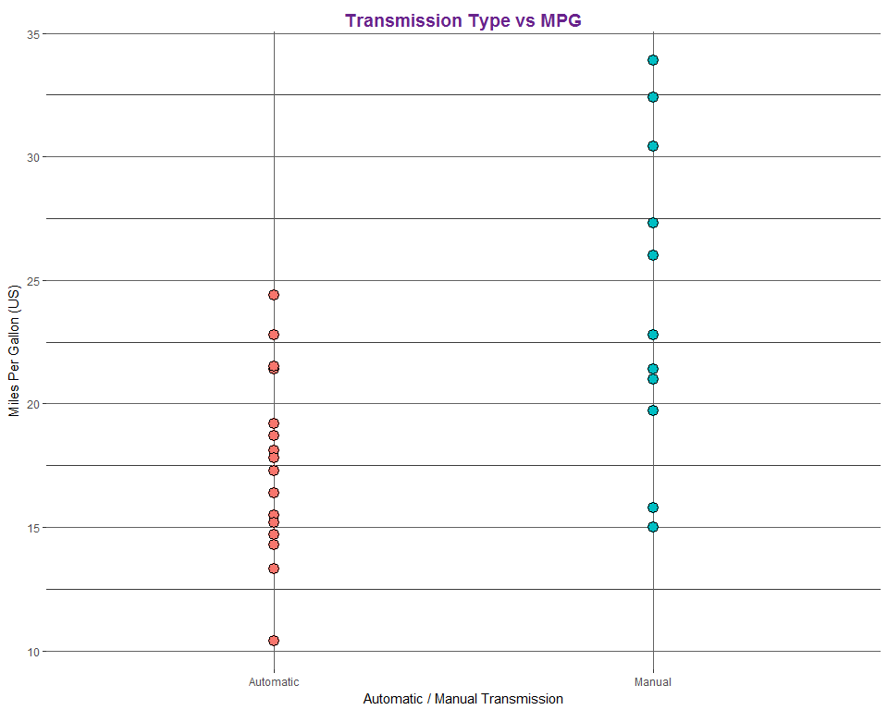

### Fourth Hypothesis

#### H_0 - Status Quo Toothgrowth Length

#### H_a - A Dose of 1, through either delivery method, improves tooth growth

#### T-Test Length ~ Dose @ 2

#### Outcome : The p-value is small showing that it is unlikely these results would be

#### obtained without the impact of the dose.

#### The alternative hypothesis should be accepted.

### Conclusions:

### The delivery method of Vitamin C has no impact on tooth growth.

### The dose level of Vitamin C has varying impacts, with the dose level of

### 2.0 mg/day having the greatest improvement on tooth growth.