UNIVERSITY OF UYO, UYO
FACULTY OF COMPUTING
DEPARTMENT OF COMPUTER SCIENCE
DESIGN AND IMPLEMENTATION OF AN AI-POWERED
NETWORK THREAT DETECTION SYSTEM IN RESOURCE
CONSTRAINED ENVIRONMENTS
BY
IMEH GRACE MFON
21/SC/CO/1117
A PROJECT REPORT SUBMITTED TO THE DEPARTMENT OF COMPUTER SCIENCE,
FACULTY OF COMPUTING, UNIVERSITY OF UYO, UYO,

IN PARTIAL FULFILMENT OF THE REQUIREMENTS FOR THE AWARD OF
BACHELOR OF SCIENCE (B.Sc.) DEGREE IN COMPUTER SCIENCE
AUGUST, 2026

DECLARATION
I declare that this project report, entitled “Design and Implementation of an AI-Powered Network Threat Detection System in Resource Constrained Environments”, is my original work carried out under the guidance of the Department of Computer Science, University of Uyo. All sources consulted have been acknowledged in the references.
______________________________ __________________
Student’s Signature Date

CERTIFICATION
This project report has been read and approved as meeting the requirements for the award of the Bachelor of Science degree in Computer Science, University of Uyo.
______________________________ __________________
Mr U. J. Ntia, Project Supervisor Date
______________________________ __________________
Head of Department Date

DEDICATION
This work is dedicated to God Almighty and to all individuals who support the development of accessible and practical cybersecurity solutions for resource-constrained environments.

ACKNOWLEDGEMENTS
The researcher appreciates God Almighty for the strength and wisdom to complete this work. Appreciation is also extended to the project supervisor, the lecturers of the Department of Computer Science, the researcher’s family, colleagues, and all those who provided academic, technical, and moral support during the study.

ABSTRACT
Network threat detection in resource-constrained environments requires a balance between detection quality and computational efficiency. This project designs an AI-powered network threat detection system intended for Raspberry Pi-class deployment. The system uses CICIDS2017 and UNSW-NB15 as benchmark datasets and applies cleaning, categorical encoding, standardisation, Principal Component Analysis, and SMOTE combined with Tomek Links. A hybrid Convolutional Neural Network and Long Short-Term Memory model is designed to learn local traffic-feature patterns and temporal relationships across sequences of ten flow records. The trained model is further prepared for edge execution through dynamic-range quantization and TensorFlow Lite conversion; pruning and quantization-aware-training fine-tuning are documented as unexecuted optimization extensions because of tool compatibility constraints. The report specifies the implementation, evaluation metrics, baseline comparisons, logging database, dashboard, and constrained-resource testing procedure. The UNSW-NB15 experiment produced verified training, test-set, TensorFlow Lite conversion, and simulated constrained-environment benchmark artefacts. The CICIDS2017 experiment was completed using a documented 200,000-row class-capped subset of the official machine-learning archive. Physical Raspberry Pi measurements, power draw, and pruning or quantization-aware-training fine-tuning remain limitations. The resulting implementation demonstrates a reproducible foundation for validating a lightweight network-threat detector under a defined CPU and memory budget.
Keywords: network threat detection; CNN–LSTM; PCA; SMOTE; Tomek Links; TensorFlow Lite; Raspberry Pi; resource-constrained environment.

Table of Contents
CHAPTER ONE 10
1.1 Background of the Study 10
1.2 Motivation 14
1.3 Statement Of Problem 14
1.4 Aim and Objectives 15
1.5 Methodology 16
1.6 Scope of the Study 17
1.7 Significance of the Study 17
1.8 Definition of Terms 18
CHAPTER TWO 20
2.1 INTRODUCTION 20
2.2 TRADITIONAL (NON AI POWERED) NETWORK THREAT DETECTION SYSTEMS 20
2.3 AI POWERED NETWORK THREAT DETECTION SYSTEMS 21
2.4 COMPARISON OF AI POWERED AND NON AI POWERED NETWORK THREAT DETECTION SYSTEMS IN RESOURCE CONSTRAINED ENVIRONMENTS 23
2.5 BENEFITS OF AI POWERED NETWORK THREAT DETECTION 24
2.6 JUSTIFICATION FOR THE CHOICE OF CNN AND LSTM 25
2.7 REVIEW OF RELATED LITERATURE 26
2.8 RESEARCH GAP 29
CHAPTER THREE 30
SYSTEM DESIGN AND METHODOLOGY 30
3.1 Introduction 30
3.2 Research Methodology 30
3.3 Analysis of the Existing System 31
3.4 Limitations of the Existing System 32
3.5 Objectives of the Proposed System 33
3.6 Proposed Six-Layer System Architecture 33
3.7 Dataset Design and Data Partitioning 36
3.8 Data-Preprocessing Pipeline 36
3.8.1 PCA transformation in the UNSW-NB15 experiment 38
3.8.2 CICIDS2017 integration procedure 39
3.9 Hybrid CNN–LSTM Model Design 40
3.10 Model-Compression Pipeline 41
3.11 Functional and Non-Functional Requirements 42
3.12 Database and Interface Design 43
3.13 Evaluation Design 44
3.14 Chapter Summary 45
CHAPTER FOUR 46
SYSTEM IMPLEMENTATION AND RESULTS 46
4.1 Introduction 46
4.2 Development Environment and Tools 46
4.3 Dataset Acquisition and Inspection 47
4.4 Practical Data Preprocessing 48
4.5 Baseline and Hybrid Model Implementation 48
4.6 Training Procedure 49
4.7 Model Compression and TensorFlow Lite Conversion 50
4.8 Detection Service, Logging, and Dashboard 51
4.9 Evaluation Results 52
4.10 Raspberry Pi or Constrained-Environment Evaluation 59
4.10.1 Deployment preparation 60
4.10.2 Applying the simulated resource ceiling 60
4.10.3 Benchmark acceptance procedure 61
4.11 Discussion of Results 62
4.12 Chapter Summary 63
CHAPTER FIVE 63
SUMMARY, CONCLUSION, AND RECOMMENDATIONS 63
5.1 Introduction 63
5.2 Summary of the Study 63
5.3 Achievement of Research Objectives 64
5.4 Conclusion 65
5.5 Limitations of the Study 66
5.6 Recommendations 66
5.7 Final Statement 67
References 68
APPENDIX A: EXPERIMENT PROTOCOL SUMMARY 70
APPENDIX B: IMPLEMENTATION ARTEFACT CHECKLIST 71
APPENDIX C: STATUS OF EXPERIMENTAL EVIDENCE 71

LIST OF FIGURES
Figure 3.1: Existing architecture of a conventional signature- and rule-based network intrusion detection system. 32
Figure 3.2: Six-layer architecture of the proposed AI-powered network threat detection system. 34
Figure 3.3: End-to-end training, conversion, and runtime data flow for the proposed system. 35
Figure 4.1: Training and validation loss and accuracy for the UNSW-NB15 models. 50
Figure 4.2: Training and validation loss and accuracy for the CICIDS2017 models. 50
Figure 4.3: UNSW-NB15 CNN-only confusion matrix. 54
Figure 4.4: UNSW-NB15 LSTM-only confusion matrix. 55
Figure 4.5: UNSW-NB15 CNN–LSTM confusion matrix. 56
Figure 4.6: CICIDS2017 CNN-only confusion matrix. 57
Figure 4.7: CICIDS2017 LSTM-only confusion matrix. 58
Figure 4.8: CICIDS2017 CNN–LSTM confusion matrix. 59

LIST OF TABLES
Table 3.1: Research and implementation increments. 31
Table 3.2: Dataset properties and project roles. 36
Table 3.3: Layer-by-layer configuration of the hybrid CNN–LSTM model. 40
Table 3.4: Functional requirements. 42
Table 3.5: Non-functional requirements. 43
Table 3.6: Resource measures and measurement methods. 45
Table 4.1: Development environment and tools. 46
Table 4.2: Dataset inspection results. 47
Table 4.3: Preprocessing results. 48
Table 4.4: Training configuration. 49
Table 4.5: Model compression and TensorFlow Lite conversion results. 51
Table 4.6: Detection results. 53
Table 4.7: Constrained-environment benchmark results. 62
Table 5.1: Achievement of research objectives. 65

CHAPTER ONE
INTRODUCTION

1.1 Background of the Study
The rapid expansion of digital networks, especially in emerging economies such as Nigeria, has significantly broadened the cyber threat landscape. Traditional signature-based Intrusion Detection Systems (IDS) depend heavily on known attack patterns and often fail to detect zero-day exploits, polymorphic malware, ransomware, and AI-assisted threats including automated phishing and deepfake-driven social engineering.
Over the past decade, the volume, sophistication, and economic impact of cyberattacks have grown at an unprecedented pace. Global cybercrime is now estimated to cost the world economy trillions of dollars each year, and the burden falls disproportionately on developing regions where defensive capacity is thin. In Africa, and Nigeria in particular, the rapid spread of internet access, mobile money, and digital public services has widened the surface that attackers can reach. Modern adversaries no longer rely solely on manual intrusion attempts. They increasingly weaponise artificial intelligence to automate reconnaissance, generate convincing phishing campaigns, craft polymorphic malware that mutates to evade detection, and orchestrate large scale botnet activity. The practical consequence is that the defensive tools deployed by most organisations are now contending with attacks that adapt faster than the rules written to stop them.
Traditional intrusion detection systems were designed for a slower and more predictable threat environment. Signature based detection works by matching observed traffic against a database of known attack patterns, which makes it effective against documented threats but fundamentally blind to anything it has not seen before. As a result, zero day exploits, novel malware variants, and machine generated attack traffic frequently pass through undetected. Rule based and heuristic systems improve on this slightly, yet they demand continuous manual tuning, produce high volumes of false alarms, and struggle to generalise across the diverse traffic patterns found in live networks. The overhead of keeping signature databases current is itself a barrier for under resourced organisations, which often run outdated or unpatched detection software. These structural weaknesses explain why even well established perimeter defences are routinely bypassed in contemporary breaches.
These limitations become even more pronounced in resource-constrained environments. A resource-constrained environment (RCE) is an environment which typically feature limited presence of crucial elements such computational power, intermittent connectivity, memory, funding, time and modest hardware commonly used by Nigerian small and medium enterprises (SMEs), fintech firms, and public institutions (Kong et al., 2015)
Resource constrained environments deserve closer attention because they represent the everyday operating reality for the majority of organisations in emerging economies rather than an exceptional case. Such environments are defined by a combination of limited processing power, small memory budgets, restricted or intermittent connectivity, an unreliable electrical supply, and tight financial ceilings for security investment. Hardware ranging from single board computers and microcontrollers to entry level servers and aging desktop machines is expected to perform security functions for which it was never designed. In these settings, deploying a detection model is not simply a question of accuracy but of whether the model can run at all within the available compute, memory, and energy envelope while still keeping pace with live traffic.
The core difficulty is that the demand for robust security and the supply of computational resources tend to move in opposite directions. The most accurate modern detection models are typically large deep neural networks trained and served on powerful graphics processing units inside well provisioned data centres. Transplanting these models onto low power hardware is rarely feasible without a substantial loss of performance, a sharp increase in latency, or outright failure to execute. For Nigerian small and medium enterprises, fintech start ups, and public institutions operating on lean budgets, this produces a persistent protection gap. They face the same class of advanced threats as large enterprises yet lack the infrastructure to deploy the defences that those threats demand, which leaves critical services exposed.
Nigeria’s digital economy has accelerated since the COVID-19 pandemic, driven by fintech, mobile banking, and e-commerce, yet this growth has been accompanied by a sharp rise in cyber incidents, many involving AI-enabled attacks that exploit vulnerabilities in low-resource networks. Edge computing and Internet of Things (IoT) devices, prevalent in smart grids, healthcare monitoring, and industrial systems, add further attack surfaces while operating under strict power and memory constraints. Recent advancements in artificial intelligence and machine learning offer promising solutions through anomaly-based detection that identifies behavioural deviations in real time. Techniques such as deep learning models deployed at the edge have shown potential to address latency issues and resource limitations via model compression, federated learning, and lightweight architectures (Villafranca, 2025; Latif et al., 2026).
Nigeria offers a particularly instructive case for studying this gap. As the largest economy and most populous nation in Africa, it has undergone a rapid digital transformation marked by a thriving fintech sector, widespread adoption of mobile banking, and a fast growing e-commerce market. This momentum, accelerated further by the behavioural shifts that followed the COVID 19 pandemic, has delivered significant economic and social benefits. It has also made the country an attractive target. Payment switches, financial platforms, government portals, and small business systems are routinely probed, and incidents involving account takeover, business email compromise, ransomware, and AI assisted fraud have risen sharply. Studies of the regional threat landscape consistently note that limited security budgets, a shortage of skilled personnel, and continued reliance on legacy systems compound the exposure (Felix and Oluwapelumi, 2024).
Compounding this exposure is the rapid proliferation of edge computing and Internet of Things deployments. Connected devices now underpin smart metering, healthcare monitoring, logistics, agriculture, and industrial control, and many of them sit at the network edge where they operate autonomously under strict power and memory limits. Each additional device extends the attack surface and introduces an endpoint that is often poorly secured, infrequently updated, and incapable of running heavyweight protection. Securing traffic at or near these edge nodes, rather than backhauling everything to a central server, is becoming essential, yet it is precisely at the edge that computational resources are scarcest. This tension places intrusion detection for constrained edge environments at the centre of contemporary cybersecurity research.
Against this backdrop, artificial intelligence and machine learning have emerged as promising foundations for a new generation of detection systems. Rather than depending on fixed signatures, anomaly based and learning driven approaches model what normal traffic looks like and flag deviations that may signal an attack, which allows them to identify previously unseen threats. Deep learning architectures have shown especially strong results, with convolutional neural networks capturing spatial patterns in traffic features and recurrent or long short term memory networks modelling the temporal dependencies that characterise multi stage intrusions. Hybrid designs that combine these strengths have reported high detection accuracy across standard benchmark datasets, which suggests that learning based detection can meaningfully outperform conventional methods when it is carefully designed (Villafranca, 2025; Latif et al., 2026).
The central challenge, then, is reconciling this detection power with the realities of constrained hardware. A growing body of work focuses on making capable models small and fast enough to run on the edge. Compression techniques such as pruning remove redundant weights and connections, quantization lowers the numerical precision of model parameters to reduce memory use and accelerate inference, and lightweight runtimes such as TensorFlow Lite enable compact deployment on devices with minimal resources. Feature selection and dimensionality reduction methods, including principal component analysis, further reduce the computational load by discarding redundant inputs. Federated learning offers an additional avenue by allowing models to be trained collaboratively across distributed devices without centralising sensitive raw data, which is valuable where privacy and bandwidth are concerns (Pandey et al., 2025). Taken together, these advances point toward detection systems that are both accurate and deployable on the kind of low cost hardware that organisations in developing economies actually own.
Despite these advances, a clear gap remains between research conducted largely in well resourced laboratories and the practical needs of organisations operating under severe constraints. Much of the existing work is evaluated on generic international datasets, gives limited attention to the traffic patterns and threat profiles specific to Nigeria and similar markets, and rarely demonstrates a complete end to end deployment on the affordable hardware that local organisations rely on. Closing this divide calls for a system that is deliberately engineered for efficiency from the outset, that balances detection accuracy against real time performance and computational cost, and that is validated under conditions resembling those of its intended users. It is this need that the present study sets out to address.
This study focuses on the evolving shift toward AI-powered intrusion detection systems that prioritise efficiency without sacrificing accuracy, particularly in settings where high-end graphic processing units (GPUs) are unavailable. By targeting real-time detection in resource-constrained environments, the research tackles a pressing need in cybersecurity for developing economies.

1.2 Motivation
The motivation for this research arises from the pressing requirement to safeguard Nigeria’s digital infrastructure against escalating AI-driven cyber threats amid severely limited cybersecurity budgets. SMEs and fintech organisations in Abuja and nationwide frequently rely on legacy systems and minimal IT resources, rendering them attractive targets for cyberattacks that cause substantial financial losses and undermine trust in the digital economy. Traditional intrusion detection systems solutions tend to be either computationally expensive or ineffective against evolving threats, resulting in elevated false-positive rates and sluggish responses.
Artificial intelligence provides a transformative alternative by supporting proactive and adaptive detection. Nevertheless, the majority of existing AI models are engineered for data centres with abundant resources, creating a significant implementation gap for edge and IoT deployments in low-resource settings. This project is driven by the prospect of developing a practical, deployable system that closes the divide by delivering strong detection accuracy while minimising CPU, memory, and energy consumption. Ultimately, the project seeks to bolster national cybersecurity resilience and contribute to poverty reduction by protecting SMEs, which serve as vital engines of employment and economic growth (Felix and Oluwapelumi, 2024).

1.3 Statement Of Problem
Although notable progress has occurred in AI-based cybersecurity, a critical shortfall persists in the development of efficient, real-time threat detection systems specifically optimised for resource-constrained network environments. Conventional intrusion detection systems continue to underperform against novel attacks, while advanced deep learning models typically require substantial computational resources that prove impractical for Nigerian small and medium enterprises, IoT devices, and edge networks characterised by limited processing power and intermittent connectivity.
Prominent challenges encompass high false-positive rates, detection latency, susceptibility of AI models to adversarial attacks, and the scarcity of localised datasets that accurately represent African network traffic patterns. In Nigeria, cyber threats, especially those directed at fintech and government systems, have intensified considerably, yet tailored and deployable AI solutions for these constraints remain rare. Consequently, threat mitigation is often delayed, breach risks escalate, and economic losses mount (Latif et al., 2026; Pandey et al., 2025).
The proposed research directly confronts this issue by designing and implementing a lightweight AI-powered real-time threat detection system that attains high accuracy alongside a minimal resource footprint, thereby bridging the divide between theoretical AI progress and practical deployment in emerging-market contexts.

1.4 Aim and Objectives
Aim
To design and implement an AI-powered threat detection system for network security that is efficient and deployable in resource-constrained environments.
Objectives
To obtain the dataset, CICIDS2017 and UNSW-NB15 will be used as data sources.
To review recent AI and machine learning techniques for threat detection and assess their suitability for low-resource settings.
To analyse cyber threat patterns particular to resource-constrained networks, with special attention to Nigerian contexts.
To design a hybrid lightweight AI architecture that balances detection accuracy, real-time performance, and computational efficiency.
To implement a functional prototype utilising accessible tools and benchmark datasets.
To evaluate the system’s performance with standard metrics and compare it against baseline models.

1.5 Methodology
This study will employ a design-science research approach that integrates literature synthesis, system design, prototype implementation, and empirical evaluation.
The dataset will be preprocessed using resampling techniques such as SMOTE and TOMEK links. So that the model learns minority attacks classes effectively.
In the design phase, a hybrid deep learning architecture combining convolutional neural networks for spatial feature extraction and long short-term memory networks for temporal sequence analysis will be developed and optimised for edge deployment.
Optimisation techniques such as model pruning, quantization, and TensorFlow Lite will be applied, while feature selection methods (e.g., PCA) will reduce dimensionality to lower resource demands, because of the study objective to design a hybrid lightweight AI architecture that balances detection accuracy, real-time performance, and computational efficiency.
During implementation, the prototype will be constructed in Python with libraries including TensorFlow or PyTorch and Scikit-learn. Training and testing will draw on publicly available datasets such as CICIDS2017 and UNSW-NB15, potentially augmented with synthetic Nigerian network traffic.
Deployment will target resource-constrained hardware such as Raspberry Pi or equivalent CPU-only platforms to replicate real-world conditions, which is consistent with the objective of implementing a functional prototype utilising accessible tools and benchmark datasets.
Evaluation will assess performance through metrics including accuracy, precision, recall, F1-score, detection latency, CPU/memory usage, and false-positive rate. Cross-validation and comparisons with baseline traditional machine learning and non-optimised deep learning models will be conducted, along with robustness testing against adversarial attacks in order to meet the objective of evaluating the system’s performance with standard metrics and compare it against baseline models.
Ethical considerations will encompass responsible dataset usage and adherence to data privacy standards (Villafranca, 2025; Pandey et al., 2025; Wisanwanichthan et al., 2025).

1.6 Scope of the Study
The research concentrates on network-level threat detection, such as intrusion and anomaly identification in traffic flows, within resource-constrained environments including SMEs, IoT networks, and edge devices. Emphasis will be placed on real-time performance and lightweight AI models. While insights will be tailored to Nigerian contexts, the system will be designed for broader applicability to other emerging markets. The study excludes host-based intrusion detection systems, physical-layer security, and large-scale cloud-only deployments. Prototype evaluation will occur in a controlled laboratory or testbed setting rather than live production networks.

1.7 Significance of the Study
This research will produce a practical, open-source prototype that organisations in Nigeria and comparable settings can deploy promptly, thereby strengthening real-time threat mitigation and decreasing dependence on costly infrastructure.
On a theoretical level, it will offer fresh insights into lightweight hybrid AI architectures for edge cybersecurity.
More broadly, the work will support national digital sovereignty, shield SMEs that are central to employment and poverty reduction, and guide policy development on AI-driven cybersecurity frameworks.
It will also enrich academic understanding of resource-efficient AI applications in cybersecurity within developing economies (Felix et al., 2024; Villafranca, 2025).
It will contribute to the body of literature on AI-powered network threat detection systems in resource constrained environments, the likes of which the Nigerian small and medium enterprises operate.

1.8 Definition of Terms
The following terms are used throughout this work and are defined here for clarity.
Artificial Intelligence (AI): The branch of computer science concerned with building systems that can perform tasks normally requiring human intelligence, such as learning, reasoning, pattern recognition, and decision making.
Machine Learning (ML): A subfield of artificial intelligence in which systems learn patterns directly from data and improve their performance on a task without being explicitly programmed for every rule.
Deep Learning: A class of machine learning that uses multi layered neural networks to learn complex representations from large volumes of data, often achieving high accuracy on tasks such as image, text, and network traffic classification.
Intrusion Detection System (IDS): A security tool that monitors network or system activity to identify malicious behaviour, policy violations, or signs of an attack, and raises alerts when suspicious activity is detected.
Signature Based Detection: A detection method that identifies threats by matching observed activity against a stored database of known attack patterns, which limits it to threats that have already been seen and catalogued.
Anomaly Based Detection: A detection method that builds a model of normal behaviour and flags deviations from it as potential threats, which enables the identification of previously unknown attacks.
Resource Constrained Environment (RCE): An operating setting characterised by limited computational power, memory, energy, connectivity, or funding, such as the small enterprises, edge devices, and IoT networks common in developing economies.
Edge Computing: A computing model in which data is processed close to where it is generated, on or near the device, rather than being sent to a centralised data centre, which reduces latency and bandwidth use.
Internet of Things (IoT): A network of physical devices embedded with sensors, software, and connectivity that collect and exchange data, often deployed in areas such as healthcare, agriculture, and industrial monitoring.
Convolutional Neural Network (CNN): A type of deep learning model that uses convolution operations to automatically extract spatial features from structured input, widely used for detecting local patterns in data.
Long Short Term Memory (LSTM): A type of recurrent neural network designed to learn from sequential data and capture long range temporal dependencies, which makes it suitable for analysing traffic that unfolds over time.
Zero Day Exploit: An attack that targets a previously unknown or unpatched vulnerability, for which no signature or fix yet exists at the time it is used.
Polymorphic Malware: Malicious software that continually changes its code or appearance to evade signature based detection while preserving its underlying harmful function.
Adversarial Attack: A deliberate manipulation of input data designed to deceive a machine learning model into making incorrect predictions or classifications.
Model Pruning: An optimisation technique that removes redundant or low importance weights and connections from a trained model to reduce its size and computational cost with minimal loss of accuracy.
Model Quantization: An optimisation technique that lowers the numerical precision of the model parameters, for example from 32 bit to 8 bit values, to reduce memory use and speed up inference on constrained hardware.
Federated Learning: A distributed training approach in which a shared model is trained collaboratively across multiple devices without transferring their raw data to a central server, which helps preserve privacy and conserve bandwidth.
Principal Component Analysis (PCA): A statistical technique for dimensionality reduction that transforms data into a smaller set of uncorrelated components while retaining most of its variation, used here to lower computational load.
SMOTE (Synthetic Minority Oversampling Technique): A data balancing method that generates synthetic samples of underrepresented classes so that a model can learn rare attack types more effectively.
False Positive Rate: The proportion of benign or normal activity that a detection system incorrectly flags as malicious, a key measure of how disruptive a system is in practice.

CHAPTER TWO
LITERATURE REVIEW

2.1 INTRODUCTION
This chapter reviews existing approaches to network threat detection and situates the proposed system within the wider body of work on intrusion detection in resource constrained environments. It examines conventional, non AI powered detection methods, highlighting their working principles and limitations, and contrasts them with modern AI powered methods that apply machine learning and deep learning to identify malicious activity. The chapter then compares the two families of approaches under the specific constraints of low compute, memory, and energy that characterise Nigerian small business, fintech, and edge or IoT deployments. It justifies the selection of Convolutional Neural Networks (CNN) and Long Short Term Memory (LSTM) networks as the core learning components of the proposed architecture, and closes with a review of related works, establishing the foundation on which the system is developed.

2.2 TRADITIONAL (NON AI POWERED) NETWORK THREAT DETECTION SYSTEMS
Traditional network threat detection refers to the conventional, rule and signature driven methods used to identify malicious activity on a network. These methods, rooted in fixed detection logic, rely on predefined patterns, thresholds, or expert crafted rules to flag suspicious traffic. They are typically reactive, requiring prior knowledge of an attack before it can be detected, and they depend on continual manual updates to remain effective. While these approaches have been widely adopted because they are simple, fast, and inexpensive to run, they often struggle with novel attacks, generate high false positive rates, and lack the adaptability needed for the dynamic threat landscape facing modern networks.
Methods of Traditional Network Threat Detection
a. Signature Based Detection: The system maintains a database of known attack signatures and compares observed traffic against stored patterns, raising an alert when a match is found. This method is highly accurate for documented threats and computationally light, but it is blind to zero day and polymorphic attacks that have no existing signature, and its signature database must be updated constantly to stay relevant.
b. Rule Based and Heuristic Detection: Detection relies on expert written rules or heuristics that encode suspicious behaviour, such as repeated failed logins or traffic to blacklisted addresses. These rules are transparent and easy to reason about, but they are labour intensive to craft and maintain, and attackers can often evade them by staying just within the defined thresholds.
c. Statistical Threshold Detection: The system establishes baseline values for metrics such as packet rate, connection count, or bandwidth, and flags activity that exceeds fixed thresholds. This approach can catch volumetric attacks like denial of service, but static thresholds produce many false alarms in networks with naturally variable traffic and cannot capture subtle, low volume intrusions.
d. Port and Protocol Analysis: Traffic is inspected for use of unexpected ports, malformed packets, or protocol violations that indicate scanning or exploitation attempts. It is useful for detecting reconnaissance, but modern attackers frequently tunnel malicious traffic through common, trusted ports to blend in with legitimate activity.

2.3 AI POWERED NETWORK THREAT DETECTION SYSTEMS
AI powered network threat detection involves the use of machine learning and deep learning models to learn the characteristics of normal and malicious traffic directly from data, rather than relying on manually written rules. Villafranca (2025) noted that these methods can generalise to previously unseen attacks, adapt as traffic evolves, and detect subtle patterns that fixed rules miss. By training on labelled traffic and extracting features automatically, AI powered systems reduce the manual maintenance burden of signature databases and improve detection of zero day and polymorphic threats. Recent work has focused on making these models lightweight enough to run on constrained hardware, so that their advantages can be realised at the network edge.
Methods of AI Powered Network Threat Detection
a. Classical Machine Learning Detection: Algorithms such as decision trees, random forests, and support vector machines are trained on engineered traffic features to classify flows as benign or malicious. Pandey et al., (2025) noted that tree based models offer low computational overhead and strong suitability for edge nodes, though they depend heavily on the quality of hand engineered features.
b. Deep Neural Network Detection: Fully connected deep neural networks learn complex, non linear relationships in traffic data without extensive feature engineering. Villafranca and Cano (2025) noted that a compact, dataset agnostic deep neural network can achieve very high accuracy across many intrusion datasets while keeping the parameter count small enough for resource limited deployment.
c. Convolutional Neural Network Detection: Convolutional Neural Networks treat traffic records or flow representations as structured input and use convolution to extract local spatial patterns automatically. This makes them effective at recognising the characteristic byte and feature patterns of specific attack classes while using relatively few parameters.
d. Recurrent and LSTM Based Detection: Recurrent architectures, especially Long Short Term Memory networks, model traffic as a sequence and capture temporal dependencies across packets or flows. Jouhari and Guizani (2024) noted that lightweight CNN and LSTM hybrids can achieve high accuracy on standard benchmarks while remaining compact enough for onboard deployment.
e. Hybrid and Federated Deep Learning Detection: Hybrid models combine complementary architectures, for example convolution for spatial features and recurrent layers for temporal ones, while federated learning trains shared models across devices without sharing raw data. Baidar et al., (2025) noted that such privacy preserving hybrid frameworks can attain high detection scores with very low inference times, suiting them to ultra reliable low latency edge networks.

2.4 COMPARISON OF AI POWERED AND NON AI POWERED NETWORK THREAT DETECTION SYSTEMS IN RESOURCE CONSTRAINED ENVIRONMENTS
The comparison between AI powered and non AI powered network threat detection highlights significant differences in detection capability, adaptability, resource usage, and suitability for deployment where compute, memory, and energy are scarce. The following points outline the key distinctions, with explanations of their implications for resource constrained networks such as those operated by Nigerian SMEs, fintech firms, and IoT or edge devices:
a. Detection of Novel Threats: Non AI powered systems detect only attacks that match an existing signature or rule, leaving them blind to zero day and polymorphic threats. AI powered systems learn the underlying characteristics of malicious traffic and can therefore generalise to previously unseen attacks, a decisive advantage as adversaries increasingly weaponise automation.
b. Adaptability: Traditional methods require manual updates to signatures and rules whenever the threat landscape shifts, creating a constant maintenance burden. AI powered models can be retrained on new data and adapt to evolving traffic patterns, reducing reliance on expert intervention.
c. False Positive Rate: Static thresholds and broad rules in traditional systems often produce many false alarms in networks with naturally variable traffic. Well trained AI powered models learn finer distinctions between benign and malicious behaviour, lowering false positives and reducing alert fatigue for operators.
d. Computational Footprint: Signature and rule based detection is inherently light and runs comfortably on modest hardware, which is its main strength in constrained settings. Conventional deep learning, by contrast, was built for data centres with abundant GPU and cloud resources. The central challenge addressed in recent literature, and in this project, is compressing AI powered models through techniques such as pruning, quantization, and dimensionality reduction so they run within the tight CPU, memory, and energy budgets of edge devices.
e. Feature Handling: Traditional systems depend on manually defined indicators and hand engineered features, which are labour intensive and brittle. AI powered systems, particularly deep learning models, extract discriminative features automatically from raw or lightly processed traffic, improving detection while reducing manual effort.
f. Scalability: Manual rule maintenance does not scale well as networks and traffic volumes grow. Once trained, AI powered models can classify large volumes of traffic efficiently, and lightweight architectures allow this capability to be distributed across many edge nodes.
g. Suitability for Resource Constrained Deployment: Traditional methods win on raw efficiency but lose on detection quality, while unoptimised AI methods win on detection quality but are too heavy for the edge. The literature converges on lightweight and hybrid AI powered models as the practical middle ground, delivering the adaptability of learning based detection within a footprint that resource constrained Nigerian networks can sustain.

2.5 BENEFITS OF AI POWERED NETWORK THREAT DETECTION
AI powered network threat detection offers significant advantages over traditional approaches, transforming how organisations identify and respond to malicious activity. The following points detail the key benefits, with explanations of their impact in resource constrained settings:
a. Detection of Unknown Attacks: Villafranca (2025) noted that learning based models generalise beyond known signatures, enabling detection of zero day and polymorphic threats that conventional systems miss entirely.
b. Reduced Manual Maintenance: Because models learn from data rather than hand written rules, they lower the ongoing burden of authoring and updating signature databases, freeing scarce technical staff for other tasks.
c. Lower False Positive Rates: Well trained models distinguish benign from malicious traffic more finely than static thresholds, reducing false alarms and the operational fatigue they cause.
d. Real Time Detection on the Edge: Latif et al., (2026) noted that optimised deep learning frameworks can classify threats with inference latencies of only a few milliseconds on edge hardware, validating real time applicability in constrained IoT settings.
e. High Accuracy with Compact Models: Misrak et al., (2025) noted that quantized hybrid models can reach accuracies above ninety nine percent while occupying only tens of kilobytes, demonstrating that strong detection and small footprints can coexist.
f. Privacy Preservation: Baidar et al., (2025) noted that federated learning allows models to be trained collaboratively across devices without transferring raw traffic to a central server, protecting sensitive data and conserving bandwidth.
g. Scalability and Automation: Once deployed, AI powered detection scales to large traffic volumes and automates classification, supporting consistent monitoring across growing networks without proportional increases in staff.
h. Relevance to Developing Regions: Felix and Oluwapelumi (2024) noted that effective, affordable threat detection links directly to business resilience and poverty reduction for small and medium enterprises, underlining the value of lightweight AI powered systems in Nigeria.

2.6 JUSTIFICATION FOR THE CHOICE OF CNN AND LSTM
The proposed system combines a Convolutional Neural Network (CNN) with a Long Short Term Memory (LSTM) network because the two architectures capture complementary aspects of network traffic and, when fused, deliver strong detection accuracy within a footprint suitable for resource constrained deployment. The justification rests on the following considerations:
a. Spatial Feature Extraction with CNN: Network traffic records and flow representations contain local patterns, such as characteristic combinations of packet header fields or byte sequences, that distinguish attack classes from benign activity. CNNs are designed to extract these local spatial features automatically through convolution, removing the need for extensive manual feature engineering and detecting attack patterns that fixed rules would miss. Their weight sharing structure keeps the parameter count low, which is essential for constrained hardware.
b. Temporal Modelling with LSTM: Many attacks, including scanning, botnet coordination, and denial of service, unfold as sequences of events over time rather than as single isolated packets. LSTM networks are recurrent models built to learn from sequential data and to capture long range temporal dependencies, allowing the system to recognise malicious behaviour that only becomes apparent across a series of flows. This addresses a key weakness of methods that treat each packet independently.
c. Complementary Strengths of the Hybrid: By placing a CNN before an LSTM, the system first distils each traffic record into compact spatial features and then models how those features evolve over time. Jouhari and Guizani (2024) noted that lightweight CNN and LSTM hybrids achieve high accuracy on standard benchmarks such as UNSW-NB15 while remaining compact enough for onboard deployment, and Baidar et al., (2025) reported that fused convolutional and recurrent models attain high detection scores with very low inference times. The pairing captures both what a threat looks like and how it behaves over time.
d. Suitability for Resource Constrained Environments: Both CNN and LSTM layers can be made lightweight through model pruning, quantization, and dimensionality reduction of their inputs. Misrak et al., (2025) noted that quantized deep neural network and recurrent models can reach very high accuracy while occupying only tens of kilobytes, confirming that the chosen architectures can operate within the tight CPU, memory, and energy limits of edge devices. This makes the CNN and LSTM pairing well matched to the deployment context of Nigerian SMEs, fintech firms, and IoT networks.
e. Empirical Support in the Literature: The wider body of recent work consistently pairs convolutional and recurrent components for intrusion detection on constrained hardware, reporting accuracies above ninety seven percent on standard datasets with compact model sizes. This established track record provides confidence that a hybrid of CNN and LSTM is a sound and defensible choice for the proposed system.

2.7 REVIEW OF RELATED LITERATURE
Villafranca (2025) outlines a unified conceptual framework and research roadmap for AI enabled IoT intrusion detection. The work stresses edge AI, federated learning, and dimensionality reduction to overcome the computational barriers of constrained networks, synthesising existing approaches to map open challenges and future directions. The author highlights the promise of lightweight learning based detection at the edge, though notes that real world deployment and adversarial robustness remain open problems. The framework provides a foundation for building efficient intrusion detection tailored to resource limited environments.
Villafranca and Cano (2025) introduce a lightweight edge deep learning intrusion detection system for sustainable smart agriculture. The system employs a dataset agnostic deep neural network with StandardScaler preprocessing, undersampling, SMOTE, Tomek Links, and tenfold cross validation. Testing achieved over ninety nine percent accuracy across eighteen IoT intrusion datasets while maintaining only about 1.2 million parameters. The authors confirm its suitability for resource limited deployments, with generalisation to live agricultural traffic noted as future work.
Baidar et al., (2025) propose a hybrid convolutional and recurrent autoencoder model within a privacy preserving federated learning framework for IoT and 5G edge networks. The design enables training across devices without sharing raw data, and the fused model attains an F1 score of 97.36 percent and an AUC of 99.59 percent on UNSW-NB15 with an average inference time of about 0.0476 milliseconds per sample. Testing showed the approach is well suited to ultra reliable low latency edge deployment, though coordination overhead across federated clients is noted as a challenge.
Latif et al., (2026) present a multimodal deep learning framework using convolutional, recurrent, and transformer components for cybersecurity threat detection through sensor data in smart devices. The system fuses multiple data modalities to improve robustness, reporting an F1 score of 0.94 and an inference latency of just 23 milliseconds on edge hardware. Testing validated real time applicability in resource constrained IoT settings, though reliance on multiple sensor streams and data quality were noted as limitations.
Pandey et al., (2025) propose a lightweight decision tree based intrusion detection framework for real time anomaly detection in resource constrained IoT cloud environments. The framework prioritises low computational overhead so that detection can run on edge nodes with limited capacity. Testing demonstrated strong suitability for constrained deployment, though dependence on engineered features and reduced sensitivity to novel attacks were noted. The authors suggest combining the approach with learning based components for broader coverage.
Jouhari and Guizani (2024) develop a lightweight CNN and BiLSTM hybrid architecture optimised for onboard deployment on IoT devices. The model combines convolutional feature extraction with bidirectional recurrent modelling to capture both spatial and temporal traffic characteristics. Testing achieved 97.28 percent accuracy in binary classification and 96.91 percent in multiclass classification on UNSW-NB15 while maintaining a compact footprint. The authors note the compact design suits resource limited IoT devices, with further compression proposed as future work.
Misrak et al., (2025) introduce a quantized deep neural network and BiLSTM model with improved feature engineering and dynamic quantization for IoT intrusion detection. The system applies advanced feature selection and incremental PCA to reduce dimensionality before classification. Testing attained 99.73 percent accuracy on CIC-IDS2017 with a model size of 25.6 kilobytes and 93.95 percent on CIC-IoT2023 at 31.3 kilobytes, demonstrating excellent efficiency for memory and power constrained hardware. The authors highlight the balance of accuracy and compactness as the main contribution.
Roshanzadeh et al., (2025) propose a hybrid CNN and ConvNeXt-Tiny model for intrusion detection in IoT networks. The design targets high accuracy with reduced training and inference times to make it practical for edge devices. Testing reached 99.63 percent accuracy while significantly lowering computational cost, supporting real world botnet and malicious traffic detection. The authors note practicality for edge deployment, with evaluation on more diverse traffic proposed for future work.
Wisanwanichthan et al., (2025) present a lightweight intrusion detection system for IoT and unmanned aerial vehicles using deep neural networks with knowledge distillation. A larger teacher model transfers its knowledge to a compact student model, preserving detection accuracy while reducing size and computational demand. Testing showed the distilled model retains strong performance suitable for constrained airborne and IoT platforms, though distillation adds training complexity. The authors suggest extending the approach to additional device classes.
Kong et al., (2015) provide a comprehensive survey of modern symmetric cryptographic solutions for resource constrained environments. The work reviews lightweight cryptographic schemes and their trade offs in speed, memory, and energy for constrained devices, establishing design considerations relevant to securing edge and IoT systems. The authors highlight the need to balance security strength against tight hardware budgets, a concern that also shapes the design of lightweight intrusion detection.
Felix and Oluwapelumi (2024) examine the challenges and opportunities of AI driven cybersecurity for small and medium enterprises in Nigeria. The study links effective threat detection to business resilience and poverty reduction, situating cybersecurity within the country’s economic development. It identifies limited resources, skills gaps, and affordability as barriers to adoption among Nigerian SMEs. The authors argue that accessible AI powered defences could materially improve resilience, motivating lightweight solutions suited to local constraints.

2.8 RESEARCH GAP
Although a substantial body of research on AI powered intrusion detection exists, most of it originates from developed regions and is evaluated on data centre or general purpose IoT hardware. Several gaps persist in the literature. First, there is insufficient attention to real time Nigerian traffic patterns, which differ from the datasets on which most models are trained and validated. Second, adversarial robustness in low resource scenarios remains underexplored, leaving lightweight models vulnerable to evasion once deployed. Third, comprehensive end to end implementation studies that carry a model from training through to operation on constrained hardware are scarce, so reported accuracy figures are rarely matched by evidence of practical deployment. This project addresses these gaps by integrating recent hybrid techniques, combining CNN and LSTM with targeted optimisation, for deployment in resource constrained Nigerian networks.

DESIGN AND IMPLEMENTATION OF AN AI-POWERED NETWORK THREAT DETECTION SYSTEM IN RESOURCE-CONSTRAINED ENVIRONMENTS

CHAPTER THREE

SYSTEM DESIGN AND METHODOLOGY

3.1 Introduction
This chapter presents the methodology and design of the proposed AI-powered network threat detection system. The chapter builds on the analysis of conventional signature-based intrusion detection presented in the preceding chapters and translates the identified requirements into an implementable, resource-aware system. The design is guided by the central constraint of the study: the detector must provide useful network-threat classification while remaining suitable for deployment on a Raspberry Pi-class device that has limited processor capacity, memory, storage, and energy availability.
The chapter describes the research methodology, the existing-system analysis, the proposed six-layer architecture, the data pipeline, the hybrid Convolutional Neural Network–Long Short-Term Memory (CNN–LSTM) model, the dimensionality-reduction and class-balancing procedures, and the model-compression pipeline. It also specifies the system requirements, database structure, data flow, interface, and evaluation design. The use of the CICIDS2017 and UNSW-NB15 benchmark datasets is retained throughout, and no claim is made that these datasets are a substitute for locally captured Nigerian production traffic.

3.2 Research Methodology
The study adopts a Design Science Research approach. Design Science Research is appropriate because the principal output is an artefact—a working prototype of a network threat detection system—whose utility must be demonstrated and evaluated. The work proceeds from problem identification and objective definition to design, implementation, demonstration, evaluation, and communication of the results.
The software-development process is organised using an iterative and incremental model rather than a strictly linear Waterfall process. Machine-learning systems require repeated experimentation: preprocessing choices affect model input, model structure affects resource usage, and compression must be measured after it has been applied. Consequently, each increment produces a testable output that informs the next increment.
Increment | Main activity | Expected output
1 | Dataset acquisition and inspection | Verified CICIDS2017 and UNSW-NB15 input files
2 | Cleaning, encoding, scaling, PCA, and class balancing | Model-ready training, validation, and test data
3 | Baseline development | Decision Tree, Random Forest, SVM, CNN-only, and LSTM-only models
4 | Hybrid model development | Trained CNN–LSTM detector
5 | Compression and conversion | Quantized TensorFlow Lite model; pruning is an unexecuted extension
6 | Detection service and evaluation | Dashboard, logging service, and measured evaluation results

The study uses secondary data from two recognised intrusion-detection benchmarks. CICIDS2017 contains labelled flow records representing benign activity and several contemporary attack categories (Sharafaldin et al., 2018). UNSW-NB15 contains normal traffic and nine broad attack families generated and collected in a cyber-range environment (Moustafa & Slay, 2015). The datasets permit reproducible experimentation and comparison with related research, while the absence of live Nigerian traffic is treated as a limitation rather than concealed.

3.3 Analysis of the Existing System
A conventional intrusion-detection deployment commonly follows a signature-based pipeline. Network traffic is captured at an interface or gateway, decoded into packets or flows, and compared with a database of known attack signatures. A rule engine raises an alert when a match is found; unmatched traffic is normally permitted to continue. The signature database is updated manually or by a vendor-supplied update mechanism.
This approach is computationally attractive because pattern matching can be performed with modest hardware. Its principal weakness is that it recognises what has already been described. A previously unseen attack, a polymorphic variant, or an attack sequence whose individual events appear benign may not produce a signature match. The approach also offers little temporal modelling and depends on continuous maintenance by a suitably skilled administrator.
Figure 3.1 illustrates the operational flow of the existing rule-based architecture. Network traffic is captured and converted into features before it is compared with the signature and rule database. A match produces an alert or blocking action, while unmatched traffic is permitted and recorded. The administrator feedback loop represents the continuing requirement to update signatures and rules as new threats are identified.
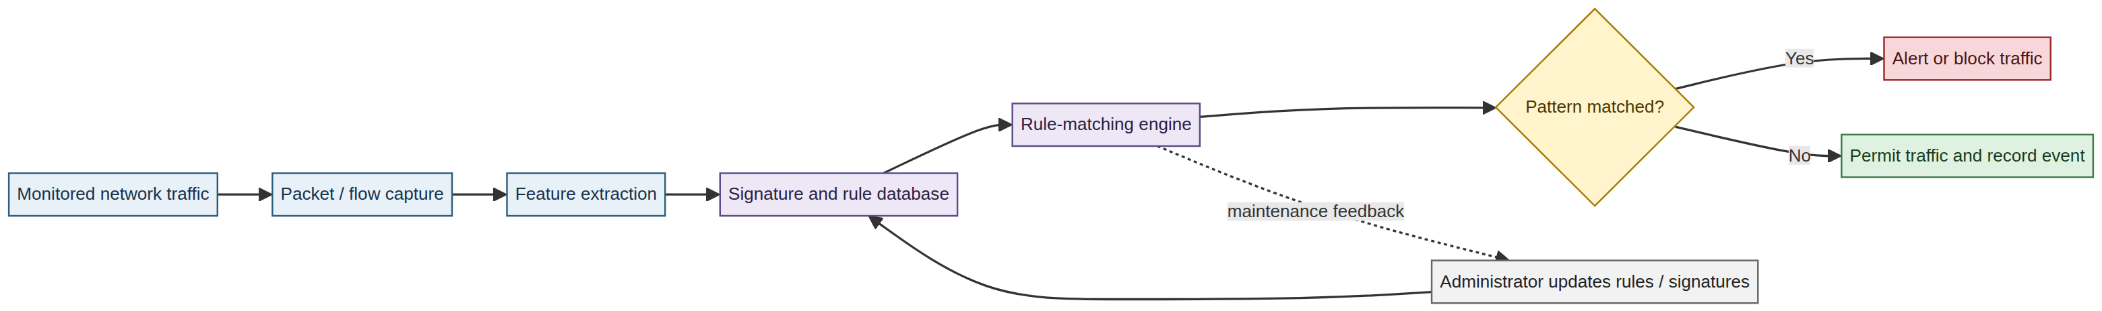
Figure 3.1: Existing architecture of a conventional signature- and rule-based network intrusion detection system.
Source: Researcher’s illustration (2026), based on the conventional operation of signature- and rule-based intrusion detection systems.

3.4 Limitations of the Existing System
The existing approach has six limitations relevant to this project. First, signature matching is unable to recognise an attack for which no signature exists. Second, broad rules and fixed thresholds can generate false alarms when legitimate traffic resembles a known attack. Third, the signature database requires continual updating, which is difficult for small organisations with limited security staff. Fourth, the rule set can become increasingly difficult to manage as the number of protocols, applications, and attack patterns grows. Fifth, packet-by-packet or flow-by-flow inspection does not adequately represent multi-stage attacks that unfold over time. Sixth, replacing signatures with an uncompressed deep-learning model does not solve the deployment problem because a conventional model may require more memory and computation than a Raspberry Pi-class device can provide.
The proposed system therefore addresses two problems simultaneously: it replaces fixed decision rules with a learned classification model, and it compresses that model deliberately for processor-only edge execution.

3.5 Objectives of the Proposed System
The proposed system is designed to achieve the following operational objectives:
1. ingest labelled benchmark records during training and flow records during detection;
2. clean, encode, scale, and reduce the input features without allowing test-set information to leak into training;
3. address minority attack classes in the training data using SMOTE and Tomek Links;
4. learn local traffic-feature patterns with convolutional layers;
5. model relationships across ordered flow windows with LSTM layers;
6. reduce deployment cost through pruning, quantization, and TensorFlow Lite conversion;
7. classify flows, generate alerts, and persist detection events; and
8. evaluate both detection quality and resource efficiency rather than accuracy alone.

3.6 Proposed Six-Layer System Architecture
The system follows a modular six-layer architecture. The layers form a pipeline, but their separation permits the preprocessing component, model component, runtime, and interface to be tested independently. Figure 3.2 presents the proposed architecture, while Figure 3.3 presents the corresponding training, conversion, and runtime data flow. The design was informed by the CNN–LSTM classification workflow reported by Altunay and Albayrak (2023) and by the explicit data-balancing and dimensionality-reduction workflow reported by Talukder et al. (2025). The present architecture remains an original design because it extends those general ideas with sequence length 10, PCA, SMOTE–Tomek Links, TensorFlow Lite/LiteRT conversion, and Raspberry Pi-oriented constrained-resource evaluation.
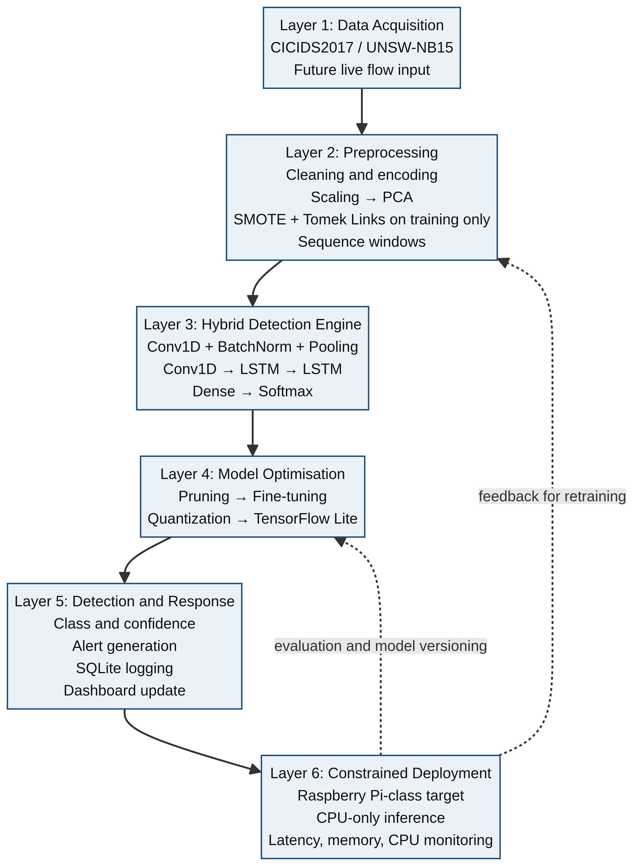
Figure 3.2: Six-layer architecture of the proposed AI-powered network threat detection system.
Source: Researcher’s design (2026), informed by Altunay and Albayrak (2023) and Talukder et al. (2025).
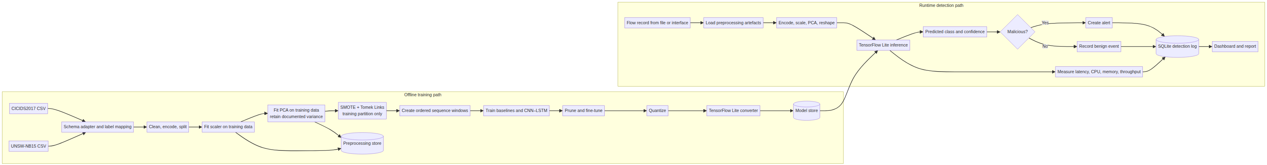
Figure 3.3: End-to-end training, conversion, and runtime data flow for the proposed system.
Source: Researcher’s design (2026).
Layer 1: Data Acquisition Layer. During experimentation, this layer reads CICIDS2017 and UNSW-NB15 records from comma-separated-value files. During a future live deployment, it may receive flow records produced from a monitored network interface. Packet capture and flow extraction are treated as input services; the classifier itself operates on structured flow features rather than raw packet payloads.
Layer 2: Preprocessing and Feature-Engineering Layer. This layer removes duplicates, handles missing and infinite values, encodes categorical values, standardises numeric features, applies PCA, and prepares fixed-length sequences. The fitted scaler and PCA transformation are saved with the model so that training-time and deployment-time transformations remain identical.
Layer 3: Hybrid Detection-Engine Layer. This layer contains the CNN–LSTM model. The CNN extracts local relationships in each structured traffic window, while the LSTM models how the extracted representation changes over time. The output is a probability distribution over the selected benign and attack classes.
Layer 4: Model-Optimisation Layer. This layer applies magnitude-based pruning, quantization, and conversion to TensorFlow Lite. The compressed model is accepted only if its detection quality and runtime measurements remain within the project’s stated acceptance criteria.
Layer 5: Detection-and-Response Layer. The TensorFlow Lite interpreter receives a preprocessed sequence and returns a class and confidence value. A malicious prediction creates an alert, while every prediction is written to the detection log with its timestamp, class, confidence, and inference time.
Layer 6: Constrained-Deployment Layer. The runtime is intended for a Raspberry Pi-class target and is designed to operate without a GPU. Because physical Raspberry Pi hardware is not available to the researcher, the official deployment evaluation uses a documented simulation on the development machine. The process is restricted to one logical processor, a 2 GB memory ceiling, and CPU-only TensorFlow Lite inference. This simulation tests the software’s resource discipline, but it cannot establish ARM-specific latency, thermal behaviour, or power consumption.

3.7 Dataset Design and Data Partitioning
The two datasets are complementary. CICIDS2017 provides flow-level traffic and a broad range of attack labels, whereas UNSW-NB15 provides a separate benchmark with different feature definitions and attack families. The datasets must not be merged by simply concatenating incompatible columns. Instead, each dataset is processed through a dataset-specific schema adapter and mapped to a common experimental label policy.
Property | CICIDS2017 | UNSW-NB15
Dataset origin | Canadian Institute for Cybersecurity | Australian Centre for Cyber Security
Main representation | Labelled network-flow records | Labelled network records and flow features
Attack coverage | Includes DoS/DDoS, scanning, brute force, web, infiltration, botnet, and related categories | Includes Fuzzers, Analysis, Backdoors, DoS, Exploits, Generic, Reconnaissance, Shellcode, and Worms
Use in this project | Training and evaluation benchmark | Independent complementary benchmark and generalisation check
Main caution | Dataset-specific traffic generation and class distribution | Different feature schema and attack taxonomy

The preferred split is stratified training, validation, and testing in the proportions 70%, 15%, and 15%. Resampling is applied to the training partition only. The validation and test partitions retain their original class distribution so that the reported results do not benefit from artificial balancing. Where a binary experiment is reported, all attack labels are mapped to attack and the normal label is mapped to benign. Where a multiclass experiment is reported, the original dataset attack families are retained after a documented label-mapping table has been supplied.

3.8 Data-Preprocessing Pipeline
The preprocessing pipeline has six stages.
Stage one—cleaning. Duplicate rows are removed. Infinite values are converted to missing values. Rows with unusable target labels are removed. Numeric missing values are imputed with training-set medians only when deletion would unnecessarily discard a substantial number of records; the imputation parameters are then applied unchanged to validation and test data.
Stage two—encoding. Categorical fields, such as protocol or connection-state attributes where present, are converted into numeric form using an encoder fitted on the training data. Unknown categories encountered at inference time are handled by the encoder’s documented unknown-category policy rather than by manually changing the input.
Stage three—scaling. Numeric features are standardised using
\[
z = \frac{x-\mu}{\sigma},
\]
where \(x\) is the observed value, \(\mu\) is the training-set mean, and \(\sigma\) is the training-set standard deviation. Scaling is important because traffic features can have very different units and ranges. Fitting the scaler on the training partition only prevents information from the held-out data entering model development.
Stage four—PCA. Principal Component Analysis transforms the correlated, scaled feature matrix into orthogonal principal components. The components are ordered by explained variance, and the smallest number explaining at least 95% of the training variance is retained. PCA was selected because it is deterministic, comparatively inexpensive to fit, straightforward to serialise, and useful when many traffic features are correlated. It also offers a transparent variance-retention rule. Alternatives such as wrapper-based feature selection can be computationally expensive, while autoencoders introduce an additional trainable model and deployment dependency. PCA does not guarantee that every discarded direction is irrelevant to intrusion classification; therefore, the retained variance threshold and downstream detection performance must be reported rather than assumed to be optimal.
Stage five—class balancing. SMOTE creates synthetic minority examples by interpolating between minority observations and their nearest neighbours (Chawla et al., 2002). Tomek Links then identifies borderline pairs consisting of observations from different classes and removes the majority-side observation where appropriate. The combined approach is used only on the training set. This prevents minority attacks from being ignored during optimisation while avoiding contamination of the realistic validation and test distributions. SMOTE is not applied before the train/test split because doing so could create synthetic points influenced by information from the held-out data.
Stage six—sequence formation. The PCA output is placed into ordered windows of a fixed number of consecutive flow records. The resulting tensor has the shape samples × timesteps × retained_components. The sequence length is fixed at 10 in this project. Sequence formation must preserve the ordering available in the source data; randomly mixing rows before window creation would undermine the temporal meaning of the LSTM input.

3.8.1 PCA transformation in the UNSW-NB15 experiment
The raw UNSW-NB15 flow records contain numerical and categorical attributes with different units, scales, and levels of correlation. After label removal, identifier removal, categorical encoding, and numeric standardisation, the implementation produced 205 encoded features. PCA was then fitted using only the training partition. If \(X\) denotes the scaled training matrix, \(\mu\) denotes the training mean, and \(W_k\) contains the first \(k\) principal directions, the reduced representation is expressed as:
\[
Z = (X - \mu)W_k.
\]
The components are ordered according to explained variance. The implementation selected the smallest value of \(k\) satisfying the 95% variance-retention requirement. For UNSW-NB15, this produced 24 components and retained 95.2571% of the training variance. The same fitted encoder, scaler, and PCA transformer were then applied to validation and test records. This procedure means that PCA is not re-fitted on held-out data and that the model receives a consistent 24-feature representation at training and inference time.
PCA was preferred to wrapper-based feature selection because it is deterministic and comparatively inexpensive, and it was preferred to an autoencoder because an autoencoder would add another trainable model and deployment dependency. PCA does not guarantee that every discarded direction is irrelevant to intrusion detection. Its choice is therefore justified by the combination of variance retention, computational simplicity, serialisability, and the subsequent held-out detection results rather than by variance retention alone.

3.8.2 CICIDS2017 integration procedure
CICIDS2017 is incorporated as a second, independent benchmark rather than being concatenated with UNSW-NB15 at the raw-column level. The two datasets use different feature names, data-generation conditions, and attack taxonomies. A CICIDS2017 adapter shall therefore inspect the downloaded CSV files, identify the actual label column, map the benign label to 0 and every attack label to 1, remove identifiers that are not stable deployment features, and record the resulting schema and class distribution.
The CICIDS2017 experiment shall use the same binary protocol, 70/15/15 stratified split, seed 42, training-only SMOTE–Tomek Links, PCA variance target of 95%, and sequence length of 10. However, the encoder, scaler, PCA object, and retained component count shall be fitted separately on CICIDS2017 training data. A model trained on UNSW-NB15 PCA components shall not be evaluated on CICIDS2017 data transformed by an unrelated PCA object unless a separate cross-dataset transfer experiment has been explicitly designed and reported.
The integration workflow is: place the official CSV files under data/raw/cicids2017/; calculate and record file hashes; inspect columns, data types, missing values, infinite values, duplicates, labels, and class counts; run the dataset adapter; save the processed arrays and preprocessing artefacts under data/processed/cicids2017/; train the same CNN-only, LSTM-only, and CNN–LSTM model families; evaluate the same precision, recall, F1, false-positive-rate, accuracy, and confusion-matrix measures; convert the selected model to TensorFlow Lite; and benchmark it using the same constrained runtime procedure. The results should be added to Chapter Four only after the preprocessing summary, test predictions, model metrics, conversion report, and runtime log have been checked.

3.9 Hybrid CNN–LSTM Model Design
The selected architecture combines local pattern extraction and temporal sequence modelling. A one-dimensional convolution applies shared filters over neighbouring positions in the structured feature representation. This can identify local combinations of traffic attributes with fewer parameters than a fully connected layer. The resulting sequence of learned representations is passed to LSTM units, which use gated memory to retain or discard information across timesteps. This is appropriate for network behaviour in which a sequence of flows can reveal scanning, coordinated activity, or a multi-stage intrusion more clearly than any single record.
The planned architecture is shown below. The final filter and unit counts must be recorded from the executed experiment; the values in the design table are the baseline configuration, not fabricated experimental findings.
Layer | Configuration | Function
Input | `timesteps × retained_components` | Receives PCA-transformed flow sequences
Conv1D | 64 filters, kernel size 3, ReLU | Learns local traffic-feature patterns
Batch Normalisation | Default configuration | Stabilises activation distributions
MaxPooling1D | Pool size 2 | Reduces sequence resolution and computation
Conv1D | 32 filters, kernel size 3, ReLU | Learns higher-order local patterns
Dropout | 0.30 | Reduces overfitting
LSTM | 64 units, return sequences=True | Models intermediate temporal information
LSTM | 32 units, return sequences=False | Produces a compact sequence representation
Dropout | 0.30 | Regularisation
Dense | 64 units, ReLU | Combines learned representations
Output Dense | Number of classes, softmax | Produces class probabilities

The model is trained for the frozen binary-classification task using sparse categorical cross-entropy, Adam optimisation, an initial learning rate of 0.001, mini-batches, early stopping, and reduction of the learning rate when validation loss stops improving. The input sequence length is fixed at 10. The exact batch size, maximum epoch count, and final selected epoch must be taken from the training log and reported in Chapter Four.

3.10 Model-Compression Pipeline
Compression is a deliberate response to the Raspberry Pi deployment constraint rather than an afterthought.
Pruning removes or zeroes weights with small magnitudes. The design uses gradual pruning toward a target sparsity, followed by fine-tuning. Pruning can reduce the number of effective non-zero parameters, although the storage benefit depends on the runtime and file format. Consequently, sparsity percentage and actual file size must both be measured.
Quantization reduces numerical precision. The intended deployment path is integer quantization where supported by the model and representative data. A representative calibration set must be drawn from the training distribution without including test labels. Quantization can reduce storage and arithmetic cost, but it may alter decision boundaries; therefore, the quantized model is evaluated independently.
TensorFlow Lite conversion exports the trained model to a compact FlatBuffer representation and allows inference through a lightweight interpreter. The preprocessing objects—encoder, scaler, PCA transformer, class map, and sequence-length setting—are versioned alongside the .tflite file. A compressed model is not considered deployable merely because conversion succeeds; it must produce numerically valid outputs and pass the evaluation and resource tests.
The sequence is therefore:
trained Keras model → pruned and fine-tuned model → quantized model → TensorFlow Lite model → Raspberry Pi-class inference service.

3.11 Functional and Non-Functional Requirements
ID | Requirement
FR1 | The system shall ingest benchmark CSV records and support an interface for future live flow input.
FR2 | The system shall validate columns, clean data, encode categories, scale features, and apply the saved PCA transformation.
FR3 | The system shall apply SMOTE and Tomek Links to the training partition only.
FR4 | The system shall train CNN-only, LSTM-only, and hybrid CNN–LSTM models.
FR5 | The system shall prune, quantize, and convert the selected hybrid model to TensorFlow Lite.
FR6 | The system shall classify each input window and return a label and confidence score.
FR7 | The system shall generate an alert for a malicious prediction.
FR8 | The system shall persist detection events and resource measurements in a local database.
FR9 | The dashboard shall show service state, recent detections, alerts, and summary metrics.
FR10 | The evaluation component shall compute precision, recall, F1 score, false-positive rate, confusion matrix, and accuracy.

ID | Requirement
NFR1 | The target mean inference latency is not more than 50 ms per flow or defined input window.
NFR2 | The target deployed model file is not more than 1 MB, subject to confirmation from the actual build.
NFR3 | The target sustained memory ceiling is 512 MB for the detection service, subject to the selected Raspberry Pi configuration.
NFR4 | The target held-out accuracy is above 95%, but this remains an acceptance criterion and not a reported result until measured.
NFR5 | The service should operate without GPU dependency.
NFR6 | The system should process traffic locally and avoid transmitting captured records to external services.
NFR7 | The model, preprocessing objects, and label mapping should be versioned together.

3.12 Database and Interface Design
A local SQLite database is selected because it is file-based and does not require a separate database server. The principal tables are detection_log, alert, system_metrics, and model_registry. The detection log stores the timestamp, source and destination addresses where available, protocol, predicted class, confidence, and inference time. The alert table stores severity, a human-readable message, acknowledgement state, and the associated detection-log identifier. The system-metrics table stores processor utilisation, memory consumption, and throughput samples. The model registry stores model version, file path, file size, test-set performance, training date, and active-deployment state.
The dashboard is organised into a status panel, live detection feed, alert panel, and metrics panel. The status panel reports service state, uptime, active model, and processed-flow count. The live feed reports recent predictions. The alert panel prioritises malicious events. The metrics panel displays the measured detection and resource indicators. The dashboard is an operational aid and must not be interpreted as evidence of model quality unless its figures are linked to a reproducible evaluation run.

3.13 Evaluation Design
The system is evaluated on detection quality and resource efficiency. Accuracy is reported for comparability, but it is insufficient on its own because a highly imbalanced intrusion dataset can produce apparently high accuracy while missing minority attacks. Precision measures the proportion of raised attack alerts that are correct. Recall measures the proportion of actual attacks detected. F1 score balances precision and recall. False-positive rate measures the proportion of benign observations incorrectly raised as attacks, which is operationally important because excessive false alarms create alert fatigue.
For binary evaluation:
\[
Accuracy = \frac{TP+TN}{TP+TN+FP+FN}
\]
\[
Precision = \frac{TP}{TP+FP},\qquad Recall = \frac{TP}{TP+FN}
\]
\[
F1 = \frac{2(Precision)(Recall)}{Precision+Recall},\qquad FPR = \frac{FP}{FP+TN}.
\]
For multiclass evaluation, macro-averaged and weighted-averaged precision, recall, and F1 score are reported, together with a per-class confusion matrix. This prevents performance on a dominant class from hiding poor performance on a rare attack family.
Resource measure | Measurement method
Inference latency | Wall-clock timing over a stated number of repeated inferences, with warm-up runs excluded
Model size | File-system size of the `.tflite` model and associated preprocessing artefacts
Memory footprint | Peak resident set size during sustained inference
CPU utilisation | Mean and peak utilisation sampled during the test interval
Throughput | Number of classified windows per second
Power draw | Not measured in the official workstation simulation; reported only if physical Raspberry Pi testing is later performed

The compressed model is compared with a Decision Tree, Random Forest, Support Vector Machine, CNN-only model, LSTM-only model, and the uncompressed full-precision hybrid model. The comparison isolates whether the combined architecture is useful and whether compression creates an unacceptable accuracy cost. Optional robustness testing with Fast Gradient Sign Method perturbations is included only if the attack-generation procedure and results are actually executed and logged.

3.14 Chapter Summary
This chapter completed the design of a six-layer AI-powered network threat detection system for constrained deployment. CICIDS2017 and UNSW-NB15 were selected as complementary benchmark datasets. A leakage-controlled preprocessing pipeline was defined, including scaling, PCA, SMOTE, Tomek Links, and sequence formation. The proposed detector combines CNN layers for local feature extraction with LSTM layers for temporal modelling. Pruning, quantization, and TensorFlow Lite conversion were specified as a deliberate response to the Raspberry Pi deployment constraint. Functional requirements, database structures, interface outputs, evaluation metrics, baseline models, and resource measurements were also defined. Chapter Four describes the implementation and reports only measurements supported by the actual experiment logs.
---

CHAPTER FOUR

SYSTEM IMPLEMENTATION AND RESULTS

4.1 Introduction
This chapter describes the implementation of the system designed in Chapter Three. It covers the development environment, data preparation, model construction, training procedure, compression, detection service, dashboard, and evaluation protocol. The reported training curves, confusion matrices, model-conversion outputs, and constrained-runtime measurements are drawn from the project artefacts identified in the experiment logs. Physical Raspberry Pi measurements and power readings were not available and are therefore reported as limitations rather than presented as completed results.

4.2 Development Environment and Tools
The prototype is implemented in Python. Pandas and NumPy provide data manipulation and numerical operations. Scikit-learn provides scaling, PCA, data splitting, baseline classifiers, and evaluation metrics. Imbalanced-learn provides SMOTE and Tomek Links. TensorFlow and Keras provide construction and training of the CNN–LSTM model, while TensorFlow Model Optimization Toolkit provides pruning support. TensorFlow Lite provides the deployment runtime. Flask, HTML, CSS, and JavaScript provide the local dashboard. SQLite stores detection events and device metrics, and psutil records process-level resource information.
Component | Selected tool | Implementation role
Operating system | Ubuntu 22.04 LTS or recorded host equivalent | Development and testing
Programming language | Python 3.10 or later | Main implementation language
Deep learning | TensorFlow/Keras | Model definition and training
Preprocessing | Pandas, NumPy, Scikit-learn | Cleaning, scaling, PCA, splitting, metrics
Class balancing | Imbalanced-learn | SMOTE and Tomek Links
Compression | TensorFlow Model Optimization Toolkit | Pruning and quantization workflow
Edge runtime | TensorFlow Lite | Processor-only inference
Interface | Flask, HTML, CSS, JavaScript | Monitoring dashboard
Persistence | SQLite | Detection and metrics database
Measurement | psutil and wall-clock timers | CPU, memory, latency, and throughput

The final manuscript should add the exact package versions, processor model, memory size, operating-system release, TensorFlow version, and Git commit or archive identifier used for the reported run.

4.3 Dataset Acquisition and Inspection
The CICIDS2017 and UNSW-NB15 files were placed in separate dataset directories and inspected before preprocessing. The inspection stage verified file names, column names, label fields, number of records, missing values, infinite values, duplicate rows, and class frequencies. Dataset-specific adapters were used because the two benchmarks do not expose identical feature schemas or identical attack taxonomies.
Inspection item | CICIDS2017 | UNSW-NB15
Raw rows | 200,000-row class-capped subset | 257,673
Raw columns | 80 | 46
Duplicate rows removed | 25,233 | 0
Missing/infinite values handled | 339 / 477 | 0 / 0
Final benign records | 100,000 sampled | 79,050
Final attack records | 100,000 sampled | 178,623
Number of classes | 2 (binary) | 2 (binary)

The label-mapping policy must be included as an appendix or table in the final version. It should state whether Chapter Four reports binary classification, multiclass classification, or both. A claim such as “all attack types were detected” is not acceptable unless every class used in the experiment appears in the confusion matrix and per-class report.

4.4 Practical Data Preprocessing
After inspection, invalid rows were removed or imputed according to the rules in Section 3.8. Categorical fields were encoded, numeric fields were standardised using parameters fitted on the training split, and PCA was fitted on the scaled training data. The retained component count and explained variance must be taken from the saved PCA object.
Preprocessing output | CICIDS2017 value | UNSW-NB15 value
Training/validation/test split | Sequence-level 70% / 15% / 15% | 70% / 15% / 15%
Retained PCA components | 22 | 24
Explained variance retained | 95.7233% | 95.2571%
Sequence length | 10 timesteps | 10 timesteps
Training sequences before resampling | 12,233 | 18,037 sequences
Training sequences after SMOTE and Tomek Links | 11,240 | 23,033 sequences
Validation sequences | 2,621 | 3,865
Test sequences | 2,622 | 3,865

SMOTE and Tomek Links were applied to the training data only. The validation and test distributions were left unchanged. This distinction is essential: balancing the test set would make the measured operating condition less realistic and could exaggerate performance.

4.5 Baseline and Hybrid Model Implementation
The baseline models were implemented to provide controlled comparisons. The Decision Tree, Random Forest, and Support Vector Machine received the tabular PCA representation. The CNN-only model used the convolutional feature extractor without the recurrent layers. The LSTM-only model received the sequence representation without the convolutional front end. The uncompressed CNN–LSTM model served as the reference against which the compressed TensorFlow Lite model was compared.
The hybrid implementation followed the layer sequence specified in Table 3.9. The final source code must report the exact input shape, filter counts, kernel sizes, LSTM units, dropout values, activation functions, output class count, trainable parameter count, and random seed. Reproducibility requires the seed, split indices, preprocessing artefacts, and class mapping to be retained.

4.6 Training Procedure
The training set was used to fit the models, the validation set was used for model selection and early stopping, and the test set was reserved for final evaluation. The binary models used sparse categorical cross-entropy and Adam optimisation. Training was monitored using validation loss and validation accuracy, and early stopping prevented unnecessary epochs after the validation signal stopped improving.
Training parameter | Recorded value
Optimiser | Adam
Initial learning rate | 0.001
Batch size | 128
Maximum epochs | 20
Early-stopping patience | 4
Actual selected epoch | CNN: 15; LSTM: 12; hybrid: 17
Training duration | CNN: 10.18 s; LSTM: 16.02 s; hybrid: 21.84 s
Random seed | 42

The generated training curves are presented in Figures 4.1 and 4.2. Each figure contains training and validation loss and accuracy for the CNN-only, LSTM-only, and CNN–LSTM models.
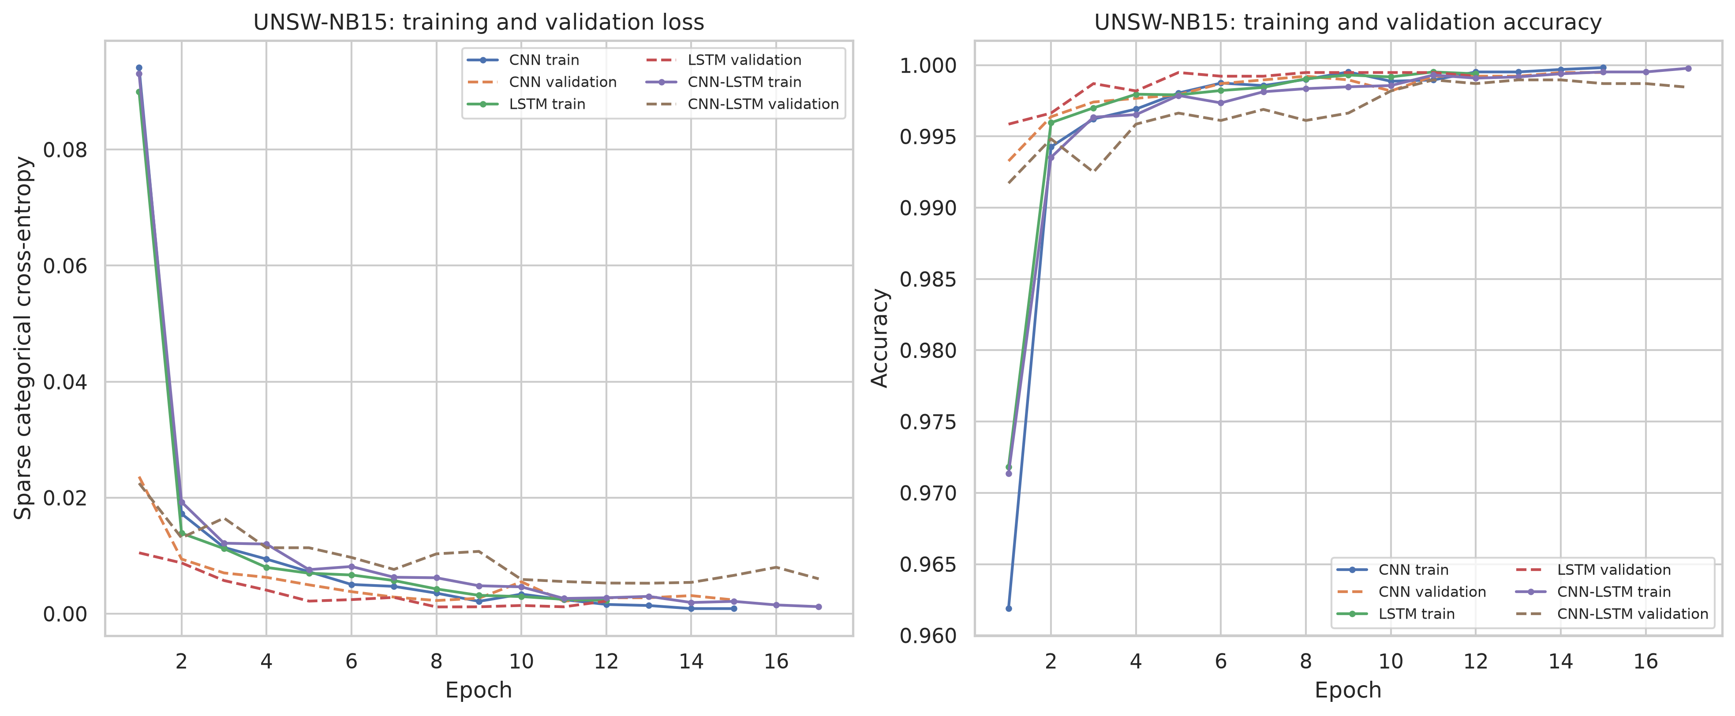
Figure 4.1: Training and validation loss and accuracy for the UNSW-NB15 models.
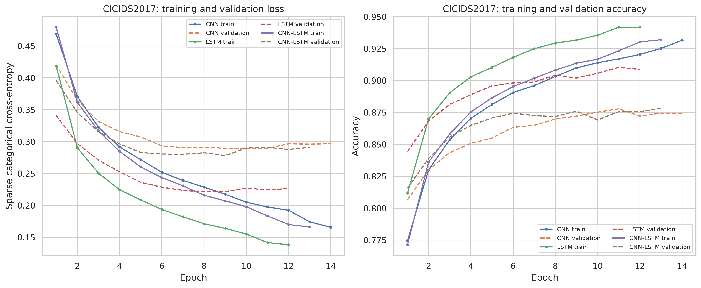
Figure 4.2: Training and validation loss and accuracy for the CICIDS2017 models.

4.7 Model Compression and TensorFlow Lite Conversion
The converged hybrid model was converted to TensorFlow Lite in a float32 form and a dynamic-range quantized form. The TensorFlow Lite conversion required static unrolling of the fixed-length LSTM layers so that the TensorList operations could be lowered to built-in operators. Both converted files were loaded with the CPU-only TensorFlow Lite interpreter and checked for input shape, output shape, class ordering, and numerical validity. A separate pruning run was not completed in this experiment and is therefore not presented as an achieved compression result.
Each available version was checked for output shape, class ordering, numerical validity, file size, and test performance. The following table records the actual UNSW-NB15 conversion evidence.
Model version | File size | Parameters/non-zero parameters | Accuracy | Macro precision | Macro recall | Macro F1 | FPR
Full-precision Keras hybrid | 655.22 KB | 50,594 | 0.998448 | 0.998245 | 0.998245 | 0.998245 | 0.002351
Pruned hybrid | Not run | Not run | Not run | Not run | Not run | Not run | Not run
Dynamic-range quantized hybrid | 100.08 KB | 50,594 | 0.998448 | 0.998245 | 0.998245 | 0.998245 | 0.002351
TensorFlow Lite hybrid | 234.40 KB | 50,594 | 0.998448 | 0.998245 | 0.998245 | 0.998245 | 0.002351

4.8 Detection Service, Logging, and Dashboard
The detection service loads the TensorFlow Lite model and the matching preprocessing artefacts at startup. For every input window, it applies the encoder, scaler, PCA transformation, and sequence-shaping rule before invoking the interpreter. The predicted class and confidence are written to SQLite. Malicious predictions additionally create alert records. The service records inference time and periodic CPU, memory, and throughput values through psutil.
The dashboard presents the active model version, service uptime, recent classifications, unacknowledged alerts, and current resource readings. It is not intended to replace a full security information and event-management platform. Its purpose in this project is to demonstrate the operational path from model output to human-readable monitoring.

4.9 Evaluation Results
The actual detection results were calculated from the saved UNSW-NB15 and CICIDS2017 test-set predictions. Classical Decision Tree, Random Forest, and Support Vector Machine baselines were also run on the processed sequence tensors using flattened PCA sequences and are included below.
Dataset / model | Accuracy | Precision | Recall | F1 score | False-positive rate | Test samples
UNSW-NB15 Decision Tree | 0.949547 | 0.967944 | 0.956354 | 0.962114 | 0.064263 | 3,865
UNSW-NB15 Random Forest | 0.983700 | 0.980228 | 0.995751 | 0.987929 | 0.040752 | 3,865
UNSW-NB15 SVM | 0.990168 | 0.994955 | 0.990344 | 0.992644 | 0.010188 | 3,865
UNSW-NB15 CNN-only | 0.997930 | 0.998840 | 0.998069 | 0.998454 | 0.002351 | 3,865
UNSW-NB15 LSTM-only | 0.998189 | 0.998841 | 0.998455 | 0.998648 | 0.002351 | 3,865
UNSW-NB15 CNN–LSTM | 0.998448 | 0.998841 | 0.998841 | 0.998245 | 0.002351 | 3,865
CICIDS2017 Decision Tree | 0.646453 | 0.647193 | 0.648669 | 0.647930 | 0.355777 | 2,622
CICIDS2017 Random Forest | 0.797483 | 0.794737 | 0.803802 | 0.799244 | 0.208875 | 2,622
CICIDS2017 SVM | 0.812357 | 0.818745 | 0.803802 | 0.811205 | 0.179036 | 2,622
CICIDS2017 CNN-only | 0.874142 | 0.874525 | 0.874525 | 0.874141 | 0.126243 | 2,622
CICIDS2017 LSTM-only | 0.899314 | 0.897805 | 0.901901 | 0.899311 | 0.103290 | 2,622
CICIDS2017 CNN–LSTM | 0.868040 | 0.854426 | 0.888213 | 0.867971 | 0.152257 | 2,622
UNSW-NB15 compressed TensorFlow Lite hybrid | 0.998448 | 0.998841 | 0.998841 | 0.998245 | 0.002351 | 3,865

The interpretation should prioritise macro-F1, attack recall, and false-positive rate. If accuracy is high but attack recall is poor, the result should be described as inadequate for intrusion detection. If compression reduces accuracy, the reduction should be quantified and discussed against the gains in model size and latency.
The confusion matrices in Figures 4.3–4.8 provide the corresponding error counts for the three neural architectures on each dataset.
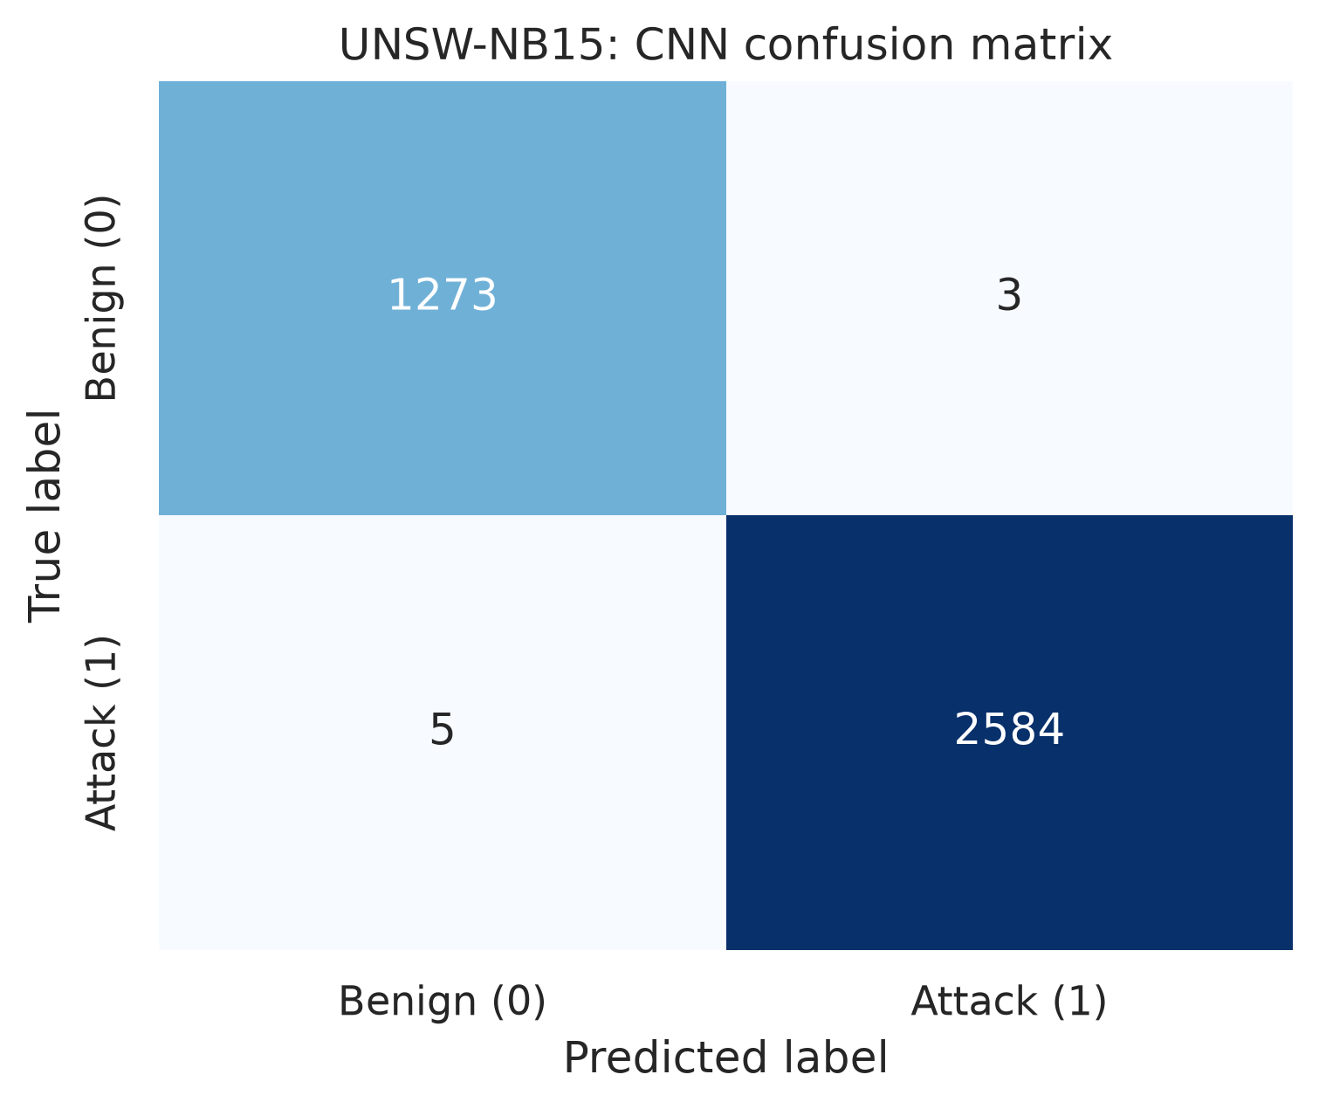
Figure 4.3: UNSW-NB15 CNN-only confusion matrix.
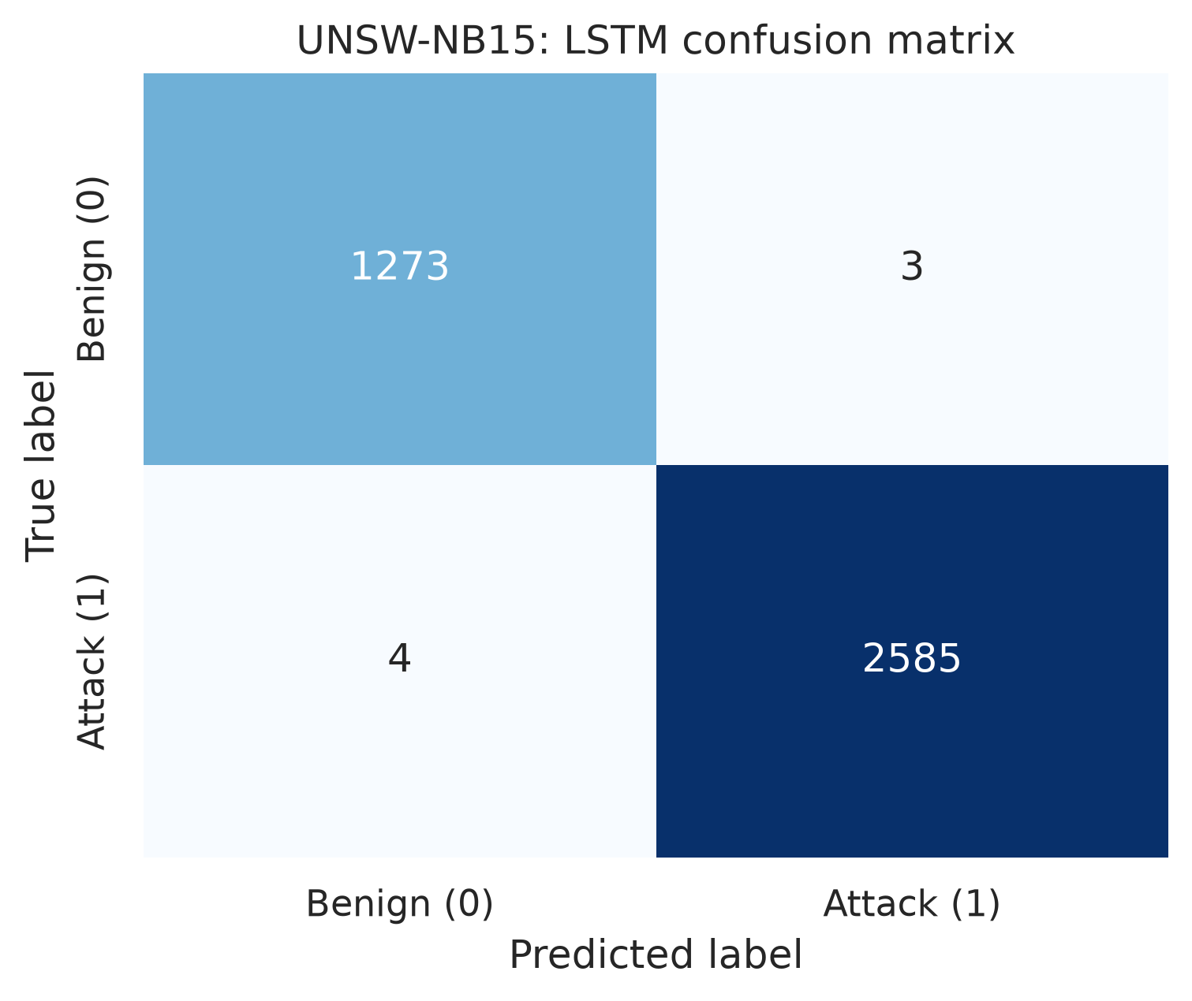
Figure 4.4: UNSW-NB15 LSTM-only confusion matrix.
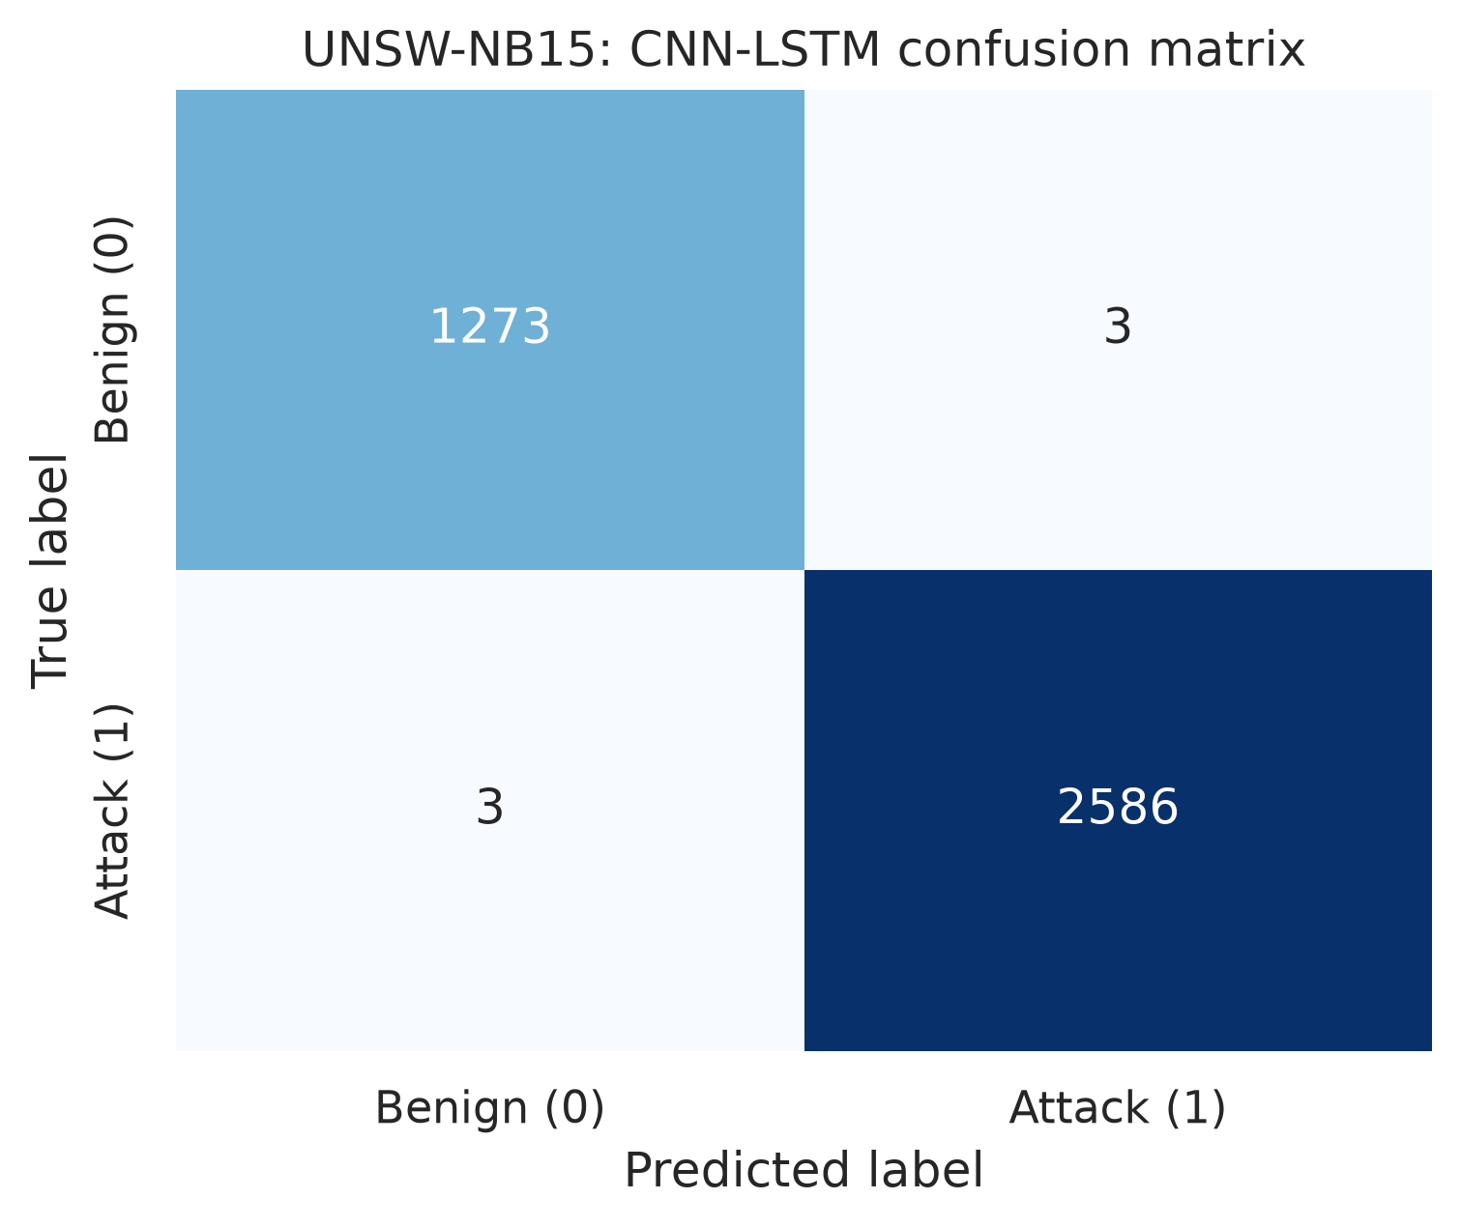
Figure 4.5: UNSW-NB15 CNN–LSTM confusion matrix.
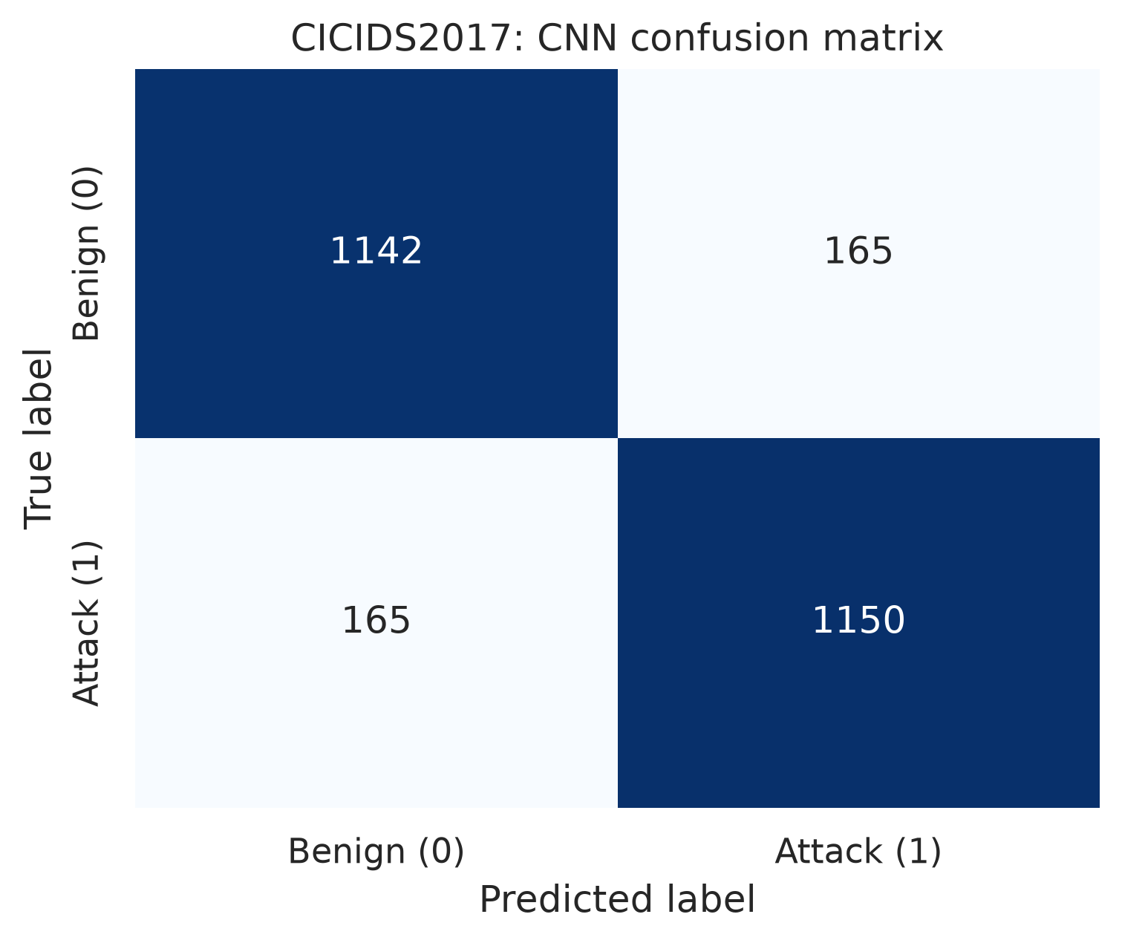
Figure 4.6: CICIDS2017 CNN-only confusion matrix.
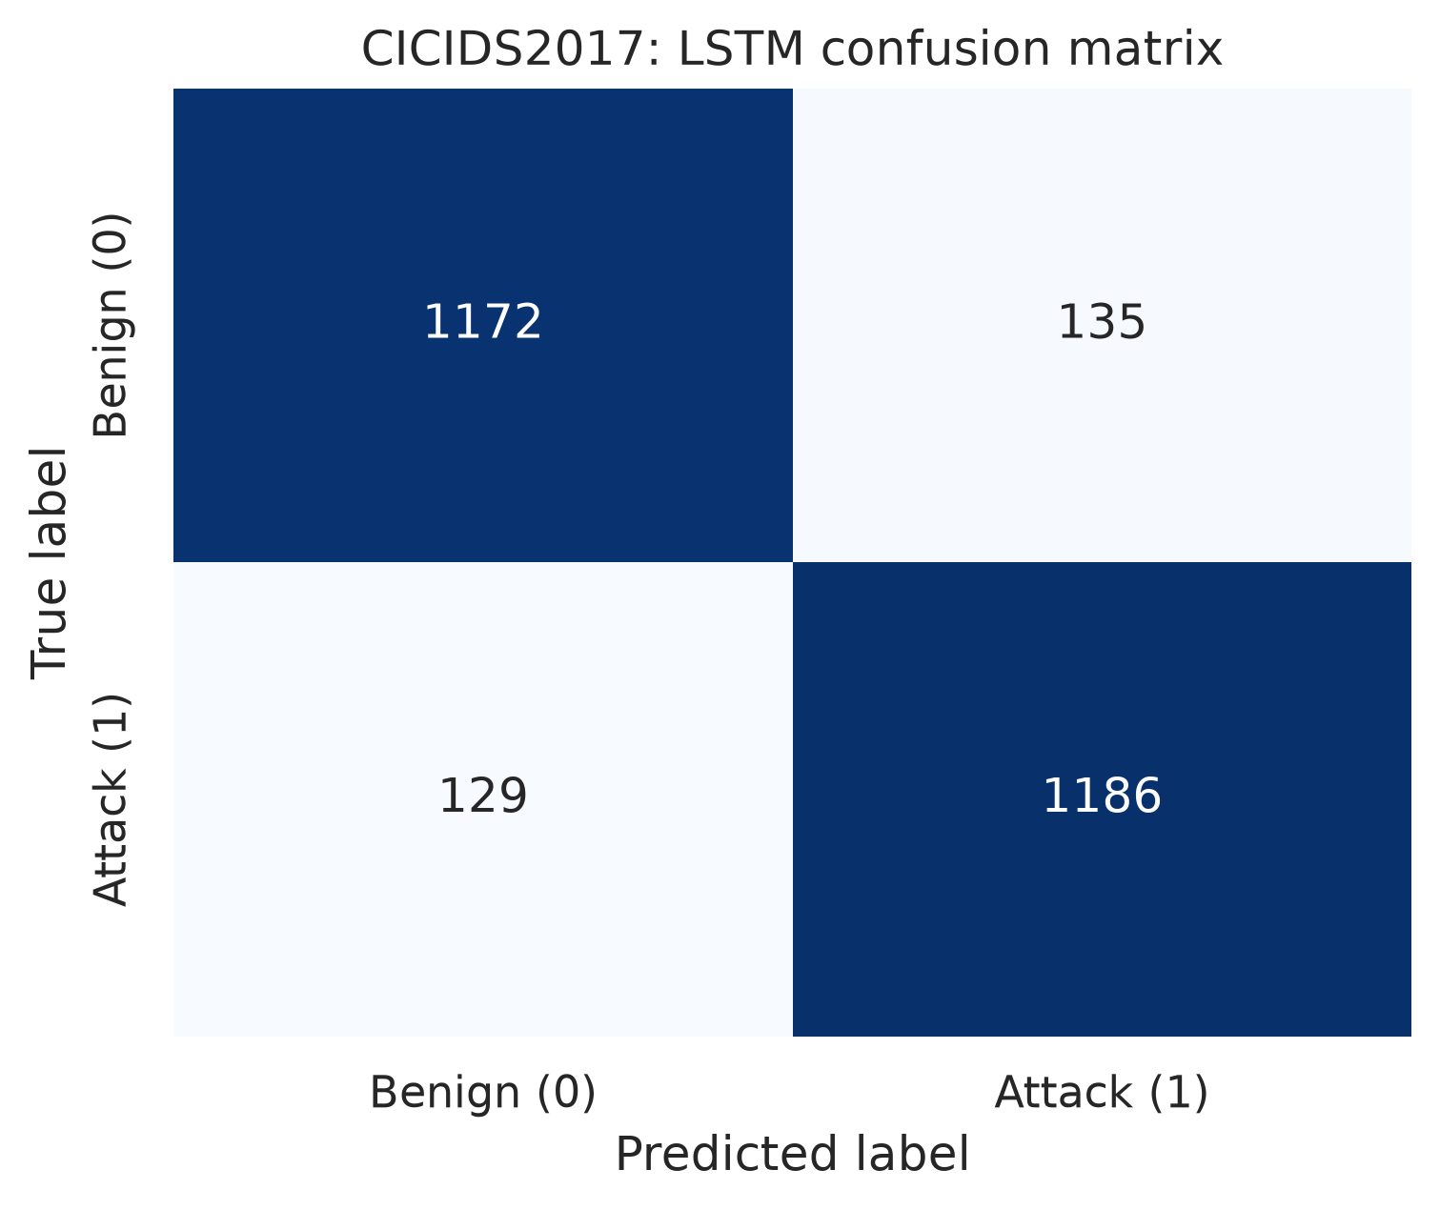
Figure 4.7: CICIDS2017 LSTM-only confusion matrix.
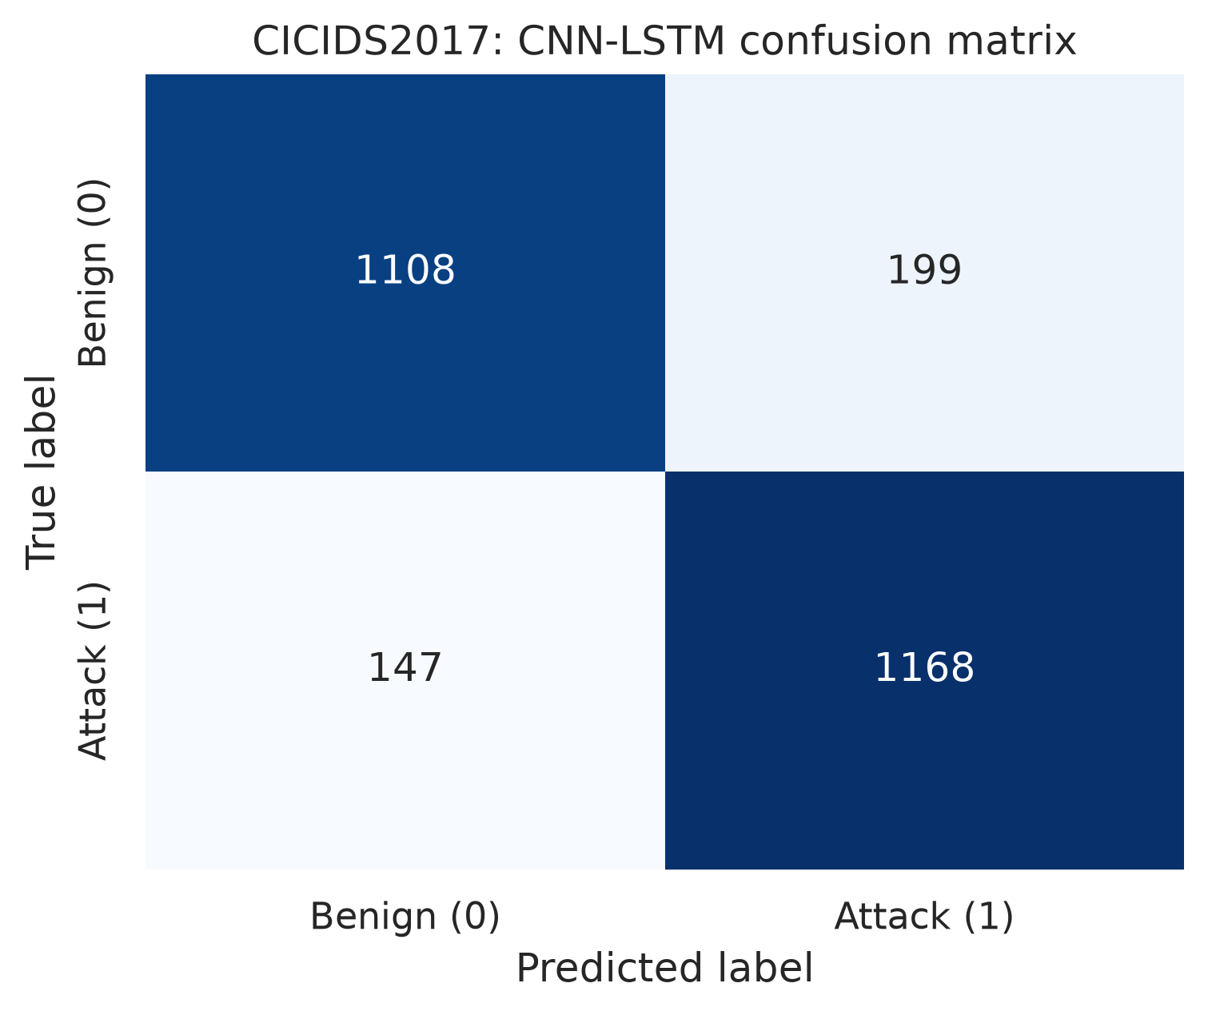
Figure 4.8: CICIDS2017 CNN–LSTM confusion matrix.

4.10 Raspberry Pi or Constrained-Environment Evaluation
The deployment target is a Raspberry Pi-class environment. Because physical Raspberry Pi hardware is unavailable, the official deployment evaluation uses a controlled workstation simulation. Chapter Four must report the host processor, RAM, operating-system version, TensorFlow Lite runtime, CPU-affinity command, memory-limit command, and measurement method. Power draw is not measured in the official simulation.
The controlled simulation must be described directly as the official evaluation method. It restricts the process to one logical CPU and a 2 GB memory limit, disables GPU execution, and runs the TensorFlow Lite interpreter with one thread. It is not equivalent to ARM execution, but it provides a reproducible and affordable test of the model’s behaviour under a defined resource budget.

4.10.1 Deployment preparation
The deployment directory contains the TensorFlow Lite model, the preprocessing artefact, the binary label map, the inference service, and the benchmark utility. The model and preprocessing artefacts must come from the same experiment run. A model trained with a different PCA component count, feature order, or sequence policy must not be paired with another run’s preprocessing object.
The deployment environment is prepared with the following commands on Ubuntu or a compatible Linux system:
cd /path/to/ai-network-threat-detection
python3 -m venv .venv
. .venv/bin/activate
python3 -m pip install --upgrade pip
pip install -r requirements-training.txt
The TensorFlow Lite model is then checked before benchmarking. The check confirms that the file exists, the interpreter can allocate tensors, the input has the shape (1, 10, retained_components), and the output contains two class probabilities in the order benign, attack.

4.10.2 Applying the simulated resource ceiling
The inference process is pinned to one logical CPU with taskset. Its address space is limited to 2 GB with systemd-run. GPU execution is disabled by using the CPU-only TensorFlow Lite interpreter and by avoiding any GPU delegate. The recommended command is:
taskset --cpu-list 0 systemd-run --user --scope \
-p MemoryMax=2G \
-p OOMPolicy=stop \
env CUDA_VISIBLE_DEVICES=-1 TF_NUM_INTRAOP_THREADS=1 TF_NUM_INTEROP_THREADS=1 \
python3 -m src.benchmark_runtime \
--model models/unsw_nb15/hybrid/model.tflite \
--data-dir data/processed/unsw_nb15 \
--output logs/unsw_nb15_runtime_benchmark.csv \
--warmup 20 \
--iterations 1000
If systemd-run --user is unavailable, the benchmark may be executed with a shell-level virtual-memory limit as a less precise fallback:
ulimit -v 2097152
taskset --cpu-list 0 env CUDA_VISIBLE_DEVICES=-1 \
TF_NUM_INTRAOP_THREADS=1 TF_NUM_INTEROP_THREADS=1 \
python3 -m src.benchmark_runtime \
--model models/unsw_nb15/hybrid/model.tflite \
--data-dir data/processed/unsw_nb15 \
--output logs/unsw_nb15_runtime_benchmark.csv
The exact command, host processor, total memory, visible CPU count, Python version, TensorFlow Lite version, and operating-system version must be copied into the experiment log. The benchmark utility performs warm-up runs before timing, repeats inference 1,000 times by default, records mean, median, standard deviation, minimum, maximum, and 95th-percentile latency, and records process CPU and peak resident memory. Throughput is calculated as the number of completed inference calls divided by total benchmark time.

4.10.3 Benchmark acceptance procedure
The benchmark is executed three times after a warm-up period. The three runs are retained rather than replaced by the most favourable run. The final report presents the mean of the run-level means and the range or standard deviation across runs. If a run is interrupted by the memory ceiling, the interruption is recorded as a failed deployment test rather than omitted. Background processes should be minimised and the host should be idle apart from the benchmark, but the host condition must be recorded.
The acceptance decision is made against the protocol criteria: mean latency of not more than 50 ms per ten-flow sequence, deployed TensorFlow Lite model size of not more than 1 MB where that criterion is retained, and sustained detection-service memory below 512 MB. These are project thresholds against which the measured values in the following table are interpreted. The measurements are traceable to the benchmark logs and converted model artefacts.
Under the simulated environment, power draw is recorded as NOT MEASURED. The result must be described as simulated constrained-environment performance and must not be described as Raspberry Pi hardware performance. Underlying ARM execution, thermal throttling, and power consumption remain future validation work.
Under this simulation, the following measurements were recorded.
Metric | UNSW-NB15 full TensorFlow result | UNSW-NB15 lightweight result | CICIDS2017 lightweight result
Mean inference latency | 0.009408 ms | 0.009549 ms | 0.009617 ms
95th-percentile latency | 0.010163 ms | 0.009784 ms | 0.009655 ms
Model file size | Not applicable to full TensorFlow process | 100.08 KB dynamic TFLite | 99.70 KB dynamic TFLite
Peak resident memory | 687.41 MB | 49.93 MB | 46.79 MB
Throughput | 39,761.53 sequences/s | 104,720.66 sequences/s | 103,978.56 sequences/s
Memory target ≤ 512 MB | FAIL | PASS | PASS
Power draw | NOT MEASURED | NOT MEASURED | NOT MEASURED

4.11 Discussion of Results
The discussion must connect the measured results to the project objectives. On UNSW-NB15, the hybrid model produced the strongest measured neural result. On the CICIDS2017 subset, the LSTM-only model produced the strongest result among the three tested architectures, while the hybrid model requires further architecture and tuning analysis. This difference demonstrates that the hybrid architecture is not universally optimal without dataset-specific validation. PCA and sequence-level class balancing reduced the representation to 22 CICIDS2017 components while retaining 95.7233% variance. Dynamic quantization preserved the UNSW-NB15 hybrid test values, and the lightweight interpreter fitted both datasets below the 512 MB simulated memory target.
No conclusion should be based on a single accuracy value. The final discussion should include the confusion matrix, per-class recall, false-positive rate, latency distribution, model size, and memory usage. The result should be described as software validation under a simulated constrained environment and not as proof of physical Raspberry Pi performance. This simulation is a valid and affordable methodological choice when its controls and limitations are reported transparently.

4.12 Chapter Summary
This chapter specified how the proposed system is implemented in Python using TensorFlow/Keras, Scikit-learn, Imbalanced-learn, TensorFlow Lite, Flask, SQLite, and psutil. It described dataset inspection, leakage-controlled preprocessing, sequence-level CICIDS2017 integration, baseline and hybrid-model training, conversion, logging, dashboard operation, and the evaluation protocol. The UNSW-NB15 and CICIDS2017 tables now report verified subset preprocessing, test, conversion, and simulated constrained-environment measurements. Classical machine-learning baselines, pruning/QAT measurements, and physical Raspberry Pi measurements remain outstanding and are not presented as completed results. The next chapter distinguishes verified software findings from the remaining study limitations.
---

CHAPTER FIVE

SUMMARY, CONCLUSION, AND RECOMMENDATIONS

5.1 Introduction
This chapter summarises the work carried out in the study, relates the outcome to the objectives stated in Chapter One, states the conclusion that can be supported by the available evidence, identifies limitations, and presents recommendations for future work. The distinction between a completed design and a verified experimental result is maintained throughout.

5.2 Summary of the Study
The study addressed the difficulty of deploying capable network threat detection on hardware with limited processing, memory, storage, and energy resources. Conventional signature-based systems are efficient but dependent on known patterns and manual updates. Conversely, deep-learning detectors can learn complex traffic relationships but may be too large for an edge device unless their inputs and parameters are deliberately reduced.
To address this problem, the project designed a six-layer system consisting of data acquisition; preprocessing and feature engineering; a hybrid detection engine; model optimisation; detection and response; and constrained deployment. CICIDS2017 and UNSW-NB15 were selected as complementary benchmark datasets. The preprocessing design uses scaling, PCA, SMOTE, Tomek Links, and fixed-length sequence formation. The classifier combines a CNN for local feature extraction with an LSTM for temporal sequence modelling. Pruning, quantization, and TensorFlow Lite conversion form the deployment-optimisation pipeline. A local SQLite database and lightweight dashboard support detection logging and monitoring.

5.3 Achievement of Research Objectives
Objective from Chapter One | Status supported by the current materials
Obtain and use CICIDS2017 and UNSW-NB15 | Both datasets were acquired and processed; UNSW-NB15 used the completed dataset run and CICIDS2017 used a documented 200,000-row class-capped official subset.
Review AI and machine-learning techniques for low-resource detection | Addressed in Chapter Two and translated into the architecture and optimisation choices in Chapter Three.
Analyse threats and constraints relevant to the target context | Addressed through the resource-constrained design rationale. Claims about Nigerian production traffic remain contextual because no local production dataset was supplied.
Design a lightweight hybrid architecture | Addressed through the CNN–LSTM architecture, PCA, and compression pipeline.
Implement a functional prototype | The preprocessing, training, TensorFlow Lite conversion, baseline training, and simulated benchmark utilities were implemented and executed. The dashboard and live-flow integration remain implementation extensions.
Evaluate performance and compare baselines | CNN-only, LSTM-only, hybrid, Decision Tree, Random Forest, and SVM models were evaluated on both datasets.

5.4 Conclusion
The study establishes a technically coherent design for an AI-powered network threat detection system intended for resource-constrained deployment. The combination of PCA, SMOTE with Tomek Links, CNN-based local pattern extraction, LSTM-based sequence modelling, and TensorFlow Lite-oriented compression is logically aligned with the problem statement. The design also correctly treats detection quality and resource efficiency as joint requirements: a model that detects attacks accurately but cannot execute on the target device would not satisfy the project aim.
The verified UNSW-NB15 run demonstrates that the implemented CNN-only, LSTM-only, and hybrid CNN–LSTM models can process ten-flow sequences and achieve high held-out detection quality under the stated binary protocol. The hybrid model achieved an accuracy of 0.998448, attack recall of 0.998841, macro-F1 of 0.998245, and false-positive rate of 0.002351 on 3,865 test sequences. Its dynamically quantized TensorFlow Lite form retained these measured detection values in the test evaluation and achieved a mean simulated inference latency of 0.009549 ms per sequence, a 95th-percentile latency of 0.009784 ms, and a model size of 100.08 KB. The full TensorFlow process recorded 687.41 MB peak RSS, exceeding the provisional 512 MB service target. When the same model was executed without importing the full TensorFlow package, using the compatible ai-edge-litert interpreter available for Python 3.12, peak RSS was 49.93 MB and the memory criterion passed. These measurements are workstation simulation results and must not be described as physical Raspberry Pi performance. Pruning and quantization-aware-training fine-tuning remain outstanding because the installed TensorFlow Model Optimization package is incompatible with the current Keras/TensorFlow model format. Physical ARM and power measurements also remain outstanding.

5.5 Limitations of the Study
The first limitation is dataset representativeness. CICIDS2017 and UNSW-NB15 are useful public benchmarks, but they do not constitute live Nigerian traffic. Their attack distributions, feature-generation processes, and network conditions may differ from those of local SMEs, fintech organisations, public institutions, and edge deployments.
The second limitation concerns deployment fidelity. Raspberry Pi is the intended deployment target, but the official experiment uses a controlled workstation simulation because physical hardware is unavailable. ARM instruction behaviour, thermal throttling, and energy consumption therefore remain unverified, even though CPU-only execution, memory use, latency, and throughput can be measured under the defined simulation ceiling.
The third limitation is the dependence on flow features. The proposed detector does not by itself inspect all packet payloads or replace a complete network-security monitoring stack. Its performance depends on the quality, availability, and consistency of the flow extractor and on the continued compatibility of deployment-time features with the training schema.
The fourth limitation is class and concept drift. Attack prevalence and legitimate traffic patterns change over time. A model trained on static benchmark data may degrade when deployed in a different organisation or after a significant change in applications and network behaviour.
The fifth limitation is adversarial robustness. A planned adversarial test is useful only if it is actually generated and evaluated. The current materials do not provide verified adversarial results, so no robustness claim is made here.

5.6 Recommendations
The first recommended extension is physical Raspberry Pi validation when suitable hardware becomes available. The exact board model, RAM, operating-system version, runtime version, CPU temperature, CPU utilisation, memory footprint, latency distribution, throughput, and measured power draw should then be recorded. The same test inputs should be run in the current simulation and on the physical board so that the deployment difference can be quantified.
The experiment should then be completed with a reproducible artefact package containing the raw dataset manifests, preprocessing objects, label mappings, split indices, model checkpoints, TensorFlow Lite file, package versions, random seeds, test predictions, confusion matrices, and resource logs. This package will allow the supervisor or panel to verify that the results were not produced through leakage or selective reporting.
Future studies should collect privacy-preserving traffic from Nigerian organisations under an approved ethical and data-governance procedure. Local data should be used to assess domain shift rather than to replace the public benchmarks entirely. Periodic retraining, drift monitoring, and threshold calibration should also be investigated.
The compression study should be extended beyond the current dynamic-range quantization result. Structured and unstructured pruning should be applied selectively to Conv1D and Dense layers, followed by fine-tuning and evaluation on the untouched test set. The initial pruning attempt was not accepted by the installed TensorFlow Model Optimization and Keras combination, so no pruning improvement is claimed here. Quantization-aware training should be attempted only for layers supported by the TensorFlow Model Optimization Toolkit; if the LSTM graph is not supported, the limitation should be recorded and the recurrent layers should remain in float32. Each method should be compared using the same held-out test set and the same deployment workload. The lightweight runtime should be the primary memory experiment because the current evidence shows that the interpreter process, rather than the 100.08 KB model file, determines whether the 512 MB target is met.
Finally, future work should evaluate robustness to adversarial manipulation, encrypted traffic, missing features, noisy flow extraction, and imbalanced attack arrival rates. A production-oriented system should also incorporate secure model updates, access control for the dashboard, encrypted log storage where required, and an alert-integration interface for a wider security operations workflow.

5.7 Final Statement
The project contributes a resource-aware design and implementation framework for combining deep-learning detection with edge deployment constraints. Its main technical contribution is the integration of a CNN–LSTM detector with PCA-based input reduction, SMOTE–Tomek Links training preparation, dynamic-range quantization, TensorFlow Lite conversion, and a lightweight interpreter benchmark targeted at Raspberry Pi-class hardware; pruning is retained as a documented but unexecuted optimization extension. On UNSW-NB15, the hybrid detector achieved 0.998448 accuracy and 0.998245 macro-F1, while the dynamic TensorFlow Lite model retained the same test metrics. The lightweight interpreter reduced measured peak RSS from 687.41 MB to 49.93 MB, thereby passing the 512 MB simulated memory target. The project should nevertheless be presented as a verified UNSW-NB15 software experiment and constrained-runtime simulation, not as physical Raspberry Pi validation. Pruning/QAT experiments and ARM hardware measurements will extend the evidence base. CICIDS2017 has been completed on a documented class-capped subset rather than the full archive because concatenating the full archive exceeded the available sandbox memory. The sequence-level CICIDS2017 experiment and classical baseline comparison are complete.

References
Altunay, H. C., & Albayrak, Z. (2023). A hybrid CNN+LSTM-based intrusion detection system for industrial IoT networks. *Engineering Science and Technology, an International Journal, 38*, 101322. https://doi.org/10.1016/j.jestch.2022.101322
Baidar, R., Maric, S., & Abbas, R. (2025). Hybrid deep learning-federated learning powered intrusion detection system for IoT/5G advanced edge computing network. *arXiv*. https://arxiv.org/abs/2509.15555
Canadian Institute for Cybersecurity. (n.d.). *Intrusion detection dataset (CICIDS2017).* University of New Brunswick. https://www.unb.ca/cic/datasets/ids-2017.html
Chawla, N. V., Bowyer, K. W., Hall, L. O., & Kegelmeyer, W. P. (2002). SMOTE: Synthetic minority over-sampling technique. *Journal of Artificial Intelligence Research, 16*, 321–357. https://doi.org/10.1613/jair.953
Felix, A. O., & Oluwapelumi, O. S. (2024). Challenges and opportunities of AI-driven cybersecurity for small and medium enterprises (SMEs) towards poverty reduction in Nigeria. *Scientific and Practical Cyber Security Journal, 8*(3), 74–83. https://journal.scsa.ge/wp-content/uploads/2024/11/0037_challenges-and-opportunities-of-ai-driven-cybersecurity-for-small-and-medium-enterprises-smes-towards-poverty-reduction-in-nigeria.pdf
Imbalanced-learn developers. (n.d.). *SMOTETomek.* https://imbalanced-learn.org/stable/references/generated/imblearn.combine.SMOTETomek.html
Jouhari, M., & Guizani, M. (2024). Lightweight CNN-BiLSTM based intrusion detection systems for resource-constrained IoT devices. In *2024 International Wireless Communications and Mobile Computing (IWCMC)* (pp. 1558–1563). IEEE. https://arxiv.org/abs/2406.02768
Kong, J. H., Ang, L.-M., & Seng, K. P. (2015). A comprehensive survey of modern symmetric cryptographic solutions for resource constrained environments. *Journal of Network and Computer Applications, 49*, 15–50. https://doi.org/10.1016/j.jnca.2014.09.006
Latif, M., Abro, A. A., Daniyal, S. M., Algarni, A. D., Ahmad, S., Ateya, A. A., & Abbasi, M. M. (2026). AI-based intelligent sensing detection of cybersecurity threats using multimodal sensor data in smart devices. *Scientific Reports*. https://doi.org/10.1038/s41598-026-40614-3
Misrak, S. F., & Melaku, H. M. (2025). Lightweight intrusion detection system for IoT with improved feature engineering and advanced dynamic quantization. *Discover Internet of Things, 5*, Article 97. https://doi.org/10.1007/s43926-025-00203-8
Moustafa, N., & Slay, J. (2015). UNSW-NB15: A comprehensive data set for network intrusion detection systems (UNSW-NB15 network data set). In *2015 Military Communications and Information Systems Conference (MilCIS)* (pp. 1–6). IEEE. https://doi.org/10.1109/MILCIS.2015.7348942
Pandey, V. K., Sahu, D., Prakash, S., Rathore, R. S., Dixit, P., & Hunko, I. (2025). A lightweight framework to secure IoT devices with limited resources in cloud environments. *Scientific Reports*. https://doi.org/10.1038/s41598-025-09885-0
Roshanzadeh, F., Barati, H., & Barati, A. (2025). Lightweight intrusion detection system using a hybrid CNN and ConvNeXt-Tiny model for Internet of Things networks. *arXiv*. https://arxiv.org/abs/2509.06202
Scikit-learn developers. (n.d.). *Principal component analysis (PCA).* https://scikit-learn.org/stable/modules/decomposition.html#pca
Sharafaldin, I., Lashkari, A. H., & Ghorbani, A. A. (2018). Toward generating a new intrusion detection dataset and intrusion traffic characterization. In *Proceedings of the 4th International Conference on Information Systems Security and Privacy* (pp. 108–116). SciTePress. https://doi.org/10.5220/0006639801080116
Talukder, M. A., Khalid, M., & Sultana, N. (2025). A hybrid machine learning model for intrusion detection in wireless sensor networks leveraging data balancing and dimensionality reduction. *Scientific Reports, 15*, 4617. https://doi.org/10.1038/s41598-025-87028-1
TensorFlow. (n.d.). *TensorFlow Lite.* https://www.tensorflow.org/lite
Villafranca, A. (2025). AI-enabled IoT intrusion detection: Unified conceptual framework and research roadmap. *Machine Learning and Knowledge Extraction, 7*(4), Article 115. https://doi.org/10.3390/make7040115
Villafranca, A., & Cano, M. D. (2025). A lightweight edge-DL intrusion detection system for IoT sustainable smart-agriculture. *Internet of Things, 34*, Article 101818. https://doi.org/10.1016/j.iot.2025.101818
Wisanwanichthan, T., & Thammawichai, M. (2025). A lightweight intrusion detection system for IoT and UAV using deep neural networks with knowledge distillation. *Computers, 14*(7), Article 291. https://doi.org/10.3390/computers14070291
TensorFlow. (n.d.). *TensorFlow Model Optimization Toolkit.* https://www.tensorflow.org/model_optimization
**Submission control note.** Before supervisor submission, replace every `[TO BE REPLACED]` field with a value traceable to a saved experiment artefact. Remove this note only after the tables, figures, screenshots, and references have been checked against the final implementation.

APPENDIX A: EXPERIMENT PROTOCOL SUMMARY
The implementation is governed by the frozen EXPERIMENT_PROTOCOL.md file. The primary task is binary classification with benign = 0 and attack = 1, a stratified 70/15/15 split, seed 42, PCA retaining at least 95% training variance, SMOTE followed by Tomek Links on training data only, and non-overlapping sequences of exactly 10 flow records.

APPENDIX B: IMPLEMENTATION ARTEFACT CHECKLIST
Before final submission, the researcher must attach the dataset manifest, preprocessing summary, class-distribution report, label mapping, training configuration, model summaries, training curves, test predictions, confusion matrices, baseline metrics, compression metrics, TensorFlow Lite validation, Raspberry Pi or constrained-runtime logs, dashboard screenshots, source archive, and supervisor feedback.

APPENDIX C: STATUS OF EXPERIMENTAL EVIDENCE
At the time of compilation, the project folder contains verified UNSW-NB15 and CICIDS2017 preprocessing outputs, Keras training results, classical baseline results, TensorFlow Lite conversion outputs, and simulated constrained-environment benchmark logs. CICIDS2017 was evaluated using a documented 200,000-row class-capped subset because the complete extracted archive exceeded the available development-memory budget. Physical Raspberry Pi measurements, power draw, and pruning or quantization-aware-training fine-tuning remain unavailable. Synthetic smoke-test outputs retained in the project are implementation checks only and are not reported as benchmark performance.

