CHAPTER ONE

INTRODUCTION

1.1 Background of the Study
The management of visitors is an important administrative and security activity in organizations where individuals who are not permanent members of the organization frequently enter the premises. Schools, universities, government establishments, hospitals, corporate offices, residential facilities, and other institutions need to maintain reliable information about visitors entering and leaving their premises. Traditionally, visitor information has been recorded manually in paper-based registers, where visitors provide details such as their names, contact information, purpose of visit, person being visited, and time of arrival. Although this approach is simple and inexpensive, it presents several challenges when visitor records need to be retrieved, monitored, or preserved over an extended period.
The increasing adoption of information technology has created opportunities for organizations to replace manual administrative processes with computerized information systems. A computerized visitor management system can capture visitor information electronically, store records in a structured database, and make information available to authorized personnel when required. Such systems can also support visitor check-in and check-out, record searching, monitoring, and report generation. Research on intelligent visitor systems has identified traditional manual and computer-assisted visitor management as being associated with human involvement, inefficiency, identification difficulties, and security concerns (Zhao et al., 2023).
The importance of accurate visitor information extends beyond simply knowing who is present within an organization. Visitor records can provide an administrative history of individuals who have accessed an organization's premises. For example, when an organization needs to determine whether a particular person visited its premises on a particular date, a properly organized digital record can make the information easier to retrieve. A computerized approach can therefore improve the availability and organization of information compared with relying exclusively on physical registers.
Another important consideration is the accuracy of information. Manual registration requires staff or visitors to write information by hand, which can result in illegible entries, incomplete information, duplication, or inconsistent recording. Computerized data entry can incorporate validation mechanisms that help ensure that required information is supplied in an appropriate format before a record is stored. This creates more structured records and can make subsequent searching and reporting easier.
Visitor management has also increasingly incorporated technologies such as cloud computing, biometric identification, facial recognition, and Internet of Things (IoT) devices. Zhao et al. (2023), for instance, presented an intelligent visitor system based on cloud and edge collaborative computing that incorporated visitor information verification, face recognition, voice interaction, and real-time data processing. Their system illustrates how visitor management can move beyond simple record keeping toward more automated forms of identification and monitoring.
However, advanced visitor management technologies can involve considerable technical complexity and infrastructure requirements. For a general organizational environment, a simpler computerized system that concentrates on the fundamental functions of visitor registration, record storage, check-in, check-out, searching, and administrative monitoring may be more appropriate. Such a system provides the basic benefits of digitization without requiring sophisticated biometric or artificial intelligence infrastructure.
The proposed Computerized Guest Information Tracking System is therefore concerned with providing a structured digital method for capturing and managing guest information. The proposed system will provide an interface through which visitor information can be entered, while the underlying database will organize the records for subsequent retrieval. Authorized personnel will be able to access visitor records and monitor relevant information. The system will also distinguish between visitor registration and administrative access so that sensitive records are not unnecessarily exposed.
The proposed system will be implemented as a web-based prototype using a client-server approach. The presentation layer will provide the user interface, the application layer will handle system operations and validation, while the database layer will provide structured storage for guest information. This architecture is consistent with the broader direction of computerized visitor systems, where user interfaces, application services, and centralized data storage work together to provide visitor registration and record management functions. Zhao et al. (2023) similarly described a visitor architecture incorporating front-end applications, application programming interfaces, application services, and database storage.
The development of this prototype will provide an opportunity to demonstrate how a manual visitor registration process can be transformed into a computerized information management process. Rather than attempting to reproduce every advanced feature found in sophisticated commercial or research systems, the project concentrates on the fundamental requirements of a guest information tracking system. These include capturing visitor details, maintaining records, recording entry and exit information, providing authorized access to records, and supporting efficient information retrieval.
The project is particularly relevant to the field of Computer Science because it combines several fundamental areas of computing, including system analysis and design, database management, web application development, user interface design, information security, and software engineering. The resulting prototype will demonstrate the practical application of these concepts to an administrative problem.
Consequently, this study proposes and implements a Computerized Guest Information Tracking System as a prototype solution for improving the management of visitor information. The system is intended to provide a more organized, accessible, and efficient alternative to conventional paper-based visitor registers while establishing a foundation that can be extended with more advanced features in future work.

1.2 Statement of the Problem
Many organizations still rely on manual registers to record information about visitors entering their premises. In a typical manual arrangement, visitors are required to write their personal information and details concerning their visit in a physical logbook. While this method is straightforward, the increasing volume of information and the need for timely access to records make manual visitor management increasingly difficult to manage effectively.
One major problem associated with manual visitor registration is difficulty in retrieving records. When information is recorded in a physical register, locating a particular visitor's record may require searching through several pages or multiple books. This can consume administrative time, particularly when records from previous dates are required. A computerized database, in contrast, can support searching and retrieval based on specific fields such as name, date, or identification information.
Another problem is data accuracy and completeness. Handwritten records may be difficult to read and visitors may accidentally omit important information. Different individuals may also record similar information in different formats. These inconsistencies reduce the reliability of the records and make subsequent analysis more difficult.
Data loss and physical deterioration also present challenges. Paper registers can be misplaced, damaged, or destroyed. Where an organization depends entirely on physical records, preserving historical visitor information can become difficult. Digital storage provides an alternative approach in which records can be organized systematically and backed up where appropriate.
There is also the problem of limited monitoring of visitor movements. A manual register may record when a visitor arrives but may not always provide an efficient mechanism for monitoring whether the visitor has subsequently checked out. A computerized system can provide separate check-in and check-out functions, making it easier for authorized personnel to determine which visitors have completed their visits.
Security and privacy are additional concerns. Physical visitor registers may expose previously recorded information to subsequent visitors because several individuals may write in or view the same book. A computerized system can instead introduce authentication and authorization mechanisms that restrict access to visitor records. This is particularly important because visitor information may contain personal details that should only be available to authorized personnel.
Research into intelligent visitor systems has similarly identified weaknesses associated with traditional visitor management, including dependence on human participation, inefficiency, identification problems, and security concerns (Zhao et al., 2023).
Therefore, there is a need for a computerized approach that can provide structured visitor registration, secure record storage, efficient record retrieval, and systematic tracking of visitor entry and exit information. This study addresses this problem through the design and implementation of a Computerized Guest Information Tracking System prototype.

1.3 Aim and Objectives of the Study

Aim of the Study
The aim of this study is to design and implement a Computerized Guest Information Tracking System that improves the registration, storage, retrieval, and monitoring of visitor information within an organizational environment.

Objectives of the Study
The specific objectives are to:
- examine the existing manual process of registering and managing visitor information;
- identify the limitations associated with manual visitor record management;
- design a computerized interface for capturing and managing guest information;
- develop a structured database for storing visitor records;
- implement visitor registration and check-in/check-out functionalities;
- provide authorized users with the ability to search and retrieve visitor records efficiently;
- incorporate authentication and access-control mechanisms for protecting visitor information; and
- evaluate the developed prototype based on its functionality, usability, and ability to address the identified limitations of manual visitor management.

1.4 Significance of the Study
The study is significant to organizations, administrative personnel, visitors, security personnel, researchers, and students in the field of Computer Science.

Organizations
The study will provide organizations with a computerized approach to visitor information management. The proposed system can reduce dependence on paper-based registers and provide a more organized method for storing and retrieving visitor information. It can also provide a foundation upon which organizations can introduce more advanced visitor management capabilities in the future.

Administrative Personnel
Administrative and reception personnel are responsible for registering visitors and maintaining visitor records in many organizational environments. The proposed system can simplify these activities by providing a structured interface for entering visitor information and retrieving existing records. This can reduce the time spent searching through physical registers and improve the organization of administrative records.

Security Personnel
Security personnel can benefit from improved access to visitor information. The system can provide a centralized record of visitors and their entry and exit information, allowing authorized personnel to determine who has registered and whether visitors have checked out. This can support better monitoring of visitor activities.

Visitors and Guests
Visitors can benefit from a more organized registration process. Instead of relying entirely on handwritten entries, information can be captured through a digital interface. A properly designed interface can reduce unnecessary delays and improve the overall registration experience.

Researchers and Students
The study will provide useful material for students and researchers working on visitor management, database systems, information systems, web applications, and access-control systems. It can also serve as a foundation for future research involving technologies such as biometrics, facial recognition, IoT, cloud computing, and automated notifications.

The Field of Computer Science
The project demonstrates the application of fundamental Computer Science concepts to a practical organizational problem. It integrates database management, system analysis and design, web development, user authentication, data processing, and information security into one application.

1.5 Scope and Limitation of the Study

Scope of the Study
This study covers the design and implementation of a web-based Computerized Guest Information Tracking System. The system is intended to provide the basic functions required for managing visitor information within an organization.
The system will cover visitor registration, through which relevant visitor details can be captured and stored. The information may include the visitor's name, contact information, purpose of visit, person or department being visited, identification information where applicable, and other relevant registration details.
The study will also cover visitor check-in and check-out. The check-in function will record the visitor's arrival, while the check-out function will record the visitor's departure. This provides a clearer record of visitor movements.
The system will include visitor record management, allowing authorized users to search for and retrieve existing visitor records. It will also provide an administrative dashboard through which authorized personnel can view relevant visitor information.
The scope further includes user authentication and access control. Administrative functions will be restricted to authorized users to reduce unauthorized access to stored visitor information.
The study also covers the database design and system architecture required to support the prototype. The database will provide structured storage for visitor records, while the system architecture will define the relationship between the user interface, application logic, and database.
The project will be implemented as a prototype rather than as a large-scale commercial visitor management platform. Advanced functions such as facial recognition, fingerprint scanning, automated badge printing, artificial intelligence-based visitor profiling, and advanced biometric identification are outside the primary scope of the study.

Limitations of the Study
The study has several limitations. First, the developed system is a B.Sc. prototype and is not intended to represent a complete enterprise-level visitor management solution. Its functionality is therefore limited to the core requirements identified for the study.
Second, the effectiveness of the system in a large organization with many simultaneous users may differ from its performance in a controlled academic demonstration environment. Large-scale deployment could require additional infrastructure, security controls, backup mechanisms, and performance optimization.
Third, the system will depend on the availability of appropriate computing infrastructure and network connectivity where network-based access is required. Problems such as power interruptions, network failure, or hardware malfunction could affect system availability.
Finally, although security measures will be incorporated into the prototype, a production-level system would require more extensive security assessment, data-protection policies, regular security updates, backup procedures, and professional penetration testing.

1.6 Related Works
Existing research demonstrates that visitor management has progressively moved from traditional manual processes toward computerized and intelligent approaches.
Teng and Shen (2020) investigated a smart visiting service management system focused on personal information collection. Their work demonstrates the application of computerized technologies to visitor information collection and management, providing evidence of the relevance of digital approaches to visitor registration.
Rivera (2021) examined mobile-based support for computerized visitor management, demonstrating the potential for mobile technologies to support visitor-related processes. Such approaches illustrate how visitor management can become more accessible and less dependent on conventional paper-based registration.
Ali et al. (2022) reviewed automated attendance management systems and discussed the broader use of automated identification and record-management technologies. Although attendance management differs from visitor management, the principles of automated identification, information capture, storage, and retrieval are relevant to the proposed guest information tracking system.
Zhao et al. (2023) developed an intelligent visitor system based on cloud and edge collaborative computing. Their system incorporated visitor verification, facial recognition, voice interaction, and centralized data services. The study demonstrates the potential of combining visitor management with modern computing technologies. However, the complexity of such a system is greater than what is required for the basic visitor information tracking prototype proposed in this study.
Limyoco (2025) investigated an Automated Visitors Monitoring System using fingerprint biometric technology in the Bureau of Jail Management and Penology. The study involved system development and evaluation with personnel and visitors and demonstrates how biometric technology can be used to improve visitor identification and monitoring.
The reviewed studies indicate that computerized visitor systems can incorporate different technologies depending on their intended environment and requirements. While some systems focus on basic visitor information management, others incorporate mobile applications, biometrics, cloud computing, edge computing, or artificial intelligence.
The present study differs in its emphasis on a simple, practical, web-based guest information tracking prototype. Rather than attempting to incorporate all advanced visitor technologies, it focuses on the core functions required to replace a manual visitor register: registration, data storage, check-in, check-out, record retrieval, and authorized administrative access.

1.7 Proposed System Architecture
The proposed system will adopt a three-tier architecture consisting of the presentation layer, application layer, and database layer.
The Presentation Layer will provide the interface through which visitors and authorized administrators interact with the system. It will contain pages for visitor registration, login, dashboard access, record searching, and visitor check-in/check-out.
The Application Layer will process requests received from the user interface. It will be responsible for validating submitted information, processing registration requests, managing authentication, recording check-in and check-out activities, retrieving records, and enforcing system rules.
The Database Layer will provide centralized storage for visitor and user information. It will contain structured records that can be retrieved through authorized system operations.
The basic information flow will therefore be:
User → User Interface → Application Processing → Database → Application Processing → User Interface
The architecture is consistent with visitor-system designs in the literature, where front-end interfaces communicate with application services and centralized databases. Zhao et al. (2023), for example, described a visitor architecture involving front-end applications, application services, APIs, and database storage.
For the prototype, the architecture will remain deliberately simple so that its core functionality can be demonstrated effectively. The system can subsequently be extended with features such as biometric identification, notifications, QR codes, or cloud-based services if required.
Figure 1: Proposed System Architecture of the Computerized Guest Information Tracking System
Insert your architecture diagram here.

1.8 Definition of Key Terms
Computerized System: A system that uses computer hardware and software to collect, process, store, retrieve, and manage information.
Guest/Visitor: An individual who enters an organization or facility for a specific purpose but is not a permanent member of the organization.
Visitor Management: The process of registering, monitoring, and maintaining information about people who visit an organization.
Guest Information Tracking: The systematic recording and management of information concerning visitors, including their identity, purpose of visit, time of entry, and time of departure.
Database: An organized collection of structured information that can be electronically stored, accessed, managed, and retrieved.
Authentication: The process of verifying the identity of a user before granting access to a system.
Administrator: An authorized user responsible for managing system operations and accessing administrative functions.
Check-in: The process of recording a visitor's arrival at an organization.
Check-out: The process of recording a visitor's departure from an organization.
User Interface: The part of a computer system through which users interact with the system and its functions.
System Architecture: The overall structural arrangement of the components of a computer system and the relationships between those components.
Prototype: A working preliminary version of a system developed to demonstrate and evaluate its proposed functionality.

Yes. Since Chapter One has now been framed around a working prototype, Chapter Two should provide the academic foundation for that system. I’ll keep the review focused on your topic and avoid padding it with unrelated literature.

CHAPTER TWO

LITERATURE REVIEW

2.1 Introduction
This chapter reviews literature relevant to the development of a Computerized Guest Information Tracking System. The review examines the concepts underlying visitor management, computerized information systems, guest information tracking, database management, authentication, visitor registration, check-in and check-out processes, and information security. It also examines existing studies on computerized and intelligent visitor management systems published between 2020 and 2026.
The purpose of the review is to establish the theoretical and practical foundation of the study, identify existing approaches to visitor information management, examine their strengths and limitations, and establish the gap that the proposed system seeks to address. Particular attention is given to systems that support electronic visitor registration, information storage, visitor monitoring, record retrieval, and administrative management.

2.2 Conceptual Review

2.2.1 Concept of Visitor Management
Visitor management refers to the processes and procedures used by an organization to identify, register, monitor, and manage people who enter its premises. A visitor management process may involve collecting personal information, recording the purpose of a visit, identifying the person or department being visited, recording arrival and departure times, and maintaining records for future reference.
In a traditional environment, visitor management is commonly performed using a physical register. However, computerized visitor management systems provide an electronic alternative in which visitor information can be captured and stored digitally. Zhao et al. (2023) noted that organizations and government departments have traditionally relied on manual records or computer-assisted manual management, both of which require human involvement and present challenges relating to identification and security.
A computerized visitor management approach therefore involves more than simply replacing a paper register with a computer form. It provides an organized information environment in which visitor records can be systematically captured, stored, searched, and managed.
For the proposed Computerized Guest Information Tracking System, visitor management is focused on the fundamental activities required within a typical organization: registration, check-in, check-out, record storage, record retrieval, and administrative monitoring.

2.2.2 Concept of Computerized Guest Information Tracking
Guest information tracking involves maintaining information about individuals who visit an organization and documenting relevant aspects of their visits. Such information may include the guest's name, contact details, purpose of visit, host or department, date of visit, time of entry, and time of departure.
Computerization makes it possible to store these details in a structured database rather than a physical register. This allows authorized personnel to search and retrieve information without manually examining previous records.
The concept is particularly relevant where an organization needs historical information about visitors. For example, an administrator may need to identify visitors who arrived on a particular day or determine whether a particular guest has checked out. A structured digital record can support such activities more efficiently than a paper-based register.
Teng and Shen (2020) proposed a smart visiting service management system in which personal information from different smart services could be collected and integrated into a larger database. Their study demonstrates the value of centralized information management in visitor-related services.

2.2.3 Electronic Visitor Registration
Electronic visitor registration is the process of capturing visitor information using a computer or digital device rather than a physical register. A visitor or authorized staff member enters the required information into an electronic form, after which the system validates and stores the information.
Electronic registration can improve consistency because required fields can be defined in advance. For example, the system can require a visitor's name, purpose of visit, contact information, and host before allowing the registration process to be completed.
It can also reduce the difficulty associated with reading handwritten records. Instead of relying on handwriting, the information is stored as digital text that can be searched and processed by the system.
The proposed system adopts electronic registration as one of its central functions. The registration interface will provide structured fields through which guest information can be captured and subsequently stored in the database.

2.2.4 Visitor Check-In and Check-Out
Check-in refers to the process through which the arrival of a visitor is recorded, while check-out refers to the recording of the visitor's departure. Both activities are important because they provide information about the movement of visitors within an organization.
A system that records only visitor registration may indicate that a person visited an organization but may not accurately indicate whether the individual is still within the premises. Recording both entry and exit information provides a more complete visitor history.
Rivera (2021) examined a mobile support application for computerized visitor management and described functions associated with visit notifications, responses to visitors, and updating the current whereabouts of users. The study demonstrates how visitor systems can extend beyond simple record keeping to support active visitor coordination.
The proposed system does not attempt to reproduce the full functionality of Rivera's mobile support system. Instead, it concentrates on recording visitor check-in and check-out information as fundamental tracking functions.

2.2.5 Database Management in Visitor Tracking
A database is an organized collection of information that can be stored, managed, retrieved, and updated electronically. Database management is particularly important in visitor tracking because visitor information must remain organized and accessible.
A relational database can store visitor information in tables containing related fields. For example, a visitor table may contain the visitor's identification details, while visit records may contain information about individual visits.
The use of a database provides several advantages over paper-based storage. Records can be searched using specific criteria, information can be updated when necessary, and reports can be generated from stored records.
The proposed system will use a structured database to store guest information and visit records. The database will serve as the central storage component connecting the registration interface with the administrative functions of the system.

2.2.6 Visitor Authentication and Access Control
Visitor systems may contain personal information, making access control an important consideration. Authentication involves verifying the identity of a person attempting to access a system, while authorization determines what that person is permitted to do after authentication.
In a computerized guest information system, visitors may only need access to the registration interface, while administrators may require access to stored visitor records and reports. Separating these privileges reduces unnecessary exposure of sensitive information.
Advanced visitor systems may use biometric identification. For example, Limyoco (2025) developed an Automated Visitors Monitoring System using fingerprint biometric technology for the Bureau of Jail Management and Penology. The study reported a pilot involving 20 personnel and 200 visitors, with 918 fingerprint entries evaluated for biometric accuracy.
However, biometric identification is beyond the core scope of the proposed B.Sc. prototype. The proposed system will instead concentrate on basic authentication and controlled administrative access.

2.2.7 Cloud-Based Visitor Information Management
Cloud computing provides an approach for storing and processing information using remote computing infrastructure. In visitor management, cloud-based systems can allow visitor information and management functions to be accessed across different locations or devices, depending on the system architecture.
Teng and Shen (2020) discussed the integration of personal information into a larger database for smart visiting services. Zhao et al. (2023) went further by proposing a cloud-edge collaborative visitor system. Their architecture included front-end applications, an API layer, platform services, and a data storage layer using MySQL and a separate facial-feature database.
Although cloud computing can provide scalability and accessibility, the proposed project does not depend on sophisticated cloud-edge infrastructure. The prototype can operate within a simpler client-server environment while retaining the architectural principles necessary for future expansion.

2.2.8 Visitor Information Security
Visitor information security concerns the protection of stored visitor records against unauthorized access, alteration, loss, or disclosure. Because visitor records may contain personally identifiable information, appropriate controls are necessary.
Security within a computerized visitor system can involve authentication, authorization, input validation, password protection, database access controls, and appropriate handling of user sessions.
Zhao et al. (2023) identified personal identification and security as important concerns associated with visitor management and incorporated identification and cloud-based services into their proposed intelligent visitor architecture.
For the proposed system, security will primarily be addressed through administrator authentication, controlled access to records, validation of submitted information, and separation of user-facing functions from administrative functions.

2.3 Theoretical Framework
The theoretical framework provides the concepts that guide the design and adoption of the proposed system.

2.3.1 Technology Acceptance Model
The Technology Acceptance Model (TAM), proposed by Davis (1989), explains how users come to accept and use information technology. Two central concepts of TAM are perceived usefulness and perceived ease of use.
Perceived usefulness refers to the extent to which a person believes that using a particular system will improve their performance. Perceived ease of use refers to the extent to which the person believes that the system will be easy to use.
Although Davis's original model predates the 2020–2026 literature period, it remains relevant to the proposed visitor management system because the success of a computerized registration system depends partly on whether administrative personnel and visitors can use it effectively.
For the proposed system, TAM suggests that the interface should be simple and intuitive. If receptionists or administrators find the system difficult to use, they may be less willing to adopt it. Similarly, if the system does not provide clear advantages over a manual register, its usefulness may be questioned.
Therefore, the principles of perceived usefulness and perceived ease of use will guide the design of the proposed user interface.

2.3.2 General Systems Theory
General Systems Theory views a system as a collection of interconnected components that work together to achieve a particular objective. Bertalanffy (1968) emphasized the relationships between components rather than considering each component in isolation.
This theory is relevant to the proposed system because the Computerized Guest Information Tracking System consists of several interconnected components. These include the user interface, authentication mechanism, visitor registration module, check-in/check-out module, application logic, and database.
The components depend on one another. For example, the registration interface collects visitor information, the application layer processes it, and the database stores it. When an administrator searches for a record, the process is reversed: the application retrieves information from the database and presents it through the user interface.
General Systems Theory therefore provides a useful foundation for understanding the proposed system as an integrated whole rather than as independent software components.

2.4 Review of Related Technologies

2.4.1 Web-Based Technology
Web-based applications allow users to interact with a system through a web browser. This approach is suitable for visitor management because it can provide a centralized interface without requiring users to install specialized software on each device.
A web-based visitor system can provide separate interfaces for visitors and administrators. Visitors can access registration functions, while authorized administrators can access management functions.
The proposed prototype adopts this approach because it provides a practical environment for demonstrating visitor registration, record management, and administrative functions.

2.4.2 MySQL Database
MySQL is a relational database management system that can be used to organize structured information. For the proposed system, it can be used to store administrator accounts, visitor details, and visit records.
A relational structure is appropriate because visitor information can be separated into logically related tables. This can reduce duplication and make information retrieval easier.
For example, the database may contain tables for:
- Administrators
- Visitors
- Visits
- Departments or hosts
Relationships between these tables can allow the system to connect an individual visitor with one or more visits.

2.4.3 Authentication Technology
Authentication technology allows the system to distinguish authorized users from unauthorized users. In the proposed system, administrator authentication will provide access to protected functions such as viewing visitor records and generating reports.
Authentication is particularly important because visitor records should not be openly accessible to every person who can access the registration interface.

2.5 Empirical Review of Related Studies (2020–2026)

Teng and Shen (2020)
Teng and Shen (2020) presented a smart visiting service management system for personal information collection. The study focused on collecting personal information through smart services and integrating the information into a database. The researchers emphasized the ability to manage information about individuals through a centralized data environment while considering personal information protection.
The study is relevant to the present research because it demonstrates the importance of centralized digital information management in visitor-related services. However, its focus extends toward smart visiting services and tourism management, whereas the present study focuses specifically on a general organizational guest information tracking system.

Rivera (2021)
Rivera (2021) developed VMS Support, a mobile-based application designed to work with a computerized visitor management system. The application receives visit notifications, allows users to respond to notifications, and enables users to update their current whereabouts. The system was designed to support communication between a computerized visitor management system and mobile users.
The study demonstrates that visitor management can be extended beyond basic registration to include communication and mobile support. However, the proposed study has a narrower objective. It focuses on core visitor information tracking functions such as registration, check-in, check-out, database storage, and record retrieval rather than mobile notification and whereabouts management.

Zhao et al. (2023)
Zhao et al. (2023) designed an intelligent visitor system based on cloud and edge collaborative computing. The system addressed visitor management in enterprises and government departments, where traditional manual or computer-assisted approaches may require considerable human involvement and present identification and security concerns.
The proposed system used several layers, including a front-end application layer, API layer, platform layer, and data storage layer. Its technologies included Android applications, browser-based administration, cloud services, MySQL, face recognition, and speech interaction.
The study provides an important architectural reference for the present work. However, the proposed B.Sc. system does not require the same level of technological complexity. It focuses on a simpler architecture appropriate for a computerized guest information tracking prototype.

Limyoco (2025)
Limyoco (2025) developed and evaluated an Automated Visitors Monitoring System using fingerprint biometric technology for the Bureau of Jail Management and Penology. The research used a mixed-methods approach involving surveys, interviews, and focus group discussions. The pilot involved 20 personnel and 200 visitors, while 918 fingerprint entries were used to evaluate biometric accuracy. The reported biometric accuracy was 100%, and user satisfaction was also high.
The study demonstrates the potential of biometric technology for improving visitor identification and monitoring, particularly in environments where security requirements are high. However, fingerprint technology introduces additional hardware and technical requirements that are unnecessary for the basic guest tracking functions addressed by the present study.

2.6 Comparative Review of Related Systems
Author/Year | Main Focus | Technology/Approach | Major Contribution | Limitation/Distinction
Teng & Shen (2020) | Smart visiting service | Smart services and database | Centralized personal information management | Focused on smart visiting/tourism environment
Rivera (2021) | Mobile visitor support | Mobile application and notifications | Supported visitor notifications and user whereabouts | More focused on mobile support than basic record tracking
Zhao et al. (2023) | Intelligent visitor management | Cloud-edge computing, AI, MySQL | Multi-layer intelligent visitor architecture | More complex than required for the proposed prototype
Limyoco (2025) | Automated visitor monitoring | Fingerprint biometrics | Improved visitor identification and monitoring | Requires biometric hardware and infrastructure
Proposed Study | Guest information tracking | Web interface, application logic, database | Registration, check-in/out, record management and retrieval | Focuses on a simpler, practical B.Sc. prototype

2.7 Research Gap
The reviewed literature demonstrates considerable development in computerized visitor management. Existing studies have explored centralized information management, mobile support, cloud-edge computing, artificial intelligence, facial recognition, and biometric identification.
However, several gaps remain relevant to the present study.
First, some existing systems incorporate advanced technologies that may be unnecessary for organizations requiring only basic visitor registration and tracking. Zhao et al. (2023), for example, incorporated cloud-edge collaboration, facial recognition, speech recognition, and multiple application layers. Such complexity may increase infrastructure and implementation requirements.
Second, biometric systems such as the one examined by Limyoco (2025) require specialized hardware and biometric processing capabilities. While this approach is appropriate for high-security environments, it is not necessarily required for a general organizational visitor register.
Third, Rivera's (2021) work demonstrates the value of mobile notifications and communication, but its primary focus is support for an existing computerized visitor management system rather than the fundamental design of a straightforward guest information tracking platform.
The present study therefore addresses the gap by focusing on a simple, accessible, and functional computerized guest information tracking prototype. The proposed system concentrates on the core processes of visitor registration, information storage, check-in, check-out, record retrieval, and administrative management. This approach provides the essential benefits of computerized visitor management without requiring advanced biometric or artificial intelligence infrastructure.

2.8 Summary of Literature Review
This chapter reviewed concepts, theories, technologies, and empirical studies related to computerized guest information tracking systems. The conceptual review established that visitor management involves the systematic registration, monitoring, and management of individuals entering an organization. Computerization can improve the organization, retrieval, and management of visitor information compared with purely manual approaches.
The theoretical review examined General Systems Theory and the Technology Acceptance Model. General Systems Theory provides a basis for understanding the proposed system as an interconnected collection of components, while the Technology Acceptance Model emphasizes usefulness and ease of use as important considerations in system adoption.
The empirical review examined studies published between 2020 and 2025, including the smart visiting service system of Teng and Shen (2020), Rivera's (2021) mobile visitor management support system, Zhao et al.'s (2023) cloud-edge intelligent visitor system, and Limyoco's (2025) biometric visitor monitoring system. These studies demonstrate different approaches to improving visitor management through information technology.
The review also identified a gap in the provision of a relatively simple computerized system focused specifically on core guest information tracking functions. The proposed study addresses this gap through the design and implementation of a web-based prototype that provides visitor registration, check-in and check-out, structured database storage, record retrieval, and controlled administrative access.

Absolutely. Since your supervisor has asked you to build a working prototype, Chapter Three should move from the literature discussion into system analysis, requirements, methodology, and design. We should also make sure we do not claim that testing or implementation has already happened until we actually build and test the prototype.

CHAPTER THREE

SYSTEM ANALYSIS AND DESIGN

3.1 Introduction
This chapter presents the methodology, analysis, and design of the proposed Computerized Guest Information Tracking System. The purpose of the chapter is to translate the problems identified in Chapter One and the findings from the literature reviewed in Chapter Two into a practical system design.
The chapter examines the existing method of managing guest information, identifies the weaknesses associated with the existing approach, and presents the proposed computerized solution. It also describes the development methodology, system requirements, functional and non-functional requirements, system architecture, data flow, database design, input and output designs, and the technologies proposed for implementing the prototype.
The system is designed as a web-based application that will enable guest information to be captured electronically and stored in a structured database. Authorized personnel will be able to manage guest records and monitor guest entry and exit information. The design follows the principle of separating the user interface, application processing, and data storage components, thereby making the system easier to understand, maintain, and extend.

3.2 Analysis of the Existing System
The existing visitor management process in many organizations is based on a manual registration procedure. When a guest arrives at an organization, the individual is usually directed to a reception or security point where their details are entered into a visitor register.
The information commonly recorded includes:
- Guest's full name
- Telephone number
- Address or other contact information
- Purpose of visit
- Person or department being visited
- Date of visit
- Time of arrival
- Time of departure
- Signature
After the information has been recorded, the guest proceeds to the appropriate person or department. At the end of the visit, the departure time may be manually entered into the register.
Although this approach does not require sophisticated technology, it becomes increasingly difficult to manage as the number of visitors and the volume of records increase.

3.2.1 Problems Associated with the Existing System

3.2.1.1 Difficulty in Retrieving Records
Finding a particular guest's previous record from a physical register can be time-consuming. Staff may need to search through several pages or multiple registers to locate the required information.

3.2.1.2 Poor Data Organization
Manual records are not always organized consistently. Different visitors may provide information in different formats, making it difficult to search, compare, or analyze records.

3.2.1.3 Illegible Handwriting
Handwritten information may be difficult to read. This can lead to errors when staff attempt to interpret or use the information contained in the register.

3.2.1.4 Risk of Loss or Damage
Physical registers can be lost, misplaced, damaged by water or fire, or deteriorate over time. This may result in the permanent loss of historical visitor information.

3.2.1.5 Limited Security
A physical visitor register may expose previously entered information to other people who have access to the book. This creates privacy concerns because visitor information may be viewed or copied without proper authorization.

3.2.1.6 Difficulty Monitoring Visitor Departure
Where check-out is recorded manually, staff may not always have an efficient way to determine which guests are still within the organization.

3.2.1.7 Limited Reporting
Generating statistics from a manual register can be difficult. For example, determining the number of visitors received within a particular period may require manually counting records.

3.3 Analysis of the Proposed System
The proposed Computerized Guest Information Tracking System provides a digital alternative to the manual visitor registration process.
The system will allow guest information to be entered electronically and stored in a structured database. An authorized administrator will be able to access stored records, search for visitors, monitor check-in and check-out information, and generate relevant information from the database.
The proposed system will consist of the following major functions:
- Administrator authentication
- Guest registration
- Guest check-in
- Guest check-out
- Guest record management
- Guest record search
- Dashboard and visitor statistics
- Report viewing
- User/logout management
The proposed system is not intended to replace human administrative personnel. Instead, it provides computerized support for the activities normally performed during visitor registration and monitoring.

3.4 Justification for the Proposed System
The proposed system is justified by the limitations identified in the existing manual approach.
First, digital records can be retrieved more efficiently than physical records. Instead of searching through a paper register, an authorized administrator can search the database using information such as the visitor's name or date of visit.
Second, the proposed system provides structured data entry. Required fields can be defined within the registration form, reducing the likelihood of incomplete records.
Third, visitor check-in and check-out can be recorded separately. This provides a clearer representation of visitor movements.
Fourth, administrative authentication can restrict access to sensitive information. This provides a basic layer of protection that is difficult to achieve with an open physical register.
Finally, storing visitor information electronically creates the possibility of generating reports and statistics that would be difficult to produce manually.

3.5 Development Methodology
The Prototyping Model will be adopted for the development of the Computerized Guest Information Tracking System.
The prototyping approach is appropriate because the project involves developing a working demonstration of a proposed information system within a limited academic period. The approach allows the major requirements to be identified, translated into an initial system design, implemented as a prototype, evaluated, and refined.
Software engineering literature recognizes prototyping as useful where requirements need to be explored and validated through an early working version of a system (Pressman & Maxim, 2020).
The development process will consist of the following stages:

3.5.1 Requirements Identification
The requirements of the proposed system will be identified from the problems associated with manual guest registration and from the objectives of the study.
The major requirements include:
- Guest registration
- Guest information storage
- Guest check-in
- Guest check-out
- Guest record search
- Administrative authentication
- Dashboard display
- Record management

3.5.2 System Analysis
The existing visitor registration process will be analyzed to determine its weaknesses and establish the requirements of the proposed system.

3.5.3 System Design
The system architecture, database structure, user interfaces, process flows, and system modules will be designed before implementation.

3.5.4 Prototype Development
The proposed design will be translated into a functional web-based prototype. The prototype will implement the core visitor management functions.

3.5.5 Testing
The developed prototype will be tested to determine whether the major functions operate as intended. Testing will include registration, authentication, database operations, check-in, check-out, searching, and other major functions.

3.5.6 Refinement
Errors identified during testing will be corrected and the prototype will be refined to improve usability and functionality.

3.6 System Requirements
System requirements describe the hardware and software resources needed to develop and operate the proposed system.

3.6.1 Functional Requirements
Functional requirements describe what the system should be able to do.

Administrator Login
The system shall allow an authorized administrator to log in using valid credentials.

Guest Registration
The system shall provide a form for entering guest information.

Guest Information Storage
The system shall store submitted guest information in the database.

Guest Check-In
The system shall record the date and time at which a guest checks into the organization.

Guest Check-Out
The system shall allow an administrator to record the departure of a guest.

Guest Record Search
The system shall allow authorized users to search for guest records.

Guest Record Viewing
The system shall display stored guest information to authorized users.

Guest Record Updating
The system shall allow authorized administrators to update relevant guest information where necessary.

Dashboard
The system shall provide a dashboard showing relevant visitor statistics, such as the number of registered visitors and current visitors.

Logout
The system shall provide a logout function that terminates the administrator's active session.

3.7 Non-Functional Requirements
Non-functional requirements describe the qualities and performance characteristics expected from the system.

3.7.1 Usability
The interface should be simple and understandable so that an administrator can perform common operations without extensive technical knowledge.

3.7.2 Security
The system should restrict access to administrative functions through authentication and authorization.

3.7.3 Reliability
The system should correctly process and store visitor information without unnecessary loss or corruption of data.

3.7.4 Performance
The system should respond to normal user requests within a reasonable period, particularly during registration, searching, and retrieval of records.

3.7.5 Maintainability
The system should be organized into logical components so that future modifications can be made without unnecessarily affecting other components.

3.7.6 Scalability
The design should allow additional features to be incorporated in the future, such as QR-code registration, email notifications, biometric identification, or cloud deployment.

3.8 Hardware Requirements
The prototype can operate using ordinary computer hardware.
The recommended hardware requirements include:
Component | Minimum Requirement
Processor | Dual-core processor
RAM | 4 GB
Storage | 20 GB available space
Display | Standard monitor
Input | Keyboard and mouse
Network | Local network or Internet connection where required
These requirements are sufficient for developing and demonstrating a relatively small web-based prototype.

3.9 Software Requirements
The proposed system can be developed using the following software technologies:
Software/Technology | Purpose
HTML | Structure of web pages
CSS | Interface styling
JavaScript | Client-side interaction
PHP | Server-side processing
MySQL | Database management
XAMPP | Local development environment
Web Browser | Accessing the application
Visual Studio Code | Source-code development
The final technology selection may be adjusted during implementation depending on the development environment available.

3.10 System Architecture
The proposed system will adopt a three-tier architecture.

3.10.1 Presentation Layer
The presentation layer provides the interface through which administrators and guests interact with the system.
It will contain interfaces such as:
- Login page
- Guest registration page
- Dashboard
- Guest records page
- Check-in/check-out interface
- Search interface

3.10.2 Application Layer
The application layer contains the business logic of the system.
It will process requests from the user interface and perform operations such as:
- Validating submitted information
- Authenticating administrators
- Registering guests
- Recording check-in and check-out
- Retrieving records
- Updating records

3.10.3 Database Layer
The database layer provides permanent storage for system information.
It will contain records relating to:
- Administrators
- Guests
- Visits
- Check-in/check-out activities

Figure 3.1: Proposed Three-Tier System Architecture

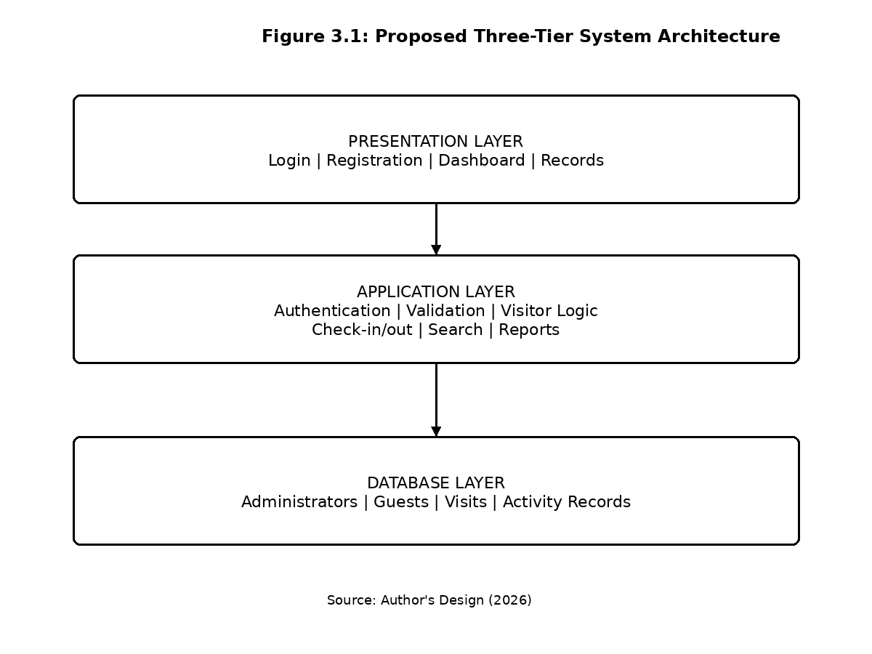
Source: Author's Design (2026)

3.11 System Modules
The proposed system will be divided into functional modules.

3.11.1 Authentication Module
This module controls administrator access to the system. It verifies login credentials before granting access to protected functions.

3.11.2 Guest Registration Module
This module provides the registration form through which guest information is entered.
Possible fields include:
- Full name
- Phone number
- Email address
- Address
- Purpose of visit
- Person being visited
- Department
- Identification information

3.11.3 Check-In Module
This module records the arrival of a guest and associates the check-in time with the guest's visit record.

3.11.4 Check-Out Module
This module records the departure of a guest and updates the visitor's visit status.

3.11.5 Guest Records Module
This module provides administrators with access to stored visitor records.

3.11.6 Search Module
The search module enables authorized users to locate records using selected criteria.

3.11.7 Dashboard Module
The dashboard provides a summary of relevant visitor information.
For example, it may display:
- Total guests
- Today's guests
- Guests currently inside
- Completed visits

3.11.8 Reporting Module
The reporting function will allow administrators to view relevant visitor information for administrative purposes.

3.12 Data Flow Diagram
A Data Flow Diagram (DFD) illustrates how information moves between users, processes, and data stores within a system.

3.12.1 Context-Level Data Flow Diagram
At the highest level, the Computerized Guest Information Tracking System is treated as one process.
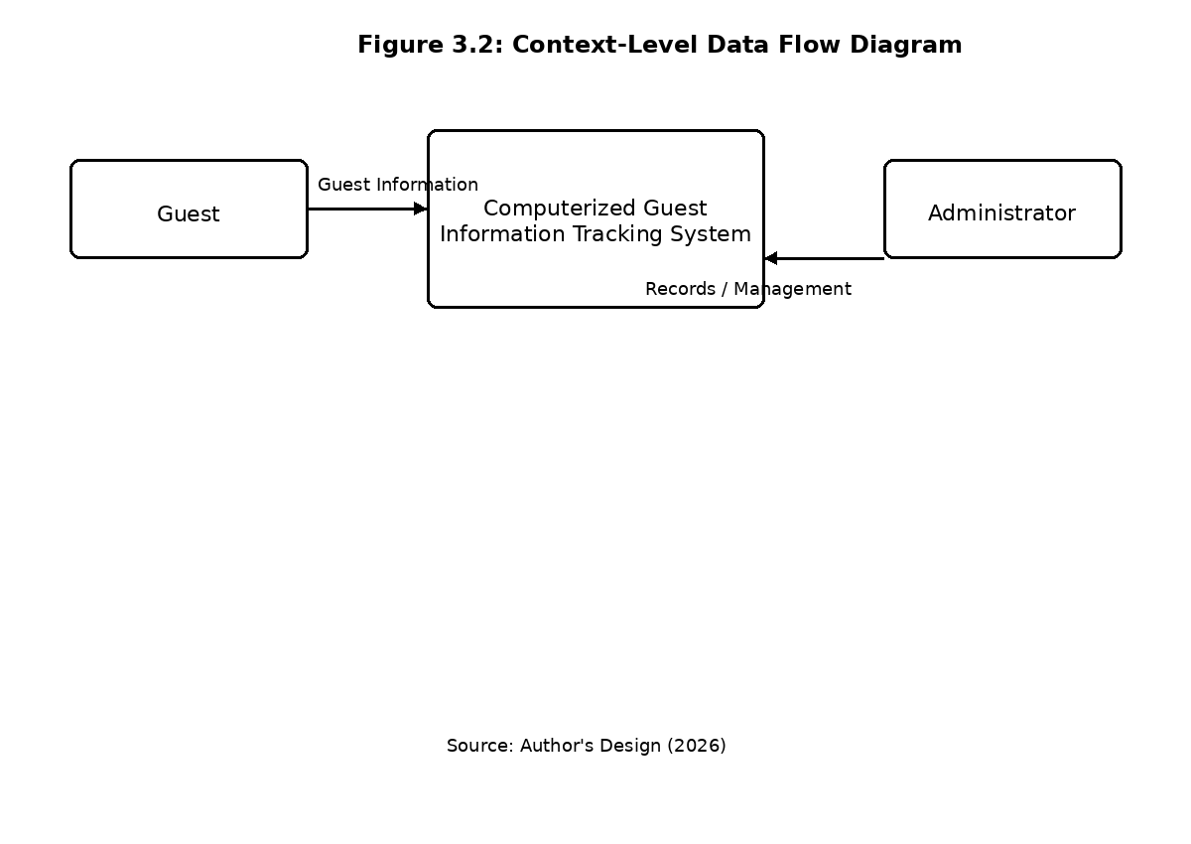

Figure 3.2: Context-Level Data Flow Diagram
Source: Author's Design (2026)
The guest provides registration information to the system. The administrator interacts with the system to manage records, monitor visitors, and retrieve information.

3.13 Level One Data Flow Diagram
The Level One DFD decomposes the system into its major processes.
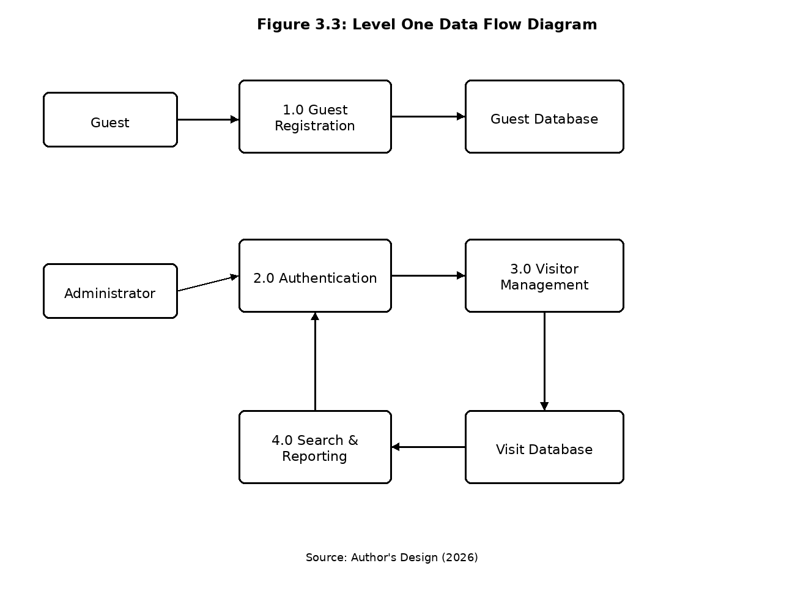
Figure 3.3: Level One Data Flow Diagram
Source: Author's Design (2026)

3.14 Entity Relationship Design
The proposed database will contain entities representing the major objects involved in the system.
The main entities are:
- Administrator
- Guest
- Visit

Administrator Entity
Possible attributes include:
- Admin_ID
- Username
- Password
- Full_Name
- Role

Guest Entity
Possible attributes include:
- Guest_ID
- Full_Name
- Phone
- Email
- Address
- Identification_Number

Visit Entity
Possible attributes include:
- Visit_ID
- Guest_ID
- Purpose
- Host
- Department
- Check_In_Time
- Check_Out_Time
- Visit_Date
- Status

Relationship
A guest may have multiple visits over time. Therefore:
One Guest → Many Visits
The Guest entity is connected to the Visit entity through Guest_ID.

3.15 Proposed Database Structure
A possible database structure is presented below.

Table 3.1: Administrator Table
Field | Data Type | Description
admin_id | INT | Primary key
username | VARCHAR | Administrator username
password | VARCHAR | Encrypted/hashed password
full_name | VARCHAR | Administrator name
role | VARCHAR | User role

Table 3.2: Guest Table
Field | Data Type | Description
guest_id | INT | Primary key
full_name | VARCHAR | Guest's name
phone | VARCHAR | Telephone number
email | VARCHAR | Email address
address | TEXT | Guest address
identification_no | VARCHAR | Identification number

Table 3.3: Visit Table
Field | Data Type | Description
visit_id | INT | Primary key
guest_id | INT | Foreign key
purpose | VARCHAR | Purpose of visit
host | VARCHAR | Person being visited
department | VARCHAR | Relevant department
check_in | DATETIME | Arrival time
check_out | DATETIME | Departure time
status | VARCHAR | Current visit status

3.16 Input Design
Input design describes how information will be entered into the system.
The major input forms will include:

Administrator Login Form
Fields:
- Username
- Password

Guest Registration Form
Fields:
- Full name
- Phone number
- Email
- Address
- Identification number
- Purpose of visit
- Host
- Department
The system will validate required fields before submitting information to the database.
For example, the system may prevent submission when a required name or purpose of visit has not been provided.

3.17 Output Design
Output design describes the information presented to users after system processing.
The proposed system will provide outputs such as:
- Successful registration message
- Guest record
- Current visitor list
- Check-in confirmation
- Check-out confirmation
- Search results
- Visitor statistics
- Administrative reports
The dashboard will provide a summarized view of visitor activities to help administrators understand the current state of the system.

3.18 Proposed User Interface Design
The system interface will be designed with simplicity and usability in mind.
The major interfaces will include:

Login Interface
The login interface will provide fields for administrator credentials and a login button.

Dashboard
The dashboard will display summary cards such as:
--------------------------------------------------
| GUEST TRACKING SYSTEM |
--------------------------------------------------
| Total Guests | Today's Visits | Currently In |
| 250 | 35 | 8 |
--------------------------------------------------
| Register Guest | Guest Records | Reports |
--------------------------------------------------

Guest Registration Interface
The registration interface will provide structured fields for capturing visitor information.

Guest Records Interface
This interface will display stored visitor information in a table, with options to search, view, update, or manage records according to the administrator's permissions.

Check-Out Interface
The interface will allow an administrator to identify a currently active visit and record the guest's departure.

3.19 Security Design
Security will be considered at different levels of the system.

Authentication
Only users with valid administrator credentials will access protected administrative functions.

Password Protection
Passwords should not be stored as plain text. Password hashing will be used during implementation.

Input Validation
User input will be validated before being processed or stored.

Access Control
Administrative functions will be restricted to authenticated users.

Session Management
The system will manage administrator sessions and provide a logout function.

Database Protection
Database access will be handled through the application layer rather than allowing ordinary users to interact directly with the database.

3.20 System Operation
The general operation of the proposed system will follow these steps:
- The administrator opens the system.
- The administrator logs into the system.
- The system validates the administrator's credentials.
- The administrator accesses the dashboard.
- A guest arrives at the organization.
- The guest's information is entered into the registration form.
- The system validates the information.
- The information is stored in the database.
- The guest's check-in time is recorded.
- The guest proceeds to the relevant person or department.
- When the visit ends, the guest's check-out is recorded.
- The visit record is updated.
- The administrator can subsequently search or review the record.

3.21 Summary of System Design
The proposed Computerized Guest Information Tracking System is designed as a web-based system consisting of a presentation layer, application layer, and database layer. The system provides core functions including administrator authentication, guest registration, check-in, check-out, record management, searching, and reporting.
The Prototyping Model was selected because it provides an appropriate development approach for producing and refining a working prototype within the scope of the study. The system design also incorporates database structures, data-flow processes, security controls, and user interface components.
The design presented in this chapter provides the foundation for the actual development and testing of the prototype.

CHAPTER FOUR

SYSTEM IMPLEMENTATION AND TESTING

4.1 Introduction
This chapter presents the implementation and testing of the Computerized Guest Information Tracking System proposed in the preceding chapters. The purpose of the implementation was to translate the system requirements and design presented in Chapter Three into a functional prototype capable of demonstrating the major activities involved in computerized guest information management.
The implemented prototype provides facilities for recording guest information, tracking visitor entry and exit, viewing stored visitor records, searching records, displaying visitor statistics, and generating a basic report output. The implementation was guided by the system architecture, database structure, functional requirements, and interface designs presented in Chapter Three.
The chapter describes the development environment, implementation of the major system modules, user interfaces, data storage approach, system operation, testing procedures, and test results. Screenshots of the implemented interfaces are also presented to demonstrate the operation and appearance of the system.

4.2 Development Environment
The development environment consists of the hardware and software resources required for developing and demonstrating the Computerized Guest Information Tracking System.

4.2.1 Hardware Environment
The system can be developed and demonstrated using a standard personal computer with the following minimum specifications:
Component | Specification
Processor | Dual-core processor or better
RAM | 4 GB or above
Storage | At least 20 GB available space
Display | Standard computer monitor
Input devices | Keyboard and mouse
Network | Local network or Internet connection where required
The hardware requirements are relatively modest because the prototype does not require specialized biometric devices or other dedicated visitor-management hardware.

4.2.2 Software Environment
The prototype was designed around standard web technologies. The major technologies used include HTML, CSS, JavaScript, and browser-based data storage.
Software/Technology | Purpose
HTML | Structure of the system interfaces
CSS | Styling and layout
JavaScript | System interaction and processing
Web Browser | Running and demonstrating the prototype
Local Storage | Demonstration data persistence
Visual Studio Code | Source-code editing
The use of standard web technologies makes the prototype relatively easy to demonstrate and provides a foundation for future connection to a server-side database.

4.3 Implementation of the Proposed System
The proposed system was implemented as a computerized visitor management prototype consisting of several interconnected modules. The implementation followed the three-tier architecture discussed in Chapter Three.
The major implemented functions include:
- Dashboard
- Guest registration
- Guest check-in
- Guest records
- Guest search
- Guest check-out
- Visitor statistics
- Report generation
- Data export
The system interface was designed to provide a simple navigation structure. Users can move between the Dashboard, Register Guest, Guest Records, and Reports sections.

4.4 Implementation of the Dashboard Module
The dashboard serves as the main administrative interface of the system. It provides a summary of visitor activities and gives the administrator quick access to the major system functions.
The dashboard displays information including:
- Total visits
- Today's visits
- Visitors currently inside
- Completed visits
- Recent visitor activities
This arrangement allows an administrator to obtain an immediate overview of visitor activities without manually examining individual records.

Figure 4.1: Implemented System Dashboard
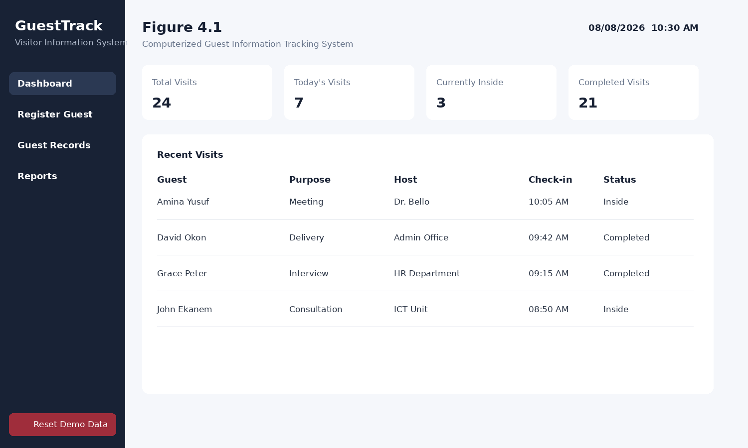Source: Author's Implementation (2026).
The dashboard shown in Figure 4.1 provides summary cards at the top of the interface. A recent-visits table is displayed below the summary cards. The interface also provides navigation to the guest registration, guest records, and reporting sections.
The dashboard therefore provides a central point from which administrative visitor-management activities can be accessed.

4.5 Implementation of the Guest Registration Module
The guest registration module provides the primary interface for capturing information about visitors.
The registration form contains fields for information such as:
- Full name
- Telephone number
- Email address
- Identification number
- Person being visited
- Department
- Purpose of visit
Required information is entered through structured input fields. The registration process is designed to reduce the problems associated with handwritten visitor registers.
When the registration form is submitted, the system creates a visit record and records the guest's check-in time.

Figure 4.2: Implemented Guest Registration Interface
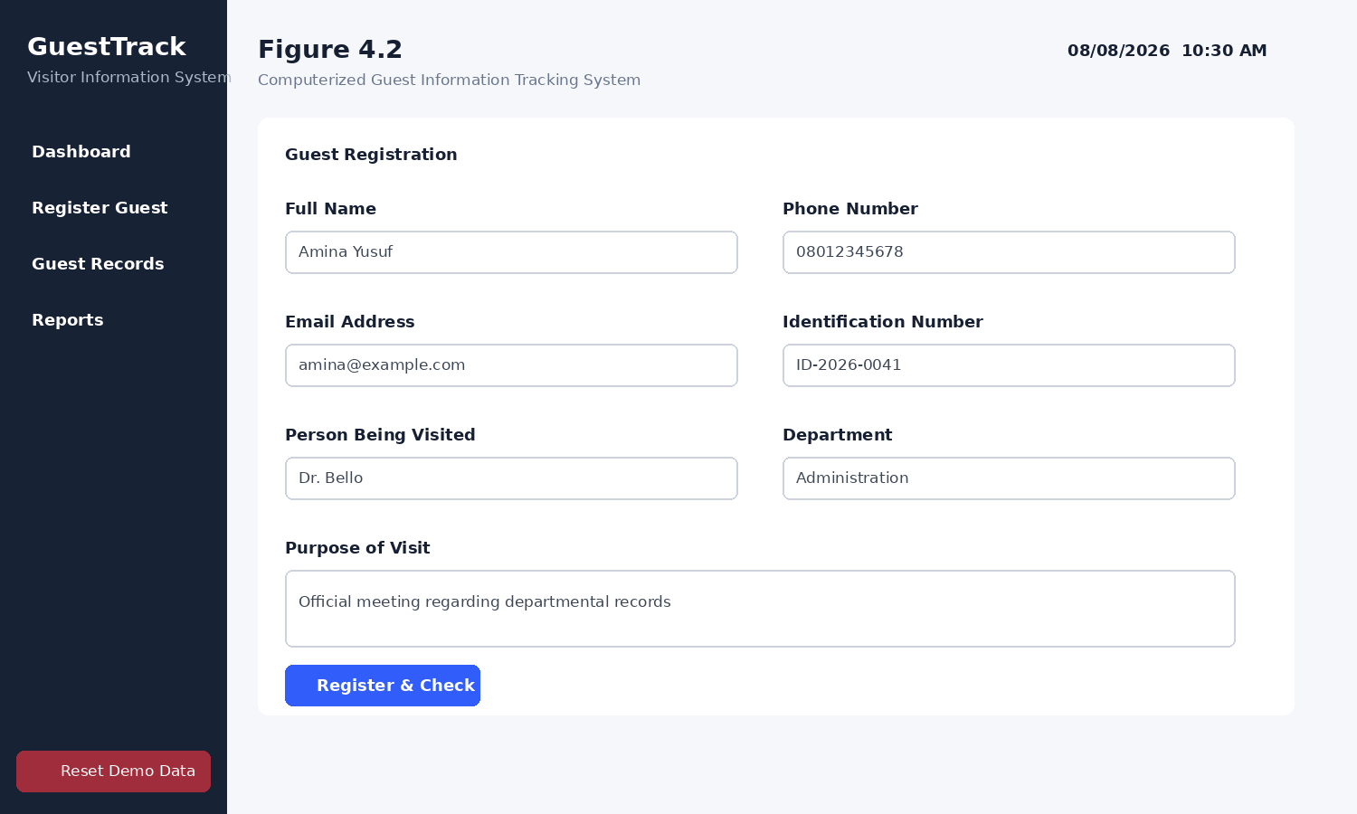Source: Author's Implementation (2026).
Figure 4.2 shows the implemented guest registration interface. The form provides clearly labelled fields for entering guest information. The Register & Check In button initiates the registration process.
The implementation provides a structured approach to collecting visitor information and ensures that the information is captured in a consistent digital format.

4.6 Implementation of the Guest Check-In Function
The check-in function records the arrival of a guest.
During registration, the system automatically records the date and time associated with the visit. This timestamp becomes part of the visitor's record.
The check-in process can be summarized as follows:
- The guest provides the required information.
- The information is entered into the registration form.
- The system validates required fields.
- A visitor record is created.
- The current date and time are recorded as the check-in time.
- The visitor's status is initially set to Inside.
- The record becomes available through the Guest Records section.
This process eliminates the need for a receptionist or security officer to manually write the arrival time in a physical register.

4.7 Implementation of the Guest Records Module
The Guest Records module provides an organized view of stored visitor information.
The records interface displays information including:
- Guest name
- Telephone number
- Host
- Purpose of visit
- Check-in time
- Check-out time
- Current status
- Available action
The system uses visitor status to distinguish between visitors who are still within the organization and those who have completed their visits.

Figure 4.3: Implemented Guest Records Interface
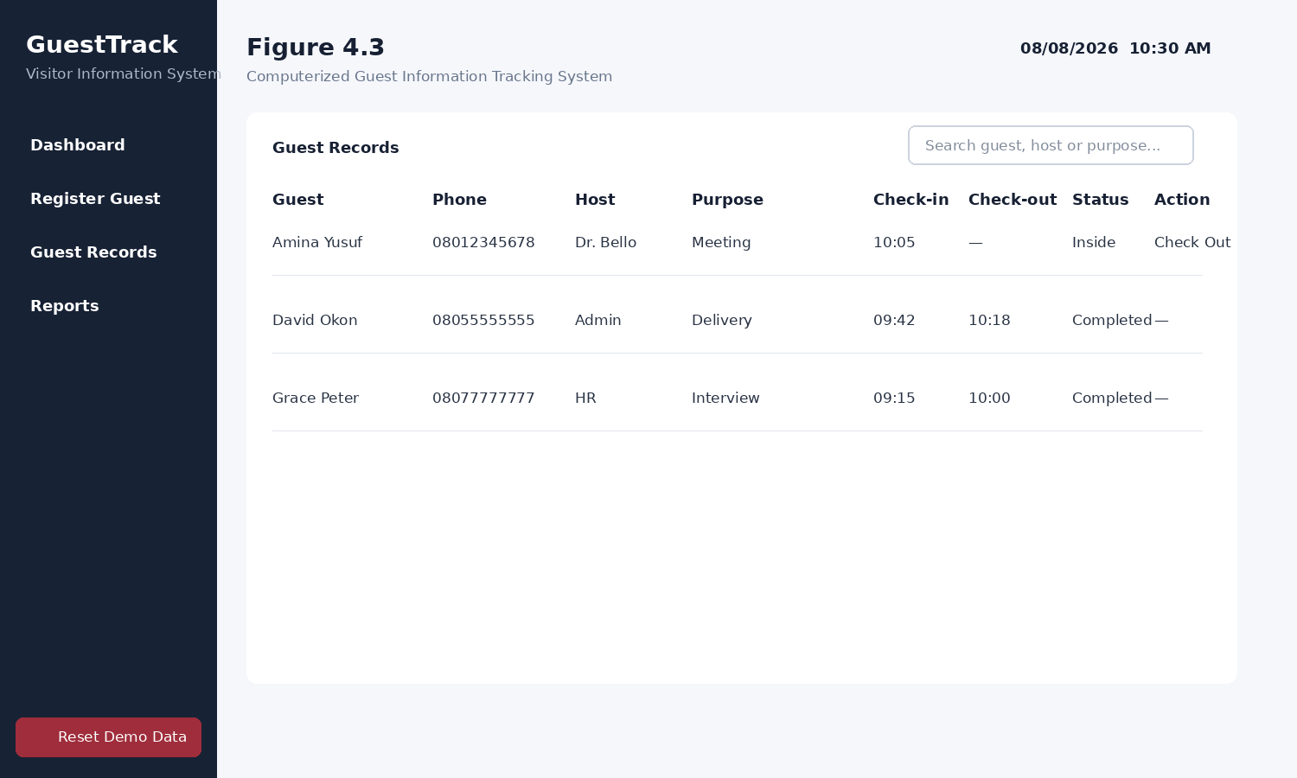
Source: Author's Implementation (2026).
Figure 4.3 demonstrates the Guest Records interface. The records are presented in tabular form, allowing an administrator to view multiple visitor records at once.
The interface also provides a search field that can be used to locate records based on visitor name, telephone number, host, or purpose of visit.

4.8 Implementation of the Search Function
The search function was implemented to improve the retrieval of visitor information.
In a manual register, finding a particular visitor may require searching through several pages. The computerized system provides a search field through which the administrator can enter relevant information.
The search function can be used to locate visitors using:
- Name
- Telephone number
- Host
- Purpose of visit
When a search term is entered, the system filters the stored records and displays matching results.
This function demonstrates one of the major advantages of converting the manual visitor register into a computerized information system.

4.9 Implementation of the Guest Check-Out Function
The check-out function records when a guest leaves the organization.
A newly registered visitor is initially assigned the status Inside. When the visitor leaves, the administrator selects the corresponding record and activates the check-out function.
The system then:
- Identifies the selected visitor.
- Records the current date and time.
- Updates the visitor's check-out field.
- Changes the visitor's status from Inside to Completed.
- Updates the dashboard statistics.
The check-out process provides a more accurate representation of which visitors have completed their visits and which visitors may still be within the organization.

4.10 Implementation of the Reporting Module
The reporting module provides summarized information derived from the stored visitor records.
The implemented prototype provides statistics such as:
- Average visit duration
- Number of unique guests
- General visitor activity
- Exportable visitor records

Figure 4.4: Implemented Reporting Interface
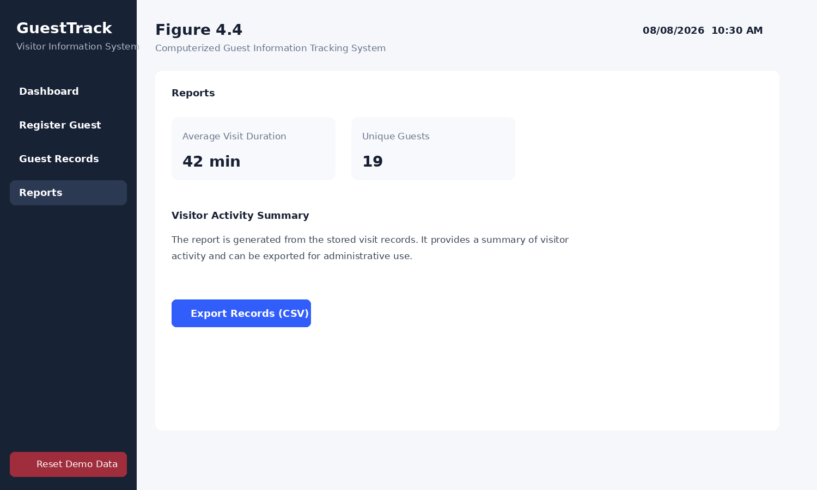
Source: Author's Implementation (2026).
Figure 4.4 shows the reporting interface. The interface presents summarized visitor information and provides an option for exporting records in CSV format.
The reporting functionality can assist administrators in reviewing visitor activity and maintaining records for administrative purposes.

4.11 Data Storage Implementation
The prototype uses structured browser-based storage for demonstration purposes. Visitor records are maintained within the browser's local storage environment.
The stored record contains information corresponding to the major fields identified during system analysis.
A typical visitor record consists of:
Field | Description
ID | Unique visitor/visit identifier
Full Name | Name of visitor
Phone | Visitor telephone number
Email | Visitor email address
Identification | Identification information
Host | Person being visited
Department | Relevant department
Purpose | Reason for visit
Check-in | Visitor arrival time
Check-out | Visitor departure time
Status | Current visitor status
The use of structured storage demonstrates the basic database logic of the system. In a production deployment, this storage mechanism can be replaced or extended with a server-side relational database such as MySQL.

4.12 Implementation of Visitor Status Tracking
Visitor status tracking is an important component of the system.
The system uses two primary statuses:

Inside
This status indicates that the visitor has registered and checked in but has not yet been checked out.

Completed
This status indicates that the visitor has checked out and completed the visit.
This distinction makes it possible for an administrator to identify current visitors without physically checking a paper register.

4.13 System Navigation
The implemented prototype provides a navigation menu containing the major system sections.
The administrator can navigate between:
Dashboard → Register Guest → Guest Records → Reports
The Dashboard provides an overview of the system, while the Register Guest page handles new visitor registration. Guest Records provides access to existing records, and Reports provides summarized visitor information.
The navigation structure was designed to reduce the number of steps required to perform common activities.

4.14 System Testing
Testing was conducted to determine whether the implemented prototype performed its major functions according to the specified requirements.
Functional testing was used because the main purpose was to determine whether individual system functions produced their expected outputs.
The major functions tested were:
- Dashboard display
- Guest registration
- Required-field validation
- Check-in
- Record storage
- Record search
- Check-out
- Visitor status update
- Statistics
- CSV export

4.15 Test Cases and Results

Table 4.1: System Functional Test Results
Test ID | Function Tested | Expected Result | Observed Result | Status
T01 | Dashboard | Dashboard loads and displays visitor statistics | Dashboard displayed correctly | Passed
T02 | Guest registration | Guest information is accepted and stored | Record was created successfully | Passed
T03 | Required fields | Empty required fields should prevent submission | Required fields were enforced | Passed
T04 | Check-in | New visitor should receive check-in time | Check-in time was recorded | Passed
T05 | Guest records | Stored records should appear in records table | Records appeared correctly | Passed
T06 | Search | Matching records should be displayed | Matching records were filtered | Passed
T07 | Check-out | Departure time should be recorded | Check-out time was recorded | Passed
T08 | Status tracking | Visitor status should change after check-out | Status changed to Completed | Passed
T09 | Statistics | Dashboard/report figures should reflect stored records | Statistics updated accordingly | Passed
T10 | CSV export | Records should be exported | CSV file was generated | Passed
Source: Author's Test Results (2026).
The test results indicate that the major functions implemented in the prototype operated according to their specified requirements.

4.16 Registration and Check-Out Test
A practical demonstration of the system involves registering a visitor and subsequently recording the visitor's departure.
The process follows these steps:
- The administrator opens the registration page.
- The guest's information is entered.
- The administrator submits the registration form.
- The system creates the visitor record.
- The visitor appears as Inside in the records.
- When the visit ends, the administrator selects Check Out.
- The system records the departure time.
- The visitor's status changes to Completed.
This test demonstrates that the system is capable of maintaining the complete lifecycle of a visitor's visit rather than simply recording the initial registration.

4.17 Search Function Test
The search function was tested using different visitor information.
For example, a visitor's name was entered into the search field. The system filtered the records and displayed the matching visitor.
The search function was also tested using other available information, including the host and purpose of visit.
The result demonstrates that digital storage provides faster access to visitor information than manually searching through physical registers.

4.18 Report Generation Test
The reporting function was tested by creating several visitor records and completing some of the visits.
The system calculated summary information from the available records and displayed it within the Reports section.
The CSV export function was also tested. The system generated a CSV file containing the visitor records and relevant fields.
This demonstrates that stored visitor information can be converted into a portable format for further administrative processing.

4.19 Security Considerations
Although the prototype focuses primarily on guest information tracking, security considerations were incorporated into the system design.
The major security considerations include:

Access Control
Administrative functions should only be accessible to authorized users.

Input Validation
Information entered by users should be validated before being processed.

Data Protection
Visitor information should not be unnecessarily exposed to unauthorized persons.

Password Protection
Where administrator authentication is implemented in a production deployment, passwords should be stored using secure hashing rather than plain text.

Session Management
Authenticated administrative sessions should be properly controlled and terminated when the administrator logs out.
The current prototype is intended for academic demonstration. A production system would require additional security controls, server-side authentication, encrypted communication, database security, backup mechanisms, and appropriate privacy controls.

4.20 Discussion of Implementation Results
The implementation demonstrates that the requirements identified during system analysis can be translated into a functional computerized visitor management prototype.
The registration function provides a structured alternative to handwritten visitor records. The check-in and check-out functions provide information about the movement of visitors, while the Guest Records module provides a centralized location for reviewing stored information.
The search function addresses the problem of retrieving historical records from physical registers. Instead of manually examining pages of records, an administrator can enter a search term and obtain matching records.
The dashboard and reporting functions also provide summarized information that would be difficult to obtain efficiently from a conventional paper-based register.
The implementation is consistent with the broader findings from previous visitor-management research. For example, Teng and Shen (2020) demonstrated the value of centralized digital information management for visiting services, while Zhao et al. (2023) demonstrated how visitor management can be structured into multiple technological layers. The present prototype adopts the fundamental information-management principles of such systems while keeping the implementation simpler and appropriate for the scope of this B.Sc. project.

4.21 Limitations of the Implemented Prototype
Although the prototype demonstrates the core functionality of a computerized guest information tracking system, it has some limitations.
First, the prototype uses browser-based storage for demonstration purposes rather than a remotely hosted production database.
Second, it does not implement biometric identification such as fingerprint or facial recognition. Such technologies would require additional hardware and software infrastructure.
Third, the prototype does not provide SMS or email notifications.
Fourth, it is not connected to an organization's existing access-control infrastructure.
Fifth, the current reporting functionality is basic and can be expanded in a future version.
These limitations do not prevent the prototype from demonstrating the core objectives of the study. Rather, they identify areas that can be considered for future development.

4.22 Summary of Chapter Four
This chapter presented the implementation and testing of the Computerized Guest Information Tracking System. The proposed design from Chapter Three was translated into a functional prototype containing a dashboard, guest registration, check-in, guest records, search, check-out, visitor status tracking, reporting, and data export functions.
Screenshots of the implemented interfaces were presented to demonstrate the appearance and operation of the system. Functional testing was also conducted on the major system components.
The results of the testing showed that the core functions of the prototype performed their intended operations. Guest records could be created, searched, updated through check-out, and used to generate visitor statistics and reports.
The implementation therefore demonstrates the feasibility of using a computerized approach to improve the organization and management of guest information compared with a purely manual visitor register.

CHAPTER FIVE

SUMMARY, CONCLUSION AND RECOMMENDATIONS

5.1 Introduction
This chapter presents the summary, conclusion, recommendations, and suggestions for further studies on the Computerized Guest Information Tracking System. The study was undertaken to examine how computerized information management can be applied to visitor registration and tracking within an organization.
The study focused on the limitations associated with conventional manual visitor registers, including slow information retrieval, inaccurate or incomplete records, difficulty in monitoring visitors, poor record organization, and challenges associated with maintaining historical visitor information. A computerized approach was proposed to provide a more structured method of collecting, storing, retrieving, and managing guest information.
The chapter summarizes the major issues addressed by the study, the approach adopted, the major outcomes of the implementation, and the possible improvements that can be made to the system in future.

5.2 Summary of the Study
The study focused on the design and implementation of a Computerized Guest Information Tracking System for improving the management of visitor information within an organization.
Traditional visitor management commonly involves the use of paper registers in which guests manually provide information such as their names, telephone numbers, purpose of visit, person being visited, and arrival time. Although this method is simple to operate, it can become inefficient when an organization receives a large number of visitors or needs to retrieve information about previous visits.
The study therefore considered the application of computerized information management principles to visitor registration and tracking. The proposed system provides a structured platform through which visitor information can be captured and maintained electronically.
The work was organized into five chapters.

Chapter One
Chapter One introduced the study by presenting the background of the study, statement of the problem, aim and objectives, significance of the study, scope and limitations, and methodology.
The chapter established the need for an improved approach to visitor information management and identified the major weaknesses associated with manual visitor registers.
The main aim of the study was to develop a computerized approach for managing guest information and tracking visitor activities within an organization.

Chapter Two
Chapter Two reviewed relevant literature on computerized visitor management, information systems, cloud-based systems, automated identification, visitor tracking, and related technologies.
The review examined existing studies and systems developed to improve visitor registration, monitoring, information retrieval, and organizational security. The literature demonstrated that computerized visitor management can improve the organization and accessibility of visitor information when appropriately designed and implemented.
The theoretical framework also provided a basis for understanding how information systems can be designed to support organizational activities and how users interact with computerized systems.

Chapter Three
Chapter Three presented the system analysis and design. The existing manual visitor registration process was examined and its limitations identified.
The proposed system architecture was then presented together with the major components and data flows. The design included modules for guest registration, check-in, record management, search, check-out, and reporting.
The chapter also described the data requirements and the methodology used in developing the prototype.

Chapter Four
Chapter Four presented the implementation and testing of the proposed system.
A functional prototype was developed to demonstrate the major activities of the proposed computerized guest information tracking system. The prototype included:
- A dashboard for displaying visitor statistics.
- A guest registration module.
- A visitor check-in function.
- A guest records module.
- A visitor search function.
- A check-out function.
- Visitor status tracking.
- A reporting interface.
- CSV record export.
The implemented prototype was subjected to functional testing. The tests examined whether the major functions performed their intended operations.
The results showed that the implemented functions were able to support the basic visitor-management activities for which they were designed.

5.3 Summary of Major Findings
Based on the study and implementation, several findings were identified.

5.3.1 Computerization Improves Record Organization
The study demonstrated that visitor information can be organized more systematically when stored electronically rather than relying entirely on handwritten registers.
The computerized approach allows visitor information to be represented as structured records containing relevant fields such as name, telephone number, host, purpose of visit, check-in time, and check-out time.

5.3.2 Digital Records Improve Information Retrieval
One of the major limitations of manual visitor registers is the difficulty of locating previous records.
The implemented search functionality demonstrated how visitor information can be retrieved using relevant details such as the guest's name, telephone number, host, or purpose of visit.
This can reduce the time required to locate information compared with manually searching through physical registers.

5.3.3 Visitor Movement Can Be Tracked
The system provides a mechanism for recording both visitor arrival and departure.
A visitor's status changes from Inside after registration and check-in to Completed after check-out. This provides a simple mechanism for determining whether a registered visitor has completed the visit.

5.3.4 Computerized Records Support Reporting
The implementation demonstrated that stored visitor records can be used to generate summary information.
The reporting component can provide information such as the number of visits, unique visitors, and average visit duration. Records can also be exported into a CSV format for further administrative use.

5.3.5 Computerization Can Reduce Dependence on Manual Registers
The proposed system provides an alternative to the traditional paper-based registration process.
Instead of requiring visitors to write their information manually into a register, an administrator can enter the information into a structured computerized interface.
This can improve consistency in the format of captured information.

5.3.6 The Prototype Demonstrates the Feasibility of the Proposed System
The implementation and testing presented in Chapter Four demonstrated that the major functional requirements of the proposed system can be implemented using standard web technologies.
The prototype therefore provides a practical demonstration of the concepts developed during the study.

5.4 Achievement of the Objectives
The study objectives were used as a basis for determining whether the work achieved its intended purpose.

Objective One: Examine the existing visitor information management process
The study examined the conventional manual visitor registration process and identified challenges associated with handwritten records, information retrieval, record organization, and visitor tracking.
Objective achieved.

Objective Two: Design a computerized guest information tracking system
A system architecture and interface design were developed to provide structured visitor registration and tracking.
Objective achieved.

Objective Three: Develop a functional prototype for guest information management
A prototype was implemented with guest registration, check-in, records management, search, check-out, dashboard, and reporting functionality.
Objective achieved.

Objective Four: Provide a mechanism for retrieving visitor information
A search function was implemented to enable users to locate visitor records using relevant information.
Objective achieved.

Objective Five: Provide a mechanism for monitoring visitor status
The prototype records check-in and check-out information and uses visitor status to distinguish between visitors who are still inside and those who have completed their visits.
Objective achieved.

Objective Six: Test the major functions of the proposed system
Functional testing was conducted on the major components of the prototype, including registration, record management, search, check-out, reporting, and data export.
Objective achieved.

5.5 Conclusion
The study examined the use of computerized information management for guest registration and visitor tracking within an organization.
The study established that reliance on manual visitor registers can create challenges in maintaining organized records and retrieving historical visitor information. The proposed computerized approach provides a structured alternative by allowing guest information to be captured, stored, searched, updated, and used for reporting.
The implemented prototype demonstrated the core functions required for computerized guest information tracking. Visitors can be registered, their arrival can be recorded, information can be retrieved through the records interface, and their departure can subsequently be recorded. The system also provides basic statistical and reporting functionality.
The testing carried out on the prototype showed that the major implemented functions performed their intended operations. The study therefore concludes that a computerized guest information tracking system is a feasible approach for improving the organization and management of visitor records.
However, the prototype represents an academic implementation rather than a complete enterprise-level visitor management platform. Additional development would be required before deployment in an organization requiring centralized cloud storage, multiple administrative users, advanced authentication, biometric identification, integration with physical access-control systems, automated notifications, and comprehensive security controls.
Overall, the study demonstrates how a computerized information system can provide a more structured, searchable, and manageable approach to visitor information tracking than a conventional manual register.

5.6 Recommendations
Based on the findings of the study, the following recommendations are made.

5.6.1 Adoption of Computerized Visitor Registration
Organizations that still depend entirely on manual visitor registers should consider adopting computerized visitor registration systems to improve the organization and retrieval of visitor information.

5.6.2 Use of Centralized Database Storage
For actual organizational deployment, the prototype should be connected to a centralized database such as MySQL or another appropriate relational database system.
A centralized database would allow authorized users to access visitor information from different workstations while maintaining a common source of records.

5.6.3 Implementation of User Authentication
The production version of the system should include secure administrator authentication.
Different categories of users can be assigned appropriate permissions. For example, a security officer may register and check out visitors, while an administrator may have access to reports and historical records.

5.6.4 Improved Data Security
Because visitor information may contain personal data, appropriate security controls should be implemented before actual deployment.
These should include secure authentication, encrypted communication, access control, database protection, regular backups, and appropriate data-retention policies.

5.6.5 Regular Data Backup
Visitor records should be backed up regularly to reduce the possibility of losing important information as a result of hardware failure, accidental deletion, or other technical problems.

5.6.6 Staff Training
Personnel responsible for operating the system should receive appropriate training.
Training should cover guest registration, visitor check-in and check-out, searching for records, generating reports, and basic data protection practices.

5.6.7 Integration with Identification Technologies
Future versions of the system may incorporate technologies such as barcode or QR-code identification, identity-card scanning, fingerprint recognition, or facial recognition where legally and operationally appropriate.
Such technologies could reduce manual data entry and improve visitor identification.

5.6.8 Integration with Notification Services
The system could be enhanced to automatically notify employees when their visitors arrive.
Notifications could be delivered through approved organizational communication channels such as email or SMS.

5.6.9 Development of Advanced Reporting
Future versions should provide more comprehensive reporting capabilities.
Reports could include:
- Daily visitor reports
- Weekly visitor reports
- Monthly visitor reports
- Department-based visitor statistics
- Frequent visitor reports
- Visit-duration analysis
- Visitor traffic trends
These reports could support administrative decision-making.

5.6.10 Regular System Maintenance
The system should be regularly maintained after deployment. Software updates, database maintenance, security reviews, backups, and performance monitoring should be conducted to ensure continued reliability.

5.7 Suggestions for Further Studies
Future researchers can extend this study in several ways.

5.7.1 Cloud-Based Visitor Management
Future work could develop a cloud-based version that allows authorized administrators to securely access visitor records from multiple locations.

5.7.2 Biometric Visitor Identification
Further research could investigate the integration of biometric identification technologies with visitor management while considering accuracy, privacy, security, cost, and ethical requirements.

5.7.3 Mobile Visitor Management
A mobile application could be developed to allow security personnel or administrators to register and monitor visitors using smartphones or tablets.

5.7.4 Integration with Physical Access Control
Future studies could investigate integration between visitor management software and physical access-control systems such as electronic doors, access cards, or temporary visitor passes.

5.7.5 Advanced Data Analytics
Future researchers could investigate the use of data analytics to identify visitor patterns, peak visiting periods, frequently visited departments, and other useful organizational trends.

5.7.6 Multi-Organization Deployment
Further studies could examine how the system can be adapted for environments with multiple branches, departments, buildings, or locations while maintaining centralized visitor records.

5.8 Contribution of the Study
The study contributes to the application of computerized information management principles to visitor information tracking.
Its major contribution is the presentation of a structured approach for replacing or complementing manual visitor registration with a computerized process. The prototype demonstrates how basic visitor information can be digitally captured, organized, retrieved, monitored, and reported.
The study also provides a foundation that can be extended with more advanced technologies such as cloud databases, mobile applications, biometric identification, automated notifications, and integration with organizational access-control systems.

5.9 Final Summary
The study focused on the development of a Computerized Guest Information Tracking System as an alternative approach to manual visitor information management.
The research examined the existing challenges, reviewed relevant literature, developed a system design, implemented a functional prototype, and tested its major functions.
The results indicate that the computerized approach can support structured guest registration, visitor tracking, record retrieval, check-out monitoring, and basic reporting. Although the prototype requires additional development before it can serve as a full-scale organizational deployment, it successfully demonstrates the fundamental principles and functionality of computerized guest information tracking.
The study therefore concludes that the proposed system provides a practical foundation for improving the management of visitor information and can serve as a basis for future development of a more comprehensive visitor management solution.

References
Ali, N. S., Alhilali, A. H., Rjeib, H. D., & Al-Sadawi, B. (2022). Automated attendance management systems: Systematic literature review. International Journal of Technology Enhanced Learning, 14(1), 37–56.
Bertalanffy, L. von. (1968). General system theory: Foundations, development, applications. George Braziller.
Davis, F. D. (1989). Perceived usefulness, perceived ease of use, and user acceptance of information technology. MIS Quarterly, 13(3), 319–340.
Dennis, A., Wixom, B. H., & Tegarden, D. (2015). Systems analysis and design: An object-oriented approach with UML (5th ed.). Wiley.
Limyoco, L. O. (2025). Enhancing efficiency and security: A study of automated visitors monitoring system in the Bureau of Jail Management and Penology. International Journal of Science, Technology, Engineering & Mathematics, 5(4), 44–63.
Pressman, R. S., & Maxim, B. R. (2020). Software engineering: A practitioner's approach (9th ed.). McGraw-Hill Education.
Rivera, J. N. D. (2021). VMS support: A mobile-based support to computerized visitor management system. Software Impacts, 8, 100056.
Teng, X., & Shen, Z. (2020). Design of a smart visiting service management system for personal information collection in order to integrate tourism management into an isolated island. Applied Sciences, 10(18), 6442.
Zhao, X.-F., Chen, Z.-H., Yin, H.-F., & Wu, X.-J. (2023). Design of intelligent visitor system based on cloud and edge collaborative computing. Journal of Algorithms & Computational Technology, 17, 1–12.

