EXERCISE NO:1

DATE:12/10/2020

AIM:

To write a python program to print the calendar of a given month and year.

PROGRAM:

import calendar as cal

year=int(input())

month=int(input())

if(year>999 and year<10000):

if(month>=1 and month<=12):

print(cal.month(year,month))

else:

print("Invalid Input")

else:

print("Invalid Input")

LINK:

<http://103.53.53.18/mod/vpl/forms/edit.php?id=229&userid=1748>

OUTPUT:

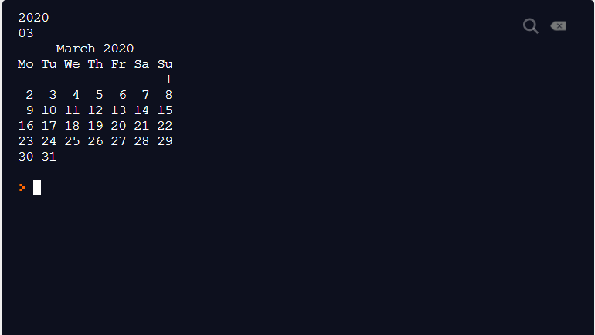

RESULT:

The output is obtained successfully.