EXERCISE NO:10

DATE:23/11/2020

AIM:

Write a Python function that accepts a string and calculate the number of upper case letters and lower case letters .

Sample String: ‘Sona College of Technology’

PROGRAM:

def string_test(s):

d={"upper":0,"lower":0}

for i in s:

if i.islower():

d["lower"]+=1

elif i.isupper():

d["upper"]+=1

print("No.of Upper case characters:",d["upper"])

print("No.of Lower case characters:",d["lower"])

s=input()

string_test(s)

LINK:

http://103.53.53.18/mod/vpl/forms/submissionview.php?id=325&userid=1748

OUTPUT:

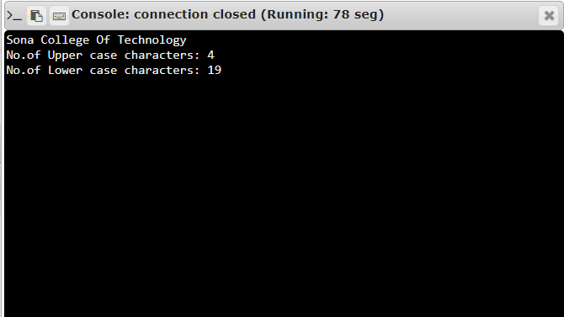

RESULT:

The output is obtained successfully.