EXERCISE NO:11

DATE:23/11/2020

AIM:

Write a Python program to find the greatest common divisor (gcd) of two integers using recursion.

PROGRAM:

def gcd(a,b):

if(b==0):

return a

else:

return gcd(b,a%b)

a=int(input("Enter first number:"))

b=int(input("Enter second number:"))

GCD=gcd(a,b)

print("GCD is:")

print(GCD)

LINK:

http://103.53.53.18/mod/vpl/forms/submissionview.php?id=326&userid=1748

OUTPUT:

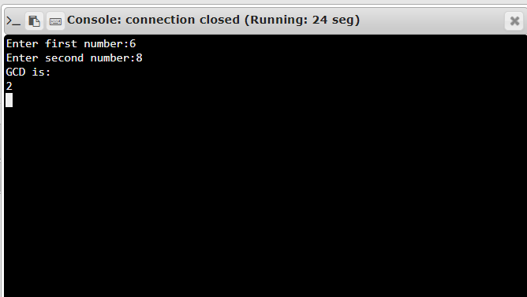

RESULT:

The output is obtained successfully.