EXERCISE NO:3

DATE:12/10/2020

AIM:

Write a Python program to remove and print every second number from a list of numbers until the list becomes empty.

PROGRAM:

def removethirdnumber(list):

temp=[]

p=1

s=0

for i in range(0,len(list)):

s=(p+s)%len(list)

vv=list.pop(s)

temp.append(vv)

return temp

v=int(input())

list=[]

for i in range(0,v):

list.append(int(input()))

p=removethirdnumber(list)

print(p)

LINK:

<http://103.53.53.18/mod/vpl/forms/edit.php?id=231&userid=1748>

OUTPUT:

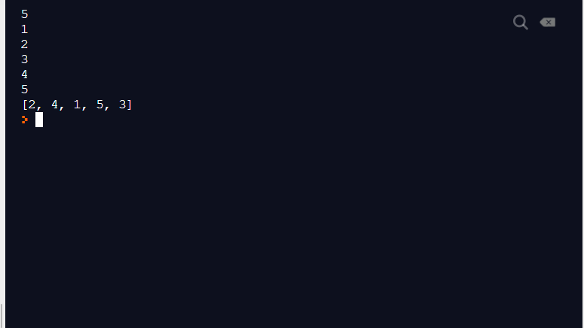

RESULT:

The output is obtained successfully.