EXERCISE NO:4

DATE:12/10/2020

AIM:

Write a Python program (function) to print a single string from two set of strings received from user and swap the first two characters of each string.

PROGRAM:

def convert(r):

new=""

for y in r:

new+=y

return new

p=input()

q=input()

r1=p.strip()

r2=q.strip()

if(len(r1)>=2 and len(r2)>=2):

s1=list(r1)

s2=list(r2)

t1=s1[0]

t2=s1[1]

s1[0]=s2[0]

s1[1]=s2[1]

s2[0]=t1

s2[1]=t2

r1=convert(s1)

r2=convert(s2)

print(r1," ",r2)

else:

print("Invalid")

LINK:

<http://103.53.53.18/mod/vpl/forms/edit.php?id=234&userid=1748>

OUTPUT:

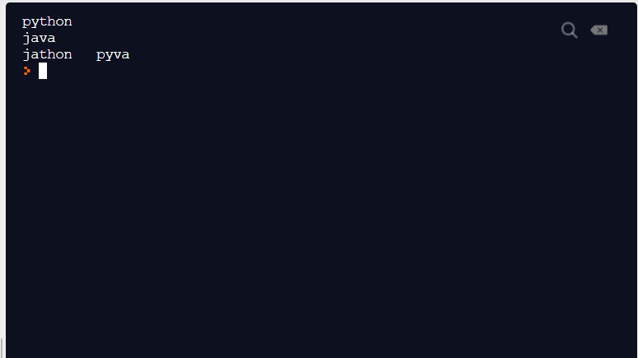

RESULT:

The output is obtained successfully.